Block – Victoria Street, La Trobe Street, Exhibition Street
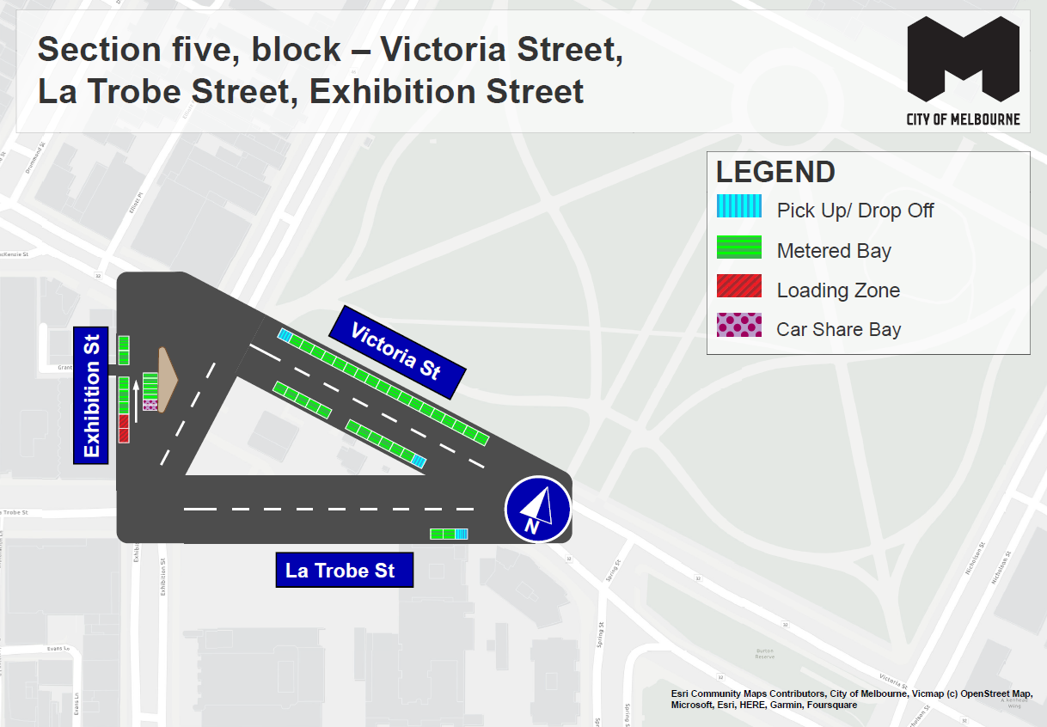
This map presents the parking conditions to be applied within this block as part of the CBD parking improvement project.

Victoria Street
The north side, from west to east, includes one pick up/drop off space, followed by 13 metered parking spaces.
The south side, from east to west, one pick up/drop off space followed by 11 metered parking spaces.

La Trobe Street
The south side, from east to west contains one pick up/drop off space, followed by two metered parking spaces.

Exhibition Street
The west side, from south to north, includes two loading zones followed by five metered parking spaces.
The east side, from south to north, includes two car share spaces followed by five metered parking spaces.

Parking controls to be applied
Simplified and consistent parking controls will be applied across the CBD.
Pick up/drop off spaces will typically be signed ‘No Parking’. We will add signage to explain that the space is for passenger pick up / drop off for up to 2 minutes.
Metered spaces will typically be signed ‘2P Meter, 7am – 10pm, Mon – Sun’. Off-peak pricing in the CBD started on 3 July 2023 and includes a reduced rate of $4 per hour after 7pm weekdays and all weekend. The offer of $0 payment for short stops of up to 15 minutes in any CBD metered parking space via the EasyPark app started on 3 July 2023. This allows short stops in any green-sign space rather than limiting short stops to a small number of specific bays (for example, ‘¼P’).
Loading Zones will typically be signed as ‘Loading Zone, 30-minute, 7am – 4pm, Mon – Fri’. These spaces will typically become ‘2P Meter, 4pm – 10pm, Mon – Fri’ and ‘7am – 10pm, Sat – Sun’. We will place some full time Loading Zones in areas with very high demand for deliveries. People making deliveries can also use green-sign spaces for short stays of up to 15 minutes for $0 via the EasyPark app.
Accessible (disability) parking spaces will typically be signed ‘2P, Disability Only, 7am – 10pm, Mon – Sun’. We will apply blue line-marking to these spaces.
Motorcycle parking will be signed as ‘P, Motor Cycles Only’ with no time restrictions.
Car Share spaces will typically be signed as ‘Permit Zone, Car Share Vehicles’ for the permitted car share vehicle operator.
Postal Vehicle spaces will be signed as ‘No Parking, Postal Vehicles Excepted’. They can be used by Australia Post vehicles, and by any other vehicle needing to access an adjacent postbox for up to 2 minutes.
Taxi Zones will be placed in areas with high demand for taxis. This includes at railway stations to support transport interchange and at key tourist destinations.
Tourist coach spaces will typically be signed as ‘No Stopping, Buses Stopping Less Than 15 Minutes Excepted’. This allows passenger pick up / drop off in the CBD. We will provide longer term parking for tourist coaches at key tourist destinations and in selected areas outside the CBD.
Authorised vehicle parking means access for permitted uses only (for example, Swanston Street delivery permit holders).
Non-vehicle occupation includes temporary infrastructure in a parking space (for example, an outdoor dining parklet).
Construction Zones will be signed as ‘Permit Zone, Construction Vehicles’ to allow construction vehicles with a permit to stop and park.

