Block – Lonsdale Street, Spring Street, Bourke Street, Exhibition Street
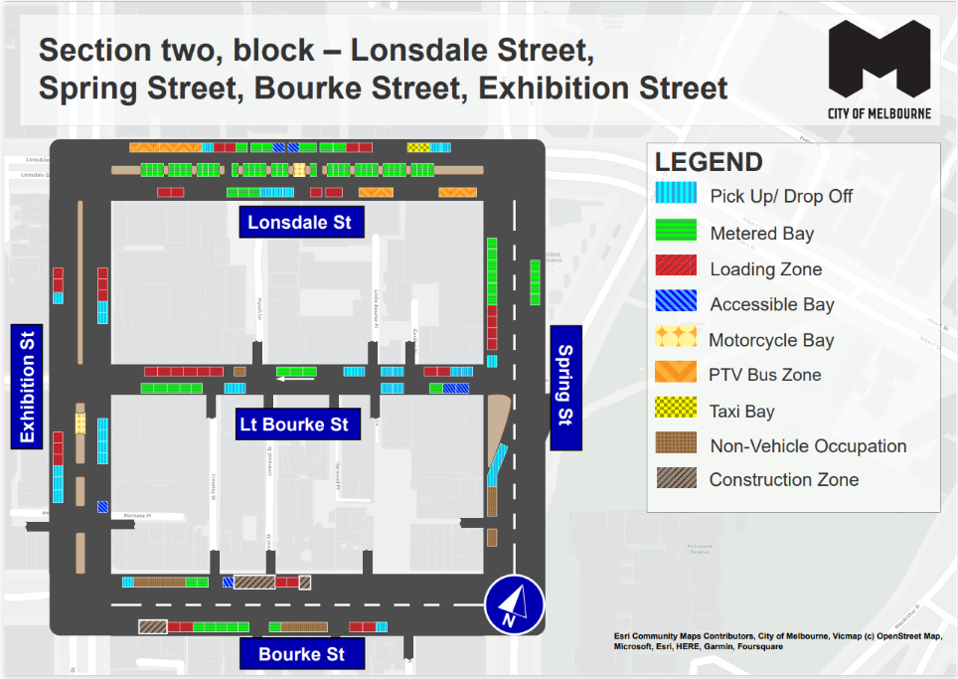
This map presents the parking conditions to be applied within this block as part of the CBD parking improvement project.

Lonsdale Street
The north side, from west to east, will include two PTV bus zones followed by one pick up/drop off space, two loading zones, three metered parking spaces, two accessible parking spaces, three metered parking spaces, two loading zones, one taxi zone area and two pick up/drop off spaces.
The south side, from east to west, will include two PTV bus zones, followed by two loading zones, three pick up/drop off spaces, three metered parking spaces and two loading zones.
The centre of road, from west to east, will include 20 metered parking spaces, one motorcycle parking area and 17 metered parking spaces.

Spring Street
The west side, from south to north, includes two non-vehicle occupation areas, followed by one long area of pick up/drop off space to the intersection with Little Bourke Street. Following the intersection, will be a pick up/drop off space, four loading zones and six metered parking spaces.
The east side, from north to south, will include four metered parking spaces to the intersection with Little Bourke Street.

Bourke Street
The north side, from west to east, will include one pick up/drop off space, followed by a non-vehicle occupation area, two metered parking spaces, one accessible parking space, a construction zone, two loading zones and a further construction zone.
The south side, from east to west, will include one pick up/drop off space, two loading zones, a non-vehicle occupation area, six metered parking spaces, two loading zones and a construction area.

Exhibition Street
The west side, from south to north, will include three pick up/drop off spaces, three loading zones to the intersection of Little Bourke Street. This is followed by one pick up/drop off space and two loading zones.
The east side, from north to south, will include three loading zones, followed by two pick up/drop off spaces to the intersection of Little Bourke Street. This is followed by four pick up/drop off spaces and one accessible parking space.

Little Bourke Street
The north side, from east to west, will include two pick up/drop off spaces, two loading zones, three pick up/drop off spaces, three metered parking spaces, on non-vehicle occupation and six loading zones.
The south side, from east to west, will include two accessible parking spaces, one metered parking space, three pick up/drop spaces and five metered parking spaces.

Parking controls to be applied
Simplified and consistent parking controls will be applied across the CBD.
Pick up/drop off spaces will typically be signed ‘No Parking’. We will add signage to explain that the space is for passenger pick up / drop off for up to 2 minutes.
Metered spaces will typically be signed ‘2P Meter, 7am – 10pm, Mon – Sun’. Off-peak pricing in the CBD started on 3 July 2023 and includes a reduced rate of $4 per hour after 7pm weekdays and all weekend. The offer of $0 payment for short stops of up to 15 minutes in any CBD metered parking space via the EasyPark app started on 3 July 2023. This allows short stops in any green-sign space rather than limiting short stops to a small number of specific bays (for example, ‘¼P’).
Loading Zones will typically be signed as ‘Loading Zone, 30-minute, 7am – 4pm, Mon – Fri’. These spaces will typically become ‘2P Meter, 4pm – 10pm, Mon – Fri’ and ‘7am – 10pm, Sat – Sun’. We will place some full time Loading Zones in areas with very high demand for deliveries. People making deliveries can also use green-sign spaces for short stays of up to 15 minutes for $0 via the EasyPark app.
Accessible (disability) parking spaces will typically be signed ‘2P, Disability Only, 7am – 10pm, Mon – Sun’. We will apply blue line-marking to these spaces.
Motorcycle parking will be signed as ‘P, Motor Cycles Only’ with no time restrictions.
Car Share spaces will typically be signed as ‘Permit Zone, Car Share Vehicles’ for the permitted car share vehicle operator.
Postal Vehicle spaces will be signed as ‘No Parking, Postal Vehicles Excepted’. They can be used by Australia Post vehicles, and by any other vehicle needing to access an adjacent postbox for up to 2 minutes.
Taxi Zones will be placed in areas with high demand for taxis. This includes at railway stations to support transport interchange and at key tourist destinations.
Tourist coach spaces will typically be signed as ‘No Stopping, Buses Stopping Less Than 15 Minutes Excepted’. This allows passenger pick up / drop off in the CBD. We will provide longer term parking for tourist coaches at key tourist destinations and in selected areas outside the CBD.
Authorised vehicle parking means access for permitted uses only (for example, Swanston Street delivery permit holders).
Non-vehicle occupation includes temporary infrastructure in a parking space (for example, an outdoor dining parklet).
Construction Zones will be signed as ‘Permit Zone, Construction Vehicles’ to allow construction vehicles with a permit to stop and park.

