City of Melbourne’s Submission
Review of the Draft World Heritage Strategy Plan for the Royal Exhibition Building and Carlton Gardens World Heritage Environs Area

11 November 2022
Contents
Submissions on behalf of City of Melbourne 3
1. Introduction 3
2. Area south of the WHEA 4
A. Royal Society Site 4
B. Inclusion of area south of Victoria Street (bounded by Russell, Exhibition and La Trobe Streets) 5
3. Area North of the WHEA 7
A. Residential zoned land north of Carlton Street 7
4. Area west of the WHEA 9
A. Planning controls for Rathdowne Street properties 9
5. State, Regional and Local Planning Policy Approach 10
6. Determining referral authority status 13
7. Statement of Significance 13
8. Other Matters 14
A. Signage 14
B. Extent of the application of the Design and Development Overlay (DDO). 14

Submissions on behalf of City of Melbourne

Introduction
- The City of Melbourne (Council) is pleased to provide its submission to the World Heritage Environs Area - draft World Heritage Strategy Plan (Draft Strategy Plan) and draft planning scheme amendment documentation (Draft Amendment) relating to the proposed Draft Strategy Plan and proposed policy and control changes to the Scheme.
- The Draft Strategy Plan seeks to update the 2009 version to ensure the ongoing protection of the Royal Exhibition Building (REB) and Carlton Gardens (CG), on the UNESCO World Heritage List. Around the REB & CG is a buffer zone referred to as the World Heritage Environs Area (WHEA) protecting the heritage values of the REB and CG together with views to and from the site.
- The Draft Strategy Plan and Draft Amendment has been considered by Council officers who recognise the substantial work undertaken in preparing the Draft Strategy Plan including the significant work undertaken by Hansen, HLCD and Heritage Victoria (HV) and the input from the Steering Control Group (which includes Council representation).
- While Council is generally supportive of the Draft Strategy Plan, and agrees with aspects of the Draft Amendment, there are some aspects of the Draft Strategy Plan and Draft Amendment which Council does not support in its present form.
- Additionally, Council has identified additional work necessary before the Draft Strategy Plan should be adopted.
- Council’s submissions are set out under the following headings:
(a) Area south of the WHEA
(i) Royal Society Site
(ii) Inclusion of area south of Victoria Street (bound by Russell, Exhibition and La Trobe Streets)
(b) Area north of the WHEA
(i) Residential zoned land north of Carlton Street
(c) Area west of the WHEA
(i) Planning controls for Rathdowne Street properties
(d) State, Regional and Local Planning Policy Approach
(e) Determining Referral Status
(f) The manner in which the Statement of Significance should be dealt with.
(g) Other matters.
(i) Signage
(ii) Extent of the application of the Design and Development Overlay.
- Having regard to the substance of Council’s submission, together with the likelihood of submission by others, Council requests that the Heritage Council conduct a hearing to ensure that all issues raised can be fully explored before the Draft Strategy Plan and Draft Amendment are finalised.
- Council confirms it wishes to be heard if such a public hearing is to be scheduled.

Area south of the WHEA

Royal Society Site
- No controls are proposed for the Royal Society site as part of the Draft Amendment.
- Council submits the absence of built form planning controls for the Royal Society Site could present a risk to the WHEA.
- The Royal Society of Victoria building, caretakers cottage and weather station (1-9 Victoria Street, c.1858, VHR H0373) are sited on a wedge of land bounded by Victoria, La Trobe and Exhibition Streets (Royal Society Site) as shown in yellow in Figure 1 below.

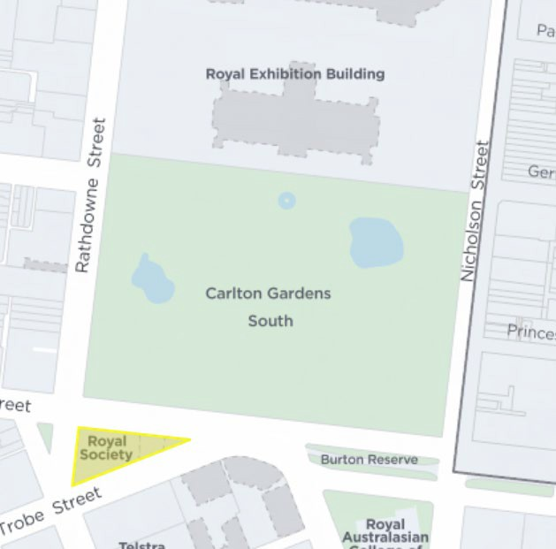
Figure 1: Location of the Royal Society Site relative to REB and CG
Source: CoMPass
- Established in 1855, the Royal Society is associated with the oldest scientific and philosophical society in Victoria. Presently, modest scale buildings are surrounded by a grassed area with multiple canopy trees. See Figure 2 below.
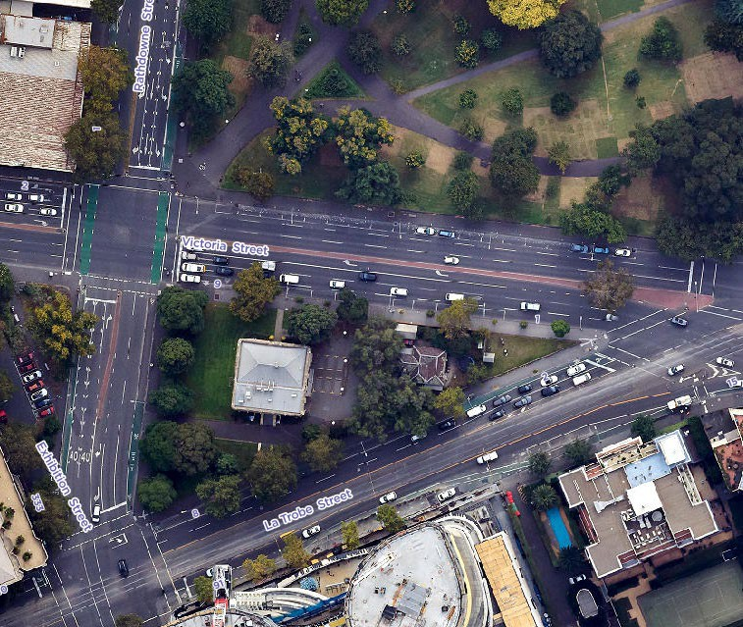
Figure 2: Royal Society Site, Aerial, April 2022
Source: CoMPass
- It is acknowledged the Royal Society Site is:
(a) On the Victorian Heritage Register (VHR);
(b) Within the boundary of the WHEA.
- Nevertheless, notwithstanding the VHR protection, given its location immediately opposite of the REB and CG on the south side of the Victoria Street carriageway, Council submits it is necessary to reconsider applying a Design and Development Overlay (DDO) protection on the Royal Society Site.

Inclusion of area south of Victoria Street (bounded by Russell, Exhibition and La Trobe Streets)
- A new DDO is proposed to implement various maximum building heights at the south- western corner of the WHEA, i.e. south of Victoria Street bound by Russell, Exhibition and La Trobe Streets being land in the Mixed Use Zone (MUZ).
- The recommended new DDO area and the associated extension of the WHEA boundary are shown as Area 3: Mixed Use Zone (MUZ) (Area 3) in map 1 to the proposed new DDO (over the page).
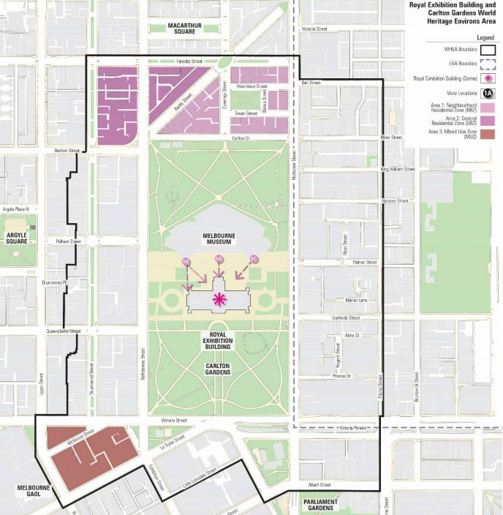
T
Figure 3: Map 1 included in the proposed Schedule to Clause 43.02
- Council considers that height controls to protect views of this area from the REB are warranted but require further work to justify the nature and drafting of the controls.
- The rationale for including the ‘Southern boundary’ area in the WHEA and the proposal to introduce mandatory height controls is based on analysis of views and built form. These indicate a threat from this part of the city to the setting of the REB. This threat is outlined broadly as the visual encroachment of CBD tower development that has the potential to overwhelm the REB skyline and primacy of the dome, when viewed from within the CG and Melbourne Museum forecourt located in the northern forecourt of the REB.
- The site specific heights are based on:
(a) The maximum building heights on a site by site basis which would be fully concealed from view from key vantage points within the northern forecourt.
(b) The determination of an 'acceptable visibility' of future built form on a site by site basis (i.e. concealment height +10m).
- Council submits the following:
(a) The ‘Southern boundary’ area is largely committed (tall buildings plus approved permits) with multiple examples puncturing the skyline.
(b) To the east of the ‘Southern boundary’ area directly south of the Royal Society Site there exists an intense Central City backdrop that must be acknowledged.
(c) The supporting strategic material with views from points 5A, B and C from the Museum Forecourt (see Map above) appears to indicate that the existing towers in the ‘Southern boundary’ area currently do not impact the skyline behind the dome and drum. However, these views are at three specific points. They, therefore, can be regarded as theoretical viewpoints in that the totality of views in the general direction of a southerly arc should be tested. Further, the visibility of the ‘Southern boundary’ area buildings needs to be analysed in relation to the total backdrop of tall buildings directly to the south – in the block bounded by La Trobe, Lt Lonsdale, Spring, and Exhibition Streets and those further south in the Central City– to determine the possible impact of the buildings in the ‘Southern boundary’ area in relation to the totality of the city backdrop. Should the above analysis indicate that height controls over the ‘Southern boundary’ area are needed, a further piece of work should be undertaken to determine whether it is appropriate to apply the proposed range of preferred and mandatory heights or if a blanket height across the area would be as effective.
(d) Should further work be undertaken to apply built form controls to the land bounded by Russell, Victoria, Exhibition and La Trobe Streets, Council would seek to lead this work, and choose the timing of such an exercise taking all planning and physical contextual considerations into account.
- In Council’s submission, protecting background views of the REB must not be the single driver to mandating building height.
- To this end, Council considers further work should be carried out considering all planning, heritage and urban design matters collectively to:
(a) Establish design objectives to identify the role of this area within the local and broader contexts. For example, the scaling and form of developments in this area should mediate between the lower scale, heritage character of Carlton and the taller built form of the Central City.
(b) Undertake built form testing of all sites within the proposed DDO that considers street wall heights and setbacks in addition to building height. An assessment of local conditions (existing heritage buildings, sensitive interfaces, adjoining public realm, and street hierarchy) in addition to established design objectives, would determine built form outcomes. Built form testing would also assess the relationship between built form and the public realm to assess any adverse impacts on pedestrian amenity (overshadowing and exposure to wind) and ensure an appropriate level of enclosure.
- Undertaking the above-mentioned strategic work can result in a suite of design objectives and built from controls in addition to overall building height to inform a future control.

Area North of the WHEA

A. Residential zoned land north of Carlton Street
- The Draft Amendment proposes a new DDO with mandatory height controls to affect residential land to the north of the CG although DDO mapping of the area is not included in the Draft Amendment.
- In Council’s submission, a new DDO over the residential area north of the WHEA is an unnecessary aspect of the Draft Amendment.
- This is because Council considers that existing zoning controls manage the interface between the residential area and the relationship with the northern end of the CG.
- Additionally, the same neighbourhood is protected for its heritage significance by:
(a) schedule 1 to the Heritage Overlay (HO1) comprising the Carlton Precinct replete with several graded properties moderating the extent and capacity for development change;
(b) schedule 992 to the Heritage Overlay (HO992) applying to the WHEA extending from the south where it applies to the REB and CG to properties on the north side of Carlton Street (in the section between Nicholson and Rathdowne Streets).
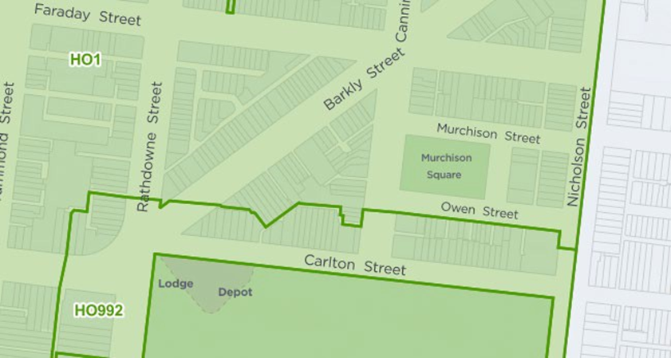
Figure 4: Location of existing HO1 and HO992 to the north and west of the REB & CG
Source: CoMPass, Council GIS
- The existing zoning of the area to the north of the WHEA is mainly Neighbourhood Residential Zone 3 (NRZ3) with some General Residential Zone 1 (GRZ1) as shown on the below zoning map.
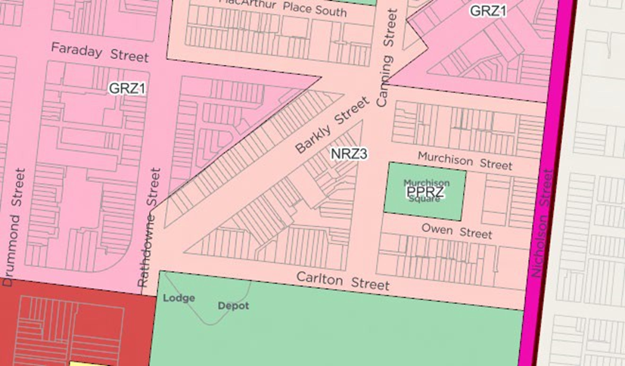
Figure 5 – Existing zoning map of area north of Carlton Street
Source: CoMPass, Council GIS
- A discrepancy has been identified between Council’s zoning map below and the depiction of the land use zoning at Map 1 (as taken from the Draft Strategy Plan) regarding land on the north-west side of Barkly Street between Canning and Rathdowne Streets. The land is actually within a NRZ (Council mapping), not a GRZ as (shown in the Draft Amendment) – a matter that needs to be, and can be corrected in the final plan.
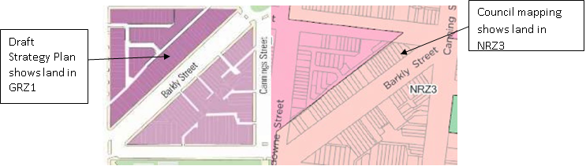
Figure 6 – Zoning map of Barkly Street (Draft Strategy Plan) on the left, Council zoning map on the right. Source: CoMPass, Council GIS
- In Council’s submission, an additional height restriction in the form of a DDO to this area to the north of the WHEA is both unwarranted and unnecessary.

4. Area west of the WHEA

A. Planning controls for Rathdowne Street properties
- In terms of Rathdowne Street, it is proposed to increase the number of sites to the west of the REB subject to height controls in the form of an extension to DDO6.
- Council supports the inclusion of the additional lots (outlined in red) within DDO6 as shown on the existing DDO6 mapping below at Figure 7.
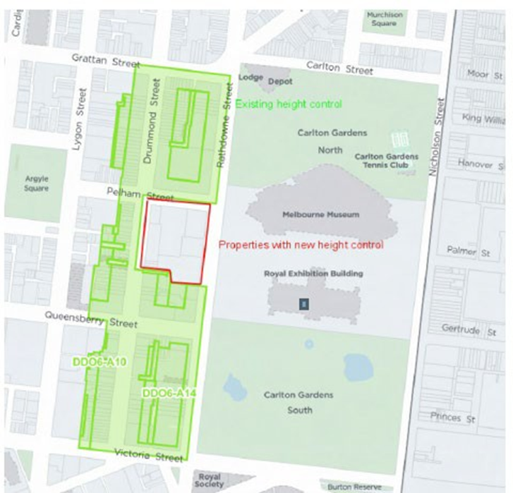
Figure 7 – Proposed extension to the DDO6 applying to area bound in red

- This is because:
(b) Rathdowne Street being the principal corridor immediately to the west of the WHEA has an immediate and direct interface with the REB and CG.
(c) the large properties in the pocket immediately to the south of Pelham Street (see Figure 8 below) are not affected by any built form overlays.
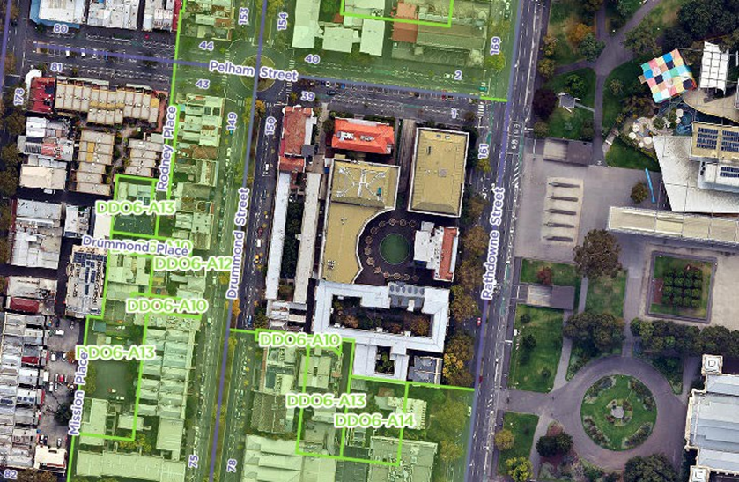
Figure 8 – Rathdowne Street, Aerial, April 2022 illustrating DDO6 gap area
Source: CoMPass
- However, in Council’s submission, the Rathdowne Street physical context is a strong candidate for the application of mandatory provisions on the basis of heritage and character value. DDO6 is presently drafted with discretionary height controls.
- Further analysis should be carried out taking into consideration the impact of development on the consistent, low scale heritage streetscape of Rathdowne Street in its entirety.
- Pressure for much higher and intensive development exists along Rathdowne Street best illustrated by 1 Rathdowne Street (former Cancer Council site).
- Council appreciates revisiting the viewpoints on this western side of the WHEA for their significance (but also for their accuracy – see comments later in our submission) and exploring the role of upper level setback controls (among other things) to justify mandatory provisions. This ought to be an appropriate next step.

5. State, Regional and Local Planning Policy Approach
- In terms of state and local policy, it is proposed to introduce amended versions of the following policies:
(d) Clause 15.03-1S Heritage Conservation
(e) Clause 22.21 Heritage Places within the World Heritage Environs Area which is to be amended to a new title Development Guidelines for the World Heritage Environs Area.
- It is also proposed to introduce a new regional level policy at clause 15.03-1R.
Clause 15.03-1S & Clause 15.03-1R
- Strengthening of State level policy for the WHEA in the Scheme is supported with the regional policy approach at clause 15.03-1R ensuring consistency in the conservation and protection approach of both Council and City of Yarra.
- Council supports the proposed approach at clause 15.03-1R subject to some minor redrafting which would appear necessary.
- For example, the drafting currently provides:
Ensure all development is appropriate in context of and area does not detract from the recognized world heritage value.
- A minor correction is necessary along the lines:
Ensure all development is appropriate in the context of the WHEA and does not detract from the recognized world heritage value.
Clause 22.21
- The Draft Amendment has been circulated with an updated clause 22.21 Heritage Places within the World Heritage Environs Area of the Scheme, which extends the WHEA boundary to the south and west, and among other things, seeks to remove the distinction between areas of greater and lesser sensitivity to create one buffer zone for the WHEA.
- As a consequence of Amendment C409 to the Scheme (gazetted as recently as 21 September 2022), the Scheme no longer has a place for clause 22 and it will be necessary for the proposed amended policy to be translated within its new home at clause 15.03- 1L-01.
- Additionally, there are some general concerns with the substantive content of clause 22.21 as broadly relating to the intent of the policy, and identification and mapping of the important viewpoints, as follows:
Drafting of the policy
- The relevant policy statement is proposed to read as follows:
Protect direct views and vistas to the Royal Exhibition Building and Carlton Gardens from bordering/abutting streets and other views and vistas to the dome available from streets within the precinct including key views illustrated in the World Heritage Environs Area Map to this clause.
- The extent of viewpoints to be considered is ambiguous.
- This is because it leaves the door ajar to the interpretation of additional locations to which this policy would apply. It is unclear if this is the intent.
- Council submits it should be very clear which views are to be protected.
Interpretation of the Proposed WHEA Map at clause 22.21
- A further issue is that clause 22.21 does not include a description of the location for the protected view as identified by the Draft Strategy Plan.
- It is understood the Draft Strategy Plan recommends protecting the following primary view lines at page 88 of the Draft Strategy Plan:
View 1A: View towards the Dome from the southern footpath of Queensberry Street, at the south eastern junction with Drummond Street.
View 1B: View towards the Dome from the southern footpath of Queensberry Street, at the south eastern junction of Lygon Street (outside WHEA boundary).
View 1C: View towards the Dome from the western footpath of Spring Street, north west corner of Lonsdale Street junction.
View 1D: View towards the Dome from the western footpath of Spring Street, south west corner of Bourke Street junction.
View 1E: View towards the Dome from the eastern footpath of Nicholson Street, south of Evelyn Place.
View 1F: View towards the Dome from the eastern footpath of Victoria Parade central median and Tram Stop.
View 3A: View towards the REB, Dome and Carlton Gardens from the western footpath of Rathdowne Street, at the north western junction with Pelham Street.
View 3B: View towards the REB, Dome and Carlton Gardens from the eastern footpath of Rathdowne Street, between 101 and 117 Rathdowne Street (pedestrian crossing).
View 5A: View towards the Dome and REB northern elevation from the Melbourne Museum Forecourt (Central Entry).
View 5B: View towards the Dome and REB northern elevation from the Melbourne Museum Forecourt (Western Entry).
View 5C: View towards the Dome and REB northern elevation from the Melbourne Museum Forecourt (Eastern Entry/ Lift).
- However, View 5B is not included on the map in clause 22.21.
- Also, clause 22.21 could do better to make it clearer from where these views are taken, and should include this detail in the legend (or elsewhere) within the policy.
- This is because in considering the map in clause 22.21 it is unclear what the distinction is between the types of viewpoints as shown in navy/black (1A – 1F) relative to light blue (3A and 3B) and pink (5A and 5C). The legend also does not distinguish between the different types of views (e.g. aspect and prospect). While these details are in the draft Strategy Plan, this information does not carry through to the proposed local policy.
- Further, there is no categorisation of the views or description of what constitutes the important elements of each view. This will make it difficult to assess how development within the WHEA will affect primary views.
57. One has to draw on the proposed background document to locate this information.
Missing Views
58. A further issue requiring clarity is the rationale for the exclusion of specific viewpoints considered by the Draft Strategy Plan.
59. For example Category 6 - Prospect Views (6B and 6C) are identified as prospect (outward looking) views of 19th century setting out of the Carlton Gardens (perimeter) and Melbourne Museum Forecourt. Given a key objective of the policy is:
to maintain and conserve the significant heritage character (built from and landscapes) of the area
the policy and map should include a reference the key prospect views from the perimeter of Carlton Gardens.
Accurate mapping of viewpoint location
60. A further important consideration is the precise location from which the view is to be protected, i.e. from the public footpath, at an intersection, etc. There is a need for greater clarity around the graphic depiction of the location of the key views to be protected, and from where they have been taken.
61. In considering the appropriateness of the viewpoints specifically included in clause 22.21 in preparing this submission, Council officers undertook a site inspection to ascertain the primacy of the views and review the key views within the WHEA proposed through the Visual Framework and Testing (Appendix 1).
62. Having regard to the mapping of the viewpoint location relative to the accompanying photographs in Appendix 1, some inconsistencies and errors were identified as follows:
(a) Discrepancies between the images, written descriptions, and map locations of some views. For example,
(i) the written description of view 1B places the view at the south-east corner of Lygon and Queensberry Streets, however the map location shows it within the Lygon Street carriageway.
(ii) View 3C (aspect view) is shown in map from the Victoria Street tram stop yet the accompanying photograph is clearly taken south of that from the footpath on the south side of the Victoria Street carriageway.
(iii) The photograph of View 4A is inconsistent with its mapped location.
(b) The document should be reviewed to ensure the written descriptions of each view matches the location the image was taken from and reflected accurately in the map and by accompanying photography. Consideration should be given to geotagging.
(c) The viewer location within the public realm varies across some images and should be clarified. This is because some images appear to be taken on the carriageway (IH, 1E, 1K, 2D) and others within the footpath area (1A, 1B, 1C).
(d) The camera angle, heights, and width of lens appear to differ across many images.
(e) The impact of recent development activity will affect some views.
63. Additionally, we note view corridors were identified and mapped along Spring, Victoria, and Queensberry Streets but not assessed and discussed in the Visual Framework.
64. We submit it is necessary for all views to be reviewed to confirm (and corrected as necessary) the viewpoint locations, mapping and/or photography in the draft Strategy Plan. Once that occurs, and having regard to our other comments, an updated clause 22.21 (now clause 15.03-1L-01) must be prepared.

6. Determining referral authority status
65. The Draft Amendment proposes to give determining referral authority status to the Executive Director, HV.
66. Council considers recommending referral authority status is a more appropriate level of authority than determining referral status.
67. To propose and then effect the status of determining referral authority puts heritage considerations ahead of other planning considerations, which is an inappropriate elevation, in the Council’s submission, having regard to the physical and planning contexts.
68. Respectfully, Council submits this level of authority tips decision making in favour of heritage considerations on key land parcels that are zoned to facilitate a range of land use and development outcomes. It has not been demonstrated that the City of Melbourne has failed to adequately apply heritage controls when assessing planning applications. On the contrary the City approaches its duties as regulators of heritage fabric seriously and conscientiously, and our multi-disciplinary experts inform our ability to arrive at consistent, integrated and balanced planning decisions.
69. Making Heritage Victoria a determining referral authority also shifts power away from decision-makers with a democratic mandate (City of Melbourne and, sometimes, the Minister) to an appointed decision-maker (the Executive Director Heritage Victoria), leading to a reduction in the democratic legitimacy of development decisions and the orderliness of planning approvals.

7. Statement of Significance
70. HV has recommended that the HO992 boundaries and its Statement of Significance (SoS) be updated in the future and that the draft SoS be incorporated into the Scheme.
71. A draft SoS is provided in the draft Strategy Plan.
72. Council is supportive of the draft SoS that has been prepared and submits the draft SoS should form part of the final amendment documentation, rather than be left as a future task. This enables it to be considered in all relevant planning decisions by virtue of it as an incorporated document under the Scheme.
73. Council recognises the heritage significance of the WHEA and the surrounding Carlton area as evidenced by Council’s preparation and progression of Amendment C405 to the Scheme seeking to implement the findings of the Carlton Heritage Review on a permanent basis (Amendment C405). Amendment C405 proposing to apply to land immediately to the north and west of the REB and CG has been formerly exhibited and recently considered by Planning Panels Victoria.

8. Other Matters

A. Signage
74. The proposal to manage signage within the WHEA is supported with consideration given to the need for additional signage controls.
75. Council submits future signage policy and/or controls must seek to prevent electronic and animated signage.

B. Extent of the application of the Design and Development Overlay (DDO).
76. The Draft Strategy Plan is unclear on the extent of the application of the DDO.
77. Council submits that the DDO should only be applied to those areas where a height control or other relevant built form provision is proposed.

