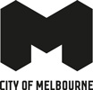
Aboriginal Community Grants Program Guidelines 2024
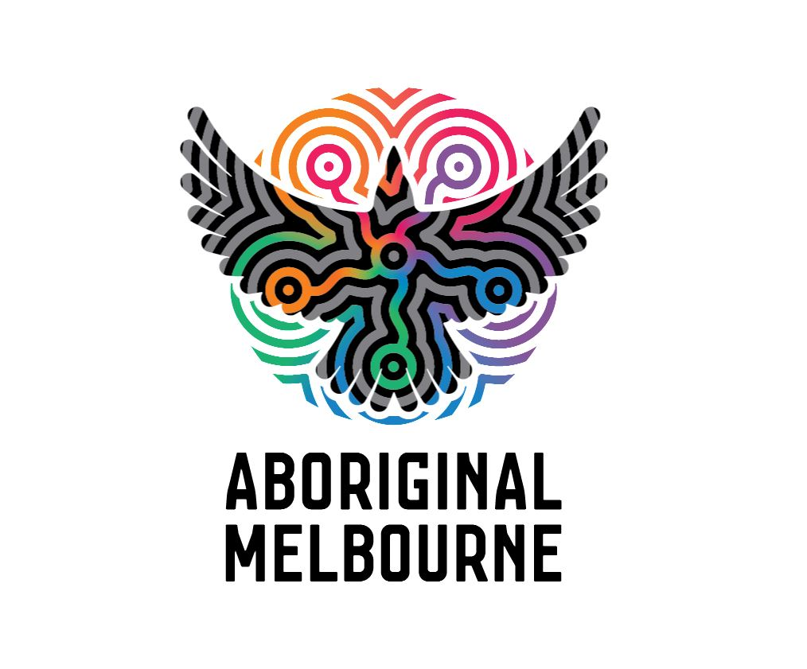

Acknowledgement of Traditional Owners
The City of Melbourne respectfully acknowledges the Traditional Owners of the land we govern, the Wurundjeri Woi-wurrung and Bunurong Boon Wurrung peoples of the Eastern Kulin and pays respect to their Elders past, present and emerging.
We acknowledge and honour the unbroken spiritual, cultural and political connection the Wurundjeri, Bunurong, Dja Dja Wurrung, Taungurung and Wadawurrung peoples of the Eastern Kulin have to this unique place for more than 2000 generations.
We are committed to our reconciliation journey, because at its heart, reconciliation is about strengthening relationships between Aboriginal and non-Aboriginal peoples, for the benefit of all Victorians.
Contents
City of Melbourne Community Grants and Partnership Framework 4
Purpose of Aboriginal Community Grants 4
Objectives of Aboriginal Community Grants 5
Eligibility criteria 5
Funding level 6
Key dates 6
Assessment process 6
Assessment criteria 7
Additional assessment notes 8
City of Melbourne reserves the right to: 8
Other 8
Essential attachments for all applications 8
Lobbying 8
Grant terms and conditions 8
Completing your application 9
Contacts 9
SmartyGrants technical assistance 9
Got questions? 10

City of Melbourne Community Grants and Partnership Framework
City of Melbourne adopted the Community Grants and Partnerships Framework in September 2018. The full Framework can be downloaded from the City of Melbourne website.
Through the Community Grants and Partnerships Framework, the City of Melbourne provides funding, expertise and support to socially-oriented organisations that address key social issues to ensure that our communities thrive. The Council Plan is the guiding document which sets out Council’s priorities and the Community Grants and Partnerships Framework enables the City of Melbourne to:
- empower our communities to identify and respond to local areas of need
- partner with community organisations to deliver shared outcomes
- activate community participation amongst residents
- build capacity within the community sector.
We encourage our communities to take an active role in identifying and responding to social issues.
The following best practice principles and practices underpin the Community Grants and Partnerships Framework and inform the priorities for funding:
Principle | Practice
Impact | We take a purposeful and strategic approach to funding projects that deliver meaningful social impact.
Inclusion | Inclusion, access and participation are the hallmarks of healthy, thriving, prosperous, self-reliant, inclusive and resilient communities.
Connection | We connect meaningfully with our communities and stakeholders and we foster more connected communities for our residents.
Partnership | We know we can’t solve tough problems alone. Through collaborative partnerships we work with others to deliver exceptional outcomes.
Innovation | Our communities experience constant change. We discover new solutions to changing needs and foster innovation in addressing our social challenges.
Transparency | We are transparent in our funding priorities, processes and decisions. All of which are published on our website.

Purpose of Aboriginal Community Grants
The City of Melbourne is committed to enabling positive outcomes and promoting self-determination for Community by building shared knowledge, respect and understanding of Aboriginal culture. We provide Aboriginal community grants of up to $10,000 for community-led projects that promote community connection, cultural and social inclusion, access and participation for Aboriginal and Torres Strait Islander people.

Objectives of Aboriginal Community Grants
Projects must support one of the following Council Plan Actions:
- Provision of opportunities which support cultural, social and economic development for Aboriginal Victorians
- Provision of education to the broader community about Victorian Aboriginal heritage and culture
- Promotion of community understanding of reconciliation as part of National Reconciliation Week
- Explore and deliver opportunities for truth-telling to facilitate learning, healing, and change within the City of Melbourne municipality.
- Engage with Aboriginal cultures and histories by celebrating NAIDOC Week/Sorry Day/Invasion Day.

Eligibility criteria
To be eligible to apply for funding through Aboriginal Community Grants, applications must meet the following criteria:
- Applicants must be a not-for-profit constituted body or a school. Auspiced applications are permitted in this program.
- Applicants must be located within, or be running the project within, the City of Melbourne municipality.
- Applications must have a focus on City of Melbourne’s local communities and/or communities that are considered vulnerable.
- Activities must take place by 31 December 2024.
- Projects funded through Aboriginal Community Grants are eligible for a maximum of two consecutive years funding.
Funding will not be considered for:
- core operational funding
- projects with a religious or political focus
- commercial activities and/or organisations
- fundraising activities, competitions, prizes or award events
- interstate and international travel costs including travel costs for facilitators/consultants
- activities that have already commenced or occurred
- projects that are being, or have already been, funded through other City of Melbourne grant or sponsorship programs
- activities run by the City of Melbourne
- organisations with outstanding acquittals or debts owing to the City of Melbourne
- incomplete applications
- late submissions.

Funding level
Applications for Aboriginal Community Grants funding can be made for any value up to $10,000.

Key dates
- Monday 4 March 2024: Applications open
- Sunday 31 March 2024: Grants close
- April/May 2024: Applicants notified of outcome

Assessment process
Once we have received your application:
- You will receive an email confirming receipt of your application.
- Your application will be assessed against the eligibility and assessment criteria. Ineligible applicants will be notified that their application is ineligible.
- Funding recommendations will be advised to Council. Council will make the final decision on the outcome of all eligible applications.
- All applicants will receive a notification via email with the result of their application within 8 weeks of application.
- Information about grant decisions will not be given over the phone.
- The list of successful applicants will be published on the City of Melbourne website once applicants have been notified and funding has been distributed.

Assessment criteria
Aboriginal Community Grant applications are assessed against the assessment criteria below. Only applications that adequately respond to the assessment criteria will be considered.
- The applicant is an Aboriginal run organisation or community group? (15%)
Please note: if applicants are not an Aboriginal and/or Torres Strait Islander organisation or community group they may still proceed in applying for the grant as long as the application meets all other criteria. Application will however be prioritised based on responses to all elements of the criteria.
- Alignment to the purpose and objectives of the Aboriginal Community Grants program (30%)
  - Does the project support one of the Aboriginal Community Grants priorities?
  - Does the project promote community connection, social and cultural inclusion, access and participation for City of Melbourne residents?
  - How many City of Melbourne residents are likely to participate?
  - Does the project target groups or individuals that face barriers to community participation?
- Community need (20%)
  - Is there a clearly identified need for this project?
  - Has evidence of this need been provided?
  - Will the project be successful in addressing this need?
  - Has the applicant appropriately engaged with target participants and other community stakeholders prior to submitting the application?
- Organisational capacity (15%)
  - Is the scope of the project appropriate to the organisation’s resources and expertise?
  - Is the application well planned with clear deliverables and a realistic timeframe?
  - Does the application identify appropriate partners that will work with them in a collaborative way?
  - Does the organisation have a track record of delivering similar types of projects successfully?
  - Does the application outline an evaluation plan?
- Budget (20%)
  - Does the budget accurately reflect the scope and scale of the project?
  - Have other funding sources been identified?
  - Have the resources that are required to deliver the project been clearly identified?
  - Does the total revenue match the total expenses?
  - Is the project financially sustainable if it is to continue beyond the funding period?
  - Have quotes been provided to support capital purchases (if applicable)?

Additional assessment notes

City of Melbourne reserves the right to:
- Not consider applications that do not meet the eligibility or assessment criteria.
- Request further information to inform our assessment.
- Recommend partial funding, in consultation with the applicant.

Other
- Normal permit requirements apply for all projects. If relevant, these should be outlined in the application. (Refer to the City of Melbourne website for permits required within the City of Melbourne).
- If quotes and/or other proposed services are provided by family, friends or committee members, this must be declared in the application.

Essential attachments for all applications
- Applicants must provide a certificate of currency for public liability or other relevant insurance.
- If you are applying to purchase significant single expenditure items (e.g. single items like computers or items over $1000) you must include at least one quote.

Lobbying
Canvassing or lobbying in relation to an application is strictly prohibited during the application process. No further consideration will be given to an application submitted by an applicant that canvasses or lobbies the Lord Mayor, City of Melbourne councillors or employees of the City of Melbourne.

Grant terms and conditions
If your application is successful, you will be required to:
- Sign a funding agreement with the City of Melbourne that provides details about the terms and conditions of funding. The funding agreement will outline reporting and acquittal requirements specific to your application.
- Grants will be paid in one instalment.
- Supply all requested information prior to any funding being released.
- Submit paperwork within the allocated timeframes. Funding is allocated from specific financial year budgets and if paperwork is not submitted within the allocated timeframe, then funding is forfeited by the funded organisation.
- In some instances, you may be required to meet or discuss your project with the grant manager and provide revised information.
- If the funded project includes contact with children aged 0-18 the organisation must ensure that all relevant staff, contractors, volunteers and committee members hold a valid working with children check and provide copies of these if requested by Council.
- Use the funding allocated for the purposes specified in the application. Grants may not be used for any purpose other than for which it is granted, without the written permission of the City of Melbourne.
- Deliver the project within the allocated budget. City of Melbourne will not be responsible for shortfalls in project budgets if the applicant is unable to meet project costs.
- Acknowledge the City of Melbourne in all promotional materials relating to the successful application, including use of the logo.
- Complete the project by the date stated in the funding agreement. Requests for extensions will need to be considered and agreed to by City of Melbourne. Projects must be completed within 12 months of the agreement date.
- Invite the Lord Mayor and Councillors to attend any significant launches or events associated with the project.
- Acquit the grant and provide receipts to demonstrate the expenditure of a minimum 75 per cent of the grant. Grants for capital works and/or capital purchases must provide receipts to demonstrate the full expenditure of the grant.

Completing your application
Applications will be submitted and managed online via SmartyGrants. Application forms can be accessed from the City of Melbourne website.
Please note the key application dates listed above.
When your application is fully submitted you will receive an automated email containing a PDF copy of your application and confirmation that it has been received.
If you experience technical issues with the SmartyGrants system, please contact SmartyGrants directly (contact information below).

Contacts
For general enquiries, please contact a member of Aboriginal Melbourne at aboriginalmelbourne@melbourne.vic.gov.au

SmartyGrants technical assistance
If you experience technical issues with the SmartyGrants system please contact them directly on email: service@smartygrants.com.au or by phone: (03) 9320 6888.

Got questions?
Q: Can my organisation submit more than one application?
A: No only one application per organisation per year will be accepted.
Q: Do I have to be an Aboriginal organisation to apply?
A: No, any eligible organisation can apply, but projects must address the Aboriginal Community Grants objectives.
Q: If we already have some funding allocated to this project, can we still apply for additional funding?
A: Yes. In fact we encourage multiple funding sources for a project as this can strengthen the application and create greater sustainability for the project. The application form will ask you to declare additional funding sources for your project.
Q: My organisation is located outside of the City of Melbourne; can I apply?
A: To be eligible, organisations must be located within, or offer a project within, the City of Melbourne municipality. In addition, the program has a focus on local and / or vulnerable communities. City of Melbourne suburbs include: Carlton, Central Business District (Melbourne), Docklands, East Melbourne, Fisherman’s Bend, Kensington, North Melbourne, Parkville, part of Port Melbourne, Southbank, parts of South Yarra and West Melbourne. You can view a map of the boundaries (PDF) on the City of Melbourne website.
Q: My group is not incorporated; can I apply?
A: To be eligible, applications must come from a school or a not-for-profit community organisation that is a legal entity. If you are an individual or an unincorporated group, you will be required to find an auspice prior to applying for an Aboriginal Grant. If you apply under the auspice of an organisation, the City of Melbourne requires that you provide a letter from your auspice confirming that they agree to this arrangement. Note that for successful applicants that have an auspice, the City of Melbourne pays the grant to the auspice organisation.
Q What is an auspice?
A: An auspice is an organisation that agrees to take legal and financial responsibility for administering the grant on behalf of the applicant where an applicant is not eligible or unable to apply for funding. To find out more about an auspice arrangement visit What is auspicing? - Not-for-profit law
Q How many years can I apply for funding for the same project?
A: Projects are eligible for funding for a maximum of two years.
Q: Can I ask for funding for operational costs?
A: No

https://www.melbourne.vic.gov.au/community/strong-communities/funding-grants/Pages/community-grants-partnerships.aspx
https://www.melbourne.vic.gov.au/about-council/vision-goals/pages/council-plan.aspx
https://www.melbourne.vic.gov.au/about-melbourne/research-and-statistics/city-population/pages/community-profiles.aspx
https://www.melbourne.vic.gov.au/community/strong-communities/funding-grants/pages/community-grants-recipients.aspx
http://www.melbourne.vic.gov.au/pages/permits.aspx
http://www.melbourne.vic.gov.au/sitecollectiondocuments/cityofmelbourne_boundarymap.pdf
http://www.nfplaw.org.au/auspicing

