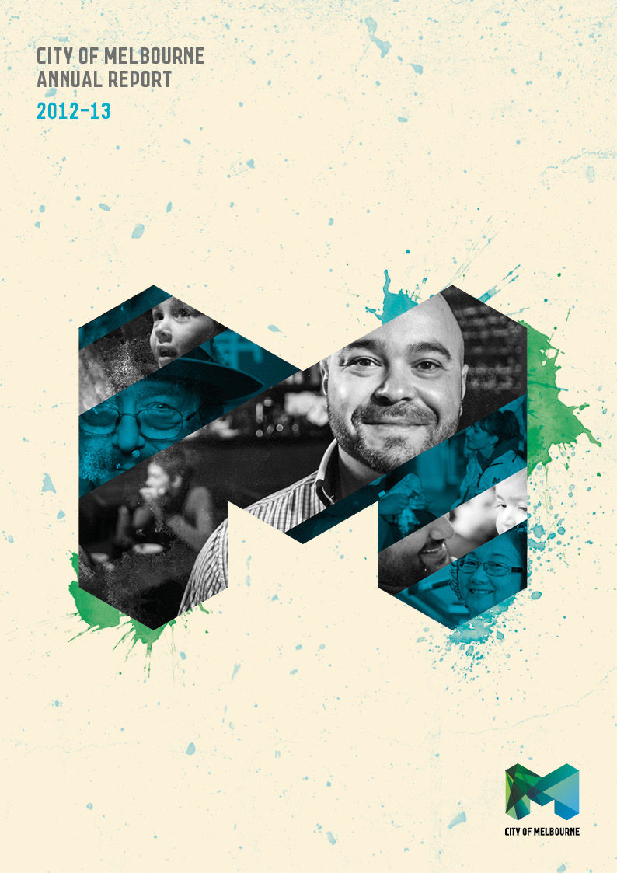

City of Melbourne
Annual Report 2012–13

We are pleased to present to you the City of Melbourne’s annual report for 2012–13.

The report outlines how the City of Melbourne performed during the financial year starting 1 July 2012 and ending 30 June 2013.

Our website at www.melbourne.vic.gov.au provides more information about City of Melbourne activities, policies and plans for the future.

We value your feedback on this report because it helps us make our next report better. If you’d like more information about any item in this report, just contact us and ask.

Email your feedback or questions to enquiries@melbourne.vic.gov.au.

Write to us at:

Corporate Planning and Learning
City of Melbourne
GPO Box 1603
Melbourne VIC 3001

Speak to a Customer Relations Officer on +61 3 9658 9658.

Fast facts

Area: 37.7 km²
Suburbs: 16
Parkland: 486 ha
Residential population: 105,381 ^
Residential student population (higher education): 26,323 *
Weekday population, including residents: 844,000 ^
Weekend population, including residents: 563,000 ^
Businesses: 17,709 ^^
Dwellings: 53,437 **
Employment: 428,709 *
Cultural backgrounds: 138 **
Languages: 121 **

Greenhouse gas emissions for the Melbourne municipality

Emissions per resident: 5.22 t CO₂-e/person +
Emissions per worker: 4.70 t CO₂-e/person +
Total emissions: 3,799,000 t CO₂-e +

* 2010
**2011
^ 2012
^^2013
+ 20010–11

The City of Melbourne

Melbourne is the capital of Victoria and Australia’s second largest city.

The organisation, although known as the City of Melbourne, is officially titled the Melbourne City Council and is one of 79 municipalities in Victoria operating as a public statutory body incorporated under the Local Government Act 1989 (Vic).

As a local government authority, the City of Melbourne strives to achieve the community’s vision of Melbourne as a bold, inspirational and sustainable city, as outlined in the Future Melbourne Community Plan, the organisation’s 10-year plan to make Melbourne a great place for people to live, work and visit.

About this report
As a capital city local government we must lead by example in our performance and in our reporting. We are committed to being open and clear communicators.

This annual report documents the City of Melbourne’s performance over the 2012–13 financial year against the objectives of the 2012–13 Annual Plan and Budget and the four-year goals set out in our Council Plan 2009–13.

The report is designed to meet our obligations under section 131 of the Local Government Act and the requirements of the Global Reporting Initiative framework for sustainability reporting.
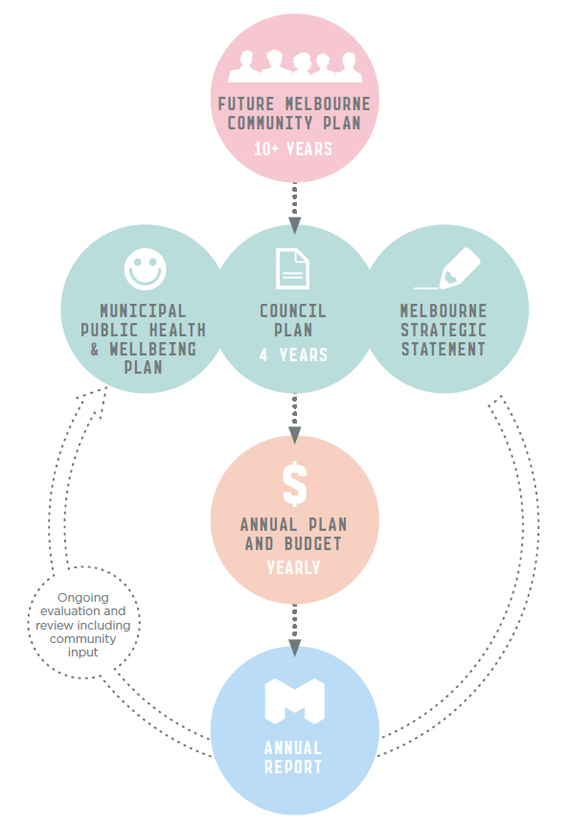

The Public Health and Wellbeing Plan is integrated with the Council Plan, and seeks to protect, improve and promote public health and wellbeing in the municipality.

The Municipal Strategic Statement is part of the Victorian Government’s Melbourne Planning Scheme, and sets out the Council’s vision, objectives and strategies for managing land use change within its local boundaries.
Contents

City of Melbourne Annual Report 2012–13 ….. 2
The City of Melbourne
About this report
Contents
Melbourne at a glance

Our city ……………….……………….………........ 6
Our Council
Our vision, our mission, our values
Message from the Lord Mayor
Message from the CEO
Our Council
Our Councillors
Council terms

Our performance ………………...……..….… 14
Performance highlights
Goal one – A city for people
Goal two – A creative city
Goal three – Economic prosperity
Goal four – A knowledge city
Goal five – An eco-city
Goal six – A connected city
Goal seven – Lead by example
Goal eight – Manage our resources well

Our organisation …………………….......…... 65
Our people
Chief Executive Officer
Divisions and directors
Organisational structure
Staff classification
Staff profile
Staff retention and turnover
Staff support services
Staff development
Staff training
Health and wellbeing
Occupational health, safety and wellbeing

Our workplace ……………………..………….…. 72
WorkCover claims
Equal employment, discrimination and harassment
Workplace diversity
Enterprise agreement
Best value service delivery
Lean Thinking
Stakeholders
Community engagement

Our corporate governance ………………. 75
Relationship with other tiers of government
Council decisions
Delegations
Participation in Council
Documents available for inspection
Councillor allowances
Expenses
Councillor conduct
Council and committee meeting attendance
Council special committees
Council of Capital City Lord Mayors
Subsidiaries and trusts

Legislative compliance ……………….………. 79
Freedom of Information
National Competition Policy compliance
Procurement Policy
Information Privacy Act
Protected Disclosure Act
Disability Discrimination Act
Domestic Animals Act
Carers Recognition Act
Inner Melbourne Action Plan

Risk management ………………………………. 83
Risk management strategy, integrated reporting and competitive neutrality
Fraud awareness and training
Insurance and risk financing
Business continuity planning and crisis and emergency management

Audit operations ……………….……..…..….… 84
Audit Committee
Audit Committee members
Internal audit
External audit

Performance statement …………………… 86
KSA 1 Planning for future growth
KSA 2 City safety
KSA 3 Homelessness
KSA 4 Climate change
KSA 5 Streetscapes
KSA 6 Queen Victoria Market
KSA 7 Swanston Street redevelopment
KSA 8 Knowledge Melbourne
KSA 9 Community infrastructure
KSA 10 Connected bike network
Signed statement …………………..………. 105
Independent Auditor’s Report
Victorian local government indicators
Global Reporting Initiative indicators

Financial statements ………………..……. 113
Financial report overview
Reading our financials
Standard statements
Financial statements
Signed statement ……………………...…..……. 178
Independent Auditor’s Report

City of Melbourne at a glance

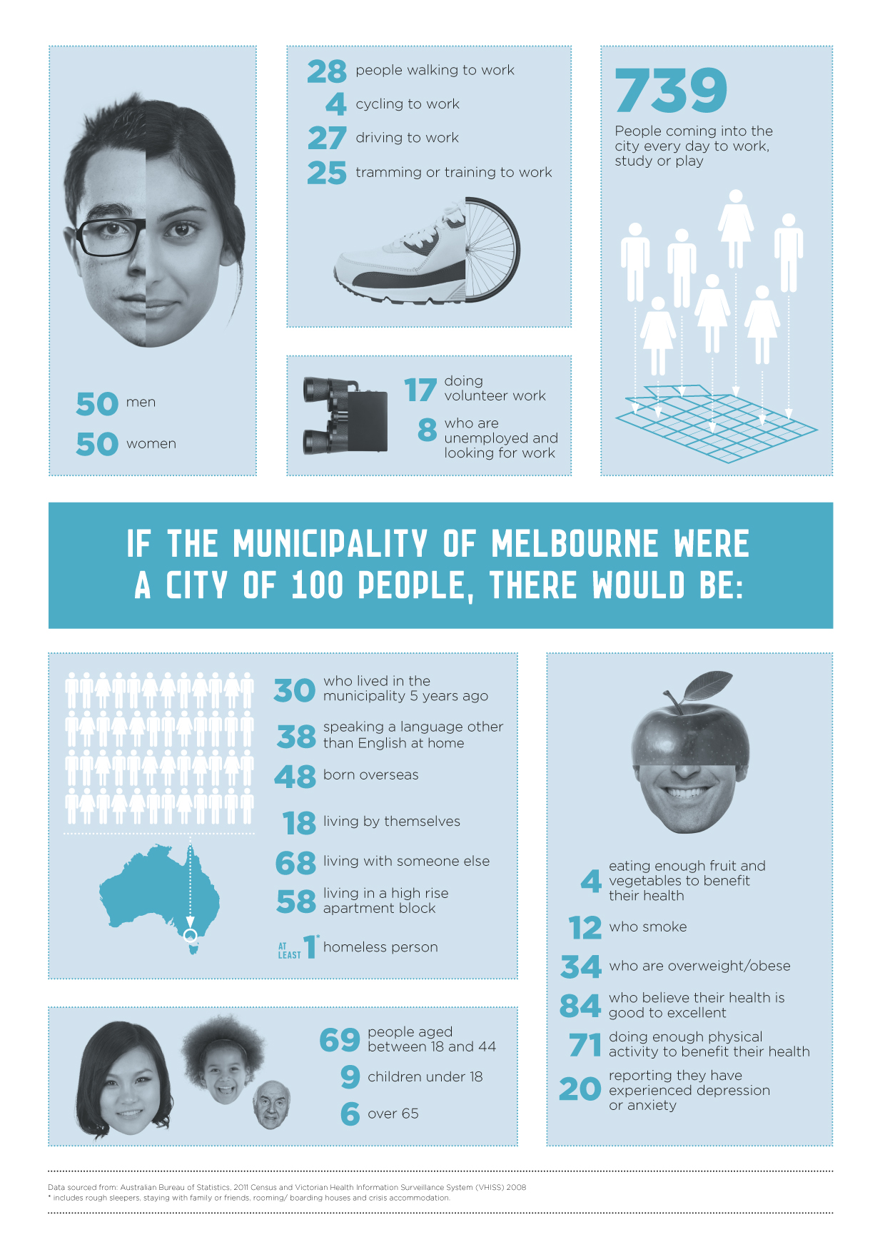

Our city

Our history

For more than 40,000 years the people of the Kulin Nation lived on and managed the land that is now known as the City of Melbourne. They included people of the Boonwurrung, Woiwurrung, Taungurung and Djadjawurrung tribes.

The city we know today was established in 1835 by pastoral settlers from Tasmania and within two years the orderly grid of the central city was laid out beside the Yarra River. In 1842 Melbourne was incorporated as a town, with a Town Council elected to manage the town’s affairs.

Less than a decade later, the 1851 discovery of gold in regional Victoria transformed Melbourne from a small port city into a major world centre. Immigrants poured in from around the world to find their fortune and the rapid population growth and enormous wealth of the goldfields ignited a boom which lasted 40 years. By the 1880s Melbourne was larger than most European cities and its grand buildings rivalled those of New York and London. A global trading centre brimming with optimism and opportunity, the city was celebrated as ‘marvellous Melbourne’, a name it retains today.

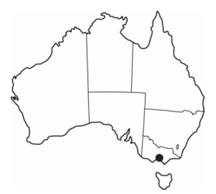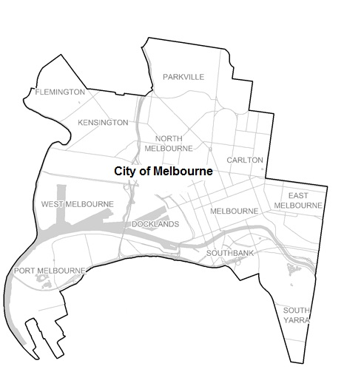

Melbourne today

Melbourne’s original city grid has expanded into a major global business centre home to some of Australia’s largest companies and also the regional headquarters of global businesses. Our city is now a thriving residential, entertainment, cultural and educational precinct and its population is growing rapidly as more people seek its many business, work, study and social opportunities.

The central city includes a mix of classical and modern architecture, interesting laneways, arcades and shopping precincts as well as world-class theatre, art galleries, museums and sporting facilities , with a rich cafe culture and restaurant scene that rivals any in the world.

Melbourne is Australia’s retail, events and sporting capital and the city’s many parks, gardens and public squares provide the perfect backdrop to all the city has to offer.

Together these elements combine to make Melbourne a thriving, dynamic and cosmopolitan city.
A great place to live, work and play and a city consistently ranked among the world’s most liveable cities.

Our vision, our mission, our values

Vision
Melbourne is a bold, inspirational and sustainable city.

Mission
The City of Melbourne will strive to achieve the community’s vision of Melbourne as a bold, inspirational and sustainable city which:

  - is great for people to live in and visit
  - achieves its creative potential
  - is prosperous
  - is a recognised knowledge city that supports innovation and technology
  - demonstrates leadership in environmental sustainability
  - is connected and supports the efficient and safe movement of people and freight.

Values
The actions and decisions of City of Melbourne employees and councillors are guided by five fundamental and unifying values:

Integrity: we take responsibility for our actions in an honest and transparent way.
Courage: we create new and better ways of doing business, identify problems or dishonesty and work to resolve the issues.
Accountability: we take responsibility for decisions and actions to achieve agreed outcomes.
Respect: we consider and understand the perspective and contribution of others.
Excellence: we continuously improve our performance to achieve outstanding outcomes for Melbourne.

Our goals
Our Council Plan 2009–13 includes eight goals that will guide us towards our vision. The community’s aspirations for the city are reflected in the first six goals. Our municipality will become:

1. a city for people
2. a creative city
3. economically prosperous
4. a knowledge city
5. an eco-city
6. a connected city.

A further two goals relate to our internal organisational performance and give direction for the good governance and management of our organisation. The City of Melbourne will:

7. lead by example
8. manage our resources well.

Message from the Lord Mayor

When I came to office I was determined to establish the Council as a cohesive and effective voice championing Melbourne. Working with fellow councillors, we have taken great strides and we are now a key player in the robust debate shaping the future of our great city.

The 2012–13 Annual Report outlines our efforts at finishing what we started when we were elected in 2008. It tells a story of sound economic management, planning for growth and working to improve city safety and amenity.

During 2012–13 we increased our programs and services by $17 million to $357 million – the largest investment in programs we have ever made. A substantial $117 million in infrastructure spending delivered important community assets such as the Swanston Street redevelopment, the Docklands Library, Carlton Family and Resource Centre, Drill Hall and redevelopment of the Boyd School, as well as new on-road and off-road bike lanes and connections across the city.

We future-proofed our iconic parks and gardens with new trees and innovative water saving projects. We planted 3000 new trees this year and have the potential to save up to 360 million litres of potable water through our water harvesting projects in the Fitzroy Gardens, Birrarung Marr and the Queen Victoria Gardens.

We expanded green public open spaces in our neighbourhoods by building new gardens in Neil Street Carlton and in Errol Street North Melbourne, and upgraded facilities at Domain Gardens, Princess Park, Royal Park, JJ Holland Park and the North Melbourne Community Centre.

We continued to address the critical social issue of city safety by investing $20.8 million in a range of direct and indirect city safety initiatives, with a strong focus on safety around night-time activities including the Queen Street Taxi Rank and Docklands Taxi Shelter.

Our relationship with others is critical to our ability to get things done and we worked closely with our working groups, advisory boards and committees that provide support and enthusiasm, keeping us inspired and on track to deliver a bold, inspirational and sustainable Melbourne.

I am proud to report the City of Melbourne is debt free and we have budgeted for our next four-year Council Plan while maintaining a surplus. Financial strength gives us the ability to fund capital works, programs and activities and adds power to our voice as my fellow Councillors and I continue to advocate for Melbourne.

All of this could not have been delivered without the work of our dedicated staff and volunteers. I would like to offer my sincere gratitude to all those who have contributed to the City of Melbourne’s success.

Robert Doyle
Lord Mayor
City of Melbourne

Message from the CEO

The past 12 months were very busy as we worked to bring our Council Plan 2009–13 to completion. Our dedicated staff worked hard as individuals and teams to contribute to achieving the community’s vision for a bold, inspirational and sustainable city. Their efforts have generated a year filled with achievements for the City of Melbourne and more benefits and opportunities for the people who live, work and visit here.

Community engagement is vital to our core business and we embed it in everything we do as an organisation. We introduced our Community Engagement Framework in 2009 and since then have become a leader in finding new ways to engage with our community to better understand their aspirations, needs and opinions. Every major project we do involves community consultation at some level. We continue to train staff from across all five divisions to develop and implement their own community engagement strategies. We also are getting better at engaging online and in June launched our new Participate Melbourne website.

Sustainability continued to be foremost on our agenda as we worked towards strengthening our city’s resilience to climate change. In March, we were certified carbon neutral for council operations, a significant step towards our aspirational goal of achieving zero net emissions for the city by 2020. We entered into an Environmental Upgrade Agreement to retrofit one of our city office block and established the Exceptional Tree Register to protect the city’s significant trees. Implementation of our Urban Forest and Open Space Strategies are now well underway, along with a number of stormwater harvesting projects. These significant achievements are by no means the end of our eco journey and we continue to work on projects across the municipality to preserve our future.

Focusing on how we manage our own resources has enabled us to remain a financially responsible organisation. Our Lean journey, which began in 2009, has continued to return a steady stream of improvement to the City of Melbourne. More than 500 staff completed the Lean Essentials and Lean Basics workshops, and a further 73 graduated from the intensive Lean Learner and Lean Practitioner courses. Lean thinking helped us save money while improving services in areas including aged care, maternal child health, arts grants, permits, parking and document management.

Local government elections in October saw us welcome five new Councillors, each bringing their different experiences, skills and perspectives to the development of our organisation and city. Voters returned the Lord Mayor for his second term in the elections, along with the Deputy Lord Mayor and four serving Councillors.

I use this opportunity to acknowledge and highlight the considerable efforts of all City of Melbourne staff. Your dedication, passion and persistence have been an inspiration. Your efforts were recognised through a raft of prestigious awards. You are a huge part of our sustained success as the world’s most liveable city and your contributions are what makes ‘marvellous Melbourne’ today.

I look forward to continue working with staff, the community and the Council to see Melbourne recognised as a bold, inspirational and sustainable city for many years to come.

Dr Kathy Alexander
Chief Executive Officer
City of Melbourne

Our Council

The Council comprises a lord mayor and deputy lord mayor and nine councillors.

Under the provision of the City of Melbourne Act 2001 (Vic):
- Melbourne is not divided into wards
- the leadership team is elected separately from councillors
- the preferential voting system is used to elect the leadership team and proportional representation is used to elect councillors.

Melbourne City Council operates as a public statutory body incorporated under the Local Government Act 1989 (Vic). The Act sets out the purposes and objectives of the Council and defines its functions and powers.

The role of the Council is to govern the municipality of Melbourne in service of the community.
The Council:

- acts as a representative government and considers community needs when making decisions
- establishes strategic objectives for municipal services and monitors their achievement
- oversees the responsible and accountable management of the City of Melbourne’s resources
- advocates local community interests to other communities and governments
- is a responsible partner in government, taking the needs of other communities into account
- fosters community cohesion and encourages participation in civic life.

Our Councillors

In 2012–13 the community was represented by the following office bearers on the Melbourne City Council. The positions held by office bearers in the profiles outlined below reflect membership of those bodies and committees which were in operation on 30 June 2013.

Lord Mayor Robert Doyle
First elected as Lord Mayor in 2008 and re-elected in 2012

The Lord Mayor is Chair of meetings of the Melbourne City Council. He is also the Chair of the Future Melbourne (Major Projects) Committee. The Lord Mayor also represents the City of Melbourne on following external organisations:

- Council of Capital City Lord Mayors
- Shrine of Remembrance Trustees
- Lord Mayor’s Charitable Foundation
- Melbourne Arts Trust
- Cancer Council of Victoria
- United Nations Advisory Committee of Local Authorities
- C40 Cities Climate Leadership Group.

Deputy Lord Mayor Susan Riley
First served as Deputy Lord Mayor from 2001 to 2004. Elected again as Deputy Lord Mayor in 2008 and re-elected in 2012.

The Deputy Lord Mayor represents the City of Melbourne on the following advisory committees and external organisations:

- Audit Committee, City of Melbourne
- Inner South Metropolitan Mayors’ Forum
- Melbourne Awards Advisory Board (Chair)
- Melbourne Arts Trust
- Melbourne Retail and Hospitality Advisory Board
- Melbourne Spring Fashion Week Advisory Board (Deputy Chair)
- Procurement Australia
- Lady Mayoress’ Committee (Co-Chair)
- Business Partner City Network
- Lord Mayor’s Commendation Group.

Councillor Richard Foster
Elected in 2012

Cr Richard Foster is Chair of the Future Melbourne (People City) Committee and Deputy Chair of the Future Melbourne (Transport) Committee.

Cr Foster also represents the City of Melbourne on the following advisory committees and external organisations:

- Family and Children’s Advisory Committee
- Homelessness Advisory Committee
- Parks and Gardens Advisory Committee
- Metropolitan Transport Forum.

Councillor Rohan Leppert
Elected in 2012

Cr Rohan Leppert is Chair of the Future Melbourne (Arts and Culture) Committee and Deputy Chair of the Future Melbourne (Finance and Governance) Committee.

Cr Leppert also represents the City of Melbourne on the following advisory committees and external organisations:
- Audit Committee, City of Melbourne
- Victorian Local Governance Association
- Melbourne Music Week Steering Committee
- Music Strategy Advisory Committee
- Melbourne Symphony Orchestra Board.

Councillor Kevin Louey
First elected in 2008 and re-elected in 2012

Cr Kevin Louey is Chair of the Future Melbourne (Economic Development) Committee and Deputy Chair of the Future Melbourne (Knowledge City) Committee. He is also Co-Chair of the Docklands Coordination Committee.
Cr Louey also represents the City of Melbourne on the following advisory committees and external organisations:

- Docklands Steering Group
- City Licensing Approvals Forum
- Melbourne Business Precincts Inc
- Business Partner City Network
- Melbourne Retail and Hospitality Advisory Board.

Councillor Stephen Mayne
Elected in 2012

Cr Stephen Mayne is Chair of the Future Melbourne (Finance and Governance) Committee and Deputy Chair of the Future Melbourne (Planning) Committee.

Cr Mayne also represents the City of Melbourne on the following advisory committees and external organisations:

- Audit Committee, City of Melbourne
- Municipal Association of Victoria
- Melbourne Art Trust
- Inner South Metropolitan Mayor’s Forum
- Melbourne Business Precincts Inc.

Councillor Cathy Oke
First elected in 2008 and re-elected in 2012

Cr Cathy Oke is Chair of the Future Melbourne (Transport) Committee, Deputy Chair of the Future Melbourne (Environment) Committee.

She represents the City of Melbourne on the following advisory committees and external organisations:

- International Council for Local Environment Initiatives (ICLEI) Global Executive Committee
- ICLEI Regional Executive Committee
- Melbourne Music Week Steering Committee
- Victorian Road Based Public Transport Advisory Council
- Yarra Park Advisory Committee
- Metropolitan Transport Forum.

Councillor Ken Ong
First elected in 2008 and re-elected in 2012

Cr Ong is Chair of the Future Melbourne (Planning) Committee, Deputy Chair of the Future Melbourne (Major Projects) Committee. Cr Ong also represents the City of Melbourne on the following advisory committees and external organisations:

- Committee for Melbourne
- Disability Advisory Committee
- Metropolitan Local Government Waste Forum
- Inner Melbourne Action Plan Implementation Committee.

Councillor Beverley Pinder-Mortimer
Elected in 2012

Cr Beverley Pinder-Mortimer is Chair of the Future Melbourne (Marketing Melbourne) Committee and Deputy Chair of the Future Melbourne (Arts and Culture) Committee. She also represents the City of Melbourne on the following advisory committees and external organisations:

- Lord Mayor’s Commendations Advisory Group
- Melbourne Awards Advisory Board
- Melbourne Music Steering Committee
- Melbourne Retail and Hospitality Advisory Board
- Melbourne Spring Fashion Week Advisory Board.

Councillor Jackie Watts
First elected on count back in July 2011 and re-elected in 2012
Cr Jackie Watts is Chair of the Future Melbourne (Knowledge City) Committee and Deputy Chair of the Future Melbourne (People City) Committee.
Cr Watts also represents the City of Melbourne on the following advisory committees and external organisations:
- Committee for Melbourne
- Police Community Consultative Committee – Central Activities District
- Indigenous Advisory Panel.

Councillor Arron Wood
Elected in 2012

Cr Arron Wood is Chair of the Future Melbourne (Environment) Committee and Deputy Chair of the Future Melbourne (Economic Development) Committee. He also represents the City of Melbourne on the following advisory committees and external organisations:

- Inner Melbourne Climate Adaptation Network
- Parks and Gardens Advisory Committee
- Victorian Adaptation and Sustainability Partnership Ministerial Advisory Committee.

Council terms
The current Council was elected for a four-year term in October 2012.

During 2012–13, those that held the office of Councillor for a period of time but ceased to hold such office during the course of the year as a result of resignation, or non re-election, were:
- Councillor Jennifer Kanis, resigned from office in July 2012
- Councillor Carl Jetter, not re-elected
- Councillor Brian Shanahan, not re-elected.
The next Council election is scheduled for October 2016. Further information about local government elections is available from the Victorian Electoral Commission at www.vec.giv.gov.au.

Our performance

We measure our success by our ability to achieve the objectives set out in our Council Plan 2009–13. Our objectives are divided into eight goals that we use to prioritise our activities. The following information highlights some of our achievements under the goals in 2012–13 as well as some of the outcomes we will aim for in the years ahead.

Goal 1 | A city for people – Keep the municipality a great place to live, work and visit. With appropriate community infrastructure and strategies to improve safety, we will promote individual and community health and our rich cultures will be celebrated and socially connected.

Looking back on 2012–13:
- Completed the $25.6 million Swanston Street redevelopment.
- Completed the $15 million Carlton Baths refurbishment.
- Provided funding for the NGV’s first 24-hour opening for the Winter Masterpieces.
- Upgraded the Floral Clock with new paving and lighting.
- See page 16 for more detail.

Looking ahead:
- A well-planned municipality for a growing and diverse population.
- People who are informed and supported to be healthy.
- People who participate and feel connected.
- Safe, high-quality and well-used public spaces and places.

Goal 2 | A creative city – Capitalise on and expand our reputation as a creative, bold and inspirational city. We support and promote a diverse mix of artists so that art is accessible to all.

Looking back on 2012–13:
- Provided 124 affordable working spaces housing 135 artists.
- Encouraged community participation with the 1st Friday Dance Club.
- Hosted the inaugural Victoria Indigenous Dance Forum.
- See page 26 for more detail.

Looking ahead:
- Artists are supported to work locally.
- Artistic enterprises choose to base themselves in the municipality.
- People participate in creative expression and attend arts and cultural activities.
- A growing reputation as the centre for vibrant artistic and cultural life.
- The municipality’s cultural and natural heritage is protected for the appreciation of future generations.

Goal 3 | Economic prosperity – Work locally, nationally and globally to continue to strengthen our local economy by supporting small and medium businesses and promoting a variety of events.

Looking back on 2012–13:
- Consolidated Melbourne Music Week’s place in Melbourne’s music scene.
- Approved 12 small business grants for a total of $222,215 in funding.
- Promoted Victorian produce at the Food Tech trade show in Osaka, Japan.
- See page 30 for more detail.
Looking ahead:
- A sustainable and resilient municipal economy.
- A globally connected municipal economy.

Goal 4 | A knowledge city – Build our industry innovation, research, business and information technology capabilities and position Melbourne as the city of choice for international students.

Looking back on 2012–13:
- Received an excellence award for the EDGE International Student Leaders’ Program.
- Adopted the recommendations of a report to help establish Melbourne as a knowledge city.
- Hosted the final event of the Melbourne CleanTech Network series.
- See page 38 for more detail.

Looking ahead:
- International students have a positive experience.
- Infrastructure that supports knowledge and learning.
- People participate in knowledge-related activities.
- Businesses are better informed about the knowledge sector.

Goal 5 | An eco-city – Improve the sustainability of the city's building stock, water management and recycling within the municipality, reduce carbon emissions and protect our world-renowned parks and gardens.

Looking back on 2012–13:
- Entered into a $1 million Environmental Upgrade Agreement to retrofit a city office block.
- Launched a new energy efficiency program for apartment owners called Smart Blocks.
- Established an Exceptional Tree Register to protect significant and special trees.
- See page 41 for more detail.

Looking ahead:
- Our greenhouse gas emissions are reduced.
- Less municipal waste-to-landfill with less negative impact on amenity from collecting waste.
- Sustainable water management.
- Increased biodiversity and tree canopy cover in the municipality.
- Climate change impacts on the municipality are managed.

Goal 6 | A connected city – Advocate safe, efficient and sustainable movement throughout the city and make sure Melbourne is accessible without sacrificing social or ecological values.

Looking back on 2012–13:
- Put the finishing touches on the $25.6 million redevelopment of Swanston Street
- Installed separated bicycle lanes in each direction on Clarendon Street, East Melbourne.
- See page 50 for more detail.

Looking ahead:
- People and goods can move efficiently within the municipality.
- More people are walking, cycling or using public transport to travel to and from the municipality.

Goal 7 | Lead by example – Maintain the City of Melbourne’s reputation for leadership and excellence in governance and organisational practices.

Looking back on 2012–13:
- Connected with other local government leaders at the Council of Capital City Lord Mayors.
- Adopted the new Council Plan 2013–17.
- See page 54 for more detail.

Looking ahead:
- Financial sustainability as an organisation.
- Customers who are satisfied with the service they receive.
- The attraction, retention and development of the workforce we need.

Goal 8 | Manage our resources well – Attract and retain a highly skilled workforce and strive to achieve efficiencies while maintaining high standards of service and supporting all our commitments from a diverse revenue base.

Looking back on 2012–13:
- Used Lean Thinking to reduce waste and increase customer value.
- Completed an archive relocation project.
- See page 59 for more detail.

Looking ahead:
- Increased public disclosure and access to information to become one of the most transparent councils in Australia.
- A more involved community.
- A better informed community.

Goal 1 – A city for people

The City of Melbourne has an important role to play in making the municipality a great place to live and visit. We want people to come into the city to work, play and relax in streets and public spaces that are clean, inviting and alive, while also addressing the needs of our growing population.

This goal includes the provision of relevant and affordable services, community infrastructure and strategies to improve safety in the city. We promote health both at the individual and community level and ensure that our rich cultures are celebrated and socially connected.

Outcome 1.1 People in Melbourne are socially connected

An accessible city
The City of Melbourne has always been committed to its role as a leader in accessibility and mobility within the municipality. As such we endeavour to create an environment that is inclusive and accessible and encourages participation from all members of the community.

One example of this is the recently completed Swanston Street redevelopment. The redevelopment was presented as a case study to members of the Australian Federation of Disability Organisations who came to Melbourne for a two-day workshop in February 2013. The example was used to highlight how new infrastructure projects can be designed to meet the needs of the whole community, while also substantially improving access for people with a disability.

A disability access report was commissioned to identify any areas in the municipality which did not conform to the requirements of the Disability Discrimination Act 1992 (Cth) and associated guidelines. The report identified a small number of areas which were not fully compliant and required upgrading to meet the current standards. Upgrades included fixing the floor, ramp and steps at the entrances of the North Melbourne Town Hall and the installation of handrails and tactiles to provide improved access at the entry doors.

A review of the Melbourne Mobility Centre at Federation Square revealed service duplication and low level usage. As a result the centre was closed at the end of 2012 and a number of new options to address accessibility and mobility in the city were considered. Council endorsed a number of initiatives including:

- Improving information on accessible city eating, bars, events, tourist information and mobility maps on City of Melbourne websites.
- Improving technological navigation tools to assist people with hearing or sight impairment move around the city.
- Continuing to provide mobility equipment in the city.

A welcoming city
A city for people is a city with a range of events and activities. The City of Melbourne aims to foster an inclusive and accessible environment that encourages participation from residents and visitors, young and old.

A series of community-based initiatives were established or continued in 2012–13 to connect people with their local area. These included initiatives such as the Docklands Community Garden and Docklands Community Forum. The new Docklands Community Garden opened in July 2012. The garden makes use of sustainable and raw materials, including timbers and materials salvaged from other areas during the Docklands development project. Lemon, lime, peach and plum trees are growing in numerous barrels and plant boxes, as well as lettuces, tomatoes and herbs. The garden is also equipped with its own communal barbeque, fire pit, seating and a community group to oversee operations.

In Carlton, the Opportunities for Carlton project launched in 2008 continued to engage and connect the community. The project brought together over 250 individuals and 70 agencies to help develop more than 70 community-based initiatives relating to employment, health, and social inclusion. Following on from the success of this project a new neighbourhood development model will be implemented across the municipality.

The rights of the youngest people in the municipality, our children, are supported by the City of Melbourne through implementation of the Children’s Plan 2010–13. The plan includes ongoing advocacy to that children’s voices are included in the decision-making process. Children’s Services have continued to provide high quality, affordable and accessible education and care to 444 children across the city. All services successfully implemented the new regulatory standards through the new National Quality Framework and National Quality Standards.

Responsible ownership of domestic animals was given a boost with the development of a new Domestic Animal Management Plan 2013–17. To celebrate all the animals that call the city home, a special Pets in the City event was held in Alexandra Gardens in February 2013. The day offered free pet dental health checks and obedience demonstrations as well as discount microchipping and registration and attracted over 500 people and their pets.

Outcome 1.2 Healthy people and communities

A healthy city
Providing suitable sport and recreation facilities, supporting health and wellbeing services and supporting access to nutritious food are just some of the ways the City of Melbourne can foster a healthy and happy community.

A number of community infrastructure projects were completed in 2013 including the $15 million Carlton Baths refurbishment and the installation of the new Docklands Sports Courts. The improved Carlton facilities include a new gym, a refurbished stadium, renovated change rooms and new spaces for community and family services. The new courts in Docklands provide facilities for netball, basketball and small-scale soccer. A ‘corporate challenge’ lunchtime sports competition has proved popular with 372 registered participants. The City of Melbourne also secured sponsorship for the sports courts from Lend Lease. The sponsorship will strengthen connections between the courts and the Docklands professional community and help improve the opportunities available for corporate workers to include physical activity in their weekly routine.

In addition to the provision of first-class facilities, the City of Melbourne also runs numerous programs and events to get the community active. A new reciprocal rights program between Melbourne City Baths, North Melbourne Recreation Centre, Kensington Community Recreation Centre and Carlton Baths allows members access to all facilities, which gives the community greater flexibility. The Get Active Southbank event challenged Southbank workers to work up a sweat on the ‘big red steps’ of Queensbridge Square over three consecutive Wednesdays in June. The Carlton Baths launched a Kids Club program for children with an intellectual or physical disability aged 5 to 15 years to enhance skill development in a range of activities including ball sports, gymnastics, water safety and cycling.

The City of Melbourne partnered with Vans Australia to host a Go Skateboarding one-day event to celebrate skateboarding as a sport and recreational pursuit. The day was well attended by a broad section of the skateboarding community, from mums, dads and kids, to high level pro skateboarders and included a free barbeque and giveaways. A new night skating session was also trialled at Riverside Skate Park. The event included a live DJ, free barbeque, and attracted 150 people. The event received excellent feedback and more night sessions are planned as a result.

Community spirit was brought to life at the Carlton Community Sports Carnival with some help from Sports Without Borders, University of Melbourne and the City of Melbourne. The one-day carnival included futsal, tennis, basketball and AFL football, with support from Tennis Victoria, Helping Hoops and the Carlton Football Club. During the month of Ramadan, a late night soccer tournament was staged at the North Melbourne Recreation Centre. Volunteers from the Australian Muslim Social Service Agency and the Eritrean Youth Association coordinated the tournament, while Victoria Police provided assistance with scoring. Almost 60 children played and the games were well supported by spectators.

Marathons and fun runs continue to be popular with Melburnians. The Age Run Melbourne in July 2012 saw over 26,000 people participate in 5 km, 10 km and half-marathon runs, as well as a 3 km kids' course. The Melbourne Marathon in October 2012 attracted over 30,000 entrants and finished with a lap of the hallowed turf of the Melbourne Cricket Ground.

Food retailers at the Moomba Festival worked with the City of Melbourne to code their menus using traffic light colours of the Green Light, Eat Right nutrition program. The colour coding enables consumers to better identify healthy food choices when out and about in the city.

The City of Melbourne also prescribed 31 smoke free areas under the Activities Local Law 2009 to benefit public health. The areas are located in and around children’s playgrounds and childcare centres and it is hoped education and community support will help achieve compliance. It is now an offence for a person to smoke in these areas. Research has already been undertaken to explore more smoke free areas in the municipality.

The City of Melbourne's Drill Hall complex opened its ceremonial hall to for community use in 2012–13. The hall is available for bookings from community groups and is suited to exhibitions, markets, rehearsal and light recreation activities.

Outcome 1.3 Residents and visitors feel safe

A safe city
A lively, vibrant 24-hour city with clean, well-designed public spaces can contribute to increased safety in the municipality.

The Swanston Street redevelopment included broader footpaths, more trees and flowers, better street furniture and lighting and more late night cleaning. These changes create a pleasant and friendly environment that can have a calming effect on late night crowds.

Late night activation is another tool used to enhance safety by changing the mix of people in the city. The City of Melbourne funded festivals and events such as the Melbourne International Comedy Festival, Fringe Festival, MidSumma, Next Wave, as well as late night activities programmed by the NGV and ACMI.

Through the Federation Bells program a partnership was established with Circus Oz to help stage Bong the Bells at Federation Bells. Each Friday and Saturday night at the conclusion of the 2013 Circus Oz big top show, acrobats and musicians staged a special late night performance in Birrarung Marr.

Funding was provided to the NGV in October 2012 so the popular Napoleon Winter Masterpieces exhibition could stage a one-off, 24-hour opening on its last weekend in Melbourne. The event attracted 188,500 people through its doors and was considered a great success.

A whimsical and humorous free public event called Urban Cocoon was held in City Square with support from City of Melbourne. Operating from 8pm to 11pm for a week in mid-May 2013, participants put on headphones to enter another world where their movements, gestures and expressions became part of the performance for the pedestrians and audience looking on.

The late night video event One After Another showcased the work of five emerging video artists and provided an opportunity to encounter art outside gallery hours in the comfort of a bean bag at Kings ARI. Over 150 people attended the event to view the work and chat to the artists.

The City of Melbourne also continued to work toward a safer city through its partnerships with other agencies such as Victoria Police and the Salvation Army. The Youth Street Teams trained and managed by the Salvation Army supported by Victoria Police and funded by the City of Melbourne are now in their third year of operation and continue to produce positive results. Groups of young people work on Friday and Saturday nights from 11pm to 5am to connect with and assist vulnerable young people. Almost 11,000 young people were helped in 2012–13.

The Safe City Cameras Program (CCTV system) has operated continuously since the City of Melbourne installed the technology in 1997 and it formed part of the Strategy for a Safer City 2011–2013. The provision of a safer environment for the community is a key aim of the program. In 2013 Council approved Victorian Government funding to install an additional nine cameras in city locations selected by Victoria Police. This will take the total number of cameras throughout the city to 63. An independent audit committee reports annual results of the program to the City of Melbourne and these are available to the public.

The City of Melbourne manages four Safe City Taxi Ranks at Flinders Street Station, King Street, Queen Street and Bourke Street. An average 467 passengers used the Queen Street taxi rank each Friday and Saturday night in 2012–13. This represents 100 more passengers per night than the Flinders Street Station rank over the same period and confirms the Queen Street rank as the most popular taxi rank in the central city.

Outcome 1.4 Diverse, harmonious caring communities

A diverse and growing city
The City of Melbourne supports and celebrates cultural diversity in Melbourne through a range of activities and programs.

Over 5000 people participated in neighbourhood activities and events during Cultural Diversity Week in March 2013. The event celebrates the many cultures which contribute to the community’s vibrancy and prosperity. The activities on offer included a Community Cultural Fair at Melbourne’s new venue, Drill Hall and an African drumming workshop for children at the North Melbourne Child Care.

The City of Melbourne also supported multicultural festivals presented by the Anatolian, Antipodean, Italian, Malaysian and Thai communities which showcased their colourful cultures through food, music and dance. The Carlton Italian Festa attracted approximately 10,000 people with performers, children's activities and delicacies on offer at Lygon Street’s Piazza Italia. The third season of Cinema Nights at Piazza Italia also got underway on Australia Day with a screening of The Cup.

To help build a sense of community in the new and growing neighbourhood of Southbank, a series of three community evenings called Buoyed @ Boyd were staged at the Boyd community hub. The evening included tai chi, yoga, table tennis, poetry readings, live indy folk music and mini expos from the Blood Bank, maternal and child health care workers, and a local craft group.

The Hub @ Docklands community centre celebrated its fifth birthday in July with live music, farm animals, a jumping castle, face painting, balloon sculpting, demonstrations of tai chi, yoga, jiu-jitsu and table tennis.

The City of Melbourne celebrated Aboriginal and Torres Strait Islander culture with over 2000 people participating in NAIDOC and Reconciliation Week events. During NAIDOC Week in July 2012 we collaborated with the Victorian Aboriginal Community Services Association to stage a concert at Federation Square which attracted 400 people. A national launch for Reconciliation Week was held in Federation Square in partnership with Reconciliation Australia and Reconciliation Victoria in May 2013. The launch was broadcast live on 3KnD, Melbourne’s first Indigenous-owned and managed radio station, with guest speakers including the Lord Mayor. A Reconciliation Week barbecue featuring the Hairy Men was held in the City Square with kangaroo, emu and beef burgers on offer and life-sized bunyip puppets for entertainment.

The City of Melbourne’s Blak Nite Cinema returned for its fifth instalment in February 2013 at ACMI. The festival showcased the incredible talent and diversity of Indigenous Australian art through18 short and feature documentaries from some of Australia's most celebrated Aboriginal and Torres Strait Islander artists. Film makers, musicians and an art curator talked about their experiences in conversation with Blak Nite Cinema ambassador and actor Aaron Pedersen. More than 800 people attended over the weekend.

Family violence is a key reason women become homeless, prompting the City of Melbourne to become a White Ribbon City and join the global campaign to stop violence against women. The Lord Mayor affirmed the city’s commitment to encourage a culture that rejects violence towards women by signing the White Ribbon City memorandum of understanding. A Preventing Violence Against Women strategy and action plan will be drafted to guide future work around the primary prevention of violence against women in the workplaces, the community and the home. The 2012–13 Council Budget included $40,000 for developing the strategy.

Outcome 1.5 Melbourne is vibrant, accessible, clean and welcoming

A clean and vibrant city
As well as adding to the municipality’s public infrastructure, it is important to maintain existing public assets and ensure Melbourne remains a great place to work, live and visit.

The Floral Clock in the Queen Victoria Gardens on St Kilda Road received an upgrade this year, which included new bluestone paving and the installation of lighting to illuminate the floral display and King Edward VII memorial statue standing behind the historic clock donated by Swiss watchmakers in 1966. The new design incorporates tiered steps in a symmetrical radial pattern centred on the clock face.

The Janet Lady Clarke Rotunda in Alexandra Gardens on Linlithgow Avenue was built in 1913 and received its first major refurbishment in almost 100 years. Works included the installation of a new ceiling as well as interior and exterior painting of the structure, new LED lighting, an epoxy floor finish and the upgrade of seven park benches to enable a seated audience for 28 people.

The Stapley Pavilion on the north side of Kings Domain underwent a refurbishment to restore the structure, including installation of new terracotta shingle tiles, new timber pre-primed treated fascia, scotia and new gutters, painting of all new timber work and the ceiling and an upgrade to LED lights to enhance and highlight the interior benches and brick work. The pavilion was designed by City of Melbourne architect Alderman Frank Stapley in 1937 and built in 1939.

The Carlton Gardens also received attention with the restoration of a section of missing pathway and the creation of new garden beds at the south end of the gardens. The pathway is part of the original Carlton Gardens design drawn by Edward La Trobe Bateman in 1856. A section was removed around 1940 to make way for a small depot and public toilets, which have since been removed. Funding was received from the Australia Government’s Your Community Heritage Program to reinstate the missing section. The result is a better presentation of the gardens at this location that better reflects the garden’s historic layout.

The Fern Gully and Grotto in the King’s Domain were brought back to life following severe decline during the long drought and associated water restrictions. The Grotto started off as a quarry in the original Government House Reserve and was developed in the late 1800s as a fern gully for the enjoyment and respite of the Governor and guests. The recent works restarted the waterfall, lined the ponds, rejuvenated fern, tree and shrub plantings, reduced access safety risks to the public and provided an efficient stormwater system.

The public artworks from the organisation’s Art and Heritage Collection are well maintained with regular cleaning and graffiti removal where required. Capital maintenance was carried out on a number of artworks:

- the Echo, a red geometric sculpture in Swanston Street was removed, re-painted and re-installed
- the William Cook drinking fountain in North Carlton was fitting with new plumbing
- the Tudor Village in the Fitzroy Gardens was repaired
- the granite plaque at the base of Princes Bridge was re-gilded
- seven Docklands artworks underwent routine maintenance.

Flood mitigation works for existing flood-prone sites continued in 2012–13 with $1.5 million in funding and the employment of a specialist drainage engineer. Projects to address drainage assets that had reached the end of their effective life or were under capacity were completed at several sites:

- Albermarle Street, Kensington
- Flemington Road and Park Drive, Parkville
- Errol Street, North Melbourne.

Several projects were completed in July and August 2013, just outside the financial year 2012–13, due to latent conditions and scheduled delays:

- Spencer and La Trobe streets, Melbourne
- Hoddle and Hotham streets, East Melbourne.

Extra effort was also made to clean up our waterways following large storm events.

Outcome 1.6 High quality public spaces

A city for all
High quality and welcoming public spaces benefit residents, visitors, works and businesses alike. The City of Melbourne endeavours to maintain the quality of the municipality’s public spaces at all times.

The Melbourne Planning Scheme controls land use and development within the municipality and is one way we work to maintain high quality public space. The City of Melbourne is prepared to protect the municipality’s public space through great planning and defend it where necessary. We also have successfully defended appeals in several cases resulting in positive outcomes for the community such as protecting the Yarra River from overshadowing.

Making public art a part of everyday life in Melbourne is another way the organisation works to enhance public spaces. Public art helps to make a walk through the city an ever-changing and culturally enriching experience. The Public Art Program commissioned a number of works in 2012–13. The Pubic Art Commissions included a diverse range of artworks:

- Contemporary Site Investigations: Flinders Street Station, a series of site specific projects
- Unset Typologies, a photomural wallpaper in Little Bourke Street
- Our Flower Garden, a vertical garden of coloured pinwheels planted in China Town
- Revoicing the Striated Soundscape, a sound installation exploring the sonic qualities of Melbourne’s laneways.

As the Melbourne Zoo celebrated its 150th year in 2012, Melbourne city streets were dotted with 50 ‘Mali’ mini-elephant sculptures. Each sculpture was decorated by a different artist and all 50 were auctioned off, with the proceeds going to the Zoo’s numerous preservation projects. The Lord Mayor’s Charitable Foundation purchased an elephant on behalf of the City of Melbourne and it is currently located at ArtPlay.

Outcome 1.7 Improved access to relevant and affordable community services

Investing in the community
Growing residential communities in Southbank and Docklands require a corresponding investment in community infrastructure and services so that residents have everything they need to live healthy, happy and connected lives.

Planning for new community hubs takes many years and their execution calls on the expertise of numerous services our organisation including city design, engineering, capital works, property, community strengthening, aged care, maternal and child health, recreation, arts and culture, libraries and administration.

Construction began on the new Docklands Library and Community Centre in March 2013. The new centre is the result of a tri-partite agreement between the City of Melbourne, Lend Lease and Places Victoria and is being constructed using lightweight cross-laminated timber and reclaimed hardwood. The three-storey, 3000 m² building will house a collection of 60,000 books and feature the latest in interactive technology. The library’s shelving layout will follow a reader-focused format. Specialist areas will include books on business, IT, arts, culture and travel as well as a tempting range of classic and contemporary music and film. The children’s library will encourage discovery through books and technology. In addition to the library, the hub will house a range of new services such as a recording studio, creative editing suites and provide a function and performance space and a gallery and exhibition space for community use.

The new community centre and Southbank Library at Boyd opened to much fanfare in July 2012. A unique component of the Boyd redevelopment was the integration of creative spaces with family services, a local library, a social enterprise cafe and meeting rooms. By combining these elements under one roof, the City of Melbourne engaged art, health and knowledge as the key drivers for a socially-inclusive, dynamic and creative community. As a result Boyd houses breastfeeding clinics, new parent groups and support for isolated and struggling families. Three maternal and child health nurses are based at Boyd and provided services for 445 children and their parents in 2012–13. The playroom also attracted 140 families across 12 thriving playgroups. Seven studios were designed to provide affordable work spaces for artists. One of the Creative Spaces program’s founding Indigenous artists, Reko Rennie-Gwaybilla, designed the metal cladding for the building using a diamond pattern that is a signature of his work.

The Southbank Library was designed with a strong focus on community participation and a new approach to collection layout makes the library more accessible. The new library had more than 40,000 visits and 45,000 book loans in its first 12 months of operating. The Southbank Library also attracted the attention of the Bill and Melinda Gates Foundation's International Network of Emerging Library Innovators project. The project looked at the building design, guidelines and policies of libraries around the world and named the Southbank Library at Boyd, along with 15 other international libraries, as the best in the world. Overall the City of Melbourne’s four libraries had more than 1.1 million visits and 1.4 million loans during the 2012–13 financial year.

The $15 million refurbishment of Carlton Baths included purpose-built maternal and child health facilities, with space for playgroups, parent education, family support and counselling.

In March 2013 the community grants program received a revamp with the adoption of a new policy and program to support and empower the local community. The 2013 program distributed more than $700,000 to over 150 organisations to fund community-based initiatives across the municipality.

The City of Melbourne also delivers a range of programs and services for older people in the municipality – two of which were audited against the Victorian Community Care Common Standards for the first time in 2012–13. The Home and Community Care program which receives Australian and Victorian government funding, received a score of 16 out of 18 and the Community Aged Care Packages program which received Australian Government funding received top marks with 18 out of 18.

The City of Melbourne’s children’s service continued its clinically-based teacher education program in partnership with the University of Melbourne. The partnership began in 2009 and the City of Melbourne now has three fully-funded teaching fellow positions within the university’s Masters of Teaching program. The teaching fellow is a City of Melbourne-based teacher or early childhood educator who mentors and oversees a number of teacher candidates while they work at early childhood centres within the municipality. The teaching fellows receive up-to-date training that is then passed onto centre-based staff, helping them provide the best quality of care.

As a member of the Child FIRST Western region catchment, the City of Melbourne’s family services operate within an integrated and child-centred delivery model. Family relationships are strengthened by access to specialist parenting support, family support and counselling and linkages with community partners. New and improved facilities, low fee or no fee early years’ services and targeted projects like the Access to Early Learning program have ensured we continue to deliver high quality, affordable and accessible services for families and children.
The Park Rangers’ Environment Education program for pre-school and primary school students runs during the school term. Each week, grade 5 and 6 students visited Royal Park to participate in programs about macro invertebrates, recycling, habitat and leaf litter. Many students had never climbed trees before their explorations with the rangers. By the end of the term more than 600 children had visited the park, many commenting that since meeting the rangers they had visited the park with friends and family on weekends.

The Junior Park Rangers School Holiday program in January attracted more than 200 children. The two-week program held in Royal Park and Fitzroy Gardens allowed kids to explore the urban forest, discovering the beetles, bugs, birds and frogs that inhabit them. The children were able to participate in games and activities designed to inspire and encourage curiosity about the amazing pockets of biodiversity on display in Melbourne’s parks and reserves.

Outcome 1.8 A well-planned city with a vision of the future

Planning for future growth
The City of Melbourne works hard to plan and establish a well-planned city with a vision for the future.

To meet the challenges posed by significant population growth and the impact of climate change on the city’s parks, gardens and open spaces, the City of Melbourne developed its first Open Space Strategy following extensive community consultation in 2011 and 2012. The Open Space Strategy is a 15-year strategic framework to guide the sustainable care and expansion of the municipality’s open space system. The strategy recognises the value of open space in improving community health and wellbeing and sets out significant new spaces so that all residents and workers are within walking distance of open space. The strategy was endorsed by Council on 31 July 2012.

Council endorsed the new Municipal Strategic Statement (MSS) in August 2012. The MSS sets out an overarching vision for land use and development within the municipality and articulates Council’s future design for the city to accommodate extensive residential and employment population growth over the next 20 years. The MSS supports continued growth in existing development areas (Southbank, Docklands) and also encourages urban renewal in City North, Arden-Macaulay and E-Gate precincts and reinforces the continued protection of identified stable areas so they generally remain unchanged.

Planning Scheme Amendments C190 (Arden-Macaulay) and C196 (City North) will implement the land use and built form recommendations of the Arden-Macaulay and City North Structure Plans, which Council adopted in February 2012. The amendments are important measures to enable the city’s future growth in these urban renewal areas while retaining great amenity for its growing communities. Community consultation on these amendments was extensive.

During the year, the City of Melbourne also had three significant successes in VCAT in its stand against the growth in gaming machines, particularly in sensitive areas. The Queensberry, Exchange and Francis hotels sought to install and use new gaming machines. In each case the City of Melbourne’s opposition to the application was supported by VCAT. Important guidance was given by VCAT about where gaming machines should not be located: due to increased opportunities for convenience gambling, or a social housing facility for a number of elderly and disadvantaged persons, or where there was a concentration of gaming machines in the area and a consequent increased risk of problem gaming and related negative social impacts.

Strategic indicators

Name | Indicator | Target | 2009–10 | 2010–11 | 2011–12 | 2012–13
Community satisfaction rating for City of Melbourne-owned recreational facilities | # | 75 | 78 | 75 | 69 | 71
How has the City Of Melbourne performed on planning for population growth over the last 12 months? | # |  |  |  | 54 | 51
Community satisfaction rating for health and human services | # | 70 | 68 | 71 |  | No longer asked
Community satisfaction with the overall performance of enforcement of bylaws | # | 63 | 63 | 63 |  | No longer asked
Community satisfaction for the City of Melbourne on leading debate and taking action on crime and violence and antisocial behaviour in the municipality | # | 85 | 54 | 59 |  | No longer asked
Community satisfaction rating for overall performance of waste management | # | 71 | 70 | 71 | 71 | 72
Community satisfaction rating for overall appearance of public areas | # | 72 | 70 | 72 |  | No longer asked
Participation rates at key events, festivals and programs conducted by the City of Melbourne | # | 750,000 | 670,000 | 750,000 | 1,601,280* | 1,209,872**
How has the City of Melbourne performed on community and cultural activities over the last 12 months? | # |  |  |  | 72 | 74
Number of sporting groups using City of Melbourne parks | # | 75 | 8 | 83 | 99 | 100
Percentage of visitors who feel safe in the central city | % | 90 | Survey held every 3 years | Survey held every 3 years | 89 | Survey held every 3 years
Annual reduction in the number of people experiencing chronic homelessness as measured by Street Count results, compared with previous years | # | 70 | 75 | 101 | 105 | Data now measured every two years

 
In response to feedback from local councils, Local Government Victoria introduced methodological and content changes to the Community Satisfaction Survey in 2011–12. Methodological improvements to the Community Satisfaction Survey in 2011–12 and 2012–13 included increasing the sample size from the previous minimum of 350 respondents per municipality up to 400 respondents so the sample better reflects the demographic composition of a municipality. The survey also allows for respondents to be ‘residents over 18 years of age’ instead of restricting respondents to ‘head of household’. For these reasons, direct comparison with previous Community Satisfaction Survey results is not possible.

In both forms of the survey, the response to each of the standard 'scale' questions above is assigned a value. These values are then averaged across all respondents to create an 'index score'. However, the values assigned changed in 2012:

2010–11 response scale and values
100 – Excellent: outstanding performance
80 – Good: a high standard
60 – Adequate: an acceptable standard
40 - Needs some improvement
20 - Needs a lot of improvement
Excluded – Don’t know / can’t say

2011–12 and later response scale and values
100 – Very good
75 – Good
50 – Average
25 – Poor
0 – Very poor
Excluded – Can't say

* The City of Melbourne adopted new crowd attendance technology in 2011–12 which has resulted in more reliable evidence-based calculations of event attendees.

** Data included the combined attendance numbers at the City of Melbourne's six premier events: Moomba; New Year's Eve; Summer Fun in the City; the Melbourne Awards; Melbourne Music; and Melbourne Spring Fashion Week. Five of these six events have free to the public (i.e. non-ticketed) components, so the data is estimated.
MSFW 33,472 + MMW 43,958 + NYE 231,600 + Moomba 895,300 + Sunset Series ~5000 + Melb Awards Gala 542
12/13 Qualification: NYE attendance figure no longer includes estimated attendance of 50,000 at Federation Square.
Goal 2 – A creative city

To capitalise on and expand our international reputation as a creative, bold and inspirational city, it is important to ensure art is accessible to all. We continue to support and promote a diverse range of artists and to place art in the public realm for everyone to appreciate.

Creativity is about more than just art and our aim is to get creative thinkers involved in decision-making for the city. Through this goal, the Council wants to achieve growth in creative enterprises and strengthen recognition of Melbourne as a creative city.

Outcome 2.1 More artistic and creative enterprises in the city

Artistic enterprise
The City of Melbourne invests in the arts and artists to help foster the vibrant and creative life of the city.

The triennial arts grants program provides three years of funding for arts organisations and festivals that enhance Melbourne's cultural identity. Support was given to a diverse range of art forms, from film and visual art, through to music, literature and theatre. In 2012 the triennial grant organisations attracted audiences that exceeded 3.9 million and delivered more than 5000 events. Over 400 late-night programs were delivered and more than 13,700 artists were employed in these cultural activities. The 39 triennial grant recipients for 2012–14 were:

Aphids Events
Arena Theatre Company
Artful Dodgers Studios
Arts Access
Australian Centre for Contemporary Art
Blindside Artist Run Space
Chamber Made Opera
Circus Oz
Craft Victoria
Emerging Writers’ Festival
Experimenta Media Arts
Human Rights Arts and Film Festival
Ian Potter Museum of Art
Ilbijerri Theatre Company
La Mama
La Mirada Film Festival
Lucy Guerin
Malthouse Theatre
Melbourne Festival
Melbourne Fringe
Melbourne International Comedy Festival
Melbourne International Film Festival
Melbourne International Jazz Festival
Melbourne Prize
Melbourne Queer Film Festival
Melbourne Symphony Orchestra
Melbourne Writers’ Festival
Multicultural Arts Victoria
Next Wave Festival
Orchestra Victoria
Little Big Shots
Platform Artists Group
Polyglot Puppet Theatre
Royal Melbourne Philharmonic Society
Songlines Aboriginal Music
Victorian Opera
West Space
The Wheeler Centre
Wild@Heart Community Art

Highlights from the triennial grant program included the Melbourne Symphony Orchestra (MSO) and the Emerging Writers’ Festival. The MSO staged a series of four free concerts in the Sidney Myer Music Bowl in February. About 40,000 people attended the concerts and the summer weather offered the perfect setting for audiences to relax and picnic while listening to the music. The Festival engaged with young writers in numerous readings, performances and workshops during May. Over 50 events and activities took place within the program which attracted 11,000 attendees, of which 3,580 participated for the first time.

Our annual Arts Grants Program includes arts projects and Indigenous arts projects. The program supports one-off arts activity within the municipality in 2012–13 and over 60 artists and arts organisations, across all art forms and practices, received grants. Over 340 artists were employed as a result of the $847,000 investment and local audience numbers for annual arts grants funded activities reached 352,000.

Affordable arts spaces
The City of Melbourne’s Creative Spaces program recognises that access to an affordable work space is a critical component of an artist’s ability to work. By providing affordable space in the city, the program enables artists to remain close to significant cultural facilities and contribute to the diversity and vibrancy of the city. The Creative Spaces program manages 83 studios across three buildings and a website that lists over a thousand creative spaces across Australia. This year we provided 124 affordable working spaces to 135 artists.

Arts House in North Melbourne also provides 41 spaces, housing writers, photographers, craft workers, architects and visual artists, along with a diverse range of arts companies such as A is for Atlas, Ilbijerri Theatre Company, Next Wave Festival and larger organisations such as the Woodworkers Association of Australia and the Australian Art Orchestra. Along with space, these tenants are given the opportunity to use Arts House performance and rehearsal spaces and collaborate with Arts House programs.

Outcome 2.2 Recognition of Melbourne as a creative city

A creative city
We increase access to, and participation in, arts and culture at multiple levels to help build Melbourne’s reputation as a creative city.

Initiatives started by the City of Melbourne to help achieve this outcome include Arts House, ArtPlay, Signal, City Gallery, the Grand Organ program and Federation Bells, all of which utilise the municipality’s existing collection of arts assets.

Arts House operates as an arts space and as a curatorial body, which commissions and delivers artistic works for the community. Arts House has three historic venues within the City of Melbourne – North Melbourne Town Hall, the Meat Market and the Warehouse – which are also available for use by arts and community organisations. Arts House shows two public seasons of multidisciplinary work every year. The program for 2012 Season Two included the Back to Back Theatre’s performance Hell House and six sold out performances of Doku Rai from Melbourne's Black Lung Theatre. The 2013 Season One program featured SONG a multi-artform, multi-sensory collaboration from Ranters Theatre, Dance Massive and CultureLAB. Overall 235,900 people attended events at Arts House in 2012–13.

Dance Massive is a biennial national contemporary dance festival created by Arts House, Dancehouse, Malthouse Theatre and Ausdance Victoria. Nineteen works were presented over 13 days, positioning Melbourne as Australia’s undisputed dance capital.

CultureLAB is a creative development and support program run by Arts House and conducted in partnership with Arts Victoria. From creative collaborations and explorations to mentor programs, CultureLAB supported 13 projects, across all art forms, to create powerful, exciting, ground-breaking and original works in 2012–13.

ArtPlay is a program and a civic studio where families and children aged to 13 years can get involved in artistic, interactive and creative projects. Through an annual schedule of workshops with professional artists, ArtPlay aims to improve educational and arts opportunities for children. ArtPlay workshops in 2012–13 included Flights of Fancy where children worked alongside choreographers to develop a playful and sophisticated performance exploring the games children play as well as BUSHHHH, a 30-minute interactive performance about life in the bush and Card Art Spaces, an interactive cardboard exhibit seen by nearly 2000 people over 12 days.

Signal is a program and an arts space where young people aged 13 to 20 years can get involved in artistic, interactive and creative projects. In the September school holidays, young people learnt various forms of street art including stencils, junk sculpture and paste-ups as well as free hand street art from local artists. Their work culminated in a large-scale, collaborative artwork in Union Lane.

In the summer holidays SIGNAL 37 presented a series of workshops and conversations with a diverse range of local and international artists. The final Australia Day showcase celebrated 10 days of street art, music and poetry with performances, screenings and exhibitions in the Signal precinct.

As part of Signal’s Story Weavers film making project, five dedicated young Melbourne Pacific Islanders came together at Signal each week to develop, script and shoot a short film exploring ‘identity in urban Australia’. The workshops included meeting with and learning from Pacific cultural elders who shared their experiences of being a Pacific Islander within Australian culture. The resulting short film premiered at the closing event for the Contemporary Pacific Arts Festival in April.

Signal also partners with Contact Inc to present two evenings of interactive performance by young people experiencing disability. Developed over two weeks with seven local young people, The Best invited audiences to dance, sing, engage and listen while their party hosts shared their thoughts, experiences and barriers about love, romance and sexuality.

The City Gallery, centrally located on the ground floor of the Melbourne Town Hall, presents free, quarterly exhibitions on city life, using the City of Melbourne’s art and heritage collection to inspire the exhibitions. Specialist curators, often working in collaboration with artists and filmmakers, offer intriguing views of Melbourne life. The 2012–13 exhibitions offered audiences a fascinating look into Melbourne, past and present:

Royal Melbourne – To mark the Diamond Jubilee of Her Majesty Queen Elizabeth II in 2012, the exhibition explored the relationship between the British monarchy and the City of Melbourne – in particular royal visitors that include Queen Elizabeth and Prince Alfred.

Melbourne's parks and gardens: through the magic lantern – A rediscovered collection of old glass slides brought to life images once used as a teaching aid for horticulture students in the early 1900s. Projected through a ‘magic lantern’ the slides depict city gardens and classical statues.

Good looking: portraits from the City of Melbourne collection – The City of Melbourne’s art collection has numerous portraits and this exhibition positioned lord mayors, town clerks, British royalty, Moomba royalty and an office worker side-by-side for the first time.

Cluster: Exploring the stories and patterns behind Melbourne street names – Many suburbs contain streets connected by a theme. The exhibition gathered together some of the best to illustrate how real estate marketing capitalised on the values and aspirations of the day.

The City of Melbourne staged its annual Federation Bells composition competition in August 2012. The competition provides an opportunity for musicians, aspiring composers, students and amateurs to compose music for the bells on the Federation Bells website. Composer Daryl Wallis won $2000 for his piece Purple Daze and musician Anthony Barnao was the runner up with his piece The Dreamer. Entries were received from across Australia and were judged by Yorta Yorta composer and soprano Deborah Cheetham, PBS Program Manager Owen McKern and City of Melbourne Curator of Musical Instruments Ariel Valent.

A wide range of performances featuring the Town Hall’s Grand Organ are organised each year to attract established as well as new audiences and also international performers. The organ took centre stage during Melbourne Music Week when headline act, 1970s Italian rock band Goblin, supported by a number of local acts, demonstrated the instrument’s versatility in front of a sold-out audience at the Town Hall in November 2012. The New Zealand Organists Association also held its 2013 congress in Melbourne. The highlight of the congress was a public concert, Pipe Perfect, featuring Australian organ virtuoso Thomas Heywood playing six new works on the Grand Organ. Delegates were invited on a backstage tour of the Grand Organ and a closing reception in the Yarra Room.

The City of Melbourne also increases access and participation in the arts by producing tailored arts experiences in unique and interesting places in and around the city. The 1st Friday Dance Club, Home Art and Victorian Indigenous Dance Forum are a small sample of these contemporary arts events.
The 1st Friday Dance Club is designed to encourage community participation in the arts. On the first Friday of each month, people of all ages and abilities are encouraged to come together to dance at Queensbridge Square from 6pm to 8pm. Each month features a different genre and different choreographers. Diverse dance styles include salsa, line dancing, disco, traditional West African, Broadway jazz, poppin‘n’lockin and voguing. During White Night Melbourne in February 2013 the 1st Friday Dance Club staged a dance marathon at Federation Square featuring 11 different dance styles over 11 hours and attracting an average hourly audience of 30,000 people.

The Home Art project paired art with sustainability and took place in eight households in North Melbourne. The low carbon art works were staged by local residents in their own homes in collaboration with the performing artists. Some of Australia’s leading contemporary artists including Gideon Oberzanek and David Bridie participated in the project which was a collaboration with Tipping Point Australia. Eight short films featuring the Home Art performance were screened as part of the Sustainable Living Festival at Federation Square.

The City of Melbourne also hosted Melbourne’s first Aboriginal and Torres Strait Islander dance forum for delegates from across the state in November. The Victorian Indigenous Dance Forum provided space for Indigenous dancers to start talking about dance in the community and how it could be developed and supported.

Strategic indicators

Name | Indicator | Target | 2009–10 | 2010–11 | 2011–12 | 2012–13
The number of new artist/arts organisations located within the municipality linked to the City of Melbourne's Housing of the Arts Strategy | # | 50 | 78 | 75 | 100 | 120

Goal 3 – Economic prosperity

The sustainability and resilience of our city's economy is critical to Melbourne’s future growth. This goal capitalises on our international profile as a sporting city and promotes our world-famous events to ensure people continue to visit the municipality.

Our support of city businesses will emphasise small and medium businesses, draw on the diversity of our local economy and help Melburnians to achieve prosperity through social enterprise. The Council will work locally, nationally and globally to continue to strengthen the local economy. As a city we will be prepared and well positioned to meet the challenges of the global economy.

Outcome 3.1 A sustainable and resilient city economy

City activation
A prosperous city is a city full of life and entertainment. Events play a vital role in driving visitation to the city and stimulating the local economy.

As the events capital of Australia the City of Melbourne is well aware of the role events and entertainment play in bringing people into the municipality’s many shops, cafes, restaurants and businesses. The City of Melbourne stages a number of premier events each year to promote the city and to bring people into the municipality. These events are:

- Melbourne Spring Fashion Week – September 2012
- Melbourne Music Week – November 2012
- Christmas Festival – December 2012
- New Year's Eve – December 2012
- Sunset Series – February 2013
- Moomba Festival – March 2013.

Melbourne Spring Fashion Week 2012 supported over 120 designers, brands, students and retailers across an action-packed week of 190 events. The first ever Fashion Week mobile app provided greater audience engagement and event interactivity, as well as a retail stimulus program that offered retail incentives during September. Event highlights included an opening party and runway events at the Melbourne Town Hall, a week of free activities and lunchtime runways at City Square and free new designer exhibitions, with all sites attracting record crowds. Over 30,000 people attended the week-long festival.

In its third year Melbourne Music Week 2012 consolidated its place in Melbourne’s music scene with its largest ever program of artists and events. The program included 200 artists participating in more than 90 events. A highlight of the week was the festival hub ‘Where?House’, located in the shell of the old Argus building. In addition to a large concert venue, the hub also housed a dining hall lined with pop-up stalls from some of Melbourne’s most recognisable hospitality venues, which proved a huge success with city workers by day and festival-goers by night.

The City of Melbourne contributed to the celebrations for Christmas in 2012, consolidating Melbourne’s reputation as the Christmas capital of Australia. Residents, workers and visitors alike were dazzled by the Town Hall Projections in the lead up to Christmas. The grand old building became a canvas for a spectacular light show which transformed the walls to a candy cane palace, the clock tower to a blinking owl and a tumbling domino set rushing around the cornices while a whimsical soundtrack played in the background. At the same time, traditional Christmas decorations adorned the street poles in strategic locations, a magnificent 9.2m living Christmas tree took pride of place in Santa’s magical forest in Christmas Square and the popular Gingerbread Village by Epicure returned to the City Gallery at the Melbourne Town Hall – bigger and better than before – with more than 34,000 visitors the event raised $14,000 for the Starlight Foundation charity.

The 2012 Christmas marketing campaign extended its reach with activities including giant gift boxes featuring QR codes (scannable bar codes) scattered throughout the city to promote city retail and hospitality offers. The gift boxes had nearly 7000 scans over the six-week campaign.
The city’s New Year's Eve fireworks have grown each year and once again proved popular with patrons. The rooftop fireworks took on a new format in 2012 with spectators encouraged to watch the spectacle from one of several designated ‘live sites’ featuring live music and entertainment at Flagstaff Gardens, Treasury Gardens, Docklands and the central city. Recorded attendance at key sites increased by almost 70,000 people with the new format enticing revellers away from crowded central city areas in favour of safe, enjoyable spaces. The family festival at Yarra Park proved a highlight with 109,000 people turning out to enjoy the program of family-focused entertainment and early evening fireworks display.

The Sunset Series 2013 of free concerts in Fitzroy Gardens and Docklands provided a terrific entertainment option for residents and visitor alike, featuring a program of music and dance including Latin, Swing and Bollywood. Over 5000 people attended the series, staged over three weekends in January and February with more than 85 per cent of attendees very likely to recommend the event to a friend.

The Moomba Festival has been a Melbourne institution for almost 60 years and continues to captivate Melburnians of all ages. Despite record-breaking heat, Melburnians turned out in force on the Labour Day long weekend. The program was headlined by an opening night spectacular from Funicane and Smith, together with popular music acts throughout the festival, such as Ball Park Music and Kasey Chambers, plus six performances for families from the much loved Ashton’s Circus. The annual street parade was again staged on St Kilda Road, and the festival closed with a high energy final night performance from Nicky Bomba and the Calypso Band.

In addition to these events, funding is also provided to organisations and businesses through the City of Melbourne’s extensive Grants and Sponsorships Program. Two programs designed to increase the quality and variety of events within the municipality and help cement Melbourne’s status as an events capital are the triennial events sponsorship and event partnership programs.

The triennial events sponsorship scheme supports a diverse mix of major annual events with three years of funding. There were 11 triennial recipients in 2012–13:

- ANZAC Day
- Australia Day
- Australian Open
- Chinese New Year
- L’Oreal Melbourne Fashion Festival
- Melbourne Cup Carnival and Parade
- Melbourne Food and Wine Festival
- Melbourne Grand Prix
- Melbourne International Flower and Garden Show
- Midsumma Festival
- Toyota AFL Grand Final Week and Parade.

The event partnership program is an annual program with two rounds of funding each year and is available to enhance events, festivals and activities that contribute to the city’s vibrancy. The combined cash and in-kind budget for the triennial sponsorship and event partnership programs was $3.2 million in 2012–13.

There were 86 event partnerships in 2012–13:

Antipodes Festival – A Taste of Portugal Festival 2013 – ACMI’s Hollywood Costumes – Africa Day – Australia Day Pioneer Women Memorial Garden Ceremony – Australian DanceSport Championship – Australian Football Harmony Cup – Australian Henley Regatta 2013 – Australian Ice Hockey Trans Tasman Champions League – Australian Independent Music Awards – Bengali New Year’s Festival – Buddha's Day and Multicultural Festival – Bupa Around the Bay and Ride to Work Day – Carlton Italian Festa – Carols at Docklands – Celebrating 100 years of Thessaloniki – Chinese Film Festival – City Science – Cricket Victoria Vodafone Boxing Day Test and Team Appearance – David Jones presents Santa's Grand Arrival to the City of Melbourne – Disability Sport and Recreation Festival 2012 – Diwali Festival @ Federation Square Dutch Orange Day – Eureka Climb – Fair@Square and Trade+Ethical festival – Festival Indonesia – Fiesta Malaysia 2013 Freeplay Independent Games Festival – Go The Tan 2013 – HYP Fest Indian Film Festival – International Women's Day Festival 2013 – Karavan International Gypsy Music Festival – Kensington Australia Day Festival and Citizenship Ceremony – Kensington Celebrating Community Festival – Kirat Festival 2013 – Law Week 2013 – Light the Night – Malaysia Street Festival – Marysville to Melbourne 2013 – Maslenitsa Pancake Festival – Melbourne Heart 2012–13 Season A-League Season – Melbourne Japanese Summer Festival 2013 – Melbourne Marathon – Melbourne Rebels 2013 Super Rugby Season – Melbourne Storm 2013 Season – Melbourne Summer Boat Show – Melbourne Victory Hyundai A-League Season 2012–13 – Melbourne Vixens 2013 Season – Mother’s Day Classic – MS Melbourne Summer Cycle – Music Play 2013 – Myer Christmas Parade – NGV’s Winter Masterpieces – Nite Art – Open House Melbourne – Our Christmas Gift 2012 – Parkinson's Unity Walk – Polish Festival @ Federation Square – RACV Motorclassica – Reserve Forces Day March and Parade – Run for the Kids 2013 – Run Melbourne 2013 – Scope Walk With Me – Sleep at the G – Sonidos de mi Tierra: sounds of my land – Spring Into Shape – Spring Open Day 2012 – Suit Up and Ride – Super Sunset Series – Sustainable Living Festival – Thai Culture and Food Festival – The AMP 'Alive' Free Concert – The Long Walk – The Royal Walk – Tropfest 2013 – Turkish Festival Pazar – Victorian Dragon Boat Season 2012–13 – Victorian Fair Trade Fortnight Celebrations – Victorian Indian Music Festival 2012 – Victorian Seniors Festival – Vietnamese Children's Lantern Festival – Vision Australia's Carols by Candlelight – We Can Walk it Out 2013 – Women United through Diversity Festival – World Dance Sport Standard 2012.

Two highlights of the event partnership program were the NGV’s Winter Masterpieces and ACMI’s Hollywood Costumes. The NGV’s Winter Masterpieces program has been supported by City of Melbourne since its inception in 2004. The 2012 winter exhibition Napoleon: Revolution to Empire was a huge success with a 24-hour opening and a special $10 ticket offer on Bastille Day. The 2013 winter series, Monet’s Garden, established a new program of late night Friday openings with musical events drawing sell-out crowds. The City of Melbourne was also proud to be an official partner of ACMI’s Hollywood Costumes – an amazing exhibition organised by the Victoria & Albert Museum, London – which quickly outstripped the popularity of previous ACMI exhibitions.

Wintertime visitation to the Docklands was boosted once again with the Docklands Fireworks series in July. Each Friday night’s fireworks centred on a different theme and was accompanied by pre-show roving entertainment. Crowds turned out in large numbers with pedestrian traffic up 22 per cent on 2011.

Event calendar summary 2012–2013
Docklands Fireworks | 6, 13, 20 and 27 July 2012
Melbourne Awards Gala Dinner | 18 August 2012
Melbourne Spring Fashion Week | 3–9 September 2012
Melbourne Women in Business Lunch | 21 September 2012
Melbourne Music Week | 16–24 November 2012
Christmas Festival | 30 November 2012 to 4 January 2013
New Year’s Eve | 31 December 2012
Sunset Series: Fitzroy Gardens | 12, 13, 19 and 20 January 2013
Sunset Series: Docklands | 2 February 2013
International Women’s Day Breakfast | 7 March 2013
Moomba Festival | 8–11 March 2013
Note: No Lord Mayor’s Commendation Presentation Ceremony in 2012–13 due to change of event timing.
City visitation
The City of Melbourne promotes visitation though its first-class tourism facilities and destination marketing campaigns. The organisation’s seasonal advertising campaigns use mainstream and local print, radio and digital channels targeting the greater Melbourne community.

One of the first places many visitors seek out is the Melbourne Visitor Centre at Federation Square. Fully funded and operated by the City of Melbourne, the centre celebrated its 10th birthday in October 2012. Over the decade of its operation more than 8.7 million visitors have connected with Melbourne Visitor Centre staff and volunteers, many of whom have worked at the centre since it opened. Almost 3000 visitors stop in at the centre each day and event managers can now showcase their events and attractions on the new Melbourne events wall.

Many visitors to Melbourne are from regional centres. A new Southern Cross Station visitor information service was trialled to gauge demand in that area. The trial recorded 11,799 visitor contacts and will help inform decisions regarding the addition of a service at this location.

The free Melbourne Visitor Shuttle continued to help visitors make their way around the city. Almost 38,000 passengers boarded the bus in March, some of whom were among the 22,000 cruise ship passengers arriving in that month, making it the busiest month on record.

The City of Melbourne also presented the findings of an innovative new tourism research project at an industry forum co-hosted with the Victorian Tourism Industry Council. The research explored how digital technology has changed the way tourism operators communicate and influence visitors. The forum generated considerable interest from across the sector, both locally and regionally.

City business and event promotion
Melbourne is a great place to do business and the City of Melbourne implements a variety of strategies to support a thriving and diverse economy.

The City of Melbourne’s celebration events are a group of events that celebrate and promote the people, places and businesses that make Melbourne one of the world's most liveable cities. The events continue to enjoy significant growth, enjoying sell-out success and increased entries. Melbourne celebration events include:

Melbourne Awards 2012 – The awards celebrate the people and organisations that dedicate their time and energy for the benefit of the city. Nine inspirational organisations and individuals were honoured at a gala ceremony held at the Town Hall in August 2012:

- Contribution to sustainability by a corporation – KeepCup
- Contribution to sustainability by a community organisation – The Sustainable Living Festival
- Contribution to sustainability by an individual – Vasili Kanidiadis
- Contribution to community by a corporation – Melbourne Heart FC
- Contribution to community by a community organisation – Women in Super Mother’s Day Classic
- Contribution to community by an individual – Dr Elaine Saunders
- Contribution to profile by a corporation – Australian Open 2012 and Tennis Australia
- Contribution to profile by a community organisation – Open House Melbourne
- Contribution to profile by an individual – Hatem Saleh.

Melburnian of the Year 2012 – Michael Gudinski AM received the city’s highest accolade at the Melbourne Awards gala ceremony in recognition of his extraordinary contribution to Melbourne’s music industry and philanthropic work staging the historic Sound Relief and Bushfire Recovery benefit concerts.

Melbourne Women in Business luncheon 2012 – The luncheon celebrates the role women play in business. Hosted by TV personality Todd McKenny and featuring guest speakers Maggie Taberer AM and her daughter Amanda Taberer, the luncheon was a sell-out with 480 people in attendance. Funds raised at the event supported the official event charity partners: Women’s Cancer Foundation and Women’s Property Initiatives.
In addition, the City of Melbourne continued to support and promote local businesses through a range of marketing channels. In May 2013 the City of Melbourne launched a new marketing campaign titled ‘Visit the land of inbetween’. The campaign encouraged the discovery of unique Melbourne moments which take place in the cracks and gaps of the city, when least expected.

We also supported businesses and events in the city through numerous destination marketing channels including:

- What’s On website event and business listings
- What’s On email
- That’s Melbourne Facebook
- @That’s_Melbourne Twitter
- What’s On Google+
- City of Melbourne Pinterest
- City of Melbourne Flickr
- City of Melbourne YouTube.

Businesses and events within the municipality can list for free on the What’s On website event and business listings, be featured in the What’s On blog and weekly email, or use the hashtag #inbetweenmelb to see their own content appear on the What’s On social hub. They can also get help and training in how to maximize their effectiveness in marketing on the web.

City connection
Beyond the boundaries of the municipality, the City of Melbourne is also keen to ensure Melbourne has a good international reputation and presence in global markets.

In 1978 the City of Melbourne joined hands with the Japanese city of Osaka to forge the municipality’s first sister-city partnership. Since then the City of Melbourne has established five more international sister-city alliances:

- Tianjin, China (1980)
- Thessaloniki, Greece (1984)
- Boston, United States (1985)
- St Petersburg, Russia (1989)
- Milan, Italy (2004).

The City of Melbourne and the Victorian Department of Business and Innovation joined forces to promote the excellent quality and diversity of Victorian food at the Food Tech 2012 trade show in Osaka, Japan. The booth’s ‘Melbourne Cafe’ theme allowed visitors to enjoy coffee from Padre Coffee and Barista’s Own UHT milk by Murray Goulburn. More than 13,600 visitors from a range of food-related industries attended the trade show.

The promotion of fine food and beverages from Melbourne and Victoria continued in China where the City of Melbourne’s Tianjin office helped to arrange for over 90 Victorian and Melbourne food and beverage companies to meet with over 100 north China firms. This massive business matching event was part of the City of Melbourne’s support for the Victorian Government’s SuperTrade mission to China.

Back in Melbourne the annual Tianjin government leaders work placement program once again saw four leaders take part in a 12-week work placement in the areas of higher education, financial services and media. The program, which has run for nine years, had strengthened the working relationship and cultural understanding between the City of Melbourne and the Tianjin Municipal Government, and enabled personal and professional connections to develop between the emerging leaders in Tianjin and Melbourne.

A delegation from the free market zone Tianjin Economic Technological Development Area visited the Town Hall in July 2012 for a roundtable luncheon with local industry representatives. Prominent Melbourne urban design companies gave presentations to the visiting group.

The City of Melbourne’s ties with India were strengthened following the signing of a formal Memorandum of Understanding (MoU) between the Bio Melbourne Network and India's premier business association the Confederation of Indian Industries. With more than 90,000 member companies, the MoU will encourage and promote information sharing, strengthened research and trade cooperation between Melbourne and India.

Leaders from industry sectors with a presence in India shared their knowledge of emerging business opportunities in India with the City of Melbourne. Their insights will form the basis of a targeted program for the International Engagement Framework – India Statement and help determine the organisation’s contribution to Indian business.

The City of Melbourne also collaborated with the Victorian Government and Design Institute Australia to produce the Melbourne Mumbai design map in which design-based destinations of the two cities are featured. The aim of the project is to provide visitors from both cities with an opportunity to discover the unique design locations and showcase Melbourne’s capability in the creative industry. The map is available at the Melbourne Visitor Centre at Federation Square and in Mumbai.

Outcome 3.2 Business is diverse and sustainable

Business support
The City of Melbourne has a range of business support programs to build the capacity of small and medium enterprises and support international conferences.

The Melbourne Retail Strategy 2006–2012 is a joint initiative of the City of Melbourne and the Victorian Government and aims to position Melbourne as Australia’s leading retail city. The strategy’s final report card reflected on how Melbourne’s retail scene has changed and grown over the past six years. Since 2006 there has been an impressive 18 per cent increase in retail establishments and an industry survey revealed almost 90 per cent of stakeholders believed the retail strategy had been effective in contributing to the retail health of the city.

One of the main activation projects of the strategy was the popular Look.Stop.Shop series. The series started in 2011 and has had numerous event-themed reincarnations since then, supporting both hospitality and retail businesses. The events included:

- Look.Stop.Taste. A program to encourage people to explore food and wine offers in support of the State Library’s Gusto! exhibition in August and September 2012.
- Look.Stop.Shop. A fashion-focused program run in conjunction with Melbourne Spring Fashion Week in September 2012.
- Look.Stop.Shop. A photographic exhibition referencing local retail, music and hospitality businesses in support of Melbourne Music Week in November 2012.
- Look.Stop.Swap. A clothing exchange to celebrate low-carbon lifestyles at the Sustainable Living Festival in February 2013.

The Melbourne Hospitality Strategy 2008–2012 was developed in 2007 in conjunction with the inaugural Melbourne Hospitality Advisory Board. The strategy formalised our connections with the sector and is a key focus of Enterprise Melbourne, the City of Melbourne’s economic development initiative. Hospitality continues to boom in Melbourne, and the 2012 report (the final for this strategy period) highlighted some of the industry’s latest achievements under the strategic themes of collaboration, recognition, positioning, services and sustainability.

Extensive stakeholder consultations were also undertaken to inform and develop the next iteration of the Melbourne Retail Strategy 2006–2012 and the Melbourne Hospitality Strategy 2008–12, which both concluded in this financial year.

Looking ahead, and following an internal review, Council endorsed the establishment of a new Melbourne Retail and Hospitality Advisory Board in March 2013 to provide expert, industry-based advice to Council on retail and hospitality issues and opportunities. The new approach combines the previous two separate boards (Melbourne Retail Advisory Board and the Melbourne Hospitality Advisory Board), acknowledges important synergies shared by the sectors and generate valuable operational efficiencies for the City of Melbourne.

The new City of Melbourne Precincts Program 2013–17 was endorsed by Council in March. The program will provide annual financial support to traders in specific precincts throughout the city to assist with consumer marketing campaigns and business development activities for traders in the areas.

Small businesses play a key role in the city’s economic prosperity and make up 83 per cent of all businesses in the municipality. The City of Melbourne’s Grants and Sponsorships Program includes two grants designed specifically for small businesses:

- small business grants
- social enterprise and micro business grants.

The small business grants scheme started in 1996 and aims to support businesses with innovative services and products or business models. Since its introduction, the program has supported close to 300 businesses with $6.6 million in funding. Council approved 12 applications under the small business grants scheme in 2012–13 for a total of $222,215 in funding. Recipients included Melburnalia, Tane Furniture, Ivory Coast and Punt Tours.

Four applications were approved by Council under the social enterprise and micro business grants scheme for a total of $87,500 in funding. Some of the 2012–13 grant recipients include The Difference Incubator and Good Cycles.

The City of Melbourne and the Australian Taxation Office teamed-up to offer tax advice sessions and seminars to give small businesses in the municipality access to relevant, up-to-date tax information and advice. Over 70 people attended Tax Basics and Record Keeping workshop seminars and a further 25 people took advantage of the one-on-one sessions.

The City of Melbourne also took the opportunity to promote Melbourne as a desirable location for the head offices of large mining companies during a Business Consultation Program luncheon. Attended by 15 representatives of the mining and minerals sector, the luncheon provided the perfect platform to outline the city’s many benefits to big business and to listen to ideas from the industry experts on how to improve our attractiveness to the industry.

Conference delegates continue to provide a captive audience for tourism in Melbourne. The City of Melbourne provided support, advice and special retail offers to over 4000 delegates from Amway India, almost 3800 delegates from the International Council of Nurses conference and many more. A new delegate information desk for conferences held at the Melbourne Convention and Exhibition Centre helped to ensure delegates were informed about all the city had to offer during their stay.

A joint project with the Victorian Government Cultural Precinct Enhancement Program came to a conclusion with the launch of Stories from the Heart of Melbourne in December 2012. The 253-page book contained stories of the characters that shaped Melbourne’s three cultural precincts: Chinatown, Lonsdale Street’s Greek precinct and Lygon Street. Street pillars printed with the stories were unveiled and the book was added to the collections at all City of Melbourne libraries. The enhancement program included over $10 million to preserve the cultural character of the precincts, while highlighting each precinct’s unique charms.

Social enterprise support
The City of Melbourne is keen to build the capacity of partner organisations to contribute to social enterprise endeavours within the municipality.

A Social Enterprises Expo was held in the Town Hall by the City of Melbourne in conjunction with Social Traders and Social Firms Australia. Twenty-five social enterprises from a variety of areas showcased their goods and services and over 200 people attended, including representatives from state government departments, universities, corporate partners, Melbourne businesses and other local government representatives. The expo provided a forum to hear about the many positive employment outcomes these enterprises generated and discuss how the City of Melbourne’s procurement processes could be used to generate positive social outcomes.

The City of Melbourne also sponsored the Global Shifts 2012: Social Enterprise Conference hosted by RMIT. The conference aimed to bring together leaders from the Australian social enterprise sector to stimulate discussion. The event was attended by approximately 400 delegates, including over 90 speakers from Australia and overseas. The City of Melbourne was identified as a leading council due to our social enterprise strategy and encouragement of social procurement.

Strategic indicators

Name | Indicator | Target | 2009–10 | 2010–11 | 2011–12 | 2012–13
Community satisfaction rating for overall performance of economic development | # | 72 | 68 | 72 | 66 | 66
Average number of daily visitors to Melbourne municipality on a typical weekday | # | 771,000 | 779,000 | 788,000 | 805,000 | 844,000
Number of visitor contacts at the Melbourne Visitor Centre | # | 800,000 | 782,812 | 822,000 | 766,339 | 800,435
Number of businesses located in Melbourne municipality | # | 17,000 | 16,905 | 16,920 | 17,340 | 17, 709
Level of investment by recipients of Small Business Grants | $ | 1,000,000 | 845,690 | 4,060,000 | 1,246,439 | 1,596,967
 
In response to feedback from local councils, Local Government Victoria introduced methodological and content changes to the Community Satisfaction Survey in 2011–12. Methodological improvements to the Community Satisfaction Survey in 2011–12 and 2012–13 included increasing the sample size from the previous minimum of 350 respondents per municipality up to 400 respondents so the sample better reflects the demographic composition of a municipality. The survey also allows for respondents to be ‘residents over 18 years of age’ instead of restricting respondents to ‘head of household’. For these reasons, direct comparison with previous Community Satisfaction Survey results is not possible.

In both forms of the survey, the response to each of the standard 'scale' questions above is assigned a value. These values are then averaged across all respondents to create an 'index score'. However, the values assigned changed in 2012:

2010–11 Response scale and values
100 – Excellent: outstanding performance
80 – Good: a high standard
60 – Adequate: an acceptable standard
40 – Needs some improvement
20 – Needs a lot of improvement
Excluded – Don’t know / can’t say

2011–12 and later response scale and values
100 – Very good
75 – Good
50 – Average
25 – Poor
0 – Very poor
Excluded – Can't say
Goal 4 – A knowledge city

Melbourne's appeal to the international education market and its world-class research facilities provide an excellent foundation to expand its potential and reputation as a knowledge city. Enhancing Melbourne’s education sector, industry innovation, research, development, business and information technology capabilities will ensure it remains a world-renowned knowledge city.

Our work to position Melbourne as the city of choice for international students continues. The city's international students have access to a wide range of services and facilities that make Melbourne a global leader in the provision of education.

Outcome 4.1 Local and international students choose Melbourne

Student support
Providing support for international students is an important role for the City of Melbourne.

The Student Welcome Desk at Melbourne Airport is a one-stop shop of information for students arriving in Melbourne and was open for seven weeks during the peak arrival times for international students in 2013. The 2013 program was officially launched on 1 February at Melbourne Airport by the Lord Mayor Robert Doyle and representatives from program partners the Victorian Government and Melbourne Airport. Staff at the welcome desk provided information on temporary accommodation options, helped students find transport options to the central city or their education institutions and answered any other questions of students on their arrival. Over 12,000 information packs were distributed at the airport and over 3000 students assisted in 2013.

The City of Melbourne supported and welcomed international students in a variety of other ways including the Lord Mayor’s Welcome event held in March and August. Social activities and support is available for students at The Couch International Student Lounge and 70,000 copies of the Insider International Student Guide were distributed to assist students find their way around Melbourne and link to services, events and activities. Student leadership and volunteer opportunities are provided through the InterCoM3 student committee and by involving international students in the City Ambassador program as volunteer tourism guides.

A new leadership program developed for international students, the EDGE, was awarded one of Victoria’s Multicultural Awards for Excellence at a ceremony at Government House in December 2012. The award recognised the contribution of the program’s outstanding achievement in promoting the linguistic and cultural diversity of Victoria’s communities. The name ‘EGDE’ represents the four stages of the program – Experience, Develop, Generate and Execute. A rigorous selection process identified 20 students to participate in the intensive inaugural program in 2012, with students representing a diverse range of countries including China, USA, India, Vietnam, Iran and Kazakhstan.
India is Victoria’s second largest market (behind China) for inbound international students. The Bangalore/Delhi Melbourne School Leaders Exchange Program aims to build lasting links and partnerships between staff and students of primary and secondary schools in Melbourne, Bangalore and Delhi. School leaders from India came to Melbourne as part of the program to learn about Victoria’s education system and best practice approaches in areas such as assessment, teaching evaluation, learning evaluation, school innovation and leadership. The program is delivered by the Asia Education Foundation and the City of Melbourne contributes as part of a long-term investment in building Melbourne’s reputation as an educational provider attracting prospective students to the city.

In March 2013 the City of Melbourne sponsored the Harvard World Model United Nations Conference which saw over 2000 university students gather in Melbourne for the world’s most diverse youth summit. Volunteers and staff from Tourism Melbourne and the International Student Welcome Desk program worked together to run a Melbourne information service at the Melbourne Convention Centre. Speaking with hundreds of delegates attending the conference, volunteers were able to share their experiences of Melbourne as a desirable place to visit, live and study. The Lord Mayor also addressed delegates at a free barbeque luncheon on the final day of the conference, run by the City of Melbourne in conjunction with the Victorian Government’s Study Melbourne team.

Outcome 4.2 High quality knowledge infrastructure

Knowledge building
The 2012–13 year signalled an important commitment by the City of Melbourne to actively explore our knowledge culture and economy through the Knowledge Melbourne initiative. Knowledge Melbourne aims to deepen and broaden the collective understanding of the knowledge sector and create a wider public discourse about what a knowledge city is and why it is valuable.

To find out more about what it means to be a ‘knowledge city’ the City of Melbourne commissioned a report on Melbourne’s knowledge industries from economic consulting firm ACIL Tasman. The report found that in 2010, organisations in the knowledge sector contributed $28 billion to Melbourne’s estimated gross regional product of $53.29 billion. The report also found that of the 428,000-plus people who worked in organisations located in the municipality, approximately 67 per cent were employed in knowledge-related industries. These industries include research, information and communications technology, advanced manufacturing, digital-game and special-effects design, biotechnology, financial services and tertiary education. The Future Melbourne Committee adopted the recommendations of the report to help build Melbourne’s reputation as a knowledge city.

In August 2012 the City of Melbourne invited over 75 leaders and experts representing Melbourne’s diverse knowledge sectors to a stakeholder breakfast at Town Hall to strengthen our connection and collaboration with the industry.

The City of Melbourne continued to enhance the profile of Melbourne Knowledge Week as the signature event for the city’s knowledge sector. The third iteration of the week-long festival featured an interactive, augmented reality experience in Federation Square which enabled users to play with virtual Soma cubes or be pin-pointed by a giant magnifying glass.

As part of the Knowledge Melbourne strategy a Knowledge Melbourne microsite was developed to increase the organisation’s online knowledge assets. A number of world-renowned knowledge experts were also hosted to share and increase the city’s knowledge capital.

In June 2012 the City of Melbourne hosted the final event of the Melbourne CleanTech Network series at the Melbourne Town Hall. Keynote speakers included the CEO of Commercialisation Australia, Doron Ben-Meir and Clean Technologies Supplier Advocate, Dr Marc Newson. In October 2012 the City of Melbourne and RMIT University hosted 10 leading Indian automotive designers to create high level links between the Indian and Melbourne/Victorian automotive and industrial design industry.

At a local level the development of a local library in Docklands has begun and the new local library at Southbank (as part of Boyd) was completed. In Southbank, since the opening of the new library and community centre, the number of local Southbank residents who are members of the Melbourne Library Service has grown by 42 per cent.

The Melbourne Conversations free public speaking series is a well-established program that adds to the flow of knowledge capital within the municipality. Discussions are led by expert guest speakers and topics include current and challenging issues which influence Melbourne's intellectual culture, creativity, liveability and sustainability. In 2012–13 the series covered a variety of topics such as:

- Shaping Knowledge Cities in a digital world: What does this mean for you?
- The Culture of the Book: Celebrating our City of Literature
- Public Art: Models of Possibility
- Constitutional Recognition of Australia's first peoples: Sell out or stepping stone?
- What does the AIDS/HIV response mean for you?
- Feeding a Growing Melbourne: Issues and Opportunities.

The popularity of Melbourne Conversations continues to increase with 5042 people attending conversations in 2012–13.

Strategic indicators

Name | Indicator | Target | 2009–10 | 2010–11 | 2011–12 | 2012–13
International students studying in the city as a proportion of total tertiary students | % | 15 | 21 | 22 | 17 | 15
Local students studying in the city as a proportion of total tertiary students | % | 85 | 80 | 79 | 83 | 85
Number of primary, secondary and tertiary educational establishments in the city | # |  | 509 | 515 | 515 | 513
Ranking in the 2 Think Now Innovative Cities Index | # | 10 | 20 | 19 | 17 | 18

Goal 5 – An eco-city

This ambitious goal inspires us to improve the sustainability of the city's building stock, reduce carbon emissions in all areas of city life, develop ways to capture, store and deliver water within the municipality and protect our world-renowned parks and gardens. Managing and improving resources and promoting recycling is an increasingly important part of reducing our ecological footprint.

We have an important role to play in working with our city to develop sustainable solutions and to plan and execute our preparedness for, and response to, a changing climate. We will work to ensure Melbourne is internationally recognised for our sustainability initiatives and as a leader in sustainable design.

Outcome 5.1 A reduced ecological footprint
A range of environmental strategies and programs have been developed to create a more sustainable, liveable and workable Melbourne. These initiatives aim to improve the municipality’s environmental performance, particularly by reducing energy consumption and greenhouse gas emissions, reducing water consumption, and improving water quality and waste management.

In 2012–13 we commenced a review of two of our key sustainability strategies – Zero Net Emissions by 2020 and Total Watermark – City as a Catchment. We expect to release the finalised updates in mid 2013–14.

Zero net emissions
The City of Melbourne has set an ambitious target of zero net greenhouse gas emissions by 2020.

The Zero Net Emissions strategy identifies areas where energy efficiency can be improved, or energy can be switched to low carbon, or renewable sources. While the City of Melbourne has comparatively little direct control over activities that create emissions within the municipality, the organisation can help influence behaviour through:

- facilitating initiatives
- activating partnerships with key stakeholders
- advocating and educating
- leading by example through actions within the municipality.

Innovative commercial solutions
The innovative 1200 Buildings Program aims to encourage and support building owners, managers and facility managers to improve the energy and water efficiency and reduce waste to landfill of commercial buildings in the municipality of Melbourne. Retrofitting benefits owners by future-proofing building assets against rising energy costs and attracting and retaining tenants and benefits the community by reducing the sector’s global greenhouse gas emissions.

One Environmental Upgrade Agreement was signed in the 2012–13 financial year for 470 Collins Street. The 15-storey office block is undertaking a $1 million retrofit project which includes a new cooling tower, boilers and building management system estimated to reduce energy consumption by around 30 per cent per year and greenhouse gas emissions by 310 tonnes per year.

The 1200 Buildings retrofit seminar series introduced building owners and managers to finance incentives on offer to support retrofit activity, including the City of Melbourne's Environmental Upgrade Finance. At the ‘Retrofit Your Lighting’ seminar series in May and June 2013, building owners and property professionals were keen to learn about incentives available for lighting retrofits, as well as best practice lighting design and technology, the economics of efficient lighting, and financial lighting retrofits using the City of Melbourne’s Environmental Upgrade Finance.

The launch of a new e-book on Environmental Upgrade Agreements signalled the property sectors support for this world-leading mechanism, developed in Melbourne.

The CitySwitch program, led in Victoria by the City of Melbourne, reported carbon savings in commercial buildings of over 14,000 tonnes in 2012–13, equal to removing 3,500 cars from the road. The City of Melbourne was also instrumental in securing Australian Government funding for the next two years to resource CitySwitch across the country.

The CitySwitch Awards celebrated the achievements of the City of Melbourne’s flagship program for office tenants. Award recipients included the Public Transport Ombudsman and Wise Consultants for their outstanding efforts to improve the environmental performance of their offices. The event was attended by 130 CitySwitch participants and supporters.

City of Melbourne is also a founding partner of the Melbourne CleanTech Network, a branch of Australian CleanTech. The network provides a regular forum for investors, companies, government and academia to meet, learn about the CleanTech sector and collaborate. As part of the Australian CleanTech Network it also provides national and international linkages. The City of Melbourne sponsored an exhibitor space at the Future Build exhibition in October 2012. The event strongly promoted the City of Melbourne’s commitment to sustainability in the built environment, aligning with the 1200 Buildings Program and demonstrating the great work being done to develop the sustainability sector.

Efficient water usage
The City of Melbourne’s goal to become a water sensitive city is outlined in the Total Watermark – City as a Catchment strategy. A water sensitive city aims to protect waterways, respond to climate change and sustainably manage the total water cycle. Understanding and addressing how water flows through our municipality as well as the resulting pollutants is essential to the ‘city as a catchment’ approach.

Total Watermark – City as a Catchment adopts a sustainable water management hierarchy incorporating water supply within the local catchment and beyond where possible. Within the municipality the sustainable water management hierarchy aims to:

- reduce the demand on water
- consider rainwater harvesting
- consider stormwater harvesting
- consider recycling water.

The resilience of the municipality’s urban landscapes was increased with the addition of new water storage capacity to reduce our reliance on potable (drinking) water. An additional 15 per cent of the landscape’s water requirements will be met with the delivery of stormwater harvesting facilities co-funded by the Australian Government. Construction of the Fitzroy Gardens stormwater harvesting facility was completed, while the construction of the Birrarung Marr, Queen Victoria and Alexandra Gardens stormwater harvesting schemes were nearing completion at the end of the financial year. These landmark projects are integrated into heritage landscapes and significant event spaces. They will increase the resilience of the municipality’s urban landscapes, adapting them for future climate change and reducing reliance on potable water.

The heritage listed Hochgurtel Fountain on the south side of the Royal Exhibition Building in Carlton Gardens was refurbished and adapted for stormwater in April 2013. A new hydraulic system allows the fountain to operate on either potable or recycled water, without the use of chlorine, which had a detrimental effect on the original black iron reinforcement used in the fountainhead. The fountain will now predominantly run on stormwater harvested from the roof of the Royal Exhibition Building thanks to a joint arrangement between the City of Melbourne and Museum Victoria.

The replacement of failing trees and construction of a grassed and treed median strip in Gipps Street East Melbourne was completed in May 2013. The works have increased the number of Scarlet Oak trees to improve canopy cover and overall amenity. An existing issue of waterlogging, which had led to tree-failure in the past, was resolved with the installation of infrastructure to capture this water and redirect it to the median to maintain adequate soil moisture levels for the new trees.

New change room facilities at the North Melbourne Recreation Centre are now powered by a 3.5kw solar photovoltaics system and all toilets are flushed using backwash water from the pool. The fit out was completed with products that omit low volatile organic compounds, which use less embodied energy to produce.

Sustainable communities
The City of Melbourne has an overarching vision to improve our food system, reduce waste and increase recycling.

The City of Melbourne works with community members, businesses, universities and NGOs to determine sustainable food priorities for Melbourne. Sustainable food, community gardens and tree planting were all discussed with residents and surveys undertaken to assess engagement and knowledge. An EcoCity Food Forum held in March attracted 150 participants and explored ideas around a sustainable, resilient and fair food future. The forum brought together members of the community, academics and professionals from across the food sector.

A sustainable food information guide was developed in 2012–13 called: We need to talk about food – how we can all build a better food system. The guide helps residents, business and visitors better understand the impact food choices can have on the environment and provides information on where more sustainable options can be found.

The Start the Switch youth event and program for local schools was launched at the Town Hall in May 2013 with help from the Australian Youth Climate Coalition. Participants worked to promote awareness of sustainability within the municipality. Start the Switch is a City of Melbourne initiative developed in partnership with the Australian Youth Climate Coalition and aimed at empowering secondary students to take a leadership role in addressing climate change and developing sustainable solutions. After a successful pilot in 2012, Start the Switch is now being rolled-out nationally. Start the Switch was a finalist in the 2013 Prime Minister’s Environment Awards, in the sustainable education category.

The delivery of the Sustainable Living Festival, Eco Carlton program and Positive Charge provided residents and visitors with information and support to change behaviour in their homes and neighbourhoods.

Waste management practices are also central to the City of Melbourne’s goal to reduce the municipality’s ecological footprint. Our High Rise Recycling Project is helping apartment buildings to improve the amount and quality of recycling being collected. More than 70 per cent of residents in the municipality live in high rise apartment buildings where recycling facilities are not always optimal. Since June 2012 City of Melbourne officers have been working with the managers of apartment buildings throughout the municipality to make it easier and more convenient for residents to access their building’s recycling bins and increase the amount and quality of their recycling. At the beginning of April 2013, 101 buildings had confirmed their participation in the project, bringing the number of individual apartments involved to more than 20,500.

A food waste processing machine was trialled in the Melbourne Town Hall in 2012–13 to research the benefits for the local hotel industry. The Gaia food waste drier reduces the volume and weight of food waste by 90 per cent. The drier was used to process up to 100 kilograms of organic food waste at a time, including fruit, vegetables, grains, fish, lean meat and small bones produced by catering facilities at the town hall. There is no residual smell and the output from the machine can be used as a form of compost.

Outcome 5.2 Melbourne is better adapted to climate change

Climate change response
Climate change adaptation and mitigation is a central concern for the City of Melbourne.

To help meet this challenge the City of Melbourne launched the Inner Melbourne Climate Adaptation Network in August 2012. The network connects and facilitates communication between organisations involved in actively managing the risks associated with climate change impacts facing inner Melbourne and includes representatives from the Victorian Government, water authorities, industry, scientific organisations and emergency services. The network’s third meeting in August 2013 brought together drought and heat specialists to discuss expected climate impacts. The latest trends confirm that south east Australia, including Melbourne, will become hotter and drier with negative implications for water supplies and natural environments.

Urban landscapes and climate adaptation
Melbourne’s parks, gardens, green spaces and tree-lined streets are a defining part of the city and contribute enormously to its liveability. More than a decade of drought, severe water restrictions and periods of extreme heat, combined with an ageing tree stock, put the municipality’s trees under immense stress and many are now in a state of accelerated decline. Melbourne’s urban forest also faces two additional challenges: climate change, with its associated severe weather events, and urban growth.

The City of Melbourne’s Urban Forest Strategy seeks to manage these changes and protect against future vulnerability by providing a robust strategic framework for the evolution and longevity of Melbourne's urban forest. The strategy aims to:

- adapt our city to climate change
- mitigate the urban heat island effect by bringing our inner city temperatures down
- create healthier ecosystems
- become a water-sensitive city
- engage and involving the community.

To help understand the impacts of climate change on Melbourne’s trees the City of Melbourne undertook dendrochronological analysis of 250 trees as part of a new project with the University of Melbourne. Dendrochronology scientists, who study the annual growth rings of trees, took core samples from the trees for analysis. Results indicate that Melbourne’s climate has shifted in recent decades and that there is a strong temporal relationship between irrigation and tree growth. This information will assist the city to adjust its irrigation program to improve tree health and longevity. This innovative research is the first of its kind for an Australian city.

An additional 3000 new trees were planted over the past year throughout our parks, gardens and streets to meet Urban Forest Strategy targets and move towards doubling the city’s canopy cover. Highlights of the planting program included the installation of nine mature Canary Island Date Palms (Phoenix canariensis) along the eastern boundary of Fawkner Park adjacent to Park Place. The 12 metre, eight tonne palms, which had been relocated and stored following the upgrade of Harbour Esplanade, were transported and replanted in a major operation in January 2013. This was the first planting of mature palms the City of Melbourne had undertaken in several years and marked the start of the annual planting program.

The Exceptional Tree Register was developed to protect and celebrate the city’s most significant and special trees which are growing on private property. The register was endorsed by Council and received interim protection from the Victorian Government through the Melbourne Planning Scheme. Additionally, a new Tree Retention and Removal Policy was developed to strengthen the city’s work protecting the urban forest. This policy responds to the incremental loss of the urban forest due to development and puts in place guidelines for tree protection.

The City of Melbourne continued to run the quarterly Canopy: Melbourne Green Roof Forum to supply and exchange information to promote uptake in the area. The forum brings together developers, engineers, designers, researchers and building owners to network and learn about green urban infrastructure.

An innovative new local open space in Errol Street, North Melbourne, was launched in February 2013. The project repurposed the existing road space to increase the size of the existing reserve from 500 m² to 5000 m². The new park now has increased amenity for the local community and has also reduced the impacts of the urban heat island effect and increased environmental service provision in the area.
The installation of new permeable bluestone paving in Collins Street between Elizabeth and Queen streets will help street trees cool the city. When rain falls on the innovative permeable paving it passes through the footpath and waters the tree roots below. The permeable pavers improve the growing environment for the trees, while having an overall cooling effect on the urban environment. If the new pavement works well it could become a standard treatment for footpaths throughout the central city.

The City of Melbourne developed the Growing Green Guide for Melbourne in partnership with the Inner Melbourne Action Plan councils, the University of Melbourne and the Department of Environment and Primary Industries, to encourage residents, developers and businesses to create green rooves, walls and facades.

A leader in sustainability
The City of Melbourne is committed to leading by example in the area sustainability.
The organisation was formally certified as carbon neutral under the National Carbon Offset Standard administered by Low Carbon Australia in March 2013. The certification means Melbourne is one of just four councils in Australia to achieve this status.

The City of Melbourne’s operations produced 51,996 tonnes of greenhouse gas emissions
(t CO₂₋e) during the 2011–12 financial year. By offsetting, we have achieved an emissions reduction equivalent to taking over 13,000 cars off the road for one year, or equivalent to planting over 180,000 trees.

The City of Melbourne’s 2020 emission reduction target for corporate travel was achieved eight years ahead of schedule. Emissions were reduced by 70 per cent from baseline levels. Over the past six years emissions were cut from 635 t CO₂₋e to 331 t CO₂₋e per year. The inclusion of electric vehicles in the fleet is instrumental in this reduction and will drive future emission reductions at the City of Melbourne.

Technology exists to create a district energy system among neighbouring buildings. The City of Melbourne investigated the viability of linking the Melbourne Town Hall and surrounding buildings in a sustainable energy precinct. A study was undertaken to determine whether heating, cooling and electrical energy could be shared between buildings surrounding the town hall. The study determined there was suitable energy demand and sufficient interest and expertise in the energy sector to deliver the solutions.

A Sustainable Transport Expo was staged for staff at the car park of Council House 2 in September 2012. Approximately 200 staff members attended the expo to celebrating sustainable ways to get to work and active living. The expo also launched the new 2012–13 Enterprise Agreement Sustainable Transport targets. The inaugural cycle fashion parade demonstrated how committed and fashionable staff cyclists were.

Community education
Reduced greenhouse gas emissions can only be achieved through increased awareness of environmental issues. Increased community education is one way to help reduce the municipality’s ecological footprint.

An innovative new program, Smart Blocks, was launched in Melbourne in June 2013. The national program was developed using the research and engagement undertaken through City of Melbourne’s Hi-RES project, in partnership with Strata Community Australia, the City of Sydney, Owners Corporation Network of Australia and Green Strata. The Smart Blocks program is designed to help apartment owners and their managers save money by improving energy efficiency. It includes an interactive online toolkit that helps people identify efficiency improvements for common property in their buildings and walks them through the steps to get those improvements approved by the owners’ corporations.

Strategic indicators

Name | Indicator | Target | 2009–10 | 2010–11 | 2011–12 | 2012–13
City of Melbourne performance on refuse recycling initiatives and effective and efficient water usage | % | 70 | 67 | 68 |  | No longer asked
How has the City Of Melbourne performed on Environmental Sustainability over the last 12 months? | # |  |  |  | 62 | 62
CO2 emissions per resident per year | Tonnes | 15 | 7.8 | 5.22 | Data measured every 3 years | Data measured every 3 years
CO2 emissions per worker per year (across the municipality) | Tonnes | 10 | 9.9 | 4.70 | Data measured every 3 years | Data measured every 3 years
Tonnes of greenhouse gas emissions for the municipality per year | Tonnes | 6.4  million | 4.08 million | 3.80  million | Data measured every 3 years | Data measured every 3 years
Percentage of municipal waste diverted for recycling | % | 25 | 25 | 26 | 25 | 24
Reduction of residential waste to landfill per household | % | -1 | -3 | 12 | -4 | -6
Reduction of greenhouse gas emissions from City of Melbourne operations | % | 34 | 34 | 27 | 33 | *
Reduction of waste to landfill from City of Melbourne facilities (offices) | % | -33 | -46 | Data measured every 3 years | Data measured every 3 years | Data measured every 3 years
Number of commercial buildings retrofitted under the 1200 program | # | 50 | 37 | 44 | 46 | 180
Reduction of drinking quality water consumed for council building and gardens | % | 20 | 60 | 73 | 54 | 29

In response to feedback from local councils, Local Government Victoria introduced methodological and content changes to the Community Satisfaction Survey in 2011–12. Methodological improvements to the Community Satisfaction Survey in 2011–12 and 2012–13 included increasing the sample size from the previous minimum of 350 respondents per municipality up to 400 respondents so the sample better reflects the demographic composition of a municipality. The survey also allows for respondents to be ‘residents over 18 years of age’ instead of restricting respondents to ‘head of household’. For these reasons, direct comparison with previous Community Satisfaction Survey results is not possible.

In both forms of the survey, the response to each of the standard 'scale' questions above is assigned a value. These values are then averaged across all respondents to create an 'index score'. However, the values assigned changed in 2012:

2010–11 response scale and values
100 – Excellent: outstanding performance
80 – Good: a high standard
60 – Adequate: an acceptable standard
40 – Needs some improvement
20 – Needs a lot of improvement
Excluded – Don’t know / can’t say

2011–12 and later response scale and values
100 – Very good
75 – Good
50 – Average
25 – Poor
0 – Very poor
Excluded – Can't say

*The greenhouse gas emissions from City of Melbourne operations are now calculated using a different methodology. The 2011–12 data cannot be directly compared.

City of Melbourne sustainability indicators

The City of Melbourne consumes energy in the daily operation of its administration and buildings, community buildings such as childcare centres, public lighting and the corporate fleet. We monitor the consumption of three major energy types: electricity, natural gas and fuel.

To achieve carbon neutral accreditation in 2013, an externally-verified greenhouse gas emissions inventory was developed. This inventory calculated the energy usage of Council’s operations, including data from sources not previously counted, such as the energy used by our contractors and suppliers. The figures for 2011–12 are significantly different from previous years due to this change in methodology.

Due to issues around the timing of the Annual Report and Council’s reporting obligations under the National Greenhouse and Energy Reporting Act 2007 (Cth), the last Annual Report included some estimated data for the year 2011–12. This data was adjusted to reflect the correct figures. The 2012–13 data is not provided in this report as it is not available at the time of writing.

As 2011–12 is the year City of Melbourne received Carbon Neutral accreditation, this is now reported as the base year. The data from the Corporate Inventory for 2010–11 used the same accounting methodology and is included for reference.

City of Melbourne’s energy use by source

Energy use by source | 2010–11** | New base year  2011–12**
Electricity (Vic grid)* | 54,533 | 51,321
Natural gas | 16,163 | 21,706
Unleaded petrol | 3,996 | 3,401
LPG fuel | 354 | 4
Diesel | 889 | 1,353
Ethanol | 0 | 0
Total energy use (GJ) | 75,935 | 77,785
Electricity - GreenPower | 33,061 | 35,286
% renewable | 44% | 45%

* Only includes electricity directly under City of Melbourne control. Does not include QVM or Citywide or CitiPower street lighting.
** Based on NCOS data
2012–13 data is not available at the time of writing.

City of Melbourne’s energy use by activity

Energy use by source | 2010–11** | New base year  2011–12**
Administration facilities | 26,681 | 30,293
Child care facilities | 831 | 930
Community facilities | 2,181 | 2,825
Cultural facilities | 3,096 | 2,976
Information facilities | 2,643 | 1,922
Leased facilities | 8,061 | 9,514
Library facilities | 1,784 | 1,106
Park facilities | 1,476 | 1,823
Melbourne parking meter network | 946 | 901
Recreation facilities | 117 | 183
Melbourne security camera network | 1,222 | 887
Sports facilities | 11,640 | 11,673
Melbourne street lighting network | 12,984 | 13,196
Total energy use (GJ) | 73,662* | 78,229*
** Based on NGERS data, includes some estimates
2012–13 data is not available at the time of writing.

Total direct and indirect greenhouse gas emissions

Total emissions | 2010–11 | Base year  2011–12
Emissions (t CO2-e) | 51,502 | 51,996
Percentage from previous year | - | + 1%
2012–13 data is not available at the time of writing.

City of Melbourne (CoM) total water use

Total CoM water use | Base year 1999–2000* | 2007–08 | 2008–09 | 2009–10 | 2010–11 | 2011–12** | 2012–13***
Potable (Ml) | 1,544 | 520 | 607 | 623 | 390 | 655 | 1,192
Reclaimed (Ml) | 0 | 87 | 73 | 90 | 65 | 90 | 87
Total water | 1,544 | 607 | 680 | 713 | 455 | 745 | 1,280
Percentage from base year |  | -60.7% | -56% | -53.8% | -70.5% | -57.6% | -22.8%
Percentage from previous year |  | -19.2% | 12% | 17.4% | -36.2% | 67.95% | 81.9%
Percentage reclaimed |  | 14.3% | 10.7% | 12.7% | 14.3% | 12.1% | 6.8%
Notes
* In 1999–2000 a baseline was established which became our base year.
** Figures previously published for this year were estimates and adjustments were made to reflect actual results available at the time of printing.
*** Due to billing cycles these figures include estimated calculations based on current and seasonal trends.

City of Melbourne (CoM) water use by activity

Total CoM water use | Base year  1999–2000* | 2007–08 | 2008–09 | 2009–10 | 2010–11 | 2011–12** | 2012–13***
Administration - buildings | 11 | 4 | 4 | 9 | 15 | 11 | 18
Commercial - buildings | 1 | 2 | 6 | 4 | 4 | 3 | 3
Community use - buildings | 70 | 45 | 41 | 47 | 43 | 99 | 86
Community use – open space | 1,462 | 557 | 629 | 654 | 393 | 632 | 1,173
Total water (ML) | 1,544 | 607 | 680 | 714 | 455 | 745 | 1,280
Notes
* In 1999–2000 a baseline was established which became our base year.
** Figures previously published for this year were estimates and adjustments were made to reflect actual results available at the time of printing.
*** Due to billing cycles these figures include estimated calculations based on current and seasonal trends.

Goal 6 – A connected city

In a connected city, people can move about freely to communicate and trade – locally, regionally and globally – without sacrificing essential social or ecological values. The City of Melbourne will focus on advocating for safe, efficient and sustainable movement throughout the city and make sure Melbourne is accessible at local, regional and international levels.

Outcome 6.1 Movement of people and food within the municipality is efficient, integrated and safe, with more people choosing sustainable forms of transport
Promoting walking and cycling
A safe and inviting environment plays a central role in encouraging more people to walk and cycle in the municipality.

The focus of the first year of the Bicycle Plan 2012–16 was to strengthen connections and improve safety for people of all ages and cycling abilities. The La Trobe Street physically separated bike lanes allow cautious cyclists to travel from east to west and to access the city. Exhibition Street peak-period bike lanes connect to the popular Rathdowne Street lanes and a new lane on Princes Bridge connects cyclists to bicycle-friendly Swanston Street from the Yarra Trail and St Kilda Road.

New painted separated bike lanes in each direction on Clarendon Street, East Melbourne, were put into operation, increasing safety for cyclists in the area. The new lanes connect the Albert Street bike route and off-road paths around the MCG and the Yarra Trail. The lanes provide cyclists with a safer distance from moving and parked cars. This was measured to be very effective in encouraging cyclists to ride outside the car-dooring zone.

Elizabeth Street between La Trobe and Little Lonsdale streets received an upgrade with new bluestone paving, trees, street furniture, bicycle parking hoops and more accessible connections, making it easier for people to walk around the city. New bluestone footpaths in Collins Street between Queen and Elizabeth streets were also upgraded as part of the Streetscapes project in consultation with property owners and businesses in the area. All footpaths were upgraded to ensure they conform to Disability Discrimination Act 1992 (Cth) requirements and were de-cluttered to improve pedestrian amenity. New trees were added for shade and new permeable pavement trialled to help the trees survive periods of drought.

The shared pathway between the Royal Park Station and The Avenue was upgraded with 20 separate-solar powered LED lights to light the way for pedestrians and cyclists crossing Royal Park. The lights have a motion detector to sense movement and power up to full illumination when the path is being used and dim down if there is no movement. This helps preserve battery power and keeps the area dim for nocturnal animals. The battery powered lights did not require electrical connections so disturbance to the sensitive parklands was minimised.

October 2012 was a busy month for cycling in the city, with the annual Ride to Work Day event at Federation Square. Cyclists were treated to breakfast and an expo which included a City of Melbourne stall showcasing the services on offer for cyclists. October also saw the Around the Bay in a Day event which attracted a record 17,000 riders from across Australia and overseas. Participants rode around Melbourne’s picturesque Port Phillip Bay, finishing at Alexandra Gardens.

Safe streets and footpaths
Making Melbourne safe for uses of public, private and active transport is central concern to becoming a more connect city.

The finishing touches were put on Swanston Street after the three-year redevelopment which began in 2010 and included four new universally accessible tram stops and new bike lanes. Street furniture, landscaping and lighting were among the last elements to be completed finishing off the $25.6 million project in the second half of 2012.

During November 2012 city residents, workers and visitors were welcomed to a Talk Shop in Swanston Street to chat about road safety issues. Using an empty street-trading cylinder as a base, Talk Shop engaged pedestrians to share their thoughts and ideas about road safety to feed into a draft Road Safety Plan. A total of 220 submissions were received through the Talk Shop, stakeholder workshops and an online survey. The City of Melbourne’s Future Melbourne Committee endorsed the new Road Safety Plan 2013–17 at its meeting held on 2 July 2013.

The City of Melbourne has continued to develop road safety initiatives that deliver positive road safety messages around complying with the road rules through safe road interaction and demonstrating preferred behaviours. Projects in 2012–13 include:

- Move Mindfully Melbourne, a social marketing campaign which included a series of short clips launched during BikeFest and screened during the 2013 Melbourne International Comedy Festival.
- Move Mindfully bicycle tours for international students unfamiliar with local road rules.
- DirtGirl World Wheelie Workshops educating children and their families on bicycle safety.

The City of Melbourne partnered with the Amy Gillett Foundation and other key stakeholders to develop the Sharing the roads and paths booklet. The booklet provides information about rules and safe behaviours when sharing roads and paths with bicycle riders. Through our membership on Road Safety Action Group Inner Melbourne, a research project was also commissioned to understand more about ‘car-dooring’, or when a cyclist collides with a car door, which is the most common crash type leading to hospitalisation for cyclists in inner Melbourne. The recommendations from the research project will inform future initiatives designed to improve the safety of cyclists.

The City of Melbourne’s pedestrian monitoring data for December 2012 showed the impact the new format of New Year’s Eve celebrations had on pedestrian activity in the city. The results suggested the new format for New Year’s Eve worked well in spreading the crowds throughout the city, compared with previous years. It particularly reduced the number of revellers around the Princes Bridge sensor, north-west corner of Flinders Street Station and Princes Bridge, while other sensors along thoroughfares to other event location recorded a marked increase in pedestrian activity.

Outcome 6.2 Melbourne is connected and accessible regionally, nationally and globally

Connected and accessible
The City of Melbourne works hard to ensure the municipality is accessible for commuters, freight and delivery vehicles.

Around 800,000 people move through the city every day, a figure which is expected to increase to more than one million by 2030. The City of Melbourne’s Transport Strategy acknowledges and plans for this expected growth. Ensuring the city has adequate regional and global transport connections as well as suitable port freight and logistics helps the city’s economy to flourish.

The City of Melbourne is also keen to showcase the benefits the newly renamed Melbourne City Marina (formerly Waterfront City Marina) could have for tourism and local traders. The name change coincided with the start of the boating season and reflected changes to the marina which have made it the largest visitor berthing facility within Melbourne, providing casual short-term stay to the recreational boating community. To help promote the upgraded marina the City of Melbourne took part in the 25th annual Sanctuary Cove International Boat Show in May 2013. With 327 exhibitors and 127 boats on the water the event reported a total of 37,571 visitors.

Outcome 6.3 Use of parking space is maximised

Parking maximisation
Balancing the parking needs of the community and businesses within the municipality is a central concern for the City of Melbourne. The parking rules exist to improve traffic flow and provide safe, efficient and equitable access for all motorists.

New parking technology introduced across the municipality in 2011 performed well over the financial year. In-ground sensors that detect and record when a vehicle arrives and departs from a parking bay have increased compliance resulting in a steady turnover of parking spaces.

The pay-by-phone trial in Carlton was extended into 2013 and is offered as an alternative method of payment. The take-up of pay-by-phone parking has steadily gathered pace as drivers become familiar with the new system. Council is in the process of evaluating the trial with a view to expanding it across the municipality.

A community education campaign was rolled out across the municipality in November 2012 to raise awareness about parking rules, regulations and timeframes. The campaign included signage on parking sign poles, stickers on parking meters and ticket machines, posters, print and radio advertisements. The campaign has contributed to an increase in voluntary compliance with parking restrictions by motorists.

The City of Melbourne also coordinated and co-hosted the fifth annual Victorian Council Compliance Services Workshop. The event focuses on parking-related issues and attracted delegates from over 30 Victorian councils, as well as the City of Hobart, the Port of Melbourne Corporation and Melbourne Airport. Topics covered included service excellence, conflict management, court preparation and presentation. Feedback from internal and external delegates was positive.

Strategic indicators

Name | Indicator | Target | 2009–10 | 2010–11 | 2011–12 |  | 2012–13
Community satisfaction rating for overall performance of local roads and footpaths | # | 68 | 68 | 65 |  | No longer asked
City of Melbourne performance on promoting use of public transport | % | 65 | 73 | 80 |  | No longer asked
City of Melbourne performance on quality and coverage of bike and footpaths and convenience of walking around the central city | # | 70 | 69 | 70 |  | No longer asked
Community satisfaction rating for overall performance of traffic management and parking facilities | # | 55 | 55 | 53 |  | No longer asked
Mode share for public transport, motor bikes, walking and cycling of Victorian city users | % | 43 | 48 | 48 | 66 | Data now collected as part of national Census

 
In response to feedback from local councils, Local Government Victoria introduced methodological and content changes to the Community Satisfaction Survey in 2011–12. Methodological improvements to the Community Satisfaction Survey in 2011–12 and 2012–13 included increasing the sample size from the previous minimum of 350 respondents per municipality up to 400 respondents so the sample better reflects the demographic composition of a municipality. The survey also allows for respondents to be ‘residents over 18 years of age’ instead of restricting respondents to ‘head of household’. For these reasons, direct comparison with previous Community Satisfaction Survey results is not possible.

In both forms of the survey, the response to each of the standard 'scale' questions above is assigned a value. These values are then averaged across all respondents to create an 'index score'. However, the values assigned changed in 2012:

2010–11 response scale and values
100 – Excellent: outstanding performance
80 – Good: a high standard
60 – Adequate: an acceptable standard
40 – Needs some improvement
20 – Needs a lot of improvement
Excluded – Don’t know / can’t say

2011–12 and later response scale and values
100 – Very good
75 – Good
50 – Average
25 – Poor
0 – Very poor
Excluded – Can't say

Goal 7 – Lead by example

Council will ensure the City of Melbourne remains highly regarded for its leadership, its strong relationships and its ability to achieve the best outcomes for the community.

This includes excellence in governance and organisational practices.

Outcome 7.1 Respected and credible leadership
Good governance
Implementing good governance practices that enhance transparency, citizen participation, accountability and risk management is a key priority for the City of Melbourne.

Following the state-wide council elections in October 2012 the newly formed Council was required to formulate a four-year Council Plan to guide the work of the administration across the term of the new Council. Following 10 months of research, deliberation, debate and two rounds of community consultation, the new Council Plan 2013–17 was adopted by Council in June 2013.

The City of Melbourne participated in a liability and professional indemnity insurance audit for MAV Insurance in late 2012 and received a score of 96 per cent. The organisation’s insurance broker checked systems and records to ensure that inspections and maintenance activities were being completed as they should be, and within set timeframes. The several business processes and areas received a perfect score in their area including: stormwater and drainage (Engineering Services), swimming pools (Recreation Services), town planning (Planning and Building) and organisational and reactive risk management (Governance Services).

Reliable information
The City of Melbourne is committed to being available and accessible to the public and providing reliable information.

For the first time audio recordings of Council meetings and Future Melbourne Committee meetings were made available for download on the City of Melbourne’s website at melbourne.vic.gov.au to make it easier for the community to keep up to date with Council business.

The corporate website also provides a comprehensive and easily accessed information source. The site is updated regularly with information from across the organisation’s operations.

The City of Melbourne Twitter account is also used to quickly communicate important and timely information such as storm warnings issued by the Bureau of Meteorology and traffic jams identified by VicRoads or CityLink.

The organisation’s customer service representatives are another source of reliable information. Representatives are available to answer customer queries from 7.30am to 6pm, Monday to Friday. The overall customer satisfaction rating was 91 per cent for 2012–13 and 93 per cent of inquiries from the public were completed on time. Contact was made in a variety of ways, with the total number of customer contacts received distributed as follows:

- 273,798 by telephone
- 43,332 in person
- 15,166 via email or web
- 96,462 via SMS.

Recognised leadership excellence
The work of the City of Melbourne was recognised in a variety of industry awards throughout the financial year.

Award summary 2012–13

Award | Area
Procurement Australia  Jacinta Bartlett Award 2012  The award recognises individuals who have consistently enhanced the way in which their organisation has procured goods and services, delivered results beyond expectation and ensured that the demands of current legislation are satisfied. | Molley Qi, Manager Procurement
Public Relations Institute of Australia Victorian State Award Excellence in the Environmental 2012  The awards celebrate excellence and hard work in the industry and recognise this year's outstanding public relations and communications campaigns. | Urban Forest Strategy community engagement and communications campaign
Stormwater Victoria  Excellence in Infrastructure Award 2012  The awards recognise excellence in the innovation, development and management of stormwater projects and the stormwater professionals involved. | Darling Street stormwater harvesting project
Association of Consulting Surveyors Victoria  Peter Tyrrell Award 2012  The award recognises outstanding service to Association of Consulting Surveyors Victoria. | Chris Blackwood, Land Survey Team
Illuminating Engineering Society (IES) Excellence Awards  Lumiere Award 2012  The award recognises the light’s innovative design, which is hidden by street trees during the day and gently illuminates the street at night. | City of Melbourne Industrial Design team for new Swanston Street lights
Australian Institute of Landscape Architects Victoria  Planning Award 2012  The jury commended the City of Melbourne for commissioning its first vision for open spaces across the municipality, and ‘for identifying that the success of a strategy like this lies in the skill set that leads it, and the commitment to implement it’. | Open Space Strategy
Department of Education and Early Childhood Development Accreditation 2012  Lady Huntingfield exceeded National Quality Standards, which is the highest level of accreditation awarded. | Lady Huntingfield Children’s Centre
Victorian Government  Multicultural Awards for Excellence 2012  The award recognises outstanding achievements and services of individuals and organisations which have actively supported cultural diversity and made a real impact in promoting community harmony; and promoting the linguistic and cultural diversity of Victoria’s multicultural communities. | City of Melbourne EDGE International Student Leaders’ program
Facility Management Association of Australia  Industry Innovation Prize 2012  The award recognised the leading role the City of Melbourne has played in the development of Environmental Upgrade Finance, We are the first government in Australia to use this mechanism to support building owners to retrofit commercial buildings, contributing to our municipal zero net emissions by 2020 goal. | 1200 Buildings – Environmental Upgrade Finance
Premier’s Sustainability Awards 2012  1200 Buildings Program was one of three finalists at the Premier’s Sustainability Awards. | 1200 Buildings
Green Flag Award 2012  The Green Flag Award is recognised internationally for the highest standard for parks and green spaces. The scheme has recently been introduced to Australia, and recognises well-managed, high quality green spaces that are managed in environmentally sustainable ways. | Fitzroy Gardens
Green Room Award  Outstanding Production 2012  The Green Room Awards are Melbourne’s performing arts awards and recognise the world-class cabaret, dance, musical theatre, opera, theatre, alternative and hybrid performance productions from Melbourne’s stages each year. | City of Melbourne  Arts House  Shifting Ground – Zoe Scoglio
Australian International Design Awards  Public Furniture and Lighting 2013  The Australian International Design Awards is an international industrial design competition. This year, the competition received 250 international entries from industry leaders including Dyson, Citreon and Mercedes Benz. From a shortlist of 160, only 66 projects including City of Melbourne received honours at the gala dinner in Sydney. City of Melbourne received a prestigious design award for the new lighting and furniture in Swanston Street. | City of Melbourne, Industrial Design Team
Sustainable Living Festival Greenie Awards  Best Creative Event 2013  The award recognised the City of Melbourne’s contribution to the festival, which was seen and experienced by over 120,000 people participating in the Big Weekend at Federation Square. | City of Melbourne Look.Stop.Swap.
Association of Consulting Surveyors (Victoria)  Municipal Excellence Award 2013  The City of Melbourne was been awarded this industry recognition of sustained excellence in subdivision management by Victorian councils and shires for the ninth time. The award is based on a state-wide survey of local government performances on subdivision application processing. | City of Melbourne Land Survey Team
Association of Consulting Surveyors (Victoria)  Top 10 Subdivision Officer 2013  The top 10 nomination recognises the councils and council personnel providing an excellent service. | Leon Wilson, Land Survey Team
Chinese People's Friendship Association (Tianjin Branch) and the Tianjin Municipal People’s Government Foreign Affairs Office, People's Friendship Award 2013  The City of Melbourne Tianjin Office received the award for their outstanding contribution to the development of foreign relations and the opening of Tianjin to the world. The Melbourne Office Tianjin was the only international organisation to receive an award. | City of Melbourne, Tianjin Office
Aquatic and Recreation Victoria  Facility Management Award 2013  The award recognises the use of effective management practices to improve the operation and continued development of a facility, leading to better community outcomes. | City of Melbourne North Melbourne Recreation Centre
United Nations World Environment Day Awards, Local Government Awards, Best Specific Environmental Initiative 2013  The award acknowledges demonstrated environmental leadership through the delivery of a suite of innovative green infrastructure interventions for the urban landscape including the Urban Forest and Open Space strategies, Growing Green Guide, stormwater harvesting, expanding green space, doubling tree canopy to reduce city temperatures, introducing permeable paving and cutting edge research to understand climate change. | City of Melbourne
Prime Minister’s Environment Awards 2013  Start the Switch was a finalist in the sustainable education category. | Start the Switch
Outcome 7.2 Productive, respectful strategic relationships

Connecting with Government
The City of Melbourne is keen develop and maintain strong relationships with all levels of government.
The Lord Mayor and CEO attend the national Council of Capital City Lord Mayors (CCCLM) meetings on a regular basis to develop and maintain strong relationships with all levels of government and take part in topical debates.

At the Perth meeting of the CCCLM in July 2012, among the items on the agenda was a look towards the 2103 federal election and the likely policy platforms of the two major parties in relation to capital cities and their infrastructure needs. The political connections and experience of Melbourne’s Lord Mayor Robert Doyle and Brisbane’s Lord Mayor Graham Quirk were seen as a significant asset for group discussions on how well the role of cities is understood and supported at a federal level, by both major parties.

At the Canberra meeting of the CCCLM in November 2012, meetings were held with politicians including Simon Crean, Anthony Albanese, Tony Abbott, Warren Truss, Barnaby Joyce and Arthur Sinodinos, along with a series of senior bureaucrats. The information acquired is feeding into several Australia-wide research projects for capital cities, as well as plans for pre-election presentations to and working meetings with politicians in Canberra in 2013.

The City of Melbourne also led a multi-agency emergency management scenario exercise in the Docklands in May 2013. Named Exercise MAZU, the scenario focused on a significant incident in the waterways area of Docklands. The aim was to test the emergency management and business continuity plans of City of Melbourne and its partner agencies. It involved over 100 people from a number of different agencies, including Victoria Police, Metropolitan Fire Brigade, VICSES, Ambulance Victoria, Parks Victoria, Red Cross, CityLink, Yarra Trams and Metro Trains. It also included businesses located in the area, such as ANZ, National Australia Bank and Etihad Stadium.

Outcome 7.3 Internal unity characterised by good communications and collaboration between councillors, the senior executive team, staff and volunteers
Internal relationships
Internal relationships within the City of Melbourne are unified through the regular exchange and dissemination of information between councillors, management and staff.

A portal was launched in October 2012 to provide councillors with easy access to important information required to carry out their role. The cloud based platform provides councillors and key members of management with secured access to information from desktop computers and mobile devices from any location with internet access.

Information provided by management through the portal covers areas such as agendas, briefings, media, governance, planning and finance. The portal and an integrated app provides an alternative to paper-based agendas and gives users the ability to annotate, retain and share marked-up documents. The portal also allows councillors and other users to maintain a portable library of personal documents, which they can access remotely.

Strategic indicators

Name | Indicator | Target | 2009–10 | 2010–11 | 2011–12 | 2012–13
Community satisfaction rating for City of Melbourne 's engagement in decision-making on key local issues | # | 59 | 62 | 59 | 56 | 55
Community satisfaction rating for overall performance generally of the City of Melbourne | # | 70 | 68 | 70 | 66 | 67
Community satisfaction rating for City of Melbourne s interaction and responsiveness in dealing with the public | # | 73 | 73 | 73 | 75 | 71
How has the City of Melbourne performed on informing the community over the last 12 months? | # |  |  |  | 63 | 61
 
In response to feedback from local councils, Local Government Victoria introduced methodological and content changes to the Community Satisfaction Survey in 2011–12. Methodological improvements to the Community Satisfaction Survey in 2011–12 and 2012–13 included increasing the sample size from the previous minimum of 350 respondents per municipality up to 400 respondents so the sample better reflects the demographic composition of a municipality. The survey also allows for respondents to be ‘residents over 18 years of age’ instead of restricting respondents to ‘head of household’. For these reasons, direct comparison with previous Community Satisfaction Survey results is not possible.

In both forms of the survey, the response to each of the standard 'scale' questions above is assigned a value. These values are then averaged across all respondents to create an 'index score'. However, the values assigned changed in 2012:

2010–11 response scale and values
100 – Excellent: outstanding performance
80 – Good: a high standard
60 – Adequate: an acceptable standard
40 – Needs some improvement
20 – Needs a lot of improvement
Excluded – Don’t know / can’t say

2011–12 and later response scale and values
100 – Very good
75 – Good
50 – Average
25 – Poor
0 – Very poor
Excluded – Can't say

Goal 8 – Manage our resources well

Our programs and training will focus on attracting and retaining a highly skilled workforce and all commitments that we make will be supported from a diverse revenue base.

We recognise that revenue will be impacted by global finances and will continue to monitor our corporate performance and strive to achieve efficiencies while maintaining high standards of service.

Outcome 8.1 A diverse revenue base

Revenue sources and financial modelling
The City of Melbourne explores new revenue sources and seeks to increase existing ones through a range of means including grant applications.

Actual revenue from parking meters exceeded budget target for 2012–13 by a small amount due to unplanned removal of approximately 200 on-street parking spaces as a result of Swanston Street redevelopment and La Trobe Street bike lane works.

Several rounds of funding were received through the VicHealth Bystander Preventing Violence Against Women Project during the financial year.

Staff completed two grant applications for Crime Prevention Funding (Australian and Victorian governments). The Victorian Government application was unsuccessful and the outcome of the Australian Government application was unknown at the end of the financial year. An application for funding for international students to volunteer to assist in healthy ageing programs was also completed and was unsuccessful.

Outcome 8.2 Sufficient resource to meet commitment

Resource allocation
The organisation always endeavours to align resources with service and program delivery.

An archive relocation project was undertaken as the Little Bourke Street site has reached capacity. A team of archivists and auditors methodically checked the records and sent around 37,000 archive boxes to Grace Records Management, lodged 600 boxes with Public Record Office Victoria, and securely destroyed more than 3000 boxes of records. The project removed 11.2 kms of material and approximately 400 metres of material (less than 4 per cent of the total) was transferred to an alternative Council-owned storage facility for final assessment and processing. Altogether the volume of records reached 2.2 km higher than Mount Everest before sorting and removal.

A Business Information Systems project to develop, operate and improve systems, processes and infrastructure to meet the changing needs of the organisation was completed. Systems and processes, particularly in the support areas, were reviewed to accommodate changes in client demand and in emergent opportunities.

The Tourism Melbourne Workforce Plan was completed to ensure all areas can effectively adapt and respond to changes. Tourism implemented some of the recommended actions from the pilot including:

- cross-training of staff and volunteers over all programs, not just visitor services
- multi-skilling staff
- development of an Organisational Capability Framework
- a review of the International Student Tourism Volunteer Program.

Outcome 8.3 An efficient, service-focused organisation

Lean thinking methodology
Four years ago the City of Melbourne pioneered the application of Lean Thinking – a customer-focused improvement and management system that has transformed manufacturing and health care organisations, but not yet applied on a serious scale in local government.

Since then, we have systematically shown how the methodology can apply to every service area within our diverse organisation and we can now say with complete confidence that enormous benefits can be achieved using Lean Thinking in local government.

Throughout 2012–13, the organisational and customer benefits of the Lean Thinking problem-solving approach continued to result in a steady stream of improvement at the City of Melbourne – better, faster, cheaper and easier became the mantra.

Across the organisation, we worked on important external and internal-facing process to remove waste and increase customer value. Our small internal Lean Team focused on training, through formally recognised programs to encourage leaders and others to apply Lean Thinking every day to their work. Many of last year’s organisational improvements came from our Lean students, and increasing numbers of staff used Lean Thinking as part of their every-day work. Lean helped us work better across service, branch and divisional functional silos.

Although the headline results are clear and quantifiable, we know they are conservative – with so many staff now applying Lean Thinking there are countless day-to-day improvements across the organisation we do not capture.

Building staff capability in Lean Thinking
To make Lean Thinking the way we work at City of Melbourne, more than 200 new staff participated in Lean Essentials, the organisation's lean induction. A further 300 attended our Lean Basics workshops this year, meaning that almost half of our staff members have now learned the basics of Lean.

The Lean Learner program increased in popularity, with 53 staff completing it in 2012–13. This course requires staff to apply knowledge learned in Lean Basics to a process or problem in the workplace. Our most rigorous course is the 20-week Lean Practitioner course, which had 20 graduates in 2012–13 and a further 30 enrolled for 2013–14.

A new program called The Way we Work was developed and rolled out. It applies Lean Thinking to service delivery and challenges different areas within the organisation to consider what they deliver, who they deliver it to and why. Participants then review and analyse a high-volume service or process with a view to improvement. Twelve branch managers in 2013 are doing this course with another member from their team. Tourism is reviewing customer contacts at the Melbourne Visitor Centre, Design is examining its unplanned work and Strategic Planning is reviewing the Planning Scheme Amendment process.

Large organisational change continued to be addressed through Lean Director Streams, in which the CEO or directors learn first-hand how to apply Lean Thinking together with operational leaders and staff. Lean Director Streams focus on improving high-volume organisational-wide processes or solving large business problems. The goal is to make organisational services and processes better, faster, cheaper and easier for the benefit of customers and staff. During 2012–13 the number of streams was reduced from nine to seven to align with our increased focus on Lean training. The childcare stream ended after three years of active work that returned an impressive $466,000 in increased revenue or decreased expenditure and it released 233 days of staff time to focus more on value-added work.

Several branches stepped up their Lean efforts and contributed significantly to organisational successes. Engineering Services improvement work increased revenue from parking meters and decreased time to process a busking permit and generate key reports for contractors. Parking and Traffic used visual management to monitor performance and identify problems. Customer Relations took the time to really understand their business and redesign the way they work across the organisation to improve our service to customers.

Our formal and informal Lean activity generated more than 150 improvements, delivering better, faster and easier processes for our customers and staff. In 2012–13, the Lean program has delivered financial return estimated at $715,000 and 1080 days of released staff productivity. Some examples of how the City of Melbourne has improved services and processes are listed below.

Sharing our Lean experiences
Increasingly, the City of Melbourne’s Lean Thinking work is gaining a national and international profile. Presentations were made at two national conferences this year and one international meeting. A journal article was published in the international Lean Management journal.

The City of Melbourne featured at the May 2013 Australasian Lean Thinking and Practice Summit held in Melbourne. The summit attracted more than 200 people at the Melbourne Convention and Exhibition Centre where Dr Jim Womack, the founder of the Lean movement, and numerous other speakers including CEO Dr Kathy Alexander, shared how Lean thinking and working could improve organisational performance. Following the summit Dr Womack and 14 delegates, including representatives from BlueScope Steel, Kraft, News Ltd, the Australian Taxation Office, Melbourne Health and Brisbane City Council, took part in a Lean gemba walk around the City of Melbourne’s streets and offices to see how we incorporate Lean into our daily work.

Other visitors to the City of Melbourne this year included representatives from the National Audit Office UK, Dr Jack Billi, the University of Michigan, Bankstown City Council and the ANZ bank. Some visitors come to learn, others come to learn and share their own Lean Thinking experience.

Lean improvement snapshot to June 2013
The following examples were chosen to provide a cross section of the types of Lean activity across the organisation, from improving services to our customers to preventing errors and saving time, which allows us to better manage the challenges posed by our rapidly growing municipality.

Aged care:
- Client review backlog reduced by 84 per cent.
- Documentation first-time quality increased from 0 per cent to 84 per cent.

Maternal child health
- Nurse time with clients increased from 54 per cent to 63 per cent.
- Do Not Attend rate reduced from 10 per cent to 4 per cent.

Arts grants
- Improved process resulted in a 22 per cent increase in applications.
- Time to assess applications reduced from 80 to 35 days.
- 80 per cent of customers rated the briefing process as very good or excellent and 93 per cent indicated they would apply again.

Busking permits
- Permit application time reduced from 10 days to an on-the-spot service (and saved 31 minutes per application).

Planning and building invoices
- Process redesign reduced paper use by 3000 sheets a year.

Animal management permits
- Process improvements increased first-time quality for permits from 25 per cent to 94 per cent.

Parking meters:
- Uptime increased from 96.87 per cent to 99.07 per cent.
- Time to send a full-coin report reduced from two weeks to two days.

Document management
- Document naming trial reduced time looking for documents by 86 per cent, from 4.5 minutes to 44 seconds.
- Documents found increased by 26 per cent.

Annual Plan and Budget
- Improvements to monthly reporting process saved 7.5 hours per month.

Well managed property and assets
The City of Melbourne is committed to using property and assets effectively.

In 2012–13 the program of major works projects proceeded broadly to plan and included:
- Docklands Library and Community Centre – proceeding to plan
- Swanston Street redevelopment – completed to plan
- Carlton Baths and Resource Centre redevelopment – proceeding to revised plan
- Fitzroy Gardens redevelopment – proceeding to plan
- Fitzroy Gardens water harvesting – proceeding to revised plan
- Fitzroy Gardens depot and visitor centre – proceeding to plan
- Boyd School refurbishment – completed to plan
- Holland Park pavilion – work has commenced
- Kensington Town Hall refurbishment – completed to plan.

Completed projects delivered under the Cultural Precinct Enhancement Program include:
- Chinatown lighting – Russell to Exhibition streets
- Chinatown gateways refurbishment
- Heffernan Lane lighting upgrade
- Chinatown decorative pillars
- Tianjin Garden entry poles
- Lygon Street markers
- Piazza Italia stage
- Pelham Street upgrade
- La Mama upgrade
- Greek precinct glass screens
- Greek precinct awnings upgrade
- Greek precinct gateway lighting feature.

Outcome 8.4 The City of Melbourne employs and retains high quality staff

A safe place to work
The City of Melbourne takes Occupational Health and Safety (OHS) every seriously and strives to make the organisation a great and safe place to work.

Regular workplace inspections are conducted by internal OHS representatives and the results are reported back to the corporate OHS committee. An internal OHS audit is completed each year. Staff training is also provided to OHS representatives and staff in high risk areas.

The City of Melbourne also proactively manages employee injuries to facilitate a return to work as soon as possible. ‘Keeping our People Safe’ training is mandatory for managers and has received positive feedback regarding practical application of strategies for injury prevention and management. Continual education and support to managers, team leaders and employees was provided to develop the skills and knowledge to proactively manage work and non-work related injuries. The ‘Managing Mental Health in the Workplace’ program was piloted with extremely positive feedback and was introduced as an ongoing training support for managers.

The general health of staff is also promoted through the organisation’s health and wellbeing program. The organisation's fifth LiL Lap (a lap around a Yarra River circuit) encouraged staff to get out and active with their teams. The event ran successfully with 384 staff members participating in the event, which represents over a quarter of the organisation.

The City of Melbourne participated in the Global Corporate Challenge for the second time in 2012. The 16-week pedometer challenge was undertaken by 399 staff member in 57 teams – a 10 per cent increase on 2011 participation. The City of Melbourne was the seventh most active government organisation globally and 80 per cent of participants exceed 10,000 steps per day. The 2013 Global Corporate Challenge was launched in May, with 441 staff member in 63 teams for the third year of participation.

Staff were also offered 15 minute private health and lifestyle screenings, with 356 checks completed. There was also promotion of additional health events and initiatives including Walk to Work and Ride to Work Days and Anxiety and Depression Awareness month. Ongoing health maintenance components such as ergonomic assessments continue to be conducted daily.

The Employee Recreation Association known as CoMLife remains popular with staff. Members are entitled to a range of benefits including discounted movie tickets, fitness classes and social functions.

Outcome 8.5 Timely and accurate financial and corporate reports

Monitor and evaluate performance
The City of Melbourne understands the importance of monitoring and evaluating performance to drive ongoing improvements and increased efficiency.

The financial forecasting module introduced in August 2011 continues to improve the transparency and timeliness of the City of Melbourne’s financial performance. The software enabled management to report a monthly ‘rolling forecast’ of the projected full year financial performance of the organisation. As with any forecasts, the rolling forecast is a moving projection updated monthly to reflect the changes in the organisation’s environment.

Work was undertaken to improving the budget and planning process within the business performance unit in consultation with the corporate finance and planning teams. Improvement was made in the quality and transparency of information obtained through the budget process. This work assisted in providing a greater insight into areas the business performance unit can provide future support and assist in making process improvements.

Cross-divisional work with the management team focused on a divisional Lean plan designed to produce priorities, metrics and targets for the divisional productivity, customer voice and people (human resources) which will then be used to in the development of aligned business plans.

The Council Plan 2013–17 incorporating the Municipal Public Health and Wellbeing Plan was endorsed by Council in June 2013. Health Services was a key partner in the development of the plan alongside corporate planning. The focus of the plan now shifts to implementation and evaluation.

Strategic indicators

Name | Indicator | Target | 2009–10 | 2010–11 | 2011–12 | 2012–13
Percentage of planned City of Melbourne works programs completed | % | 90 | 91 | 94 | 91 | 93.4
Liquidity Ratio is greater than 1.5 | % | 1.5 | 3 | 2.6 | 1.7 | 1.64
Maintain a positive underlying surplus | $M | 3 | 15.5 | 17.7 | 4.4 | 0.789
Percentage of our customers satisfied with the overall customer experience when contacting the City of Melbourne | % | 85 | 84 | 83 | 89 | 89
Staff retention rate | % | 90 | 90 | 92 | 89 | 87
Staff satisfaction rating | # | 5.5 | 5.6 | 5.5 | 5.5 | Data not measured this year
Maintain Australian Standard 4801 accreditation* | % | 100 | 100 | 100 | 100 | 100
*AS/NZS 4801 is the Australian Standard and New Zealand Standard for Occupational Health and Safety Management Systems. It is a Standard that requires five main components of OH&S Management that are implemented into a business activities to ensure all OH&S issues are effectively managed.
Our organisation

Elected by the community, the Council is the decision-making body that sets the strategic direction and policy of the municipality.

Council delivers:

- The Four-Year Council Plan, which sets out what the Council will achieve during its four-year term to further the community vision.

- The Annual Plan and Budget, which describes the Council’s key objectives and activities for each 12-month period.

The administration, headed by a Chief Executive Officer appointed by the Council, delivers the vision of the elected Council.

This is done this by:

- providing advice to the Council in a timely manner

- resourcing the administration to deliver the results sought by the Council

- complying with the statutory responsibilities required under legislation

- delivering services to the community required under legislation or by the Council

- implementing the decisions made by the Council.
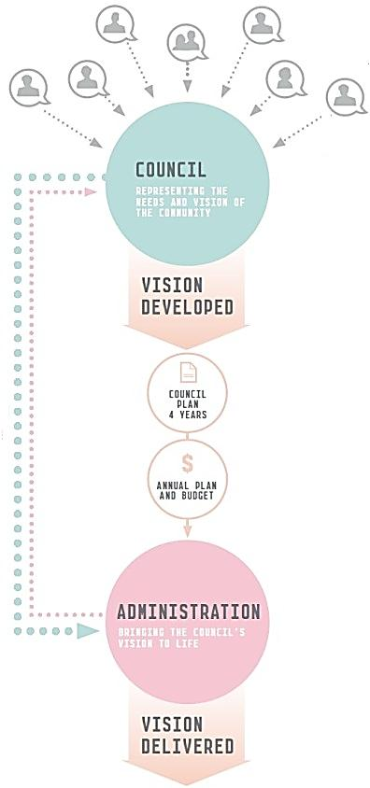
Our people
Happy, high-performing employees help us to deliver an exemplary level of service to our community. As a result, the wellbeing of our staff is one of our highest priorities.
Organisational structure
The City of Melbourne is based at the Melbourne Town Hall in Swanston Street from which it operates a range of facilities, services and administration functions at more than 30 other locations across Melbourne.

While most of staff work in the central city some are based at other sites across the municipality. As of 30 June 2013, we employed 1406 people:

- 998 full-time permanent
- 229 part-time permanent
- 119 maximum-term temporary (full-time and part-time)
- 60 casual staff.

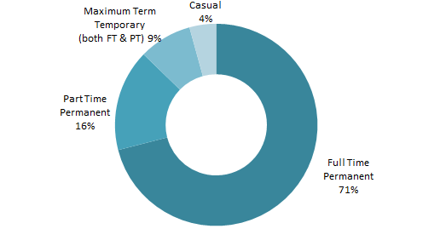

Chief Executive Officer
Dr Kathy Alexander is the Chief Executive Officer (CEO). Her functions and powers are principally determined by the Local Government Act 1989 (Vic) and include:

- establishing and maintaining organisational structures to implement Melbourne City Council decisions
- ensuring that Council’s decisions are implemented
- managing the organisation’s day-to-day operations
- providing advice to the Council
- appointing, directing and terminating staff, and managing all other issues that relate to staff.
The office of the CEO liaises with the offices of the lord mayor, deputy lord mayor and councillors, the Australian and Victorian governments and other major community and corporate stakeholders. The CEO also attends Council meetings.
Divisions and directors
The City of Melbourne has an organisational structure of five divisions. Branches within each division perform specific functions, collaborate on projects and share their particular knowledge and expertise across the organisation.

City Design – Rob Adams, Director
The City Design division is responsible for developing strategic plans and urban design policy as well as delivering best practice in design, project management and parks services. The division has primary responsibility for Docklands and the coordination and delivery of major projects and the capital works program. It also ensures we maintain our reputation as a leader in the sustainable design and management of public spaces.

City Business – Martin Cutter, Director
The City Business division focuses on supporting businesses and business development in Melbourne. The division contributes to positioning Melbourne as a world-class city in local, national and international markets through managing events, tourism services, international business relationships and marketing programs. The division works with a wide range of stakeholders including ratepayers, businesses, retailers, city visitors, tourists, sister cities, major sporting bodies and government departments.

City Planning and Infrastructure – Geoff Lawler, Director
The City Planning and Infrastructure division advises the Council on research, city planning and the future sustainable development of Melbourne. It manages the City of Melbourne’s bridges and drainage, road infrastructure, as well as municipal services such as parking and traffic management, waste management and street cleaning. The division also administers local laws and regulations to develop, improve and protect the general amenity of the municipality.

Community Development – Linda Weatherson, Director
The Community Development division plans and provides high-quality, cost-effective and customer focused services to the community. These include recreational services, health services, family and children’s services, aged care, library and customer relations services. The division addresses key social issues that affect city life, particularly in relation to city safety, public space and accessibility for all members of the community, and manages cultural programs and infrastructure, which enhance the city’s reputation as a liveable city.

Corporate Business – Mark Stoermer, Director
The Corporate Business division is primarily responsible for providing support services to the organisation. These services include legal advice, human resource management, information technology systems, corporate planning, financial services, property services and management of the municipality’s financial assets. The division also plays a role in liaising with our wholly-owned subsidiaries, which contribute to the City of Melbourne’s revenue.

City of Melbourne organisational chart

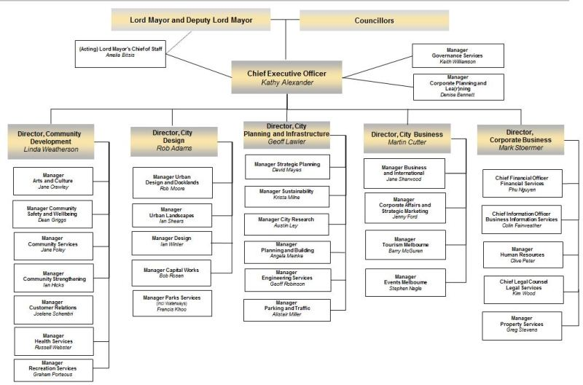

Staff classifications
- Classification 1 and 2 – child care workers, school crossing supervisors, fitness instructors, information officers
- Classification 3 – child care workers, parking and traffic, office administrative support
- Classification 4 – administrative support, environmental health, project officers, kindergarten teachers
- Classification 5 and 6 – professionals, analysts, programmers, technical staff, maternal and child health nurses, immunisation nurses, event managers
- Classification 7– team leaders and professionals
- Executive – managers, directors and the CEO.
Staff profile
The gender balance of City of Melbourne staff is 58 per cent female and 42 per cent male. Women hold 33 per cent of executive positions. Sixty per cent of female staff and 40 per cent of male staff are employed in classification range 3 to 6. The following tables illustrates how employee gender is divided across the eight classifications, how gender is spread across different age groups and the number of staff by years of service and gender.
Number of staff by classification and gender as at 30 June 2013

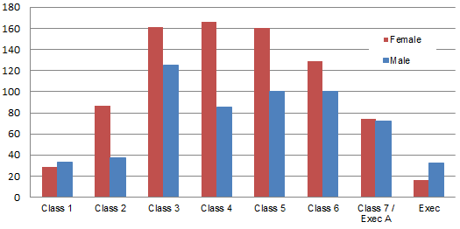
Number of staff by age group and gender as at 30 June 2013

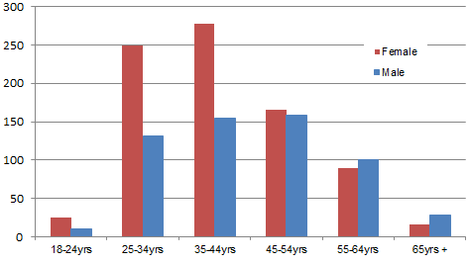
Number of staff by years of service and gender as at 30 June 2013
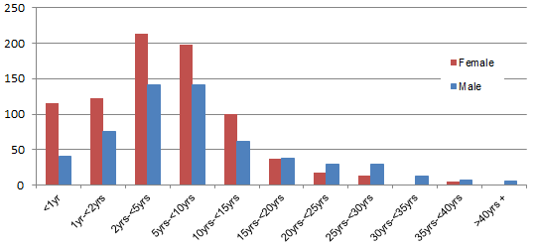
Staff retention
Improving staff retention rates is a high priority for the City of Melbourne. Voluntary staff turnover has remained around 8 per cent in the past few years.
Staff turnover
Financial year | Positions advertised | Average applicants per position | Staff turnover¹ | Absenteeism²
2012–13 | 283 | 39 | 8.36% | 3.42%
2011–12 | 291 | 37 | 8.02% | 2.54%
2010–11 | 284 | 24 | 8.42% | 2.89%
2009–10 | 232 | 26 | 9.60% | 2.80%
2008–09 | 222 | 28 | 7.90% | 2.70%
2007–08 | 381 | 23 | 12.70% | 3.00%
2006–07 | 164 | 34 | 12.70% | 3.10%
Note 1: Voluntary (resignations) turnover only
Note 2: Total sick leave absences as a percentage of ordinary time available

Staff support services
A broad range of support services and initiatives are available for all staff, including career and personal counselling, and an on-site sit or stand workstation trial. In addition, during 2012–13 the City of Melbourne supported staff in returning to work from personal or work-related illness or injury by providing:
- in-house allied health professional services
- access to specialists in occupational and environmental medicine
- early intervention strategies such as ergonomic reviews and adjustment to the workplace
- the development of return-to-work plans.

Staff development
We develop our people through a range of professional development and leadership programs, offered through our corporate learning calendar. Our City of Melbourne Education and Training program offered 19 internally-facilitated courses and 19 externally-facilitated courses with 181 workshops delivered in 2012–13.

There were 1664 attendances at these courses. We supported a further 21 employees to begin further education through our study assistance program, in addition to those already completing tertiary or higher education courses.

All new staff are required to complete online training assessment modules which includes a demonstrated understanding of our policies on equal opportunity in employment, sexual harassment in the workplace, workplace bullying, fraud and improper conduct, work health and safety and privacy.
Staff training
The average number of training hours per employee was eight hours in 2012–13. This reflects technical skills development and corporate learning programs that have been managed by our central learning and development team, but does not recognise the larger amount of informal and role-specific learning that occurs.
The following figure provides a breakdown of average training hours by gender and classification. Variances across classifications are impacted by a several factors, including the gender diversity at each classification level and the high number of males in classification 3 roles that receive a larger amount of technical skills development required by their role.

Average training hours by City of Melbourne employees year ending 30 June 2013
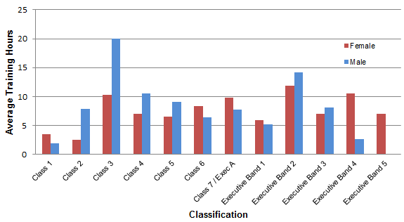
Health and wellbeing programs
We recognise that work is just one part of the lives of City of Melbourne employees. We have several support mechanisms to help staff manage a work-life balance and improve and maintain their health and wellbeing.

The Leap into Life program provides staff with educational information through various initiatives such as health events, workshops and consultations. Current initiatives focus primarily on physical activity, healthy eating habits and mental health.

Our employee recreation association, CoMLife, also provides health and wellbeing programs and social opportunities for staff who chose to be members. The association provides discounted wellbeing classes, supported corporate sports teams, encourages participation in charity events such as Movember and Cancer Council fundraising, and sources discounts for staff on health-related products. Membership of CoMLife continued to grow in 2012–13.

Occupational health, safety and wellbeing
We managed risk and occupational hazards by continuous evaluation and improvement of work environments and our occupational health and safety (OHS) management system. This system is audited against the Australian Safety Standard AS/NZS 4801:2001 and our accreditation was maintained in 2012–13.

Safety is embedded in our work culture, and occupational health and safety is extremely important. The continuous improvement of our safety systems and processes across the organisation works to provide safety at work.
Our workplace
WorkCover claims
The City of Melbourne received 22 WorkCover claims in 2012–13. Our WorkCover premium is now at 0.34 per cent. This remains significantly lower than the local government sector rate of 1.54 per cent. We have a proactive injury prevention strategy and an early intervention approach to all work-related injuries and illnesses that focuses on sustainable return-to-work programs.

WorkCover claims
Financial year | Standard claims | Minor claims | Premium incl GST ($) | Premium as % of remuneration
2012–13 | 15 | 7 | 420,264.55 | 0.34
2011–12 | 7 | 2 | 361,060.84 | 0.35
2010–11 | 4 | 1 | 818,600.13 | 0.80*
2009–10 | 16 | 4 | 599,653.00 | 0.64
2008–09 | 3 | 5 | 754,000.00 | 0.65
2007–08 | 8 | 17 | 767,000.00 | 0.88
2006–07 | 7 | 19 | 940,000.00 | 1.15
*Increased premium rate for this period was due to a Victorian WorkCover Authority increase in the industry rate.
Equal opportunity, discrimination and harassment policy
We are an equal opportunity employer and work hard to provide a work environment that is safe, supportive, free of discrimination and where individuals treat each other with respect.
Our network of contact officers are volunteers within the City of Melbourne trained to help employees identify options and resources to deal with workplace discrimination and harassment. Our equal opportunity commitment is supported by our Workforce Diversity Strategy and Action Plan and addresses requirements under Schedule 6 of the Local Government Act.
Workplace diversity
Workplace diversity involves recognising the value of individual differences and treating everyone fairly and equally. The Workforce Diversity Strategy and Action Plan 2011–13 includes principles, objectives and strategies to support diversity within the City of Melbourne. The strategy builds on our existing values: integrity, courage, accountability, respect and excellence. The Workforce Diversity Steering Committee meets quarterly to oversee the delivery of the strategy and action plan.
In early 2013 a diversity census was sent to all staff to complete on a voluntary and anonymous basis. Just over 60 per cent of staff responded, with the results showing a snapshot of the diversity we have within our workforce. It will also help us draft the next Workforce Diversity Strategy and Action Plan for 2014–16.
In 2008, an Indigenous Traineeship for Aboriginal and Torres Strait Islanders was established. Each year four to six trainees are recruited to work in different areas for 12 months. The traineeship provides participants with the opportunity to gain work experience and on-the-job skills with us, while obtaining a nationally-recognised certificate in Business Administration through APlus Apprentice and Trainee Services. In 2013, two traineeships were successfully completed, one in Property Services and the other in Engineering Services.
In addition, an integral part of the induction process for all new employees is a walk highlighting Melbourne’s Aboriginal heritage.
Enterprise agreement
The City of Melbourne has a single enterprise agreement that covers approximately 90 per cent of employees. The current agreement includes sustainability targets, work conditions and employee benefits. To maintain our position as a fair and flexible employer, we monitor the operation and application of the agreement through a staff consultative committee that meets quarterly.
Best value service delivery
The City of Melbourne reviews all existing services and adopts new service delivery models, in line with the Local Government Act, in contrast to the previously requirements to use compulsory competitive tendering.
As a result we take the following principles into account when reviewing our services so they are the best on offer to meet the needs of the community:

- the need for services to deliver against agreed quality and cost standards
- the accessibility of services to those who need them
- services being responsive to changing community needs
- continuous improvement in the delivery of services
- community consultation on services and activities
- regular annual reporting to the community on our performance.
We continuously improve our services and projects to deliver best value for the community. Community engagement and ‘Lean thinking’ programs mean we apply best value principles in the services we operate and manage.
Lean Thinking
Lean Thinking aims to deliver value to the customer, including internal customers and external end users. In service industries, Lean Thinking means delivering the right service, in the right place, at the right time, provided by the right person and done right the first time. Value for the customer is increased by systematically removing waste from processes and the associated work. Value for the City of Melbourne is achieved by meeting our goal to manage the organisation’s resources well.
More information on Lean Thinking is provided above on page 60.
Stakeholders
Our stakeholders include anyone with an interest in what we do and the services and programs we provide, such as:
- Local community – residents, ratepayers, businesses and their community, workers, students, visitors, unions, the media, community groups and associations, the education sector, neighbouring communities and other local government authorities.
- Working partners – other government bodies and agencies, our suppliers and consultants, the business community and others.
- Global partners – city partners, investors, event organisers and others.
We work with stakeholders in many ways. Our community engagement framework guides the way we engage and communicate with our stakeholders on the decision-making process of significant policies, programs and services. We also work closely with our stakeholders through specific issue advisory and reference groups and our daily interactions with those who use our services and facilities. All these interactions provide us with important insight into how we can always find ways to improve the quality of our services.
Community engagement
Community engagement involves informing, consulting with and seeking the active participation of our diverse community on issues that may impact them or are of interest to them. The engagement process is designed to help inform and influence Council decision-making.
The City of Melbourne will engage the community in any of the following circumstances:

- where the community could be impacted by a project or decision
- where community input can improve a project or decision-making
- to help identify community needs not already known
- in response to expressions of community interest
- when required by law, policy or by agreement with a government agency or statutory body.

It is important in these processes that we seek the participation of a broad cross-section of the Melbourne community so a range of ideas and opinions are considered as part of the decision-making process. Other factors that support community engagement include:

- providing information to support participation
- informing the community about how they can influence decisions
- using a variety of tools to support participation and deliberation
- using the community’s contribution to help inform decision-making
- informing the community of how their input has influenced decisions.
We review and evaluate our community engagement process so we are continuously improving. We continue to build a culture of community engagement that is integral to core business and contributes to open, transparent and responsible government and a more informed and engaged society.
Engagement approaches can vary and are tailored to support inclusive and well-informed participation. The organisation is building its online engagement capacity so we can reach more people and provide more information and more opportunities to submit feedback and ideas. Staff continue to develop skills in community engagement and facilitation and in 2012–13 we also began training for community members.
In 2012–13 the City of Melbourne sought community input on many projects including:
- Council Plan incorporating the Municipal Public Health and Wellbeing Plan
- Docklands Library, community space and children’s and boating hub
- Docklands Community Forum
- Planning for Future Growth projects
- Heritage Strategy
- Future Living – Housing Options
- Prevention of Violence Against Women Strategy
- Queen Victoria Market trader stage
- Age Friendly Cities
- Mobility services
- Streetscape improvement projects
- Bicycle Plan and bicycle network upgrades
- Exceptional Tree Register
- Returning parkland to Royal Park
- Open space improvement works in the parks and gardens
- Urban Forest Local Precinct Plans
- Knowledge Melbourne
- North Melbourne Community Centre
- Kensington Town Hall
- Domestic Animal Management Plan
- Tourism signage.

Our corporate governance

Relationship with other tiers of government
Statutory responsibility for local government lies with each Australian state or territory. An Act of each state parliament specifies local government powers, duties and functions. In Victoria, the legal basis for councils is established under the Constitution Act 1975 (Vic) and the Local Government Act 1989 (Vic).
Council decisions
Councillors make decisions at Council meetings and delegated committee meetings. Committee meeting decisions are subject to a ‘referral notice process’ meaning that where fewer than six committee members vote in favour of a motion, or the Chair uses their casting vote, members have the option of referring the matter to the next Council meeting for decision.
Delegations
Melbourne City Council’s powers under the Local Government Act or any other Act may be delegated to a Council committee, to a City of Melbourne officer including the CEO or sub-delegated to a City of Melbourne officer by the CEO. Staff members are accountable to the CEO. The Council and its committees provide policy and staff members make decisions in accordance with that policy. The exercise of delegation is subject to the Council’s Delegations Policy.
Participation in Council
The City of Melbourne welcomes community and stakeholder attendance and participation at Council and committee meetings. Members of the public can make submissions to the Council or a committee on matters listed on meeting agendas. A register of public submissions made under section 223 of the Local Government Act is available for viewing at the City of Melbourne’s offices.
Records of meetings, meeting dates and times and information on how to interact with the Council can be found on our website at melbourne.vic.gov.au.
Documents available for inspection
The Local Government Act and Local Government (General) Regulations 2004 require us to keep certain statutory registers and documents, which can be viewed on request, or in certain cases, on application. Available documents include:
- Council and committee meeting agendas and minutes
- special committees established or abolished
- agreements to establish regional libraries
- contracts valued at $150,000 or more, which the Council entered into outside the competitive process, except section 186(5) contracts
- names of the Councillors and City of Melbourne officers required to submit a return of interest and the date returns were submitted
- details of interstate and overseas travel by Councillors and City of Melbourne officers
- details of senior officers’ total salary packages
- details of all property, finance and operating leases involving land, buildings, plant, computer equipment, or vehicles entered into by the City of Melbourne (as lessor or lessee)
- list of donations and grants made by the City of Melbourne
- list of organisations of which the City of Melbourne is a member and details of membership fees
- mayoral and councillor allowances
- register of authorised officers
- register of delegations
- Protected Disclosure Act 2012 (Vic) procedures
- submissions received under section 223 of the Local Government Act
- election campaign donation returns.

Councillor allowances
Councillors are paid an allowance set by the Victorian Government. This allowance is paid in recognition of the demands placed on councillors in carrying out their civic and statutory duties, and for their work on policy development, as spokespeople on community matters and as representatives of the Melbourne City Council and Melbourne, both in Australia and overseas.

The allowances are:

- Lord Mayor – $171,482
- Deputy Lord Mayor – $85,741
- Councillors – $40,264.

Expenses
Councillors incur expenses in the course of fulfilling their roles. Expenditure is regulated by the Councillor Expenses and Resources Guidelines, as endorsed by the Finance and Governance Committee in 2009 and consistent with section 75 of the Local Government Act. Councillor expenses are reported in detail every quarter on our website.

Councillor conduct
The City of Melbourne’s Councillor Code of Conduct outlines the role of the Council and provides an overview of councillor responsibilities in accordance with the Local Government Act.

The code includes guidelines for rules of conduct, decision-making and use of City of Melbourne resources. It also includes procedures for disclosure of interests and conflicts of interest that go beyond legislative requirements.

Council and committee meeting attendance 1 July 2012 to 23 October 2012
(NB Attendance is at both ordinary and special meetings)
 | Number of meetings | LM Robert Doyle | DLM Susan Riley | Cr Carl Jetter | Cr Jennifer Kanis | Cr Kevin Louey | Cr Cathy Oke | Cr Ken Ong | Cr Brian Shanahan | Cr Jackie Watts
Melbourne City Council meetings | 5 | 5 | 5 | 5 | ^ | 5 | 5 | 5 | 5 | 5
Committee meetings
Future Melbourne | 8 | 8 | 8 | 8 | ^ | 8 | 7 | 8 | 5 | 8
Inner Melbourne Action Plan | 1 | .. | .. | .. | .. | .. | .. | 1 | .. | ..
Docklands Coordination + | 2 | .. | .. | .. | .. | 2 | * | .. | .. | ..
^ Cr Jennifer Kanis resigned from her position as Councillor at the City of Melbourne on 26 July 2012
.. Not a member
* Alternate member
In most cases, absence from committee and Council meetings is as a result of Councillors being required to represent the city on other Council business.
+ Please note that the Docklands Coordination Committee met quarterly until it resolved on 21 August 2012 to meet annually (on the third Tuesday in September each year).
Council and committee meeting attendance 2 November 2012 to 30 June 2013
(NB Attendance is at both ordinary and special meetings)

Please note that following the Electoral Representation Review, 11 councillors were elected in 2012.
 | Number of meetings | LM Robert Doyle | DLM Susan Riley | Cr Richard Foster | Cr Rohan Leppert | Cr Kevin Louey | Cr Stephen Mayne | Cr Cathy Oke | Cr Ken Ong | Cr Beverly Pinder-Mortimer | Cr Jackie Watts | Cr Arron Wood
Melbourne City Council meetings | 9 | 9 | 9 | 7 | 9 | 8 | 9 | 7 | 8 | 9 | 7 | 9
Committee meetings
Future Melbourne | 15 | 15 | 15 | 11 | 15 | 13 | 13 | 9 | 13 | 15 | 12 | 12
Inner Melbourne Action Plan | 3 | .. | .. | .. | .. | .. | .. | .. | 3 | .. | .. | ..
Docklands Coordination + | 0 | .. | .. | .. | .. | 0 | * | .. | .. | .. | .. | ..
.. Not a member
* Alternate member
In most cases, absence from committee and Council meetings is as a result of Councillors being required to represent the city on other Council business.
+ Please note that the Docklands Coordination Committee met quarterly until it resolved on 21 August 2012 to meet annually (on the third Tuesday in September each year).

Council special committees
As well as Council meetings, Melbourne City Council has three special committees:

- Future Melbourne Committee (meets twice monthly)
This committee has delegated powers, duties and functions directly relating to, or ancillary to, all aspects of the City of Melbourne’s activities. The Future Melbourne Committee’s terms of reference are grouped into 10 themes or portfolios being:
- Planning
- Finance and Governance
- Arts and Culture
- Major Projects
- Transport
- Environment
- Economic Development
- Marketing Melbourne
- Knowledge City
- People City.

All Councillors participate in the Future Melbourne Committee.

- Docklands Coordination Committee (meets annually)
This committee manages coordination between the City of Melbourne and VicUrban, now known as Places Victoria, to ensure an open public discussion in this developing area. The committee, which includes senior representatives from both the City of Melbourne and Places Victoria, meets annually to monitor place management services within the coordination area.
- Inner Melbourne Action Plan Implementation Committee (meets quarterly)
This committee has delegated powers, duties and functions directly relating to, or ancillary to, overseeing implementation of the Inner Melbourne Action Plan (IMAP) in accordance with the agreed three-year implementation program. The committee comprises representatives from the local governments of Melbourne, Port Phillip, Stonnington, Yarra and Maribyrnong. See page 81 for more details on IMAP.

Council of Capital City Lord Mayors
The Lord Mayor is a member of the Council of Capital City Lord Mayors, which comprises the lord mayors of all capital cities and the ACT’s Minister for Territory and Municipal Services. It coordinates and represents the special interests of Australia’s state and territory capital cities and their relations with other spheres of government.

Subsidiaries and trusts
The City of Melbourne has two wholly-owned subsidiaries:

- CityWide Service Solutions Pty Ltd – a company established to provide contract services on a competitive basis to local government and other public and private sector clients.
- Queen Victoria Market Pty Ltd – a company established to manage and develop the Queen Victoria Market.

The City of Melbourne has an interest in other entities including:

- Sustainable Melbourne Fund – the City of Melbourne holds all units in this trust, a strategic trust established to support and promote sustainable development.
- Regent Management Company Limited – shared with the Victorian Government, the City of Melbourne has a 50 per cent interest in this company, established to manage the historic Regent Theatre in Collins Street, Melbourne.
- MAPS Group Limited trading as Procurement Australia – the City of Melbourne is majority shareholder of this company.
Legislative compliance
Freedom of information
The Freedom of Information Act 1982 (Vic) gives any individual or organisation the right to access information held by the City of Melbourne unless that information is deemed exempt under the Act.
In 2012–13 the City of Melbourne received 54 valid applications seeking documents about building and planning matters, tenders and contracts, parking infringements and the costs and activities of Councillors and officers. The number of requests received was a decrease on the 58 valid applications received in the previous financial year.
There were two requests for internal review in 2012–13 (both decisions were upheld). No appeals were lodged with the Victorian Civil and Administrative Tribunal in 2012–13. The Act specifies a 45-day statutory time limit to process requests. The average processing time for requests was 33 days.
National Competition Policy compliance
The City of Melbourne complied with the requirements of the National Competition Policy Principles in 2012–13, which covers compliance in trade practices, local laws and competitive neutrality.
Procurement Policy
In accordance with the Local Government Act 1989 (Vic) the City of Melbourne has developed a procurement policy encompassing the principles, processes and procedures applied to the purchases of all goods, services and works by the organisation.

Our procurement policy states that in procuring goods, works and services under a contractual arrangement, the City of Melbourne will:
- support its corporate strategy, aims and objectives
- ensure it achieves best value in terms of time, cost and value
- establish and put in place appropriate performance measures
- commit to achieving sustainability objectives
- provide effective and efficient commercial arrangements.

The policy uses a sustainable approach to procurement to reduce the social, financial and environmental impact of the procurement cycle.

As a result we seek to procure environmentally preferred products and services and to do business with contractors and providers who have similar sustainability objectives and policies.

Whenever practicable and relevant, we give preference to the supply of goods, machinery or material manufactured or produced in Australia or New Zealand, and work collaboratively with suppliers to achieve these objectives.

The organisation has a procurement and corporate contract management system that prescribes best practice methodologies in its contract management and processes and is adhered to at all times.
Information Privacy Act
Standards set out by the Information Privacy Act 2000 (Vic) and the City of Melbourne’s Privacy Policy Statement control how we manage personal information. Privacy compliance is included in our staff induction program. We have a dedicated privacy officer within our Governance Services branch to help staff and members of the public with privacy-related queries or issues.
No privacy complaints were received from members of the public during 2012–13.
Protected Disclosure Act
Complaints about the improper conduct of any City of Melbourne officer can be made confidentially, under the Protected Disclosure Act 2012 (Vic), to the Independent Broad-based Anti-corruption Commission, or to any one of the following officers appointed to receive disclosures:
  - Keith Williamson, Manager Governance Services
  - Linda Weatherson, Director Community Development
  - Mark Stoermer, Director Corporate Business
  - Jane Sharwood, Manager Business and International.

During 2012–13 no disclosures were notified to the Independent Broad-based Anti-corruption Commission or the Victorian Ombudsman (which was the responsible authority prior to 10 February 2013).

Disability Discrimination Act
The City of Melbourne is committed to ensuring equity of access in all in planning, community support and service delivery functions in accordance with the Disability Discrimination Act 1992 (Cth).

Our Disability Action Plan 2010–13 includes designated actions for implementation across 25 branches of the City of Melbourne. This collective approach ensures the City of Melbourne upholds and promotes the right of all community members to equity of access as stipulated in the national Disability Discrimination Act, the Disability Act 2006 (Vic), Charter of Human Rights and Responsibilities Act 2006 (Vic) and the United Nations Convention on the Rights of Persons with a Disability ratified by Australia in July 2008.

Over the past financial year specific actions and tasks were implemented to improve access across the municipality. Key achievements in 2012–13 included:

Reducing and eliminating barriers in our facilities, programs, services and information mediums:
- Completion of mobility studies report and the development of an implementation plan to improve access in identified areas.
- Completion of the review of the program, Good Access is Good Business.
- Submissions to Accessible Transport Review, Victorian Government Disability Action Plan.
- Ongoing support and resourcing of Council’s Disability Advisory Committee.

Following best practice in our universal access planning and provision:
- Review of the terms of reference of the Disability Advisory Committee to ensure the Advisory Committee is responsive to community need.
- Funding of events to organisations for International Day for People with Disability.
- Design and works addressing access for people with a disability are currently being addressed for the development of the Docklands and Kathleen Syme Library and Community Centres Disability Discrimination Act compliance will be addressed as part of the works for both centres.

Strengthening advocacy and partnerships with other tiers of government, government departments and community stakeholders to address and eliminate barriers in our country:
- Carlton Baths facility redevelopment stage 1 completed in 2012–13 incorporating a number of design features addressing accessibility issues.
- Installation and refurbishment of full access public toilets in the Royal Park Native Gardens, Shrine Reserve, Kings Domain and the Myer Music Bowl.
- An assessment for the provision of an accessible public toilet facility was completed within the Queen Victoria Gardens (off St Kilda Road).

Reinforce a culture that celebrates the diversity of all people who live, work, study or visit our city:
- The four park areas assessed for disability access upgrades were the Shrine Reserve, Royal Park Native Gardens, Kings Domain and Queen Victoria Gardens.
- National accreditation of Home and Community Care Program completed.
- Disability awareness training across the organisation for approximately 80 staff.
- All new footpaths and refurbished paths address full accessibility requirements.
Domestic Animals Act
The City of Melbourne prepares a Domestic Animal Management Plan every four years, in line with the Domestic Animals Act 1994 (Vic).

The plan is prepared in consultation with the Victorian Government, Department of Environment and Primary Industries (DEPI) and provides the City of Melbourne with a framework to guide decision-making.

The 2008–11 plan delivered the ongoing actions into an extended fourth year term provided for the preparation of the next plan to align with the new DEPI template, Council Plan and the Council elections in October 2012.

Through increased participation in the community including officer presence in parks and public places, attendance at a number of community events including the Kensington and East Jolimont festivals, the Animal Management team has provided the community with improved access to services.

The overall review of the implementation and delivery of the first plan recognises the benefits of dogs and cats in connecting people and places in our communities to ensure everyone feels a part of the city and we look forward to delivering the 2013–17 plan.

Carers Recognition Act
Council has taken all practicable measures to comply with its responsibilities outlined in the Carers Recognition Act 2012 (Vic). Council has promoted the principles of the Act to people in care relationships who receive the City of Melbourne Home and Community Care (HACC) services, to people in care relationships and to the wider community through a number of ways including:

- providing information via our intake and information service
- assessing and responding to the needs of primary carers
- recognising the role of carers by including carers in the assessment, planning, delivery and review of services that impact on them and their role as carers
- providing respite and planned activity services to provide the primary carer a break from caring responsibilities
- providing links to Victorian Government resource materials on Council’s website
- providing information to organisations represented in Council and community networks.

Our services have policies that satisfy Community Care Common Standards which incorporate recognition of carers in relation to services that impact on them in their role as carers.

Inner Melbourne Action Plan 2012–13
The councils which make up the IMAP Implementation Committee are the cities of Melbourne, Port Phillip, Yarra and Stonnington. This group of councils seeks to help foster creativity, liveability, prosperity and sustainability across the inner Melbourne region. The action plan identified 11 regional strategies and 57 actions for implementation across the inner Melbourne region in 2012–13. Around 75 per cent of these actions are being implemented, or were completed.

Key activities for IMAP during 2012–13 included:

Transport and connectedness
- Work on linking the bicycle network across municipal boundaries continued. Original bicycle priority routes will be reassessed for the ongoing work program and IMAP participated in a review of the Victorian Government’s Bicycle Share Scheme.
- Modelling routes for through-traffic across the inner Melbourne region to develop a help assess ways to reduce the impact of through traffic on activity centres.
- The consistency of visitor signage, names, symbols and attractions across inner Melbourne was reviewed and the development of a visitor sign style guide begun to improve the experience of visitors crossing municipal boundaries.

Environmental sustainability
- The City of Melbourne is leading the new Distributed Energy Project. Work was undertaken with the CSIRO to develop an inner Melbourne energy map project to identify opportunities for distributed generation, including district energy systems, renewable and low-carbon energy generation, energy efficiency initiatives and demand management initiatives. Data gathering has begun and the CSIRO are in the first stage of developing an energy demand model and map for the IMAP region, identifying energy savings potential and impacts on utility networks.
- Work on the Growing Green Guide project continued in conjunction with the University of Melbourne, the Victorian Local Sustainability Accord and the policy and technical reference groups. First drafts were being developed for a technical manual on the construction of green roofs and walls and policy guidelines for integrating rooftop and vertical greening into regulatory schemes. An opportunity assessment was also completed for a number of pilot sites for future development of green roofs, walls and facades in the inner city.

Affordable Housing
- The first stage of an affordable housing research project conducted by the University of Western Sydney and part-funded by IMAP was delivered in 2012–13. The research culminated in a manual on Community Land Trusts in Australia that was released as a public document following information sessions held in Melbourne, Sydney and Perth.
- IMAP and the Department of Human Services collaborated to produce a report on the future direction for master planning public housing. The work aims to support the coordinated development of public housing estates in the inner city.

Regional development
- As part of Melbourne Knowledge Week, work on integrated learning opportunities such as student placements in local government was showcased. This project aims to increase communication networks between councils and universities. A number of council departments and IMAP project teams have taken on students as a result of the promotion and tools provided.
- Regional tourism continued to be developed with a review of the inner Melbourne Tourist Map, the promotion of inner Melbourne’s attractions through a SkyBus campaign and the promotion of inner Melbourne as a visitor destination throughout regional Victoria with a famil tour for Ballarat Visitor Centre volunteers.

Looking ahead, from 1 July 2013, IMAP is extending its partnership to include the Maribyrnong City Council. Modification to the IMAP Implementation Committee’s terms of reference was undertaken to include a new member clause so Maribyrnong could become a full member of the committee. A review of the action plan is also anticipated in response to the expected publication of the Victorian Government’s new Melbourne Metropolitan Planning Strategy in 2013–14.
Risk management
The City of Melbourne manages its risks to maximise opportunities and minimise losses. Risk management planning is done as an organisation-wide exercise, covering the top strategic risks plus operational and project risks. It is also part of the daily business activities of individual branches and contractors. The Council has in place a risk management framework, integrated with its corporate and business planning system.
Risk management strategy, integrated reporting and competitive neutrality
In 2012–13, the third year of the risk management strategy for 2010–13 was implemented. Risk profiling sessions were undertaken with branches throughout the year which involved a thorough review of operational risks and identified opportunities for improvement and alignment to Council’s strategic direction. Integrated quarterly and annual reporting of risks was undertaken and the CEO and directors undertook a major review of the top strategic risks. These top risks were reported to the Audit Committee throughout the year along with the high operational risks.

The risk and audit modules in the organisation’s business planning software was utilised, with the risk data used in the design of the new three year internal audit program. The review of Council’s businesses in relation to competitive neutrality also continued as scheduled.
Fraud awareness training and workshops
Online training and awareness on fraud and improper conduct continued as part of the corporate induction process for all new staff who join the City of Melbourne. It aims to ensure that expectations in this area are understood by staff at the beginning of their work at City of Melbourne. We also held risk assessment workshops with each division to conduct proactive and in-depth assessments of fraud and improper conduct risks.
Insurance and risk financing
The number of claims received by the City of Melbourne from members of the public in 2012–13 remained similar in comparison to the previous year, although the number was higher than the long-term average, a common trend emerging across local government. This included a number of claimants being represented by a lawyer. Staff continued to review this trend and put in place active measures to manage the increase, investigate the reasons behind the trend, identify any additional preventative measures and implement strategies to manage the cost of any claims. The overall cost of insurances to the City of Melbourne was within expectations during 2012–13 which in part reflects the organisation’s proactive approach to managing identified risks.

Business continuity planning and crisis and emergency management
In 2012–13 the City of Melbourne updated the Corporate Business Continuity Plan, the Municipal Emergency Management Plan, all branch business continuity recovery plans, the Information Technology Disaster Recovery Plan and the Crisis Management Manual.

A functional exercise was run by the City of Melbourne to test and practise emergency management and business continuity plans, processes and procedures. The exercise provided operational training to staff in the process involved in responding to a hypothetical significant incident in the waterways area of Docklands. This involved testing of communications and collaboration with surrounding Dockland businesses and external agencies including Victoria Police, Melbourne Fire Brigade and Ambulance Victoria.
Audit operations
Audit Committee
In line with good governance practices and in accordance with section 139 of the Local Government Act 1989 (Vic), the City of Melbourne has operated an Audit Committee since 1996. The committee oversees the activities of the City of Melbourne’s external and internal auditors and gives independent advice to the Future Melbourne Committee on appropriate accounting, auditing, internal control, business risk management, compliance and reporting systems, processes and practices within the organisation.

The Audit Committee met five times during 2012–13. The committee considered many issues including:
- the City of Melbourne’s risk profile
- statement of annual accounts and performance report for Council, and reports on its wholly-owned subsidiaries
- occupational health and safety risks
- information technology risks
- fraud and corruption risks
- business continuity planning and exercising
- governance responsibilities applicable to associated entities and trusts in which the City of Melbourne has either an indirect interest or stake
- legal action reports
- parking permits, vehicle towing and disposal processes
- procurement process compliance
- contract management procedures
- financial management and procedures
- the City of Melbourne’s climate change adaptation strategy.

Audit Committee members
The City of Melbourne Audit Committee comprises two Council representatives and three independent members. The Council representatives for 2012–13 were Deputy Lord Mayor Susan Riley and Chair of the Future Melbourne (Finance and Governance) Committee, Councillor Stephen Mayne.

The independent members during 2012–13 were as follows:

Richard Moore – Chair
Appointed to the Audit Committee in July 2009
Qualifications:
- Consultant – Risk Advisor at Grant Thornton Australia
- Former partner at PricewaterhouseCoopers for 23 years
- Five years Group Manager, Audit for the ANZ Banking Group
- Extensive consulting and management experience in risk management and internal control.

Theresa Glab
Appointed to the Audit Committee in September 2008
Qualifications:
- Consultant and advisor at Considered Compliance Services
- Former partner at Moore Stephens, Melbourne
- Masters in Accountancy
- Certified Practicing Accountant.

John Stewart
Appointed to the Audit Committee in May 2010
Qualifications:
- Director of BDO Kendalls 1986–2008
- Board member of the Executive of BDO Kendalls for six years
- Chairman of the Audit Committee of Harness Racing Victoria
- Chairman of the Finance and Audit/Risk Committee of Ritchies Stores Pty Ltd.
Internal audit
The internal audit service helps the City of Melbourne, its management and the management of its subsidiary companies perform their responsibilities. The internal audit service helps us maintain an organisational environment with strong, relevant and effective internal controls.

The City of Melbourne's internal auditor reports to the Audit Committee. The service was contracted to Deloitte Touche Tohmatsu since July 2009.
A strong internal control environment ensures our systems contribute effectively to management of operations. Services provided by the internal audit service include:
- risk assessment
- development and management of an audit program
- conducting audits and reviews
- reporting audit opinions, findings and recommendations
- presenting, discussing and providing advice on key issues.
External audit
The Victorian Auditor-General is responsible for the external audit of the City of Melbourne and its subsidiary companies. Our external audit focuses on three key areas:
- strategic planning
- detailed audit system testing
- review of financial statements.

Performance statement

Each year the City of Melbourne conducts a thorough planning process to identify the city’s Key Strategic Activities (KSAs), which are published in the Annual Plan and Budget. This summary provides a description our KSAs funded by the 2012–13 Annual Plan and Budget, in accordance with section 127 of the Local Government Act 1989 (Vic).

The City of Melbourne again adopted the framework from the Victorian Auditor General’s Office Better Practice Guide to prepare the KSAs. In doing so, we developed cost, time, quality and quantity measures and targets for the KSAs. Depending on the nature of the KSA some of these elements were found to be more relevant and material than others, therefore not all KSAs have measures and targets for all four elements.

Rating scale
For the 2012–13 Performance Statement, the City of Melbourne has used a rating scale based on a ‘percentage complete’ result against targets set at the beginning of the year and published in the 2012–13 Annual Plan and Budget. This year we have continued to use ‘percentage complete’ as we believe it gives stakeholders a very specific indication of the actual result. However in recognition of the importance of a clear statement of achievement, we have applied the following scale to the Performance Statement:

100% complete – Achieved
90-99% complete – Substantially achieved
80-89% complete – Partially achieved
Less than 80% complete – Not achieved

The method for determining percentage complete starts with the professional judgement of the responsible officer who weighs up what was achieved against what was planned. A review process then occurs where the percentage is reviewed by the appropriate manager and then the responsible director. The final determination of percentage complete is jointly reviewed by the CEO and directors.

Summary
At year end, 70 of the audit measures were achieved, 11 were substantially achieved, six were partially achieved and 11 were not achieved.

External factors impacting on achievement of KSAs
The City of Melbourne’s ability to implement KSAs can be impacted upon by external matters outside of its control. In most cases, KSA measures are established to focus on our specific role however this is not practical in all cases, especially where an external reader needs to understand the full context of the KSA.

The following Performance Statement outlines the City of Melbourne's achievement against the 10 KSAs for 2012–13:

KSA 1 | Planning for future growth | 87
KSA 2 | City safety | 89
KSA 3 | Homelessness | 91
KSA 4 | Climate change adaptation and mitigation | 93
KSA 5 | Streetscapes | 96
KSA 6 | Queen Victoria Market | 97
KSA 7 | Swanston Street redevelopment | 99
KSA 8 | Knowledge Melbourne | 100
KSA 9 | Community infrastructure | 102
KSA 10 | Connected bike network | 104

KSA 1 – Planning for future growth
As the heart of metropolitan Melbourne, the careful planning and development of our municipality is pivotal in keeping our city prosperous, liveable and sustainable. In 2012–13 the City of Melbourne continued to implement its strategic plans for the growth and development of the city, many of which were done through amendments to the Melbourne Planning Scheme.

Goal: 1 A city for people
Outcome: 1.8 A well-planned city with a vision of the future | Objective: 1.8.1 Establish a robust planning scheme that facilitates sustainable growth and development and protects heritage

Audit measure | Type | Target | Reported performance
1.01 Progress the statutory implementation of Amendment C188 Central City Built Form | Time | 30/06/2013 | Not achieved: C188 was endorsed by the 17 May 2011 Future Melbourne Committee (FMC) and sent to the Minister and Department of Planning and Community Development (DPCD) – now known as Department of Transport, Planning and Local Infrastructure (DTPLI) – for approval to exhibit on 26 May 2011. DTPLI was advised to await the outcomes of Amendment C171, which has very similar built form controls, before proceeding with C188. The outcomes were received at the end of June so C188 was not able to be progressed this year.
1.02 Progress the statutory implementation of Amendment C190 Arden-Macaulay | Time | 30/06/2013 | Achieved: On 4 June FMC resolved to refer C190 to a panel and a panel was appointed.
1.03 Progress the statutory implementation of Amendments C197 / C198 City North Heritage | Time | 30/06/2013 | Achieved: Amendments C197/C198 were prepared for the Future Melbourne Committee. In March the Committee endorsed their submission to the Minister for approval to exhibit. The Minister authorised the statutory exhibition in April. Exhibition is likely to commence in September 2013.
1.04 Progress the statutory implementation of Amendments C206 / C207 Arden-Macaulay Heritage | Time | 30/06/2013 | Achieved: Statutory exhibition was completed on 20 June 2013.
1.05 Progress the statutory implementation of Amendment C171 Southbank | Time | 30/06/2013 | Achieved: The Minister approved and gazetted C171 on 20 June 2013. Statutory process complete.
1.06 Progress the statutory implementation of Amendment C196 City North | Time | 30/06/2013 | Achieved: On 9 April the FMC resolved to refer C196 to a panel and a panel was appointed.
1.07 Progress the statutory implementation of Amendment C186 Central City Heritage | Time | 30/06/2013 | Achieved: The Minister has announced approval of part 1 of C186 and we are awaiting its gazettal.
1.08 Progress the statutory implementation of Amendment C209 Public Open Space Contributions | Time | 30/06/2013 | Achieved: The outcomes of the statutory exhibition will be reported to the 2 July FMC.
1.09 Progress the statutory implementation of Amendment C208 Development Contributions Plans Overlay | Time | 30/06/2013 | Achieved: The 4 June 2013 FMC endorsed C208 for exhibition.
1.10 Progress the statutory implementation of Amendment C187 Energy, Water, Waste Efficiency | Time | 30/06/2013 | Achieved: The Minister has approved and gazetted C187. Statutory process complete.
1.11 Housing Strategy Issues and Options Paper - produce an issues and options paper, consult and report to Council on findings | Time | 30/06/2013 | Substantially achieved: The 14 May FMC endorsed the paper for consultation. The results will be reported to the Councillor Forum in September 2013.
Operational Costs | Cost | $615,185 | $416,501: the revised scope of the KSA 1 deliverables for 2012–13 and the subsequent reductions in expenditure have resulted in a favourable variance of $198,684.
Land in the city that was enabled for urban renewal through planning scheme controls (to meet expected growth) | Quantity | Increase from pre-amendment levels | Achieved: 25.2 additional hectares were rezoned within Southbank from Mixed Use to Capital City Zone.
The number of properties for which heritage protection was enabled through planning scheme controls | Quantity | Increase from pre-amendment levels | Achieved: More than 87 additional properties were granted heritage protection through planning scheme controls in C186.

KSA 2 – City safety

As a local government authority, the City of Melbourne has key role in community safety and crime prevention. We achieve this through our many responsibilities in planning, advocacy, service provision and enforcement responsibilities. Building on the work of previous years, we delivered a range of projects to make a difference in city safety, with an emphasis on the city late at night, alcohol and drug issues and transport safety.

Goal: 1 A city for people
Outcome: 1.3 Residents and visitors feel safe | Objective: 1.3.1 Work towards a safer city through partnerships with other agencies

Audit measure | Type | Target | Reported performance
2.01 Based on evidence from the youth street teams and youth services in the central city, Carlton and Kensington / North Melbourne, deliver a project in partnership with young people in the African community | Time | 30/06/2013 | Achieved: Delivered on time.
2.02 Deliver a campaign targeting men aged under 30 with a focus on reducing violent behaviour in the central city | Time | 30/06/2013 | Achieved: Delivered on time.
2.03 Develop a five year road safety plan focusing on pedestrians and cyclists | Time | 31/03/2013 | Achieved: Delivered on time.
2.04 Complete a report that details the impact of alcohol and drug use in our community and recommends a range of possible initiatives for the Council and its partners to consider | Time | 30/06/2013 | Achieved: Delivered on time.
2.05 Implement the priority recommendations from the Dusk til Dawn research undertaken as part of KSA 2 2011–12 | Time | 30/06/2013 | Achieved: Delivered on time.
2.06 Deliver a permanent mega taxi rank at Queen Street | Time | 30/06/2013 | Achieved: Delivered on time.
Capital | Cost | $350,000 | Total expenditure $120,000: expenditure relates to external capital works and was incorrectly assigned to KSA 2. Project code 12ES305N was incorrect and should read 12ES005N.
Operational | Cost | $280,000 | $509,758: includes $274,000 operational expenditure on taxi ranks not budgeted for.
Consultation and engagement with young people in the African community | Quality | 80% of respondents reported a  positive engagement experience | Achieved: Delivered.
Deliver mega taxi rank | Quantity | 1 rank | Achieved: Delivered.

KSA 3 – Homelessness
The City of Melbourne is committed to providing a supportive environment for all residents. We support more services and programs to mitigate homelessness and help those who are at risk of becoming homeless. We also help people whose income is low and who struggle to live in a city that is becoming more expensive. We work with partners in the health sector, Australian and Victorian governments and local businesses to ensure people have the best chance of moving out of homelessness.

Goal: 1 A city for people
Outcome: 1.4 Diverse, harmonious, caring communities | Objective: 1.4.3 Support and develop sustainable pathways out of homelessness.

Audit measure | Type | Target | Reported performance
3.01 Plan and deliver a promotional campaign for the Central City Community Health Service at Drill Hall | Time | 28/02/2013 | Achieved: Project delivered on time.
3.02 Building on the rooming house research project in 2011–12, deliver the 'Pathways Pilot Project' that will link people in rooming houses to the Central City Health Service at Drill Hall and other services such as recreation, planned activity groups and housing | Time | 30/06/2013 | Achieved: Project delivered on time.
3.03 Deliver a recreation program for older homeless people accessing the Central City Community Health Service | Time | 30/06/2013 | Achieved: Project delivered on time.
3.04 Provide access to food via brokerage funds and other programs through the Central City Community Health Service at Drill Hall | Time | 30/06/2013 | Achieved: Project delivered on time.
3.05 Deliver a feasibility study for a day centre in the central city | Time | 30/09/2012 | Achieved: Report delivered 21 January.
3.06 Prepare a preventing violence against women strategy and commence actions | Time | 30/06/2013 | Achieved: Project delivered on time.
3.07 Develop and deliver community services programs with a focus on women and children experiencing homelessness | Time | 30/06/2013 | Achieved: Project delivered on time.
3.08 Deliver 'Evolution', a youth homelessness prevention program, in partnership with Signal and Frontyard Youth Services | Time | 30/06/2013 | Achieved: Project delivered on time.
3.09 Develop and commence delivery of projects implementing the outcomes from the Homelessness Summit held on 31 May 2012 | Time | 30/06/2013 | Achieved: Project delivered on time.
Operational | Cost | $539,000 | $420,406: all deliverables were achieved favourably within their operational budget, particularly in deliverables 3.03, 3.05, 3.07 and 3.09. Some consultancy work was conducted in house, with resultant savings.
Deliver educational outcomes as part Evolution program | Quality | 4 participants return to formal education | Achieved: 12 of 15 participants engaged or re-engaged in formal education as a result of participation in the program.
Deliver the Evolution program | Quantity | The program is run twice | Achieved: Delivered twice on 31/07/2012 to 19/09/2012 and 12/03/2013 to 01/05/2013.
Attendance of rooming house residents at the Central City Community Health Service | Quantity | 10 rooming house residents | Achieved: 10 rooming house residents attended.

KSA 4 – Climate change adaptation and mitigation
Melbourne’s future depends on understanding the risks that climate change poses and knowing what we will do to mitigate those threats. The City of Melbourne is working on innovative and proven ways to be better prepared and to make our city more resilient. In 2012–13 we implemented initiatives to sustainably manage the predicted impacts of climate change and minimise the municipality's contribution to it. The city’s Change Adaptation Action Plan and Zero Net Emissions by 2020 strategy underpin our sustainability work and reviews of these plans, undertaken with our community, formed a major part of this key strategic activity.

Goal: 5 An eco-city
Outcome: 5.1 A reduced ecological footprint | Objective: 5.1.1 Influence the municipality to become a zero net emissions city  5.2.1 Influence the municipality to adapt to climate change

Audit measure | Type | Target | Reported performance
4.01 Update Zero Net Emissions by 2020 Strategy | Time | 30/06/2013 | Partially achieved: Draft strategy was developed. Internal engagement around content is under way.
4.02 Update Total Watermark – City as a Catchment Strategy | Time | 30/06/2013 | Partially achieved: Draft strategy was developed. Internal engagement around content is under way.
4.03 Pilot the commercial building environment upgrade finance tenant engagement tool developed in 2011-12 and develop case studies | Time | 30/06/2013 | Substantially achieved: Direct engagement with building owners and tenants completed a successful pilot period. Three case studies were developed that captured the different experiences and applications of the tool.
4.04 Undertake an opportunity analysis for the development of a district energy system for the Melbourne Town Hall precinct | Time | 30/06/2013 | Achieved: An opportunities report was completed identifying the opportunity and next steps for the Town Hall energy precinct project. A buildings energy demand study was completed identifying the buildings with the largest energy (heating, cooling and electrical) demand in the precinct.
4.05 Develop a plan that engages Carlton business and residents in sustainable food management opportunities | Time | 30/06/2013 | Achieved: A Sustainable Food Information Tool, EcoCity Food Forum and network was established to engage businesses and residents in an action plan for Carlton.
4.06 Review the Council's tendering process to include eco-city objectives where appropriate | Time | 30/06/2013 | Achieved: A review of the Council's tendering process was completed during the year and a new process implemented to incorporate Corporate Social Responsibilities (CSR) into the tendering process. The eco-city objectives were a part of CSR. A briefing note was prepared documenting the benefits derived from the new process.
4.07 Analyse and deliver a report on the feasibility and possible mechanisms for using the City of Melbourne rates framework to encourage properties to reduce their environmental impact | Time | 30/06/2013 | Not achieved: The Local Government Legislation Amendment (Miscellaneous) Act 2012 attained assent on the 30 October 2012. Section 161 of the Local Government Act 1989 (Vic) differential rates) has subsequently been modified to include the requirement to adhere to a Ministerial Guideline when formulating differential rates. The Guidelines became available mid-2013 and an options report prepared.
4.08 Deliver a youth engagement project to work towards achieving the City of Melbourne eco-city goals | Time | 30/06/2013 | Achieved: Youth event for local schools was held in May at the Town Hall. Schools recruited and materials for the event were prepared in conjunction with the Australian Youth Climate Coalition.
4.09 Prepare a cycling and pedestrian safety plan for the Yarra River Corridor | Time | 31/03/2013 | Achieved: Draft plan distributed for internal feedback, briefing note being prepared for Council
4.10 Implement flood mitigation upgrades including works in Coventry Street, Hoddle Street between Hotham and Gibb streets, Albermarle Street, corner Flemington Road and Park Drive, corner Spencer and La Trobe streets and corner of Spencer and Collins streets (subject to funding approval of the capital budget) | Time | 30/06/2013 | Substantially achieved: Albermarle Street / Flemington Road / Errol Street (replacement project for Spencer / Collins streets) projects completed.  Spencer Street / La Trobe Street and Hoddle / Hotham streets projects partially completed due to latent conditions and scheduled delays and due to be completed in July. Coventry Street / Kingsway drain project delayed due to Melbourne Water approval. This project will be carried forward to 2013–14 financial year.
4.11 Stormwater harvesting projects – complete Fitzroy Gardens and commence construction of Queen Victoria Gardens and Birrarung Marr | Time | 30/06/2013 | Achieved: Fitzroy Gardens construction complete. Birrarung Marr construction well advanced. Queen Victoria Gardens construction well advanced.
4.12 A minimum of five landscape adaptation projects to be selected and commenced from (but not limited to) Flinders Lane (Spencer to King), Alfred Place, Carlton Squares, University Square, Hawke/Adderley Street Park, Moonee Ponds Creek, Royal Park, Errol Street Park, Water Sensitive Urban Design (WSUD) tree retrofits and increasing canopy program for streets and parks | Time | 30/06/2013 | Achieved: Landscape adaptation projects progressed well, with eight projects complete (Leonard, Walker, Levers Streets, Wellington Parade South, Little Bourke Street, Alfred Place, Queensberry Street and Franklin Street) and others at various stages of concept completion or construction. This includes construction under way in Flinders Lane and Godfrey Street, concept completion for University Square and development of WSUD fact sheets and research projects.
4.13 Development of three draft tree planting precinct plans in accordance with the Urban Forest Strategy | Time | 30/06/2013 | Achieved: Four draft precinct plans were developed. Significant community engagement was undertaken for each precinct to allow the community to participate. A website was also developed to communicate the development of the plans.
4.14 Complete landscape masterplan for Princes Park | Time | 30/06/2013 | Achieved: Princes Park Master Plan endorsed by Future Melbourne Committee in September 2012 following community consultation.
4.15 Develop a landscape masterplan for Yarra River corridor | Time | 30/06/2013 | Not achieved: Heritage nomination of the Yarra River corridor caused ongoing uncertainty with regards to the impact on how changes to the landscape (and in particular trees) are managed. These uncertainties could not be resolved in the current year and a draft Yarra River Corridor Master Plan was completed for internal use only.
4.16 Complete design and community engagement for Neill Street Reserve project between Rathdowne and Lygon Streets as part of the Carlton housing redevelopment | Time | 30/06/2013 | Achieved: Design and design development as well as community development were completed.
4.17 Undertake design and community engagement for the Sandridge Bridge greening project (currently unused section) | Time | 30/06/2013 | Not achieved: A working group was formed across Council to develop a greening concept for Sandridge Bridge. Structural engineering advice has identified the bridge has loading restrictions that will limit design opportunities. A concept was developed to reflect these restrictions, and assessed by the structural engineer and working group. Community consultation and other further was postponed, at the request of the Victorian Government, until the competition for redevelopment of Flinders Street Station is concluded.
Capital | Cost | $11,209,550 | $8,786,533: due to various issues arising within some capital expenditure components of the KSA for 2012–13, some of the proposed deliverables were not completed prior to 30 June 2013. As a result, $2,423,017 of the approved budget will be treated as capital carry-forward to the 2013–14 financial year.
Operational | Cost | $481,050 | $302,671: revisions to the scope of some of the KSA deliverables for 2012–13 and the subsequent reduction in expenditure have resulted in a favourable variance of $178,379.
The number of storm water drain upgrades in the City of Melbourne municipality | Quantity | 6 | Not achieved: Three of the six upgrades were completed.

KSA 5 – Streetscapes

Great cities have great streets. We are implementing streetscape enhancements in iconic Melbourne locations: in Elizabeth Street, between La Trobe and Little Lonsdale streets; in Collins Street, between Queen and Elizabeth streets. We prepared improvement plans for these streets with the people who use them and focused on amenities like footpaths, trees, street furniture, lighting, bike parking and the appearance of adjoining buildings. We developed a framework to ensure the condition of our streets keeps pace with the requirements of a growing community.

Goal: 1 A city for people
Outcome: 1.6 High quality public spaces | Objective: 1.6.1 Provide a range of high quality and welcoming public spaces

Audit measure | Type | Target | Reported performance
5.01 Elizabeth Street footpath upgrade – La Trobe Street to Little Lonsdale Street | Time | 30/06/2013 | Achieved: Project complete.
5.02 Collins Street footpath upgrade – Queen Street to Elizabeth Street (both sides) | Time | 30/06/2013 | Substantially achieved: Scheduled works were delayed and due to be completed in July.
5.03 Further develop the rolling program methodology to incorporate small streets and lanes, identify priority projects for future years and select one project for completion in the current year | Time | 30/06/2013 | Achieved: Identification of rolling program methodology was further developed to incorporate laneways and small streets (minor streetscapes). Priority projects were subsequently identified for 2013–14 financial year and Ridgway Place selected for the current year.
Capital | Cost | $2,650,000 | $2,350,000: Collins Street & Ridgway Place streetscape projects were completed on budget by 30 June. Ridgway Place project was able to be funded from the 12ES013N streetscape budget, resulting in an expenditure saving in the 12ES132R budget that can be reallocated to fund a road renewal project. The revised 2012–13 financial year major streetscape budget is $2.35 million.
Footpath Asset Condition Rating Improvement | Quality | Asset Condition Rating Improved | Achieved: Rating was below five and now rating is five for all Collins and Elizabeth polygons.

KSA 6 – Queen Victoria Market

As the owner of the Queen Victoria Market (QVM), the City of Melbourne is committed to its long-term viability and survival, ensured through its thriving atmosphere and the unique place it holds in a growing and prospering city. Our planning for the Queen Victoria Market is driven by our commitment to achieving social, environmental and economic success in all parts of the city. We are committed to preserving the market’s heritage while at the same time adapting to a rapidly changing retail and leisure environment and a growing community within the city’s north.

Goal: 3 Economic prosperity
Outcome: 3.1 A sustainable and resilient city economy | Objective: 3.1.1 Implement strategies to support a thriving and diverse economy

Audit measure | Type | Target | Reported performance
6.01 Undertake an integrated community engagement program | Time | 30/06/2013 | Not achieved: The City of Melbourne has developed a draft integrated communications, media and community engagement plan. Once the Victorian Government has completed its deliberations relating to renewal of the market, the community engagement program will be implemented.
6.02 Commence design options for a suite of renewal projects focusing on the market and its surrounds | Time | 30/06/2013 | Partially achieved: Early design priorities were established for a suite of renewal projects. These design priorities are intended to form part of the public discussions once the Victorian Government has completed its deliberations related to renewal of the market.
6.03 Develop a delivery and financial model for the renewal of the market precinct | Time | 30/06/2013 | Partially achieved: A number of economic studies were undertaken to help with the development of a business case. The community engagement process to come will help inform the eventual delivery and financial model.
6.04 Research and develop a sustainable infrastructure masterplan for the QVM precinct looking at district-wide water, energy and waste strategies | Time | 30/06/2013 | Not achieved: QVM was briefed on the sustainable precinct approach. Significant work has progressed on waste and energy solutions, with further work needing to be undertaken to develop a water management plan. This is being integrated into the operational review process informing the renewal briefs, which will be progressed once the Victorian Government has completed its deliberations related to renewal of the market.
6.05 Deliver ongoing asset maintenance and upgrading of QVM buildings and infrastructure | Time | 30/06/2013 | Substantially achieved: Asset maintenance and upgrading of QVM buildings and infrastructure for 2012–13 were completed with the exception of the F Shed project, which was deferred until the Victorian Government has completed its deliberations and the community engagement program is under way.
6.06 Prepare strategy to develop and enhance retail and hospitality businesses within market precinct | Time | 30/06/2013 | Not achieved: Research was undertaken and integrated into early ideas for the precinct. QVM Project stakeholders were actively engaged in the development of the new Melbourne Retail and Hospitality Strategy 2013–2017 which covers the municipality.
Capital | Cost | $1,767,000 | $1,308,544: The F-Shed project did not proceed ($220,000). The remainder of funds offered as savings.
Operational | Cost | $342,824 | $160,858: Overall project delayed – $160,000 offered as savings and remaining budget not spent due to delay.
Operational maintenance | Cost | $500,000 | $505,544: the minor overspend was a result of unbudgeted internal fees.
Develop design briefs for three renewal projects | Quantity | 3 | Partially achieved: one brief developed and further research completed to inform the other two briefs.

KSA 7 – Swanston Street redevelopment

The completion of the Swanston Street redevelopment was an essential step forward in preparing the city for future growth. The new design recognised the need for greater accessibility for the growing diversity of use, particularly for pedestrians and cyclists. The project continued to proactively consult with all user groups and Swanston Street stakeholders to ensure they were able to make the most of the street's evolution. In 2012, the works program delivered the fourth and final tram zone between A'Beckett and Franklin streets and completed the general upgrade of Swanston Street, including the installation of new street furniture and lighting.

Goal: 6 A connected city
Outcome: 6.1 Movement of people and goods within the municipality is efficient, integrated and safe, with more people choosing sustainable forms of transport | Objective: 6.1.2 Integrate public transport with cycling and walking as the preferred mode of travel to the city

Audit measure | Type | Target | Reported performance
7.01 Complete the tram stop between A'Beckett Street and Franklin Street | Time | 20/10/2012 | Achieved: Construction works complete.
7.02 Complete street furniture and landscaping renewal program between Flinders Street and La Trobe Street | Time | 20/10/2012 | Achieved: Construction works complete.
7.03 Complete lighting renewal program between Flinders Street and La Trobe Street | Time | 20/10/2012 | Achieved: Construction works complete.
Capital | Cost | $6,500,000 | $5,036,620: $290,000 will be carried forward to finalise the aesthetics of the project.  The balance is surplus.
Completion of a tram stop | Quantity | 1 | Achieved: Construction works complete.
Ongoing program of continuous improvement and refinement to improve overall effectiveness of Swanston Street to all, based on feedback from authorities and stakeholder groups | Quality | A trend of positive feedback from key authorities and stakeholder groups. | Achieved: Continual review of Swanston Street traffic and pedestrian operations required improved signage for motorists and improved pedestrian crossings.  External road safety and access consultants’ reports at post completion of each stop listed improvements to be considered under continual review.  Yarra Trams completed post completion risk assessment of all stops.

KSA 8 – Knowledge Melbourne

The City of Melbourne is committed to supporting the growth of its knowledge sector. It undertook a multi-faceted project to research, consult and identify the opportunities for the sector, determine the Council's role in the sector's future and promote our knowledge sector locally, nationally and internationally.

Goal: 4 A knowledge city
Outcome: 4.2 High quality knowledge infrastructure | Objective: 4.2.3 Establish a Knowledge City vision and foster recognition of the City of Melbourne’s knowledge economy

Audit measure | Type | Target | Reported performance
8.01 Create an inventory of organisations, assets and events within the municipality that contribute to the City of Melbourne's knowledge sector | Time | 30/06/2013 | Achieved: An inventory of organisations, assets and events was delivered through the ACIL Tasman Knowledge Sector Study (February 2013), meeting the target date.
8.02 Deliver a report showing the composition of the municipality's knowledge sector and the contribution this sector makes to the municipality's economy | Time | 28/02/2013 | Achieved: The ACIL Tasman Knowledge Sector Report was delivered in February 2013, meeting the target delivery date.
8.03 Develop and implement a community engagement and communications plan and an online presence to promote the municipality's knowledge sector | Time | 30/11/2012 | Achieved: The community engagement and communications plan was completed. The Knowledge Melbourne microsite was launched in October 2012 and is used as an ongoing resource.
8.04 Deliver Melbourne Knowledge Week 2012 | Time | 31/12/2012 | Achieved: The third annual Melbourne Knowledge Week was held from 26 November to 1 December 2012 and provided an umbrella under which organisations and individuals delivered self-funded and self-managed knowledge-related events and activities.
8.05 Establish a reference group to provide advice on the Council's service to the municipality regarding the knowledge sector | Time | 30/11/2012 | Substantially achieved: A knowledge sector reference group was successfully established and is in continual development, reflected through the Knowledge Sector Workshop on 19 June 2013.
8.06 Promote the existing Melbourne Awards program to organisations in the knowledge sector | Time | 31/05/2013 | Achieved: Knowledge Melbourne promoted Melbourne Awards to its stakeholders:  - Knowledge Melbourne hosted a table Melbourne Awards Lunch and invited specific stakeholders (16 May 2013)  - Knowledge Melbourne promoted via homepage  - Email invitation to Melbourne Award exhibition and launch  - Email notification that Melbourne Awards nominations had opened.
8.07 Develop and present to Council guidelines for a City of Melbourne research partnerships program | Time | 28/02/2013 | Substantially achieved: The partnership with the Australian Research Council was successfully developed and presented to the Council on 30 April 2013.
8.08 Develop a City of Melbourne International Students Strategy | Time | 30/06/2013 | Substantially achieved: The strategy was drafted. Internal consultation was undertaken and is being reviewed by the manager and directors for the Council meeting in September 2013.
8.09 Launch the City of Melbourne's knowledge sector service to stakeholders | Time | 30/08/2012 | Achieved: The successful launch was opened on 23 August 2012 by The Hon Lord Mayor Robert Doyle, Master of Ceremonies provided by Deputy Lord Mayor Susan Riley with guest speaker Professor CJ Lim, Professor and Vice-Dean, Bartlett University College London.
Capital | Cost | $150,000 | $0: Knowledge Melbourne advised BIS that the allocated capital budget component will not be required in October 2012 as the alternative approach utilised to achieve the required deliverable.
Operational | Cost | $497,350 | $406,298: accepting that there are a number of compensating variances, overall KSA 8 was able to achieve its deliverables for less than the approved budget, resulting in a favourable variance of $91,052.
Increase by at least five new event partners during Melbourne Knowledge Week 2012 | Quantity | 24 | Achieved: Significantly increased, with 37 event partners in 2012 compared with 19 event partners in 2011.
Increase by at least five new events held during Melbourne Knowledge Week 2012 | Quantity | 25 | Achieved: The number of events more than doubled in 2012, with 46 events compared with 20 events in 2011.
Overall positive feedback from Knowledge Week 2012 event partners | Quality | Overall positive feedback | Achieved: Fifty-seven per cent of event partners were satisfied with their experience of Melbourne Knowledge Week and 35 per cent were very satisfied.

KSA 9 – Community infrastructure

As our city grows and the needs of our residents change, we are delivering a major capital works program that will provide the infrastructure to house the community services that we deliver. Our work this year saw construction begin on the Kathleen Syme Centre and Docklands Library and Community Centre and the completion and opening of the Carlton Baths and Family Resource Centre.

Goal: 1 A city for people
Outcome:1.7 Improved access to relevant and affordable community services | Objective: 1.7.4 Establish and improve community infrastructure in all neighbourhoods

Audit measure | Type | Target | Reported performance
9.01 Complete construction of the Carlton Baths and Family Resource Centre redevelopment | Time | 31/01/2013 | Achieved: Construction complete.
9.02 Open the redeveloped Carlton Baths and Carlton Family Resource Centre | Time | 31/03/2013 | Achieved: Facility officially opened 3 March 2013.
9.03 Construct base building of Docklands Library and Community Centre in preparation for fit out in 2013–14 | Time | 30/06/2013 | Substantially achieved: Base building structure is progressing to plan for completion at the end of 2013. Design and documentation of interior fit out is complete.
9.04 Complete the brief, concept design and community engagement and commence advance design work for the North Melbourne Community Centre (Buncle St) | Time | 31/03/2013 | Achieved: Endorsed by the Council. Next phase commenced.
9.05 Establish the future use of Docklands Hub | Time | 30/06/2013 | Achieved: Places Victoria agreed to a five-year lease to accommodate city of Melbourne and community purposes. Council decision to co-locate family services into Community Boating Hub results in long term use of Docklands Hub not being required.
9.06 Complete detailed design and documentation and begin construction on the Kathleen Syme Community Centre | Time | 31/05/2013 | Substantially achieved: Tenders closed 6 June 2013. Due to delays in tender evaluation, milestone has not been met. Tender report will be submitted to the Council on 30 July 2013.
9.07 Complete construction and undertake a targeted program of community consultation so Kensington Town Hall is available for occupation | Time | 30/06/2013 | Partially achieved: Community consultation complete. Construction ongoing.
9.08 Determine the future use of 602 Little Bourke Street | Time | 31/05/2013 | Achieved: Project concept approved in principle and was referred for consideration within the context of the proposed 10-year financial plan and the four year capital works program.
Capital | Cost | $20,360,000 | The $20,360,000 target represents the total estimated cost of all projects, some being across more than one year. The 2012–13 actual spend was $13,032,696 versus annual budget of $11,950,000. Primarily relates to the additional costs of the Carlton Baths redevelopment.
Operational | Cost | $25,000 | $19,200: Consultancy for community engagement at Kensington Town Hall completed favourably within budget.
Budget variation +/- 10% | Quantity | 10% | Achieved: -8.99%
Satisfaction of stakeholders | Quality | 80% stated satisfaction | Achieved.

KSA 10 – Connected bike network

Cycling numbers throughout the City of Melbourne have increased significantly. As cyclists are vulnerable road users, providing bicycle networks with increased separation from traffic and parked vehicles is important to increasing the safety, usability and connectivity of the city's bicycle network. In 2012–13 the City of Melbourne installed a number of new and upgraded bicycle connections to improve and complement the existing bicycle network, with the aim of continuing to increase cycling numbers and safety in the municipality.

Goal: 6 A connected city
Outcome: 6.1 Movement of people and goods within the municipality is efficient, integrated and safe, with more people choosing sustainable forms of transport | Objective: 6.1.3 Expand and prioritise a connected, safe and easy to access bike and pedestrian network to promote cycling and walking in the city

Audit measure | Type | Target | Reported performance
Survey of cyclists along La Trobe Street before and after works | Quality | Cyclists feel safer after new works installed | Not achieved: The treatment on La Trobe Street was completed just prior to 30 June 2013, therefore survey of cyclists’ perception of safety will be undertaken in Q2 of 2013–14.
The number of improved bicycle routes installed | Quantity | 9 | Substantially achieved: Seven of nine routes installed. St Kilda Road south-bound will be completed in August 2013.VicRoads approval for Elizabeth Street was not received within this financial year.
10.01 La Trobe St (Victoria Street to Adderley Street): Install premium bike lanes | Time | 30/06/2013 | Achieved: Project complete.
10.02 Princes Bridge: Install on-road premium bike lanes | Time | 30/06/2013 | Achieved: Significant scope change as approved by Council.
10.03 Exhibition Street (Flinders Street to La Trobe Street): Install peak period bike lanes | Time | 30/06/2013 | Achieved: Project complete.
10.04 Off-road paths (from Henley Landing on south bank of Yarra River): Improve directional signage and linkages to and from the central city | Time | 30/06/2013 | Achieved: Project complete.
10.05 St Kilda Road Southbound: Install physically separated bike lanes | Time | 30/06/2013 | Not achieved: It took longer than expected to gain approval from VicRoads. St Kilda Road was delayed due to Princes Bridge construction and will restart in July / August.
10.06 Elizabeth Street (Haymarket Roundabout to Victoria Street): Install bike lanes including double chevron separated bike lanes running southbound and physically separated bike lanes running northbound. Design to include connection across Victoria Street | Time | 30/06/2013 | Not achieved: Unable to obtain approval from VicRoads within the financial year.
10.07 Clarendon Street (Victoria Parade to Wellington Parade): Install double chevron separated bike lanes | Time | 30/06/2013 | Achieved: Project complete.
10.08 Lorimer Street to Webb Bridge: Formalise bike path along waterfront by sealing existing gravel path and improve directional signage | Time | 30/06/2013 | Achieved: Project complete.
10.09 Cecil Street (Whiteman Street to Clarendon Street, Southbank): Improve connection and construct new path across tram reserve | Time | 30/06/2013 | Achieved: Project complete.
10.10 North Wharf: Support DPCD completion of cycling infrastructure upgrades underneath Charles Grimes bridge along Northbank | Time | 30/06/2013 | Achieved: Payment of $781,461 made to Fitzgerald Constructions on 30/5/13.
Capital | Cost | $4,850,000 | $3,767,205: variance of $1,082,795 represents the St Kilda Road, Elizabeth Street and Princes Bridge south-bound bicycle lane projects to be carried over into next financial year 2013–14.
Operating | Cost | $116,000 | $71,318: variance is attributed to design projects being undertaken in-house at no cost. A revised financial year 2012–13 amount of $71,318 for community engagement and communications was provided.

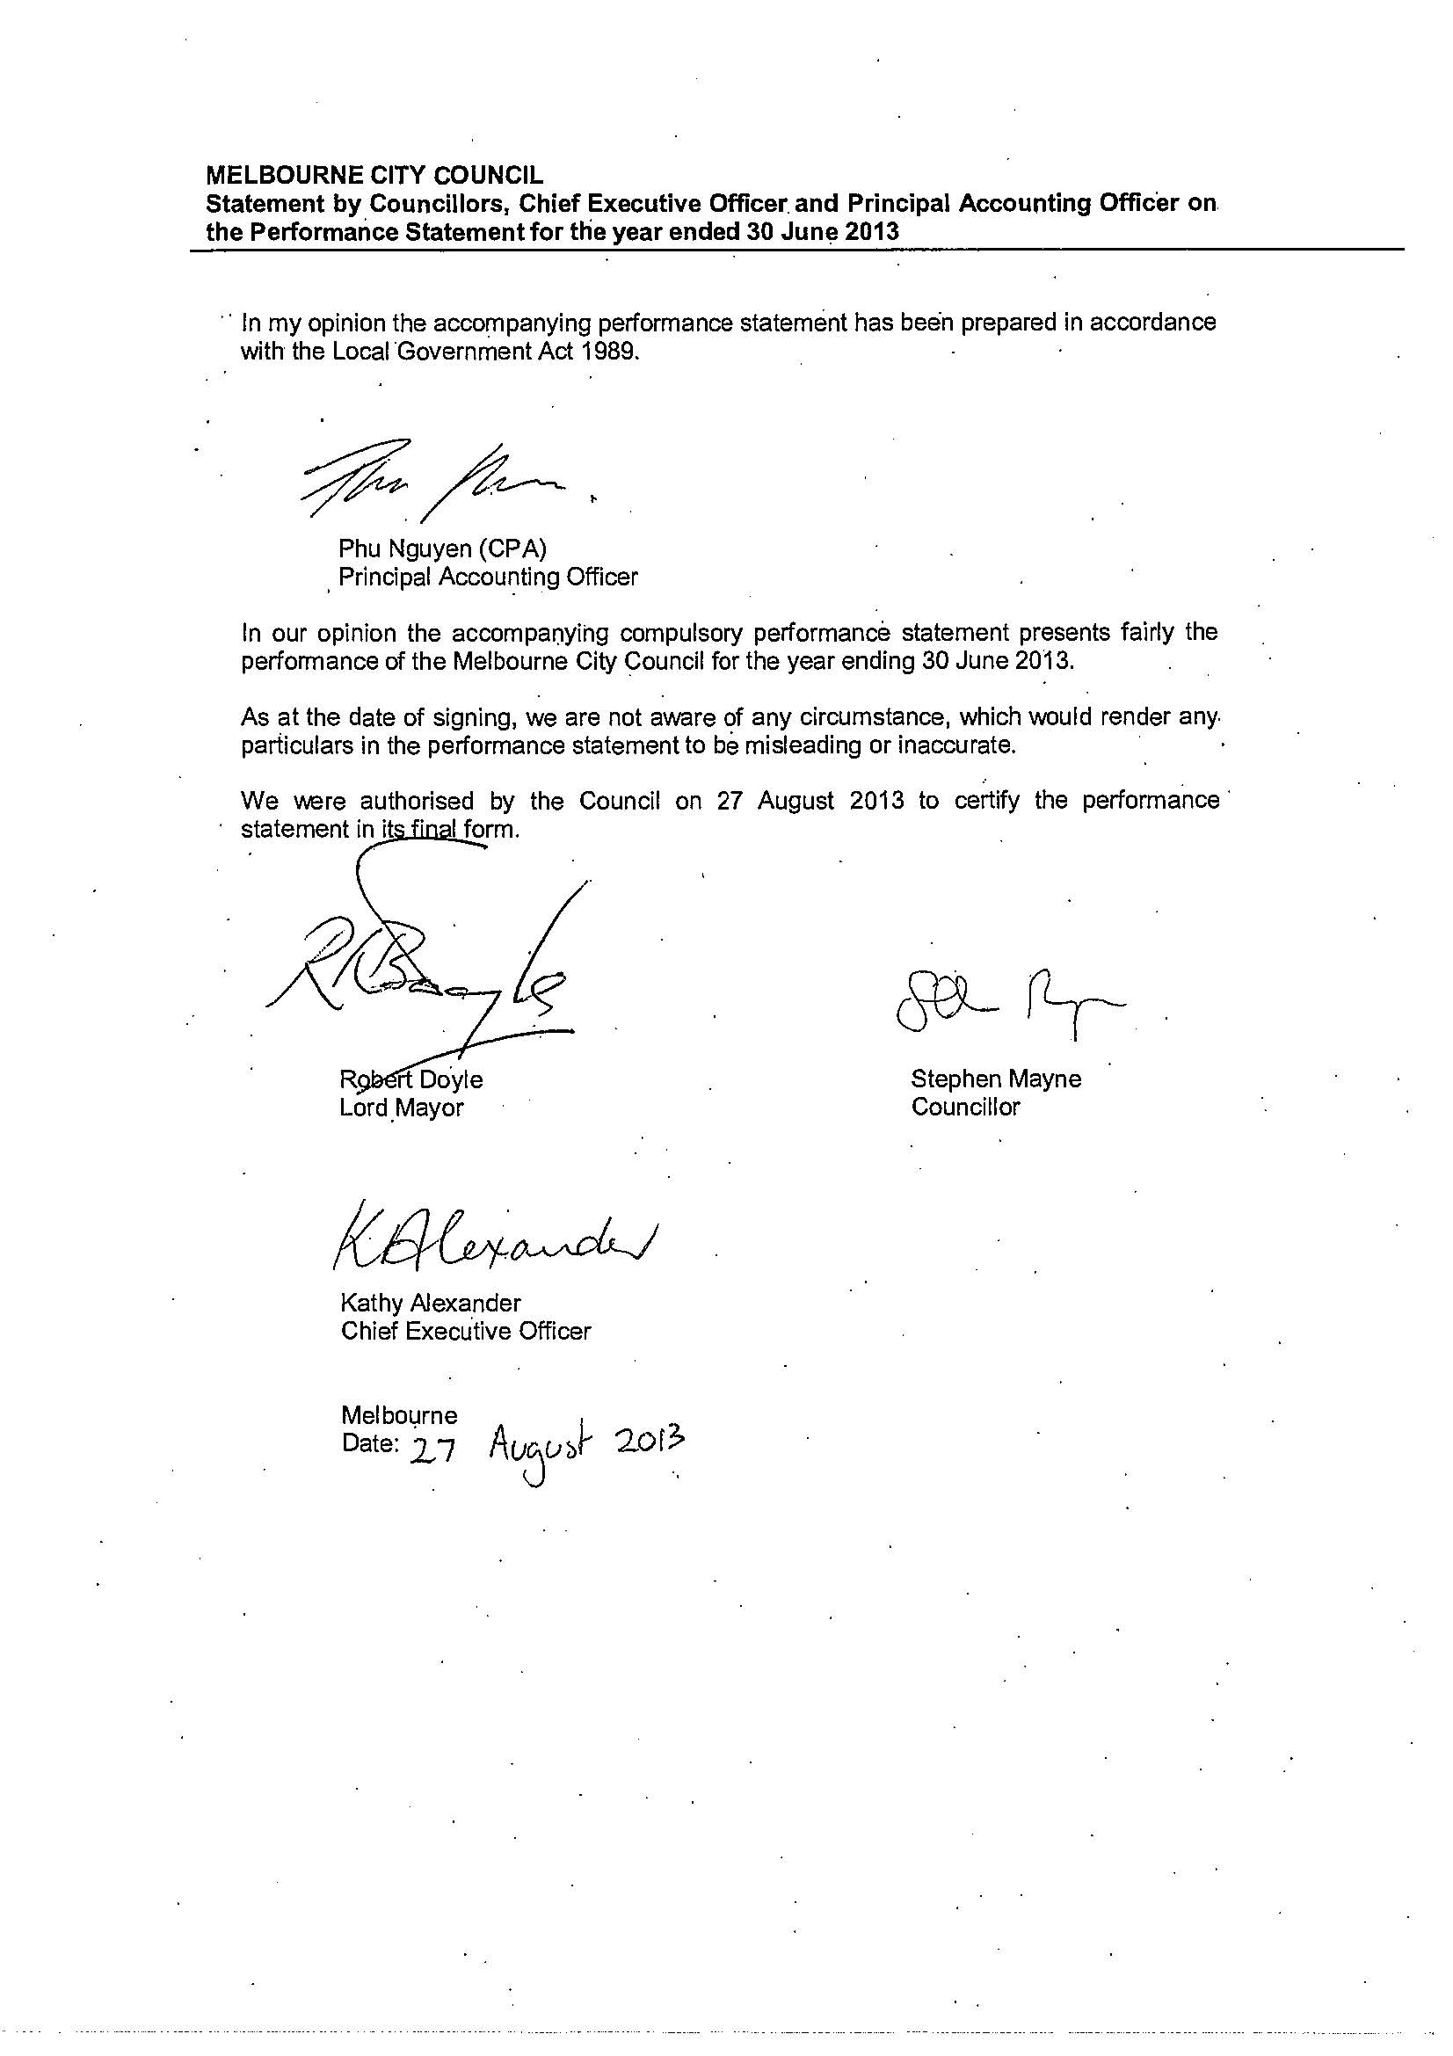
Signed statement

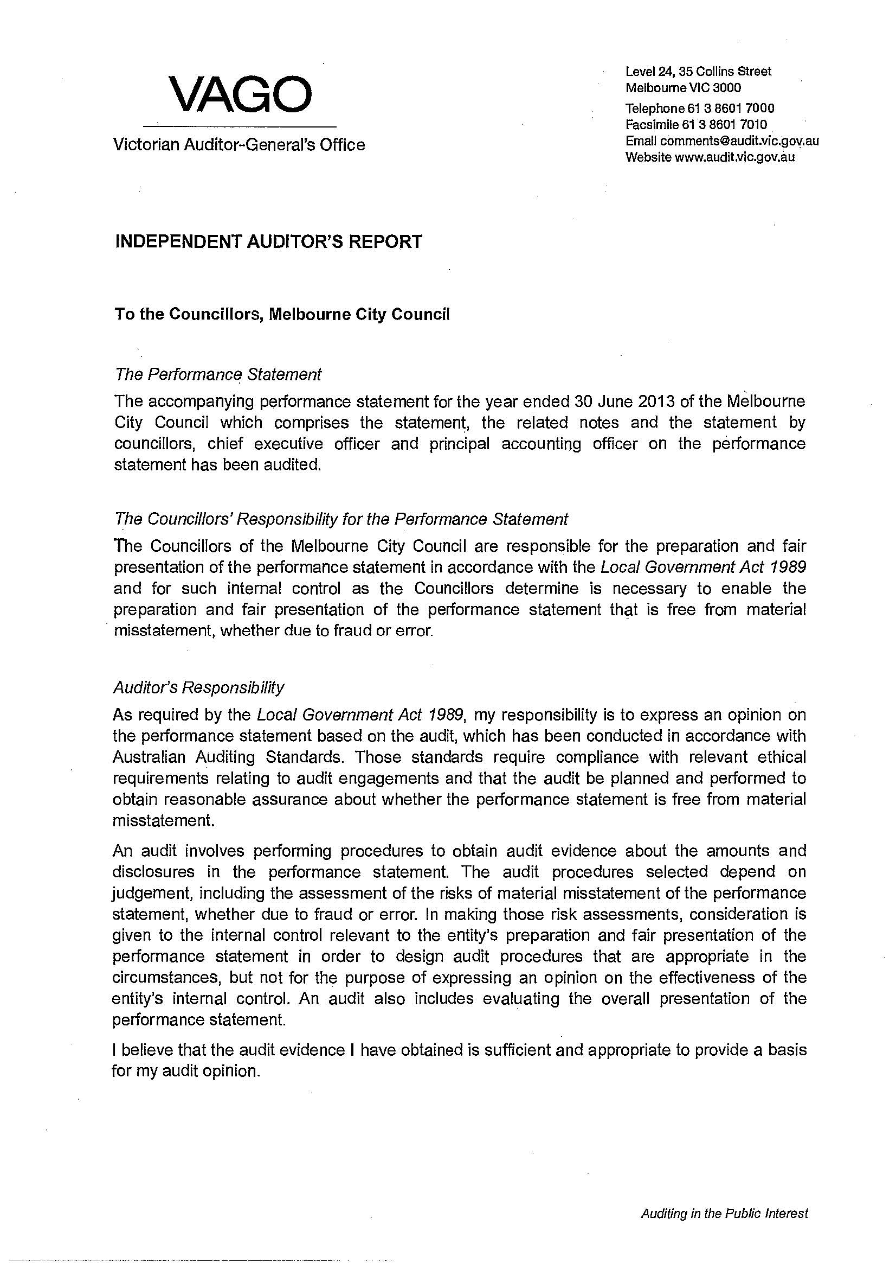
Independent Auditor’s Report
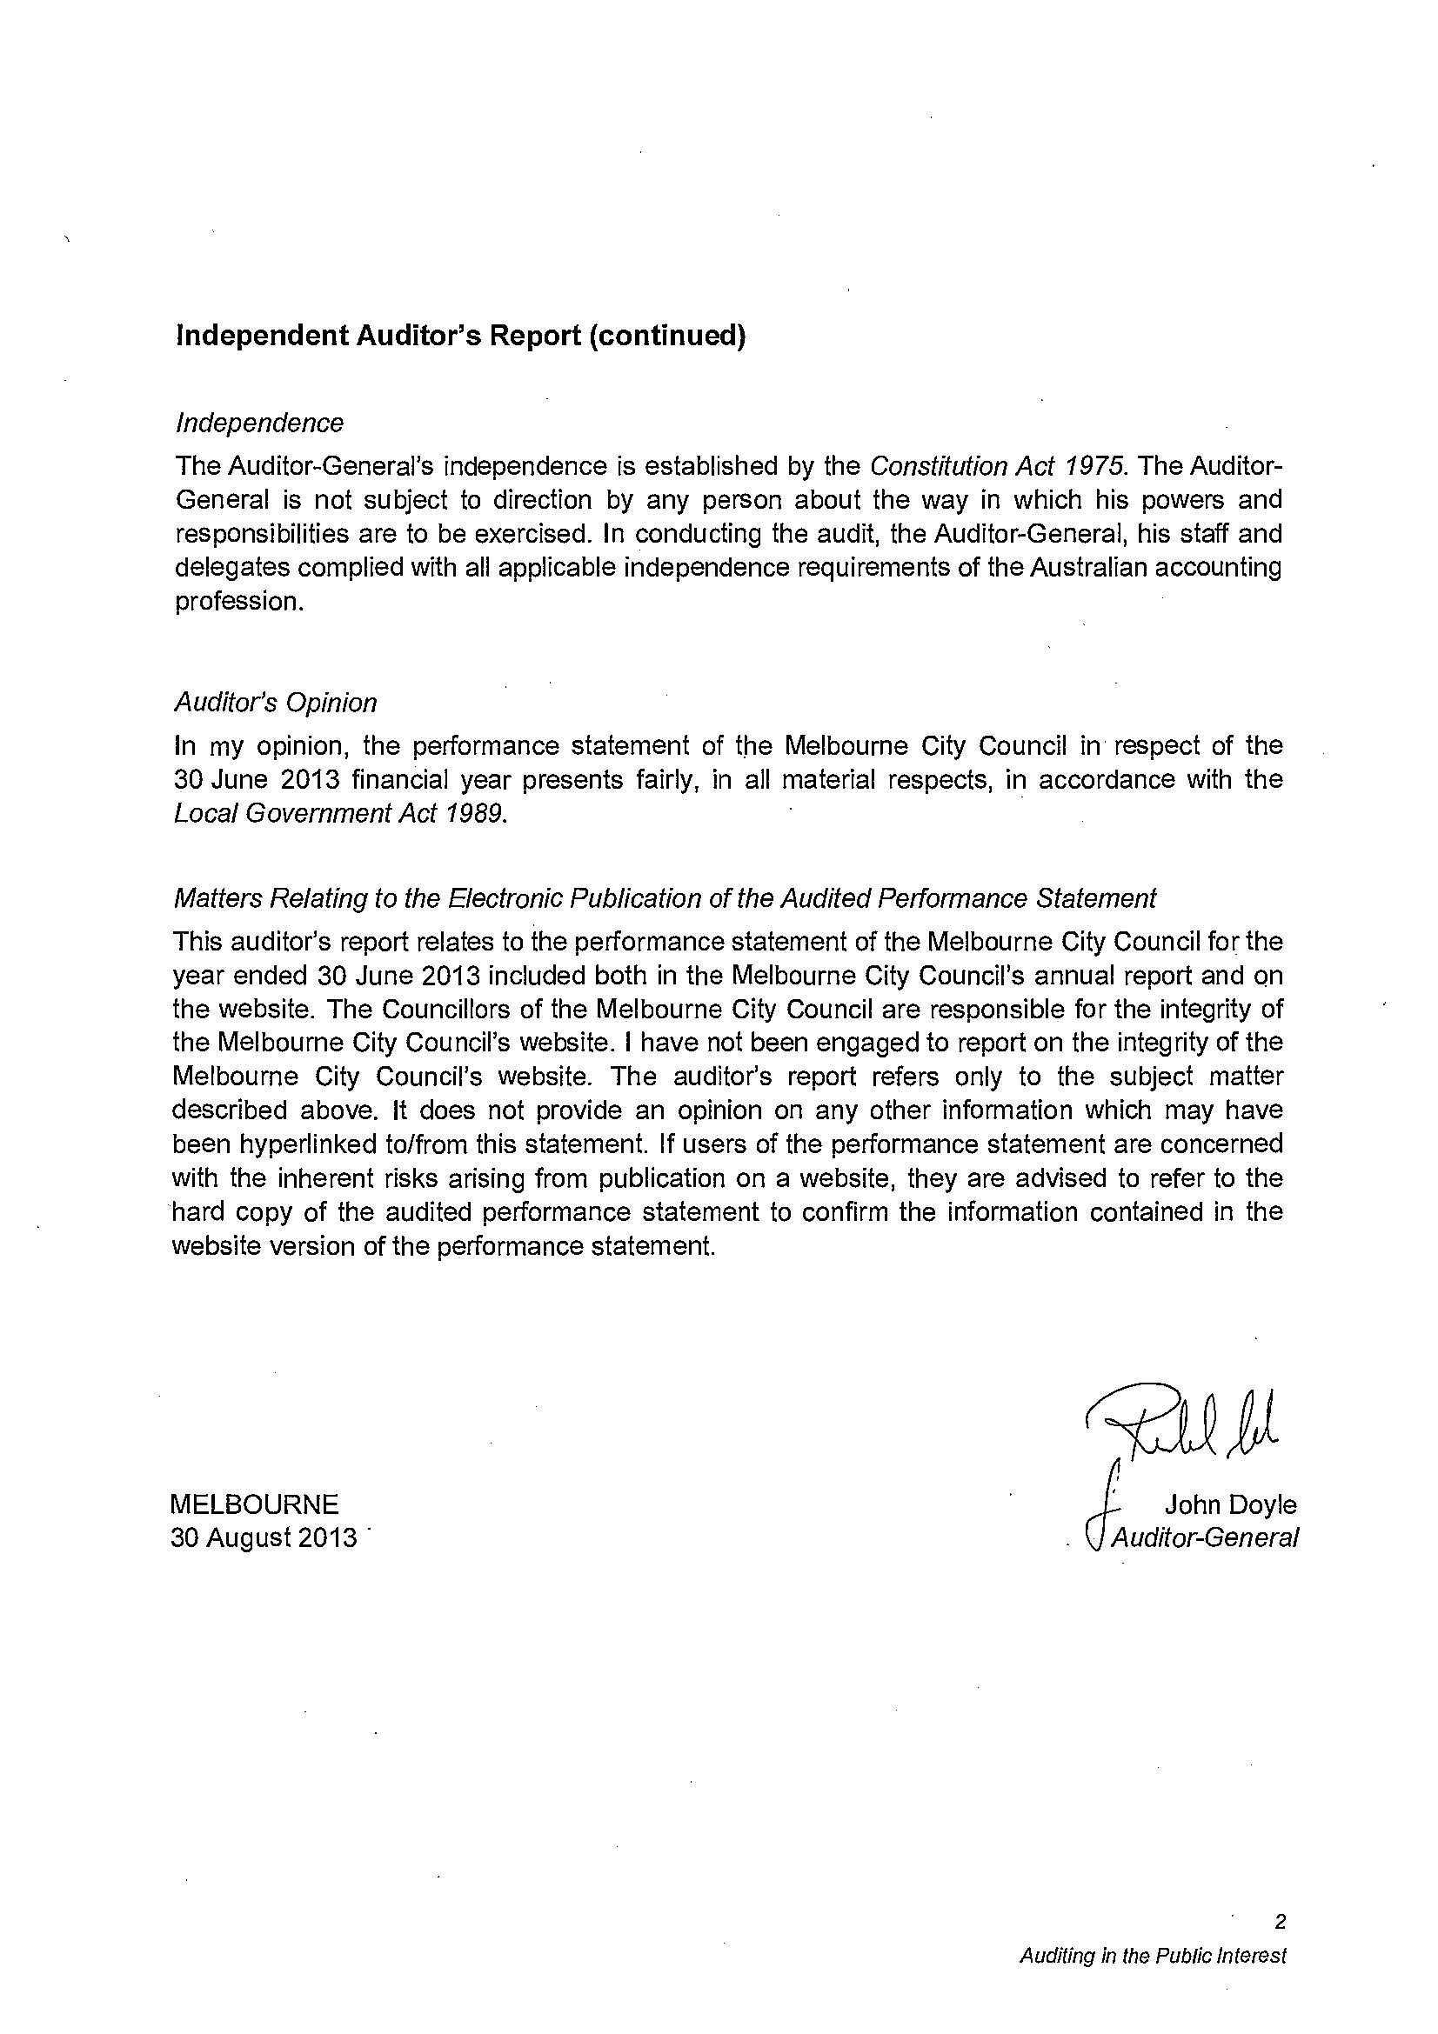

Victorian local government indicators

Indicator | Indicator | 2008–09 | 2009–10 | 2010–11 | 2011–12 | 2012–13
Overall performance  Community satisfaction rating for overall performance generally of Council | # | 66 | 68 | 70 | 66   | 67
Advocacy  Community satisfaction rating for the Council's advocacy and community representation on key local issues | # | 61 | 64 | 61 | 55   | 53
Engagement  Community satisfaction rating for the Council's engagement in decision-making on key local issues | $ | 59 | 62 | 59 | 56   | 55
All rates  Average rates and charges per assessment (all rates) | $ | $2,318 | $2,457 | $2,412 | $2,353 | $2,310
Residential rates  Average rates and charges per residential assessment | $ | $939 | $968 | $950 | $939 | $950
Operating costs  Average operating expenditure per assessment | $ | $4,333 | $4,214 | $4,227 | $4,130 | $4,052
Capital expenditure  Average capital expenditure per assessment | $ | $1,060 | $863 | $839 | $1,206 | $1,264
Infrastructure  Renewal gap | % | 70% | 76% | 73% | 97% | 86.7%
Renewal and maintenance gap | % | 72% | 79% | 77% | 97% | 88.8%
Debts  Average liabilities per assessment | $ | $989 | $817 | $1,039 | $1,174 | $978
Operating result  Operating results per assessment* | $ | $340 | $(360) | $474 | $364 | $581
 
In response to feedback from local councils, Local Government Victoria introduced methodological and content changes to the Community Satisfaction Survey in 2011–12. Methodological improvements to the Community Satisfaction Survey in 2011–12 and 2012–13 included increasing the sample size from the previous minimum of 350 respondents per municipality up to 400 respondents so the sample better reflects the demographic composition of a municipality. The survey also allows for respondents to be ‘residents over 18 years of age’ instead of restricting respondents to ‘head of household’. For these reasons, direct comparison with previous Community Satisfaction Survey results is not possible.

In both forms of the survey, the response to each of the standard 'scale' questions above is assigned a value. These values are then averaged across all respondents to create an 'index score'. However, the values assigned changed in 2012:

2010–11 Response scale and values
100 – Excellent: outstanding performance
80 – Good: a high standard
60 – Adequate: an acceptable standard
40 – Needs some improvement
20 – Needs a lot of improvement
Excluded – Don’t know / can’t say
2011–12 and later response scale and values
100 – Very good
75 – Good
50 – Average
25 – Poor
0 – Very poor

Excluded – Can't say

* Note: This represents the operating results per assessment as per the subtotal profit / loss for the period.

Global Reporting Initiative discussion and indicators
The Global Reporting Initiative (GRI) is a network-based organisation that produces a comprehensive sustainability reporting framework that is widely used around the world. The City of Melbourne has included GRI sustainability indicators as part of its performance measures since 2004–05.
The GRI’s principles of inclusiveness, relevance, sustainability context and completeness define the content of this report.
It is important to note that the GRI is a global framework that does not assume that reporting organisations have an established reporting process. The City of Melbourne’s annual report contents are substantially determined by the requirements of the Local Government Act 1989 (Vic). Like most local governments, the City of Melbourne has a long history of reporting both financial and non-financial performance to stakeholders. Many of the disclosures required as part of the GRI are also specified under the Act.
GRI Version G3.1 and G4
The City of Melbourne uses Version G3.1 of the framework, which sets out the principles and indicators that organisations can use to measure and report their economic, environmental, social, human rights, local community impacts and gender performance.
The GRI has recently released a new version of its framework, Version G4, and we are supportive of the new directions taken in this framework with its increased emphasis on only providing information that is critical to the business and stakeholders. The City of Melbourne has elected to continue working with G3.1 for this year’s annual report. We aim to adopt the G4 framework for the 2013–14 annual report. The transition to G4 will coincide with a deeper analysis of our sustainability reporting priorities.
Reading the GRI index
The GRI appears in this annual report as a list of indicators, each with a page reference to demonstrate where in the annual report the relevant data can be located.

GRI application level
‘Application levels’ were introduced with the release of GRI’s G3 guidelines in October 2006. The application level system provides organisations with a pathway towards continuous improvement of their sustainability reporting. The levels are intended to motivate reporters to enhance the quality of their reporting over time.
The application levels indicate the extent to which the G3.1 guidelines were applied in sustainability reporting. They communicate which part of the reporting framework was addressed – which set of disclosures – varying with the different levels. The levels do not give an opinion on the sustainability performance of the reporting organisation, the quality of the report, or on formal compliance with the G3.1 guidelines.
This report was prepared to meet the requirements of application level B under the GRI’s sustainability reporting guidelines, maintaining the standard of reporting and disclosure of previous years. To achieve a ‘plus’ rating (i.e. B+) organisations must seek external assurance by GRI-approved means. Given the level and cost of audit currently in place for the annual report as a whole, the City of Melbourne has chosen not to pursue further external verification of the data at this stage.
The application level table below lists the requirements for each application level. The City of Melbourne has prepared its GRI report to meet ‘B’ level requirements.

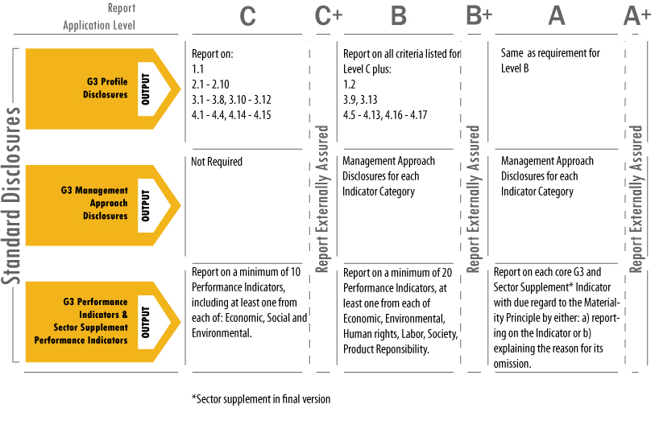

More information about the GRI is available at www.globalreporting.org

Global Reporting Initiative content table

GRI standard disclosure | Section / Page | GRI indicator
Strategy and analysis
Message from Lord Mayor and CEO | 8, 9 | 1.1
Goals and key achievements | 14–15 | 1.1
Risks and opportunities | 83 | 1.2
Respect for internationally-agreed standards | 3, 64 | 1.1
Organisational profile
Council profile, products, services and org diagram | 10–15, 68 | 2.1 – 2.10
Report parameters
Report profile | 2 | 3.1-3.4
Report scope and boundaries | 3 | 3.5-3.11
GRI context index | 112 | 3.12
Assurance | 3 | 3.13
Governance, commitment and engagement
Governance and risk management | 75–85 | 4.1 – 4.10
Commitment to external initiatives | 10–13 | 4.13
Stakeholder engagement | 73–74 | 4.14-4.17
Sustainable development policies | 41–49, 79–82 | 4.8
Economic performance indicators
Economic value generated and distributed | Financials | EC1
Risk and opportunities due to climate change | 43–45 | EC2
Significant financial contribution from government | Financials | EC4
Gross expenditure by type of payment and classification | Financials | EC8-EC9
Procurement policy | 79 | EC6
Economic, environmental and social criteria | 80 | EC5
Procurement practice and policy priorities | 79 | EC7
Environmental performance indicators
Energy | 46–49 | EN3-EN7
Water | 49 | EN9-EN10
Biodiversity | 46–49 | EN14
Emissions, effluents, and waste | 46–49 | EN16, EN18
Labour practices and decent work performance indicators
Employment, labour / management practices | 66–74 | LA1, LA2, LA4
OH&S, training and education, diversity and equal opportunity | 71–72 | LA6-LA14
Human rights performance indicators
Human rights policy and procedures training hours | 70, 72 | HR3
Society performance indicators
Local community | 24, 29, 37, 40, 53, 58, 64 | SO1
Corruption | 79 | SO2-SO4
Public policy | 10 | SO5
Compliance | 75, 79–82 | SO8
Product responsibility performance indicators
Marketing communications | 73–82 | PR6-PR8

Financial statements

Financial report overview

The City of Melbourne prides itself on being a transparent and accountable organisation. Our strong financial management and economic responsibility was once again acknowledged with a AAA/A-1+ credit rating from global ratings agency Standard & Poor’s.

The City of Melbourne was the only Australian council to achieve the top credit rating in 2013. Standard and Poor’s said that the City of Melbourne had shown strong financial leadership.

Operating result
Overall we remain in a strong financial position at the end of the 2012–13 financial year. Total revenue for 2012–13 was $387.56 million. The bulk of this figure came from rates, with the remaining portion attributed to grant and subsidies, parking fees, fines, subsidiary revenue, sales and recoveries, interest and other income streams.

This revenue was offset by the organisation’s total expenses of $357.06 million. The list of expenses includes employee costs, materials and services, insurance, grants and contributions, taxes and levies, depreciation and amortisation, maintenance and other costs.

Overall our underlying surplus was $789,000. This surplus reflects our objective to invest as much as we can in our community, while remaining fiscally responsible.

Detailed information relating to our financial performance can be found in the standard income statement.

Financial overview
The 2012–13 financial reports for the City of Melbourne provide the final chapter in the four-year story of the Council Plan 2009–13.

Cash balance

Our cash balance has remained fairly steady over the last five years, a testament to our strong financial leadership.

Cash balance ($ million)

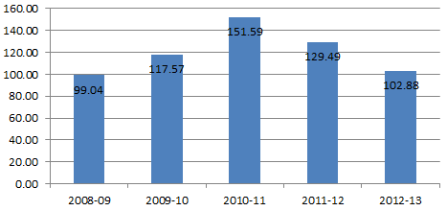

Council works

Our total council works program spend includes maintenance, new and upgrade works and renewal and refurbishment works, as well as carry forward (the cost of projects not quite finished in the previous financial year). Over the four years since the introduction of the Council Plan 2009–13 a substantial $454.86 million was spent on council works program.

Council works ($ million)

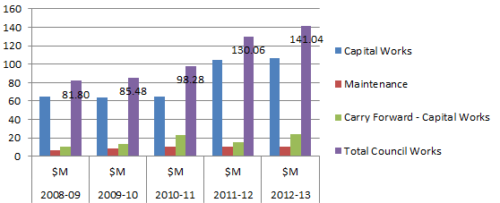

Net surplus

Our underlying surplus assisted us in funding our capital works projects over the last four years, reflecting our increasing investment in building and maintaining our infrastructure for the community.

Net surplus ($ million)

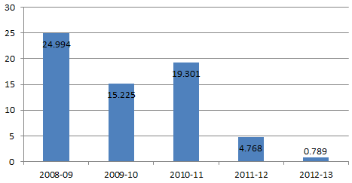

Net assets

Our Balance Sheet represents the financial position of the City of Melbourne. In 2012–13 our net assets increased by $231.5 million to $3.42 billion. These figures represent the total value of City of Melbourne-owned assets, such as property, plant and infrastructure, investments, cash and receivables, minus any liabilities such as payables, employee entitlements and provisions.

Net assets ($ million)

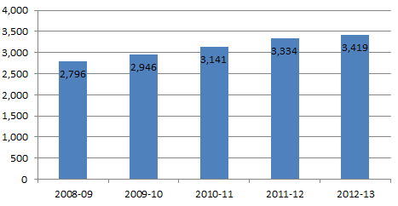

As part of our commitment to increase the level of transparency in our financial reporting, we have also included a list of the City of Melbourne’s top 20 properties by value, which represent a significant portion of our net assets. All valuations as at 30 June 2013.
Address | Consolidated  value  $million
Royal Park, Flemington Road, Parkville | $307.8
Fawkner Park, 24-88 Commercial Road, South Yarra | $189.6
Fitzroy Gardens, 230-298 Wellington Parade, East Melbourne | $162.9
Kings Domain, Alexandra Avenue, Melbourne | $130.9
Princes Park, 200-590 Royal Parade, Carlton North | $97.1
Melbourne Town Hall and Administration, 90-130 Swanston Street, Melbourne | $81.1
Queen Victoria Market, 65-159 Victoria Street, Melbourne | $80.8
Council House 2, 218-242 Little Collins Street, Melbourne | $51.1
Flagstaff Gardens, 309-311 William Street, West Melbourne | $49.3
Birrarung Marr, Batman Avenue, Melbourne | $41.1
Carlton Gardens South, Victoria Street, Carlton | $36.3
Alexandra Gardens, St Kilda Road, Melbourne | $33.7
Queen Victoria Gardens, St Kilda Road, Melbourne | $32.7
Alexandra Park, Alexandra Avenue, Melbourne | $31.7
Carlton Gardens North, 1-111 Carlton Street, Carlton | $29.6
Treasury Gardens, 2-18 Spring Street, East Melbourne | $29.4
Carlton Baths, 216-248 Rathdowne Street, Carlton | $29.0
Council House, 196-212 Little Collins Street, Melbourne | $25.9
J.J. Holland Park, 67-121 Kensington Road, Kensington | $23.1
1City Square, 99-209 Collins Street, Melbourne | $19.3

The land values included in the City of Melbourne asset register relate to land holdings both owned and controlled by the City of Melbourne. The organisation has significant crown land holdings controlled on behalf of the Crown, via various structures including crown grants, committees of management and other reservations.
The consolidated values contained within this list include both land and building asset values applicable to the specific sites. City of Melbourne is required to value land and building assets pursuant to the provisions of AASB 116. The ‘fair value’ applicable to land value assessments, specifically parks and alike, are significantly adjusted against full market value reflecting legislative provisions, site control, use restrictions and other limitations directly associated with their public use.

Reading our financials

Our financial statements provide an insight into the City of Melbourne’s financial health.

Our financial statements show:
- how the City of Melbourne and its subsidiaries performed during the year
- the value of assets held by the City of Melbourne
- the ability of the City of Melbourne to pay its debts.

What’s in the financial statements?

The financial statements consist of four financial reports, explanatory notes supporting the reports and endorsement from the Melbourne City Council and the Victorian Auditor-General.

The four financial reports are:
- income statement
- balance sheet
- statement of cash flows
- statement of changes in equity.

The explanatory notes detail the City of Melbourne’s accounting policies and the make-up of values contained in the statements.

How are the financial statements audited?

These financial statements are prepared in accordance with the Local Government Act 1989 (Vic) and the Australian Accounting Standards.

They are audited by the Victorian Auditor-General, approved in principle by the City of Melbourne’s Audit Committee and by Melbourne City Council. These auditing measures ensure the information provided is correct.

The City of Melbourne has received a clear audit of its financial statements for 2012–13.
Standard statements
Annual Report 2012–13
Budget v Actual

Note 1. Significant accounting policies

The significant policies adopted in the preparation of these Standard Statements are:
(a) Basis of preparation
The Standard Statements of the Council are special-purpose financial reports that consist of a Standard Income Statement, Standard Balance Sheet, Standard Cash Flow Statement and Standard Statement of Capital Works. These special purpose financial reports were prepared in accordance with the Local Government Act 1989 (Vic) and the Local Government (Finance and Reporting) Regulations 2004. These special purpose financial reports do not form part of Council's general purpose financial reports.

Standard income statement
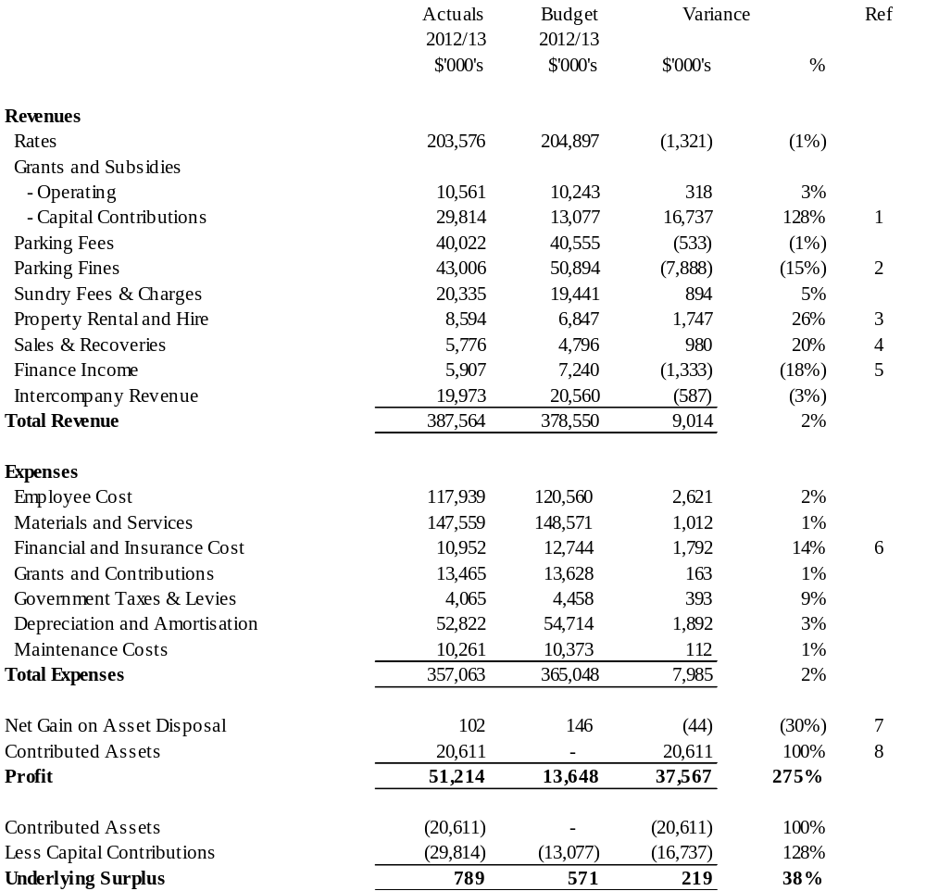

Standard statements
for the year ended 30 June 2013

Standard income statement – comparison report

Ref. | Item | Commentary
1 | Capital and asset contributions | Mainly due to additional public open space capital contributions ($5.44 million) and external capital contributions for Northbank Promenade development ($8.97 million).
2 | Parking fines | The number of parking infringements issued was lower than budgeted due to more compliance by the public. This is partially offset by lower finance cost (see Ref 6 below).
3 | Property rental and hire | Mainly due to the revaluation of Council’s investment properties and unbudgeted marina fees.
4 | Sales and recoveries | Mainly due to additional recoveries received in relation to Grants in Kind revenue ($0.66 million, fully offset from Grant in Kind payments).
5 | Finance income | Mainly due to lower cash balances and lower returns on invested funds. The official RBA cash rate has decreased by 1.50 per cent since the development of the budget.
6 | Financial and insurance cost | Mainly due to lower doubtful parking infringement provisions in line with lower parking infringements being issued ($1.91 million) (See Ref 1 above).
7 | Net gain on asset disposal | Minor variance due to lower gain on sale of plant and equipment.
8 | Contributed assets | Primarily due to contributed infrastructure assets from completed developments in Docklands.

Standard statements
for the year ended 30 June 2013

Standard balance sheet
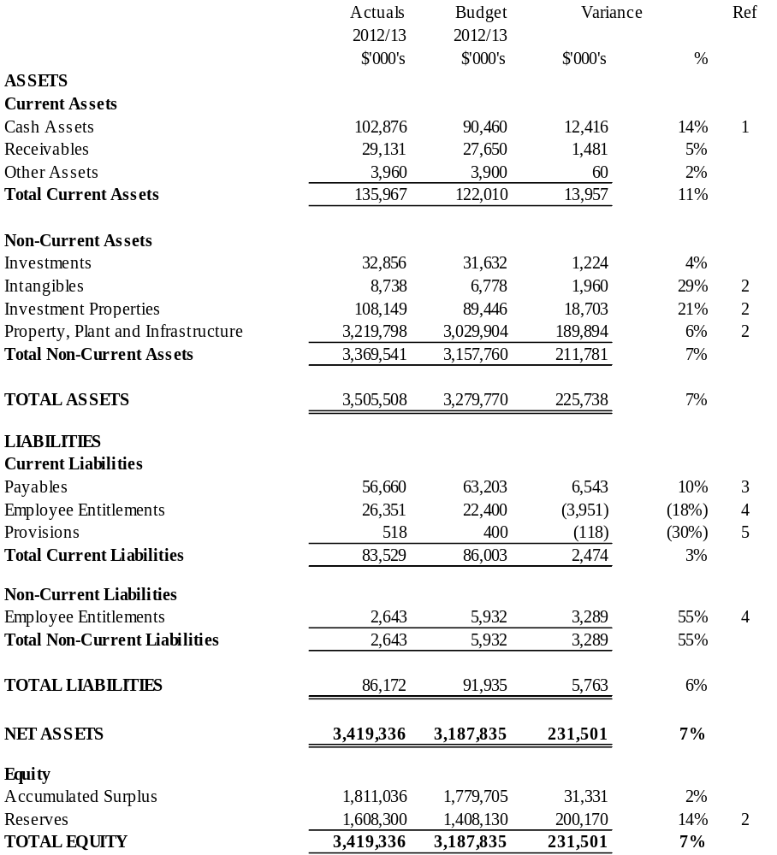
Standard statements
for the year ended 30 June 2013

Standard balance sheet – comparison report

Ref. | Item | Commentary
1 | Cash assets | The higher cash balance is mainly due to higher than anticipated capital works carried forward.
2 | Intangibles, property, plant and infrastructure and investment Properties | The higher balances are due to revaluation increments in assets such as land buildings and infrastructure following valuations conducted in 2012 and 2013. Intangible assets increase relates to the capitalisation of IT software.
3 | Payables | The lower payables primarily due to lower operating accruals than budgeted.
4 | Employee entitlements | Total employee entitlements are higher than budget due to higher provision of annual leave which is partially offset by lower long service leave provisions.
5 | Provisions | Slightly higher than budgeted provisions including insurance claims.

Standard statements
for the year ended 30 June 2013

Standard statement of cash flows (reconciliation)

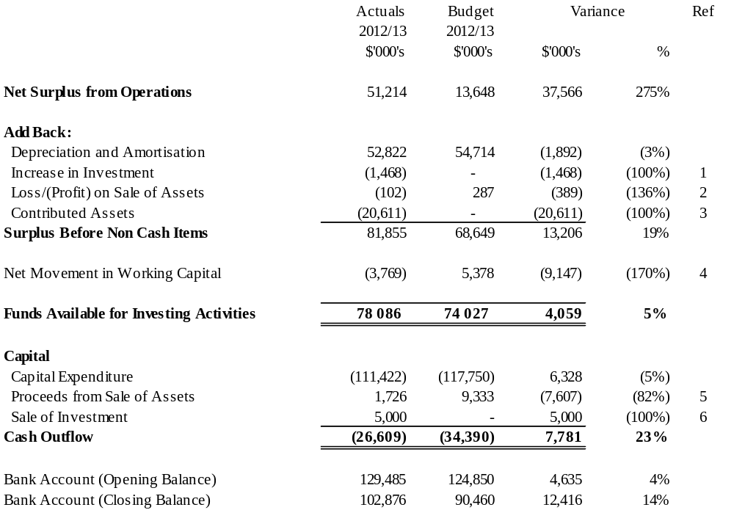
Standard statements
for the year ended 30 June 2013

Standard statement of cash flows (reconciliation) – comparison report

Ref. | Item | Commentary
1 | Increase in investment | The revaluation of Council’s investment properties has resulted in a non-cash gain.
2 | Loss/(profit) on sale of assets | Minor variance due to disposal of plant and equipment.
3 | Contributed assets | Primarily due to contributed infrastructure assets from completed Docklands developments.
4 | Net movement in working capital | The net movement in working capital reflects a decrease in creditors due to a lower level of accrued expenditure and higher creditors’ payments.
5 | Proceeds from sale of assets | Lower than budgeted proceeds from the sale of Council assets.
6 | Sale of investment | Return of share capital from the Melbourne Wholesale Fish Market Pty Ltd.

Standard statements
for the year ended 30 June 2013

Standard statement of cash flow
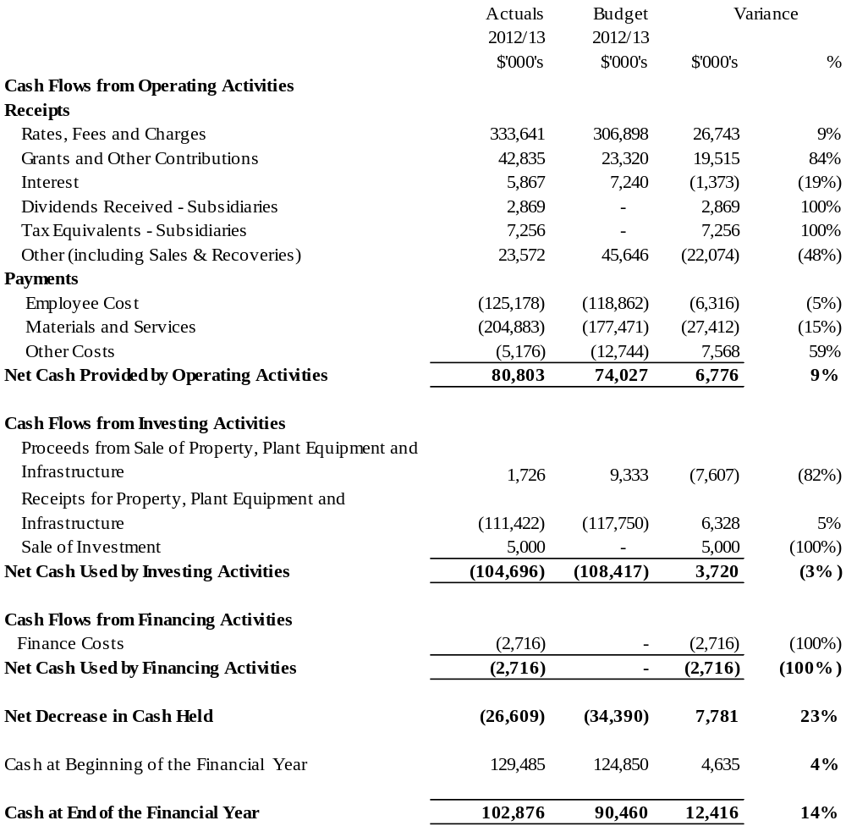

Standard statements
for the year ended 30 June 2013

Standard statement of capital works

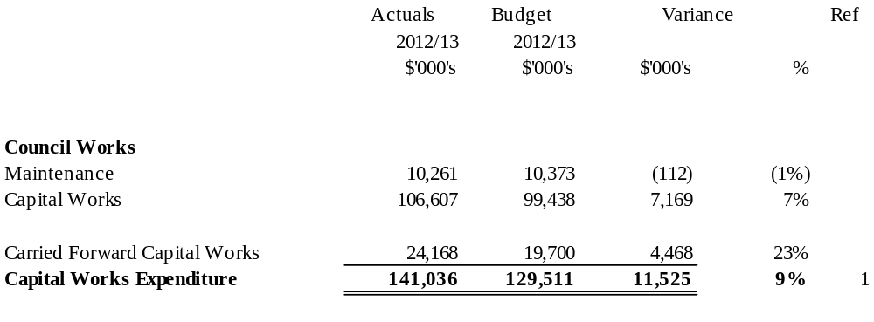

Standard statement of capital works – comparison report

Ref. | Item | Commentary
1 | Capital works expenditure | The value of capital and maintenance works completed for 2012–13 is $116.87 million. A carry forward of $24.17 million into 2013–14 is required to complete the program.  The major projects within the carry forward are $3.40 million in respect to World Trade Centre and $3.17 million for Fitzroy Gardens stormwater harvesting and new depot.

Financial report
for the year ended 30 June 2013

Prepared in accordance with the Local Government Act 1989 (Vic), Local Government (Finance and Reporting) Regulations 2004, and applicable Australian Accounting Standards.

ABN: 55 370 219 287

CONTENTS Page

Financial report
Comprehensive income statement 126
Balance sheet 127
Statement of changes in equity 128
Statement of cash flows 129

Notes to and forming part of the Financial Report
Note 1 Significant accounting policies 130
Note 2 Operating result attributable to functions/activities 139

Revenues
Note 3 Revenues 141

Expenses
Note 4 Expenses 143

Assets
Note 5 Trade and other receivables 145
Note 6 Inventories 146
Note 7 Other assets 146
Note 8 Other financial assets 146
Note 9 Property, plant, equipment & infrastructure 147
Note 10 Intangible assets 153
Note 11 Investment property 156

Liabilities
Note 12 Trade and other payables 157
Note 13 Employee benefits 157
Note 14 Provisions 157

Equity
Note 15 Reserves 158

Other Disclosures
Note 16 Gain/(Loss) on sale of fixed assets 159
Note 17 Cash flow information 160
Note 18 Leases and commitments 161
Note 19 Contingent liabilities 162
Note 20 Defined benefits superannuation funds 163
Note 21 Related party transactions 166
Note 22 Financial instruments 168
Note 23 Financial ratios 175
Note 24 Business combinations 176
Note 25 Events occurring after balance date 176

Signed statement 177
Auditor-General’s Report on the Financial Report 178

Comprehensive income statement
for the year ended 30 June 2013

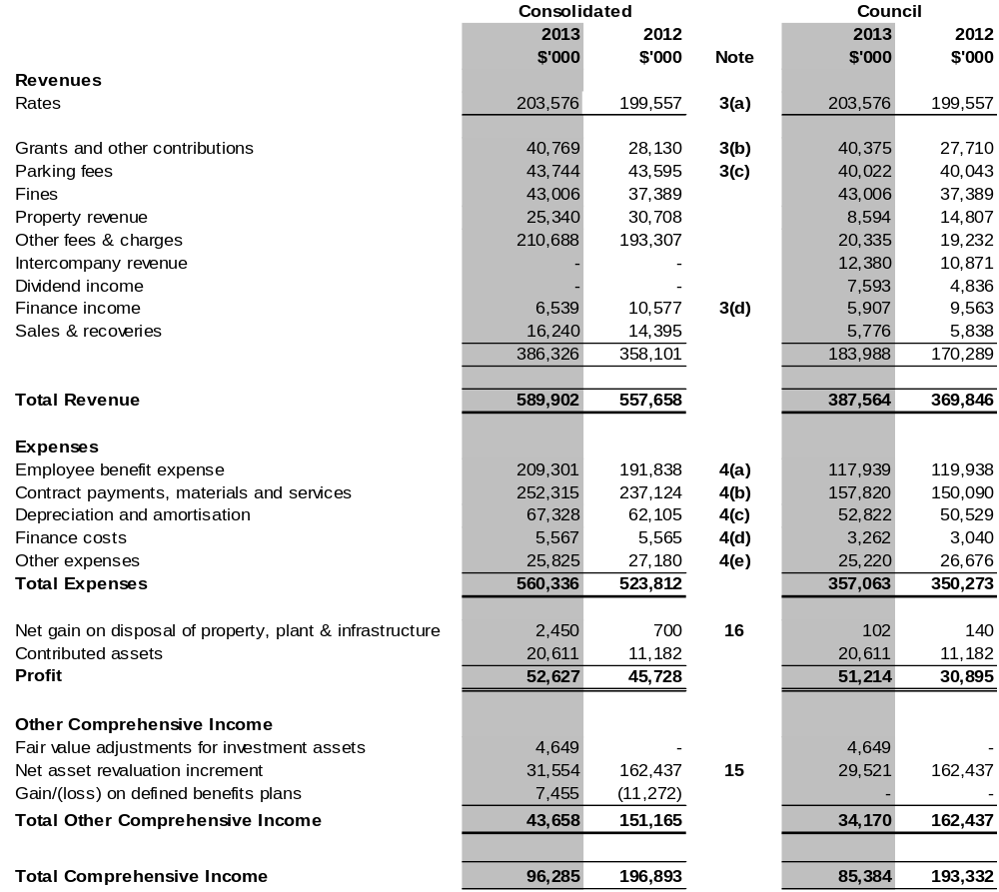
The comprehensive income statement should be read in conjunction with the accompanying notes to the Financial Report.

Balance sheet
as at 30 June 2013
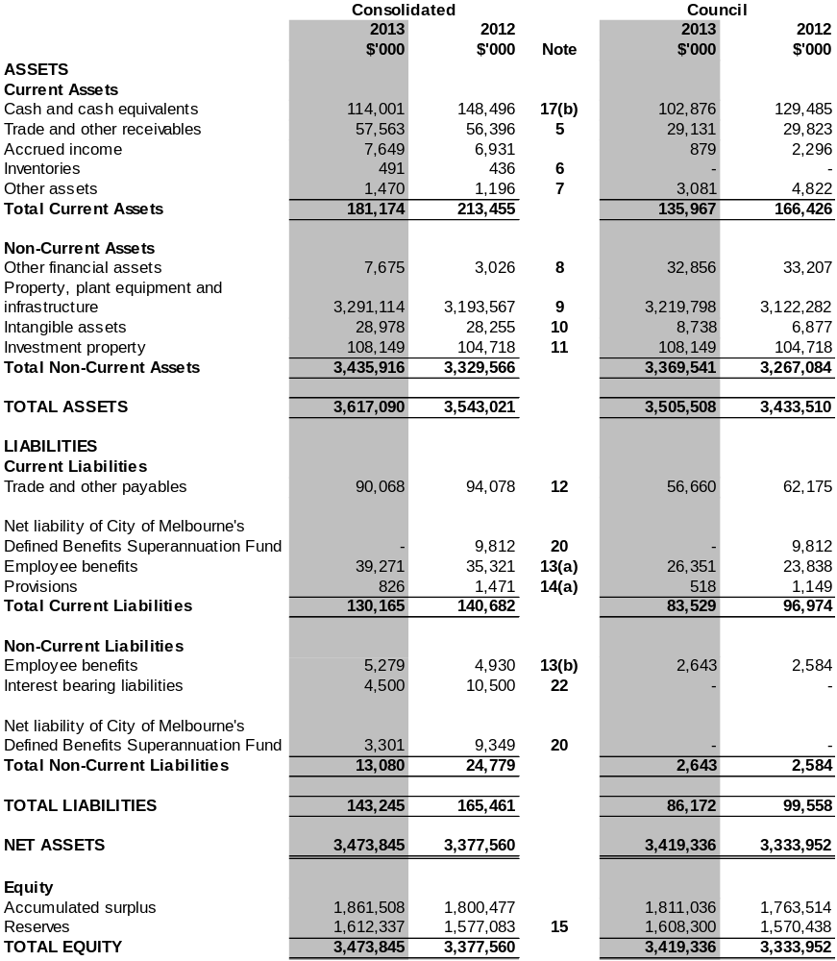

The balance sheet should be read in conjunction with the accompanying notes to the Financial Report.

Statement of changes in equity
for the year ended 30 June 2013
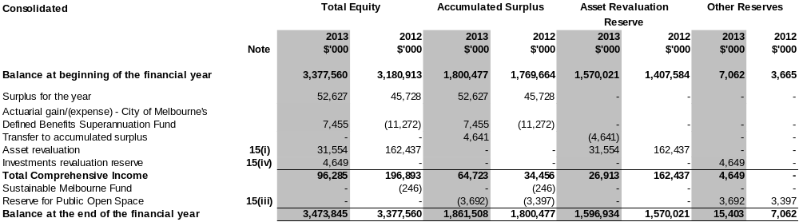
The statement of changes in equity (Consolidated) should be read in conjunction with the accompanying notes to the Financial Report.

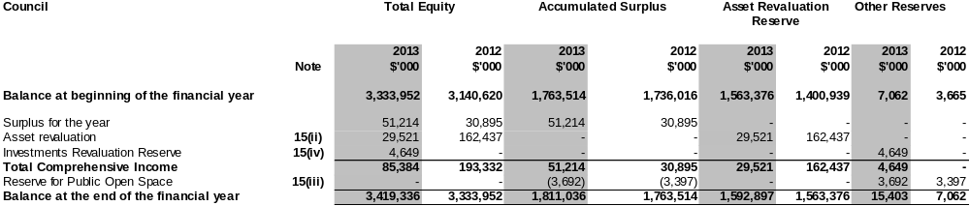
The statement of changes in equity (Council) should be read in conjunction with the accompanying notes to the Financial Report.

Statement of cash flows
for the year ended 30 June 2013

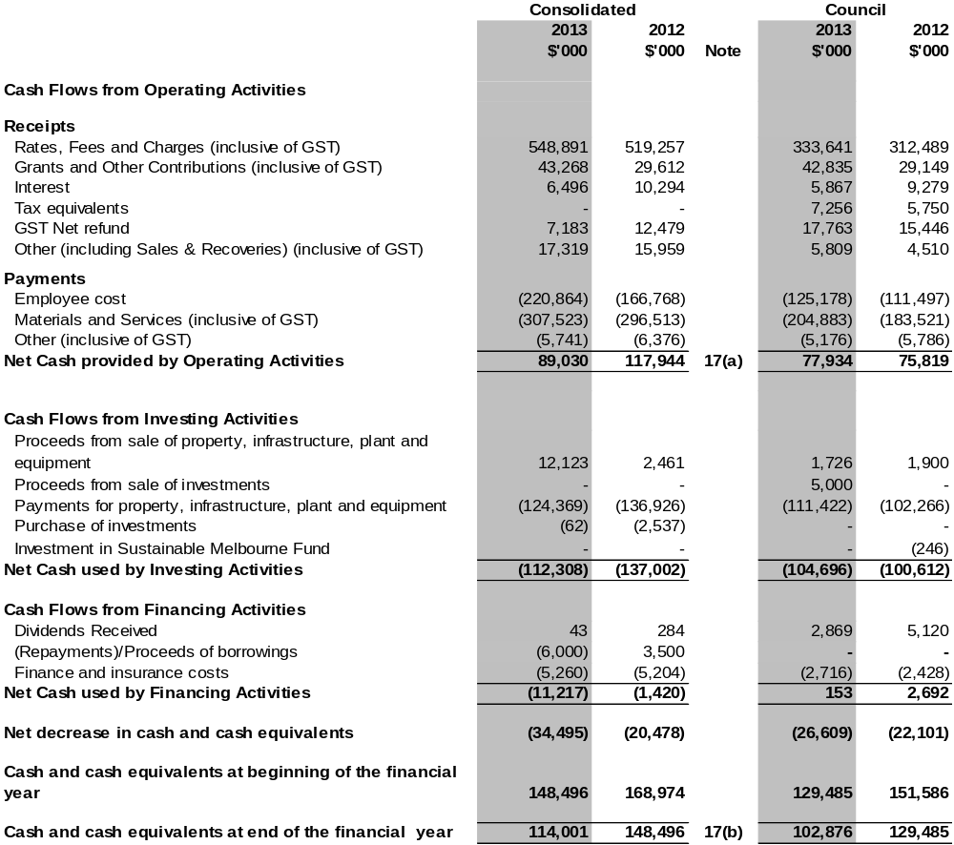

The statement of cash flows should be read in conjunction with the accompanying notes to the Financial Report.

Notes to the financial statements
for the year ended 30 June 2013

Note 1. Significant accounting policies

These financial statements are for the entity the Melbourne City Council (the "Council") and controlled entities. The Council is a body corporate, domiciled in Australia, constituted pursuant to the Local Government Act 1989 (Vic) to provide for the peace and good government of its municipal district. The Town Hall is located at 90-120 Swanston Street, Melbourne Victoria 3000.

The purpose of the Council is to:
- promote the social, economic and environmental viability and sustainability of the municipal district
- manage resources efficiently and effectively.

The Council's external auditors, advisers and bankers are:
- external Auditor – Victorian Auditor-General's Office
- internal Auditor – Deloitte Touché Tohmatsu
- solicitors – Hunt & Hunt, Ashurst, Maddocks
- bankers – Westpac Banking Corporation.

The Council's website is: www.melbourne.vic.gov.au.

The consolidated financial statements of the Council as at and for the year ended 30 June 2013 comprise the Council and its subsidiaries and the Council's interest in associated and jointly-controlled entities.

The significant policies adopted in the preparation of this Financial Report are:

(a) Basis of preparation
These financial statements are general purpose financial statements which were prepared in accordance with Australian Accounting Standards and Interpretations issued by the Australian Accounting Standards Board and the Local Government Act 1989 (Vic), including the requirements of the Local Government (Finance and Reporting) Regulations (Vic) 2004. The Melbourne City Council and Sustainable Melbourne Fund are not-for-profit entities and CityWide Service Solutions Pty Ltd and its subsidiaries and Queen Victoria Market Pty Ltd are for-profit entities for the purpose of preparing the financial statements.

The financial statements were prepared on an accrual basis and on the historical cost basis except for the following:

- investment property is measured at fair value
- land and buildings are measured at fair value.
The functional and presentation currency of the Council and consolidated entity is Australian dollars.

(b) Principles of consolidation
The consolidated results in this Financial Report include all funds through which the Council controls resources to carry on its functions. In the process of reporting on the Council as a consolidated unit, all intra and inter entity balances and transactions were eliminated.
In the Council's financial statements, investments in subsidiaries are carried at cost.
CityWide Service Solutions Pty Ltd and its subsidiaries and the Queen Victoria Market Pty Ltd are wholly-owned subsidiaries of the Council incorporated in Australia and are included in the consolidated Financial Report.
The Sustainable Melbourne Fund Trust is wholly controlled trust of the Council and is included in the consolidated Financial Report.

Council has deregistered its interest in Melbourne Wholesale Fish Market Pty Ltd in February 2013.

MAP’s Group Pty Ltd (Trading as Procurement Australia) is not consolidated as Council does not have a controlling interest.

(c) Business combinations
Acquisitions of businesses are accounted for using the acquisition method. The consideration transferred in a business combination is measured at fair value which is calculated as the sum of the acquisition-date fair values of assets transferred to the Consolidated Entity, liabilities incurred by the Consolidated Entity to the former owners and the equity instruments issued by the Consolidated Entity in exchange for control of the acquiree.

Acquisition-related costs are recognised in profit or loss as incurred.

At the acquisition date, the identifiable assets acquired and the liabilities assumed are recognised at their fair value at the acquisition date, except that:

- deferred tax assets or liabilities and liabilities or assets related to employee benefit arrangements are recognised and measured in accordance with AASB 112 ‘Income Taxes’ and AASB 119 ‘Employee Benefits’ respectively
- assets (or disposal groups) that are classified as held for sale in accordance with AASB 5 ‘Noncurrent Assets Held for Sale and Discontinued Operations’ are measured in accordance with that Standard.

Goodwill is measured as the excess of the sum of the consideration transferred, the amount of any non-controlling interests in the acquiree, and the fair value of the acquirer's previously held equity interest in the acquiree (if any) over the net of the acquisition-date amounts of the identifiable assets acquired and the liabilities assumed.

Where the consideration transferred by the Consolidated Entity in a business combination includes assets or liabilities resulting from a contingent consideration arrangement, the contingent consideration is measured at its acquisition-date fair value. Changes in the fair value of the contingent consideration that qualify as measurement period adjustments are adjusted retrospectively, with corresponding adjustments against goodwill. Measurement period adjustments are adjustments that arise from additional information obtained during the ‘measurement period’ (which cannot exceed one year from the acquisition date) about facts and circumstances that existed at the acquisition date.

The subsequent accounting for changes in the fair value of contingent consideration that do not qualify as measurement period adjustments depends on how the contingent consideration is classified. Contingent consideration that is classified as equity is not remeasured at subsequent reporting dates and its subsequent settlement is accounted for within equity. Contingent consideration that is classified as an asset or liability is remeasured at subsequent reporting dates in accordance with AASB 139 “Financial Instruments: Recognition and Measurement”, or AASB 137 ‘Provisions, Contingent Liabilities and Contingent Assets’, as appropriate, with the corresponding gain or loss being recognised in profit or loss.

(d) Taxation
The Council is exempt from the payment of income tax and capital gains tax. Payments for Fringe Benefits Tax and Goods and Services Tax (GST) are made in accordance with the relevant legislation. Payments for payroll tax are only made by the trading entities controlled by the Council.

The wholly-owned subsidiaries are subject to the Council’s tax equivalent policy. Where the subsidiary is exempt from certain taxes it pays an equivalent of the tax to Council.

Revenues, expenses and assets are recognised net of the amount of GST, except where the amount of GST incurred is not recoverable from the Australian Taxation Office. In these circumstances the GST is recognised as part of the cost of acquisition of the asset or as part of an item of the expense.

Cash flows are presented in the cash flow statement on a gross basis, except for the GST component of investing and financing activities, which are shown in the operating activities.

(e) Fees, fines, charges, rates, grants, and other contributions
Fees and charges are recognised as revenue when services are provided or the cash is received, whichever occurs first. Fines are recognised as revenue when the penalty is imposed.
Rates, grants, and other contributions are recognised as revenues when the Council obtains control over the related assets. Control over assets acquired from rates is obtained at the commencement of the rating period or, where earlier, upon receipt of the rates. Control over granted assets is normally obtained upon their receipt or upon prior written notification that a grant is secured.
Where contributions recognised as revenues during the financial year were obtained on the condition that they be expended in a particular manner or used over a particular year, and those conditions were undischarged as at the reporting date, the nature of any amounts pertaining to those undischarged conditions are disclosed in Note 3(e). That note also discloses the amount of contributions recognised as revenues in previous financial years, which were expended in respect of the Council’s operations during the current financial year.
Tax equivalents and dividends from subsidiaries are recognised as income when received or amounts were declared at the respective subsidiary company’s board meeting.
Finance income is recognised when it is earned and includes interest on investments, interest on rates and bad debt recoveries
Sales and recoveries are recognised when received and included merchandise sales, sale of publications and sundry sales not elsewhere included.
Revenue arising from service contracts is recognised by reference to the stage of completion of the contract, unless the outcome of the contract cannot be reliably estimated. The stage of completion is determined by reference to the proportion that costs incurred to date bear to the estimated total costs of the contract. Administrative overheads are not included in the costs of the contract for this purpose. Where the outcome of a contract cannot be reliably estimated, contract costs are recognised as an expense as incurred, and where it is probable that the costs will be recovered, revenue is recognised to the extent of costs incurred.

(f) Intangibles
(i) Goodwill
Where an entity or operation is acquired, the identifiable net assets acquired are measured at fair value. Fair value is defined in note 1(l)(ii). The excess of the fair value of the cost of acquisition over the fair value of the identifiable net assets acquired is brought to account as goodwill. Goodwill is not amortised, but tested for impairment annually.

(ii) Software
Software, that is not an integral part of the related hardware, is classified as intangibles, recorded at cost and amortised on a straight line basis over a 5-year period.

 | Goodwill | Software
Useful lives | Indefinite | Finite
Method used | Not depreciated or revalued | 5 years – straight line
Internally generated / acquired | Acquired | Acquired
Impairment test / recoverable amount test | Reviewed annually for indication of impairment | Amortised method reviewed at each financial year-end; reviewed annually for indication of impairment

(g) Employee benefits
- Wages, salaries, annual and long service leave
Liabilities for employees’ entitlements to wages and salaries, annual leave, and other employee benefits which are expected to be paid or settled within 12 months of balance date are accrued at nominal amounts calculated on the basis of 2012–13 wage and salary rates and payroll based on costs in accordance with AASB 119 ‘Employee Benefits’.
Liabilities for other employee benefits which are not expected to be paid or settled within 12 months of balance date are accrued as per AASB 119 at the present values of future amounts expected to be paid based on 3.75 per cent per annum projected weighted average increase in wage and salary rates and payroll based on costs over an average period of five years. Present values are calculated using the government guaranteed securities rates with similar maturity terms.
For employee entitlements, long service leave entitlements for employees with over seven years of service and all annual leave entitlements are classified as current. Long service leave entitlements for employees with less than 7 years of service is classified as non-current. Long service leave expected to be taken in the next 12 months is recorded at nominal value and long service leave not expected to be taken over the next 12 months is recorded at present value.

- Superannuation – defined contribution plans
A defined benefit contribution plan is a post-employment benefit plan under which an entity pays fixed contributions into a separate entity and will have no legal or constructive obligation to pay further amounts. Obligations for contributions to defined contribution plans are recognised as an employee benefits expenses in profit or loss in the periods during which the services are rendered by employees.
- Superannuation – defined benefits plans
A defined benefit plan is a post-employment benefit plan other than a defined contribution plan. The Council's net obligation in respect of defined benefits pension plans is calculated separately for each plan by estimating the amount of future benefit that employees have earned in return for their service in the current and prior periods; that benefit is discounted to determine its present value. Any unrecognised past service costs and the fair value of any plan assets are deducted. The discount rate is the yield at the reporting date on Government bonds that have maturity dates approximating the terms of the Council's obligations.

The calculation is performed periodically by a qualified actuary using the projected unit credit method. When the calculation results in a benefit to the Council, the recognised asset is limited to the total of any unrecognised past service costs and the present value of the economic benefits available in the form of any future refunds from the plan or reduction in future contributions to the plan. In order to calculate the present value of economic benefits, consideration is given to any minimum funding requirements that apply to any plan in the Council. An economic benefit is available to the Council if it is realisable during the life of the plan, or on settlement of the plan liabilities. When the benefits of a plan are improved, the portion of the increased benefit related to past service by employees is recognised in the profit or loss on a straight-line basis over the average period until the benefits become vested. To the extent that the benefits vest immediately, the expense is recognised immediately in profit or loss.

The Council recognises all actuarial gains and losses arising from defined benefits plans in other comprehensive income and all expenses relating to defined benefit plans in employee benefits expense in profit or loss.

The Council recognises gains and losses on the curtailment or settlement of a defined benefit plan when the curtailment or settlement occurs. The gain or loss on curtailment comprises any resulting change in the fair value of plan assets, change in the present value of defined benefit obligation and any related actuarial gains and losses and past service cost that had not previously been recognised.

However, where the Council participates in multi-employer defined benefits plans for which sufficient information is not available to use defined benefits accounting as set out above, it accounts for contributions to those plans as if they were defined contributions plans.

Details of these arrangements are set out in Note 20 “Defined benefits superannuation funds”.

(h) Depreciation
Depreciation measures the service potential of buildings, infrastructure assets, plant and equipment consumed during the year. Interest in trees, land and artworks are not depreciated as they are considered to have either unlimited useful lives or to be self-generating assets. Depreciation is recognised on a straight-line basis over the useful lives of the assets to the economic entity. Depreciation rates are reviewed each financial year. The depreciation periods for the major classes of assets are shown below represent the maximum useful life.
 | 2012–13 | 2011–12
Buildings | 50 years | 50 years
Roads & laneways – seal | 20 years | 20 years
Roads & laneways – substructure | 90 years | 90 years
Heritage assets | 100 years | 100 years
Promenades and wharves | 100 years | 100 years
Footpaths | 50 years | 50 years
Kerb & channel | 50 years | 50 years
Bridges | 94 years | 94 years
Drains | 185 years | 185 years
Plant & equipment | 20 years | 20 years
Furniture & fittings | 10 years | 10 years
Irrigation systems | 20 years | 20 years
Parks & gardens infrastructure | 50 years | 50 years
Statues, sculptures & artworks | 100 years | 100 years
Other structures | 50 years | 50 years
Assets are depreciated from the date of acquisition or, in respect of internally constructed assets, from the time an asset is completed and held ready for use.

(i) Cash and cash equivalents
For purposes of the balance sheet, cash and cash equivalents includes short term deposits, bank bills, transferrable certificates of deposit and fixed interest securities which are readily convertible to cash on hand and are subject to an insignificant risk of changes in value, net of bank overdrafts. Short-term deposits are stated at cost. Fixed interest securities are valued at net fair value. Interest is recognised when earned.

(j) Receivables and payables
Trade and other receivables are initially recognised at fair value and subsequently at recoverable amount. They are classified as current assets except where the maturity is greater than 12 months after the reporting period date, in which case they are classified as non-current.

Trade and other payables are recognised for amounts to be paid in the future for goods and services received, whether or not billed. Trade and other payables are recognised initially at fair value and subsequently at amortised cost.

(k) Impairment of financial assets
A financial asset not carried at fair value through profit or loss is assessed at each reporting date to determine whether there is objective evidence that it is impaired. A financial asset is impaired if objective evidence indicates that a loss event has occurred after the initial recognition of the asset, and that loss event had a negative effect on the estimated future cash flows of that asset that can be reliably measured. Objective evidence that financial assets are impaired can include indications of significant financial difficulties, debtor bankruptcy, financial reorganisation or default in payment. In addition, for an equity security, a significant or prolonged decline in its fair value below its cost is objective evidence of impairment.

All individually significant trade and other receivables are assessed for specific impairment. All individually significant receivables and those that are not individually significant are then assessed for impairment on a collective basis, by grouping those with similar risk characteristics. An impairment loss in respect of a financial asset measured at amortised costs is calculated as the difference between its carrying amount and the present value of the estimated future cash flows discounted at the asset's original effective interest rate. Losses are recognised in profit or loss and reflected in an allowance account against receivables. When a subsequent event (e.g. repayment) causes the amount of the impairment loss to decrease, the decrease in impairment loss is reversed through profit or loss. No allowance for impairment is made for rate debtors because the debts are collectable against the property.

(l) Property, plant, equipment and infrastructure
(i) Capital and recurrent expenditure
As a general rule, material expenditure incurred in the purchase or development of assets is capital expenditure. Expenditure necessarily incurred in either maintaining the operational capacity of the non-current asset or ensuring that the original life estimate of the asset is achieved, is considered maintenance expenditure and is treated as an expense as incurred. Items of a capital nature with a total value of less than $2000 are treated as an expense.
(ii) Acquisition
Acquisitions of assets are initially recorded at cost. Cost is determined as the fair value of the assets given as consideration plus costs incidental to their acquisition, including architectural and engineering fees and all other establishment costs.
The Council’s policy is to capitalise and depreciate individual capital expenditure over $2000.
Fair value means the amount for which an asset could be exchanged between a knowledgeable willing buyer and a knowledgeable willing seller in an arm’s length transaction.
(iii) Construction work in progress
The cost of property, plant, equipment & infrastructure constructed by Melbourne City Council includes the cost of materials and direct labour and an appropriate proportion of overheads.
(iv) Leases
The Council does not currently use any finance lease arrangements. In respect of operating leases, where the lessor effectively retains substantially the entire risks and benefits incidental to ownership of the leased property, the payments are charged to expense over the lease term.
(v) Asset revaluation
Revaluation increments are credited directly to the asset revaluation reserve, except that, to the extent that an increment reverses a revaluation decrement in respect of that class of asset previously recognised as an expense, the increment is recognised as revenue.
Revaluation decrements are recognised immediately as expenses, except that, to the extent that an increment balance exists in the asset revaluation reserve in respect of the same class of assets, they are debited directly to the asset revaluation reserve. Revaluation increments and decrements are offset against one another within a class of non-current assets, but not otherwise.
(vi) Valuation
All land and buildings are valued at fair value, being market value assuming the highest and best use permitted by the relevant land use planning provisions or existing public use whichever is the greater.
Freehold land reserved for public open space is valued at a discount, being 20 per cent of market value.
All improvements on Crown Land are valued on the basis of fair value, being either market value or written down replacement cost for special purpose buildings, Note 9 “Property, plant, equipment and infrastructure”.
Infrastructure assets are valued at fair value, being replacement cost less accumulated depreciation.
(vii) Impairment
At each reporting date, the Council reviews the carrying value of its assets to determine whether there is any indication that these assets were impaired. If such an indication exists, the recoverable amount of the asset, being the higher of the asset’s fair value less costs to sell and depreciated replacement cost, is compared to the assets carrying value. Any shortfall of the assets carrying value over its recoverable amount is expensed to the comprehensive income statement.
(m) Non-cash donations
Non-cash donations in excess of $2000 value are recognised as revenue.
(n) Rounding
Unless otherwise stated, amounts in the Financial Report are rounded to the nearest thousand dollars.
(o) Web site costs
Costs in relation to web sites controlled by the Council are charged as expenses in the period in which they are incurred unless they relate to the acquisition of an asset, in which case they are capitalised and amortised over their period of expected benefit.
(p) Allocation between current and non-current
With the exception of employee entitlements, the determination of whether an asset or liability is current or non-current, consideration is given to the time when each asset or liability is expected to be realised or paid. The asset or liability is classified as current if it is expected to be turned over within the next 12 months, being the Council’s operational cycle.

(q) Investment property
Investment property is held to generate long-term rental yields. All tenant leases are entered into at an arm’s length basis.
Investment property is carried at fair value, being market value assuming the highest and best use permitted by the relevant land use planning provisions or existing public use whichever is the greater. Any changes to fair value are recorded in the comprehensive income statement. Investment properties are not depreciated.
(r) Interest-bearing liabilities
All loans and borrowings are initially recognised at fair value, net of transaction costs incurred. Borrowings are subsequently measured at amortised cost. Any difference between the proceeds (net of transaction costs) and the redemption amount is recognised over the life of the instrument using the effective interest rate method. Borrowings are derecognised from the Balance Sheet when the obligation specified in the contract is discharged, cancelled or expires. The difference between the carrying amount of the borrowing derecognised and the consideration paid is recognised as other income or finance costs. Borrowings are classified as current liabilities unless unconditional right to defer settlement of the liability exists for at least 12 months after the reporting date.
(s) Restatement of prior year amounts
The Council has restated the prior year comparative amounts for Senior Officers Remuneration in Note 21(c) “Related Party Transactions”. The restatement reflects an increase in number of senior officers reported as a result of disclosing full salary package remuneration which eliminates timing issues of payments and staff that commence and terminate employment during the year.
The reported number of senior officers has increased to 109 in 2012 previously stated as 55. The total salary reported for senior officers has increased to $17.473 million in 2012 previously stated as $9.461 million.
The reported number of responsible persons has decreased to 10 in 2012 previously stated as 11. The total salary reported for responsible officers has decreased to $1.007 million in 2012 previously stated as $1.051 million.
(t) Income received in advance
A liability is recognised in respect of revenue that is reciprocal in nature to the extent that the requisite service has not been provided at balance date in relation to fee for services.
(u) Pending Accounting Standards
The following Australian Accounting Standards were issued or amended and were adopted where applicable to the Council.

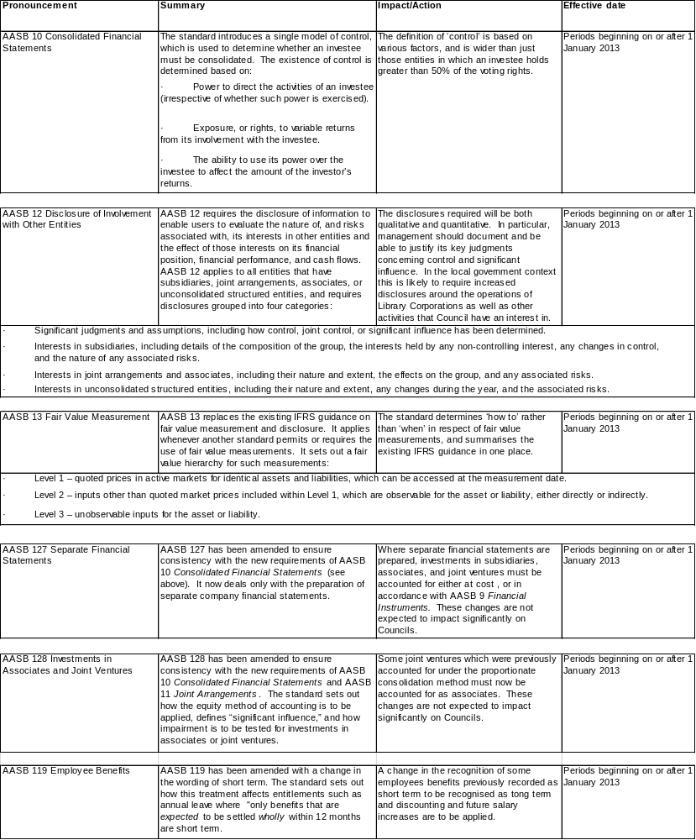

(v) Critical accounting judgements and key sources of estimation uncertainty
In application of the Council's policies, Council is required to make judgements, estimates and assumptions about carrying values of certain assets and liabilities that are not readily apparent from other sources. The estimates and associated assumptions are based on historical experience and other factors that are considered to be relevant. Actual results may differ from these estimates. The estimates and underlying assumptions are reviewed on an ongoing basis. Revisions to accounting estimates are recognised in the period of the revision and future periods if the revision affects both current and future periods.
Information about critical assumptions and estimation uncertainties that have a significant risk of resulting in a material adjustment within the next financial year are included in the following notes:
Note 9 – Property, plant & equipment and infrastructure (fair value measurement)
Note 10 – Intangible assets (goodwill impairment assessment)
Note 11 – Investment property (fair value measurement)
Note 20 – Defined benefits superannuation funds (measurement of plan assets and liabilities).

Note 2. Operating result attributable to functions / activities (consolidated)

(a) Revenues and expenses were attributed to the following functions.

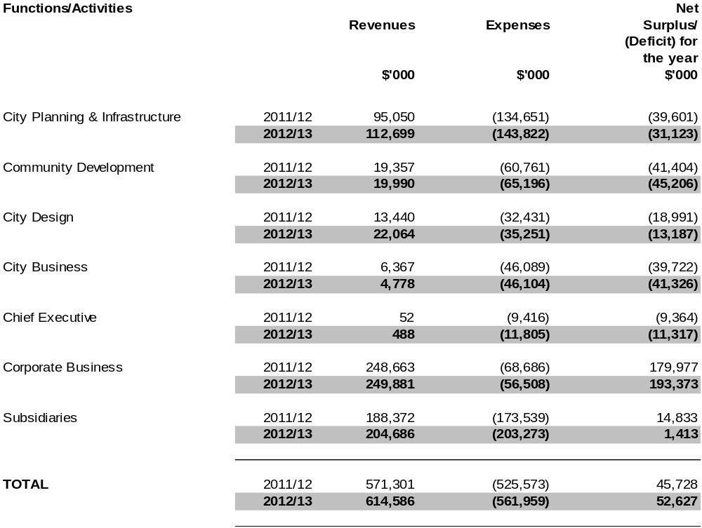

(b) A brief description of the goal of each function is as follows:

City Planning & Infrastructure
Advises the Council on city planning for the sustainable development of Melbourne through research, policy development, program and infrastructure delivery and planning.

Community Development
Provides a range of services, specific programs and recreation services for residents and visitors, contributing to building strong local communities that are inclusive and supportive. This, with the delivery of cultural programs and the management of the City’s cultural infrastructure, enhances the Council’s reputation as a safe, attractive, liveable and accessible city. The Division is also responsible for providing a direct customer liaison, information and advocacy service and driving the organisation's approach to the delivery of high quality customer service.

City Design

Responsible on behalf of the Council for providing urban design policy, advice, design, project management and management of parks and reserves.

City Business
Provides leadership in events management, communications and marketing, promoting tourism within the city and providing guidance to business and international interaction.

Chief Executive
To ensure a well-managed and leading organisation through the delivery of effective and accountable governance and business processes.

Corporate Business

To provide a range of quality support functions to the Council. This assists the Council in providing the highest standard of services to the city.

Subsidiaries include the following entities:

CityWide Service Solutions Pty Ltd and its controlled entities Sterling Group Services Pty Ltd and AWD Earthmoving Pty Ltd.
To meet the contract service needs of local government, other governments, and private and public sector corporations by providing a comprehensive range of quality, physical services at competitive rates.

Queen Victoria Market Pty Ltd
To ensure the market maintains and enhances an industry reputation as Australia’s foremost leading market, whilst meeting world’s best practice standards.

Sustainable Melbourne Fund Trust
The Sustainable Melbourne Fund (SMF) is a self-sustaining fund set up by the Council which invests funds in projects with environmental benefits to the city. The projects may extend beyond the boundaries of the Council to the broader state of Victoria, reflecting the position of Melbourne as the capital city of Victoria.
These entities support the Council in providing services to the community.

Significant Interests:
The Council has a majority ownership of the MAPS Group Ltd (Trading as Procurement Australia) through its holdings, however due to the structure of the company the Council does not have a majority of voting rights.
The Council and the Victorian Government have a 50 per cent shareholding in Regent Management Company Pty Ltd. The Company was incorporated to oversee the reconstruction of the Regent Theatre, operate as landlord of the Regent Theatre and to enter into a refurbishment agreement for the restoration and lease of the theatre.

Notes to the financial statements
for the year ended 30 June 2013

Note 3. Revenues

(a) Rates
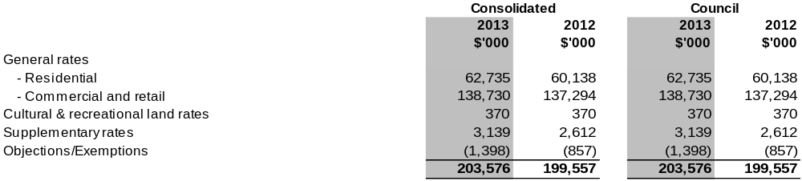

The Council uses ‘net annual value’ as the basis of valuation of all properties within the municipal district. The net annual value of a property approximates the annual net rental for a commercial property and 5 per cent of the capital improved value for a residential property.

The date of the general valuation of land for rating purposes within the municipal district was 1 January 2012 and the valuation first applied to the rating period commencing 1 July 2012. The valuation for rating purposes is performed on a two-year cycle.

(b) Grants and other contributions were received in respect of the following:

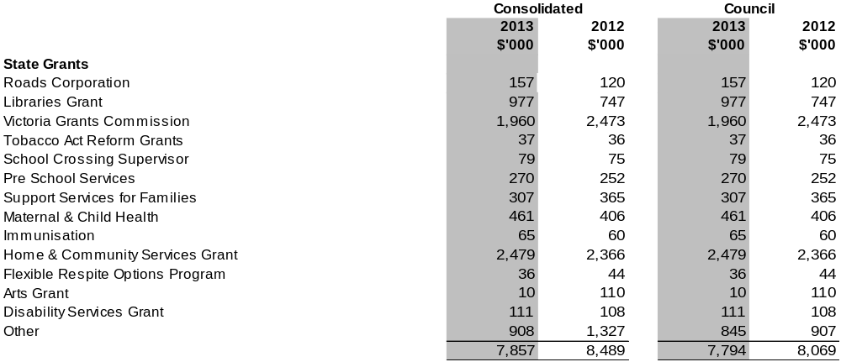

Notes to the financial statements
for the year ended 30 June 2013

Note 3. Revenues (continued)
(b) Grants and other contributions continued:
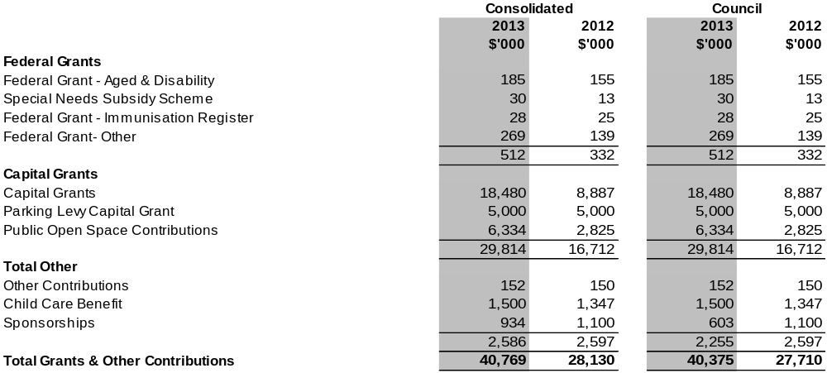

(c) Parking Fees
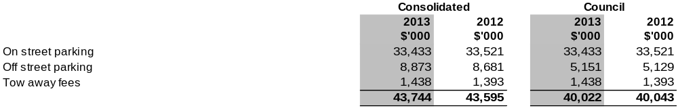
(d) Finance Income
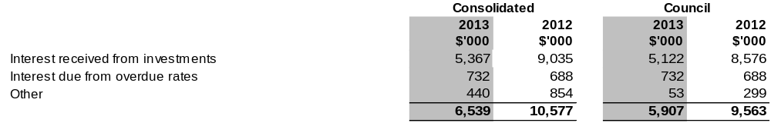

Notes to the financial statements
for the year ended 30 June 2013
Note 3. Revenues (continued)
(e) Conditions over contributions
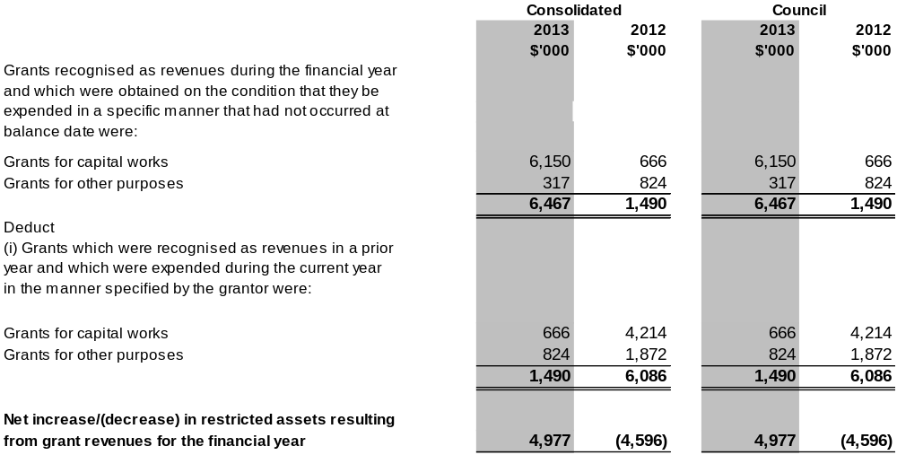

Note 4. Expenses
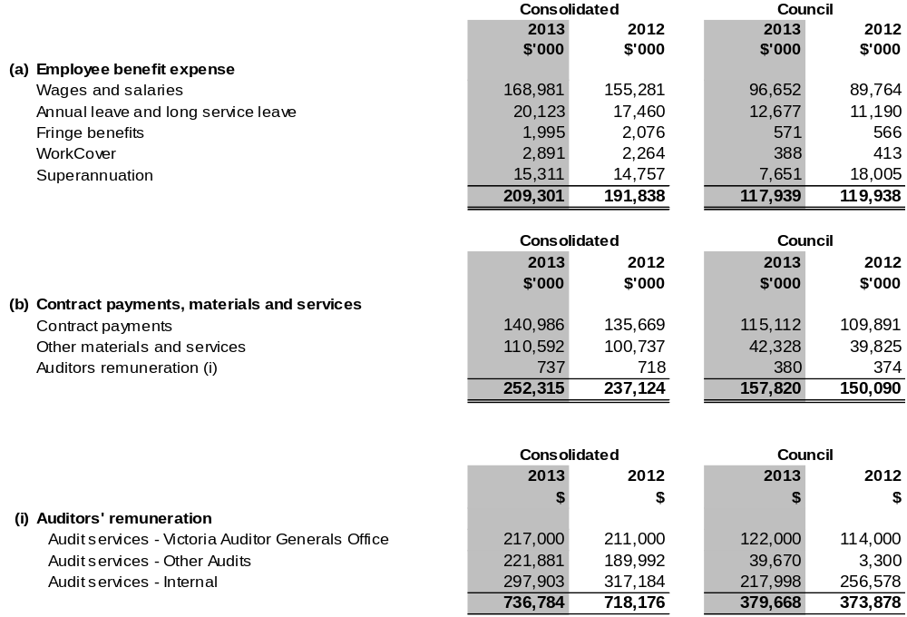
Notes to the financial statements
for the year ended 30 June 2013

Note 4. Expenses (continued)
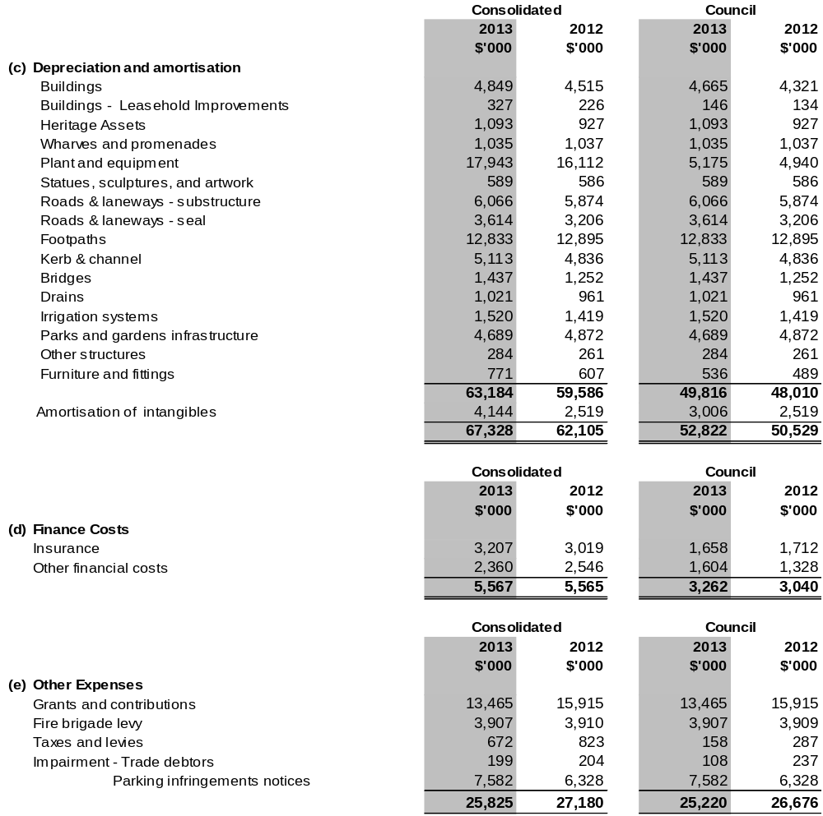
Notes to the financial statements
for the year ended 30 June 2013

Note 5. Trade and other receivables

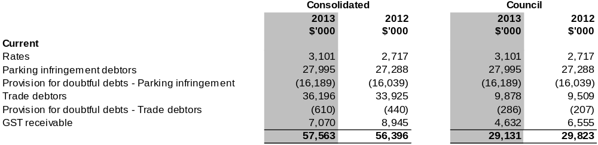
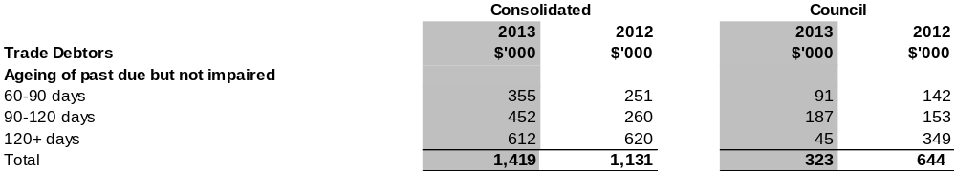

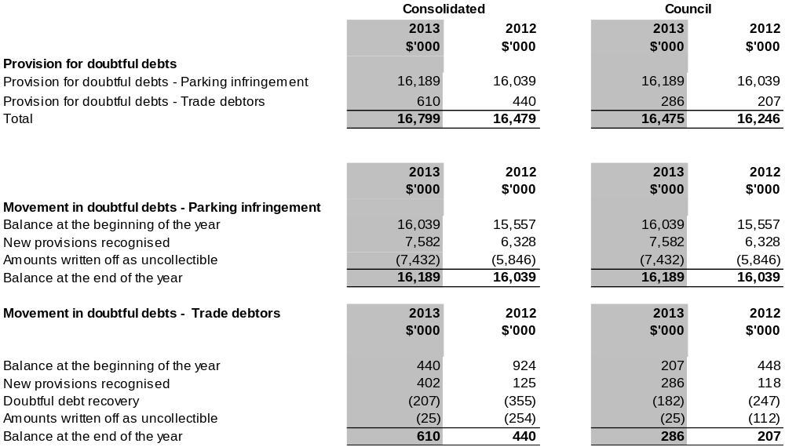

Notes to the financial statements
for the year ended 30 June 2013

Note 6. Inventories
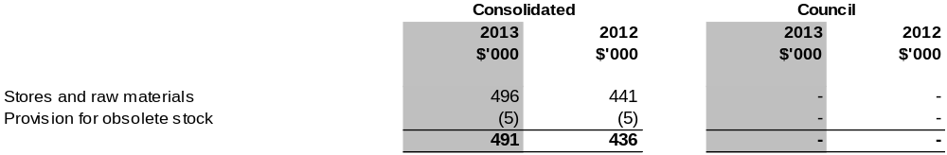

Note 7. Other Assets

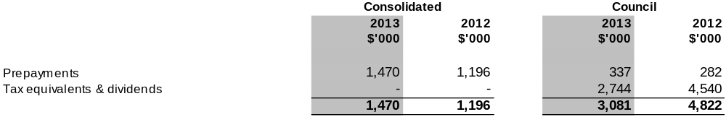

Note 8. Other financial assets

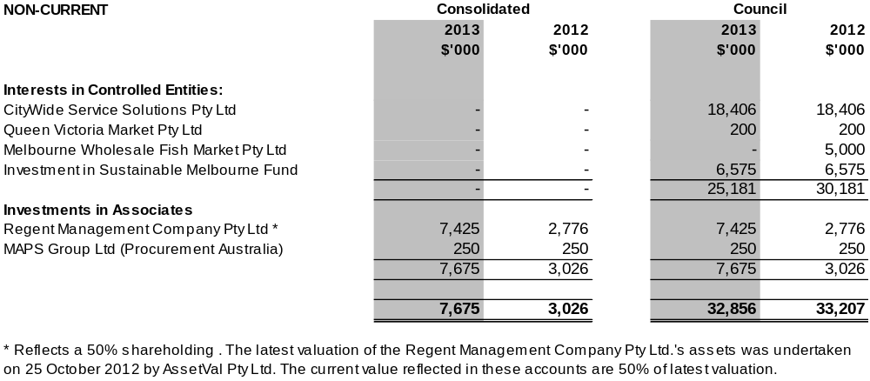

Notes to the financial statements
for the year ended 30 June 2013
Note 9. Property, plant, equipment and infrastructure
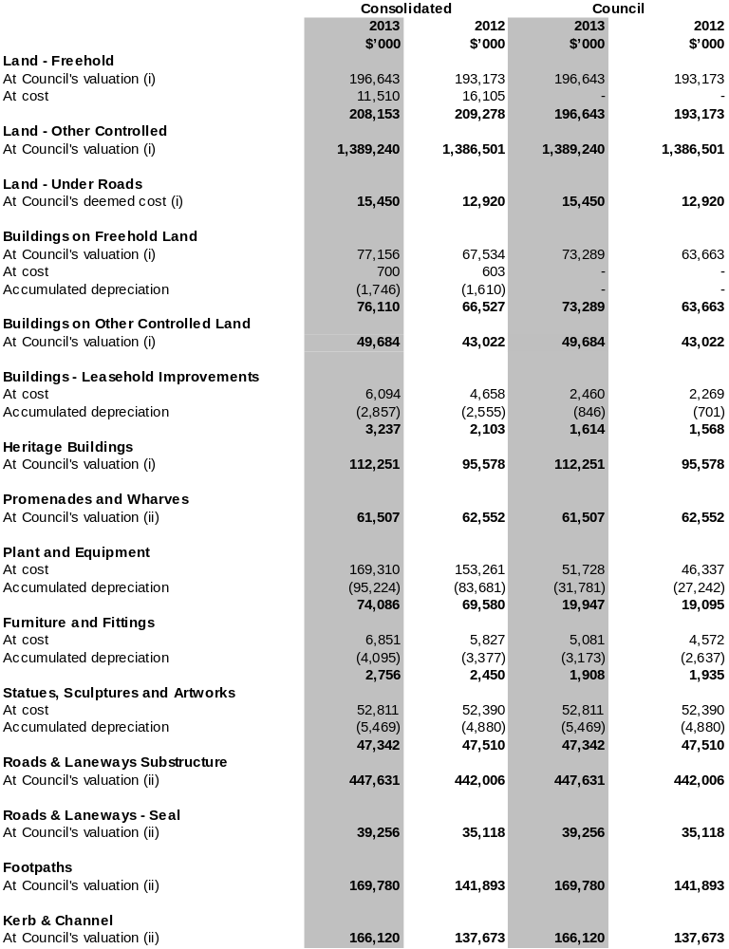
Notes to the financial statements
for the year ended 30 June 2013
Note 9. Property, plant, equipment and infrastructure (continued)

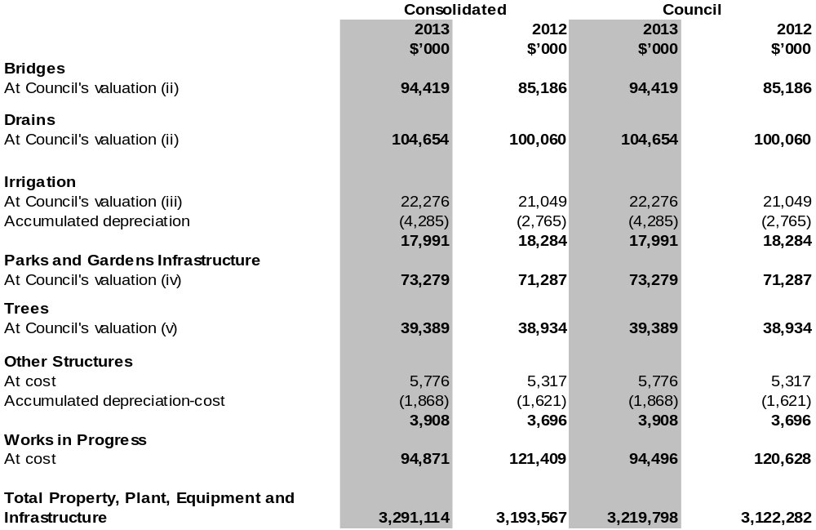

The basis of valuation is included under Note 1(l) in the Financial Report and were conducted as follows:

(i) Valuations of Council land and buildings were determined by David Slicer (Senior Valuer) Melbourne City Council.
All land and buildings are valued at fair value, being market value assuming the highest and best use permitted by the relevant land use planning provisions or existing public use whichever is the greater.
Freehold land reserved for public open space is valued at a discount, being 20 per cent of market value.
All improvements on Crown Land are valued on the basis of fair value, being either market value or written down replacement cost for special purpose buildings.

(ii) Valuations of Infrastructure Assets (Roads & Laneways, Footpaths, Kerb & Channel, Bridges and Drains) were determined by Michael Norton (Principal Engineer) Melbourne City Council.
Infrastructure assets and park assets are valued at fair value being replacement cost less accumulated depreciation, taking into account the asset condition and their remaining lives.

(iii) Valuation of Parks and Gardens Infrastructure were determined by Eugene Stackpole (Asset Management Officer) and David Slicer (Senior Valuer) Melbourne City Council. Irrigation was valued in the 2011/12 financial year.

(iv) Valuations of trees were determined by Ian Shears (Manager Urban Landscapes) Melbourne City Council.
Trees are valued at replacement cost which is arrived at from current on ground costs, current tree prices, tree planting works and maintenance through the establishment period of the tree.

The above valuations were completed as at 30 June 2013 for Council. Valuations for 30 June 2013 are at fair value. Unless otherwise stated the carrying value of each class of asset measured at fair value at balance date materially reflects their fair value at that date.
Notes to the financial statements
for the year ended 30 June 2013
Note 9. Property, plant, equipment and infrastructure (continued)

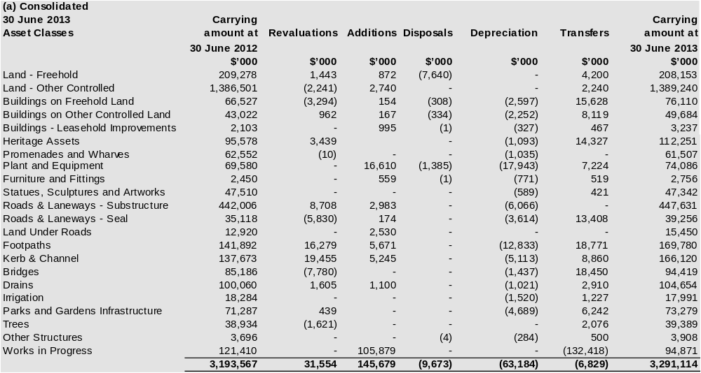

Notes to the financial statements
for the year ended 30 June 2013
Note 9. Property, plant, equipment and infrastructure (continued)

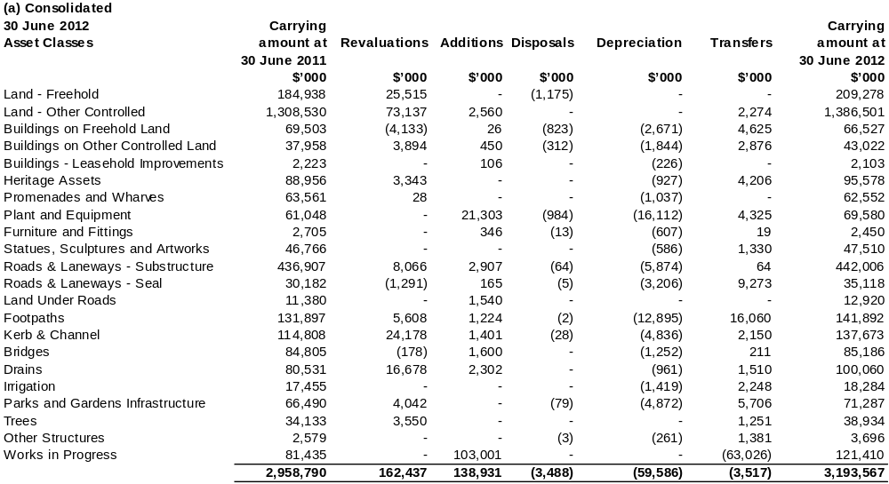

Notes to the financial statements
for the year ended 30 June 2013
Note 9. Property, plant, equipment and infrastructure (continued)

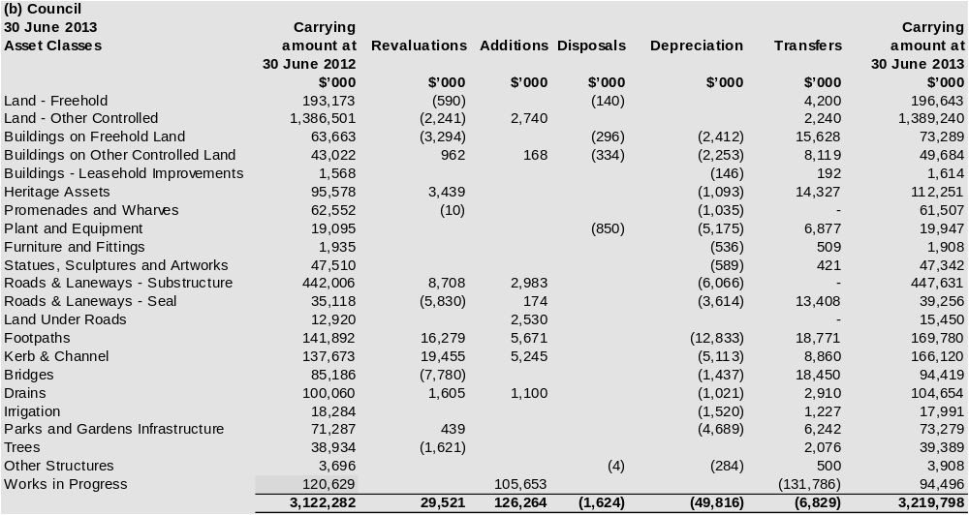

Notes to the financial statements
for the year ended 30 June 2013
Note 9. Property, plant, equipment and infrastructure (continued)

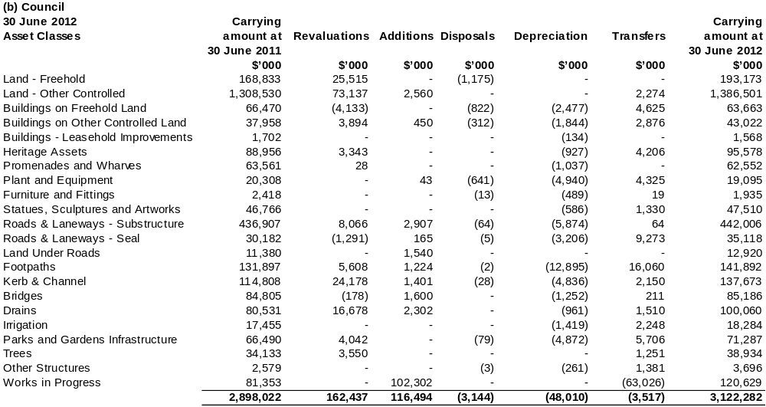
Notes to the financial statements
for the year ended 30 June 2013

Note 10. Intangible assets

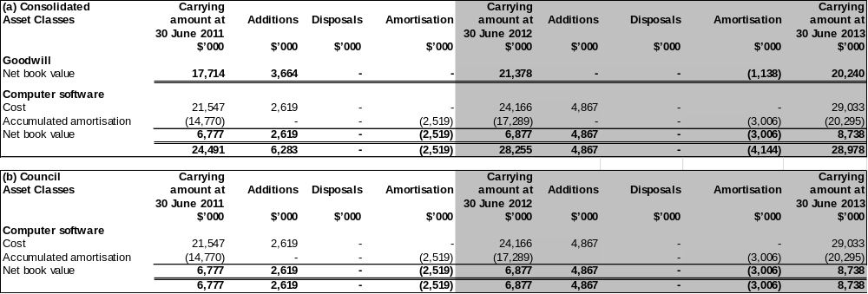

Notes to the financial statements
for the year ended 30 June 2013

Note 10. Intangible assets (continued)

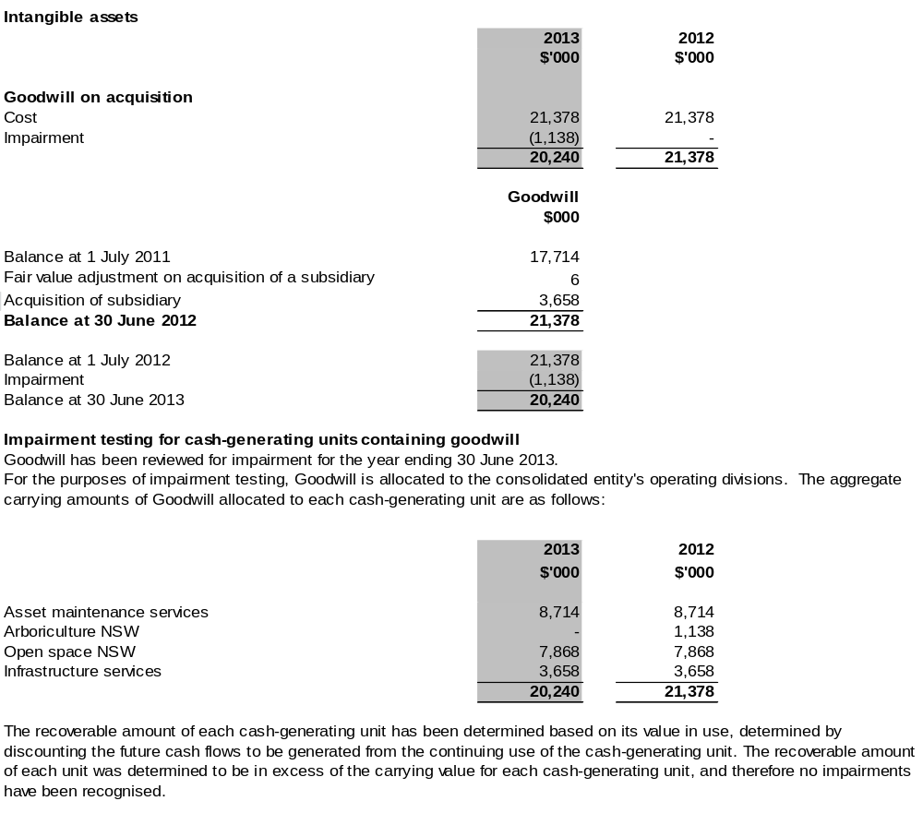

Notes to the financial statements
for the year ended 30 June 2013

Note 10. Intangible assets (continued)

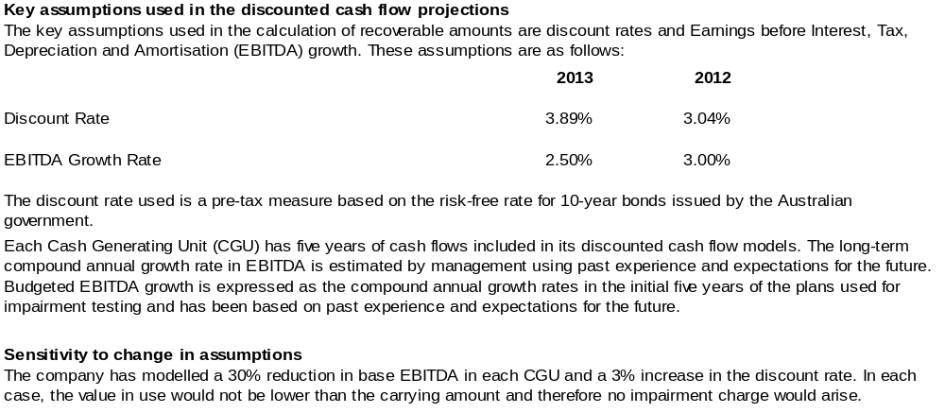

Notes to the financial statements
for the year ended 30 June 2013

Note 11. Investment property

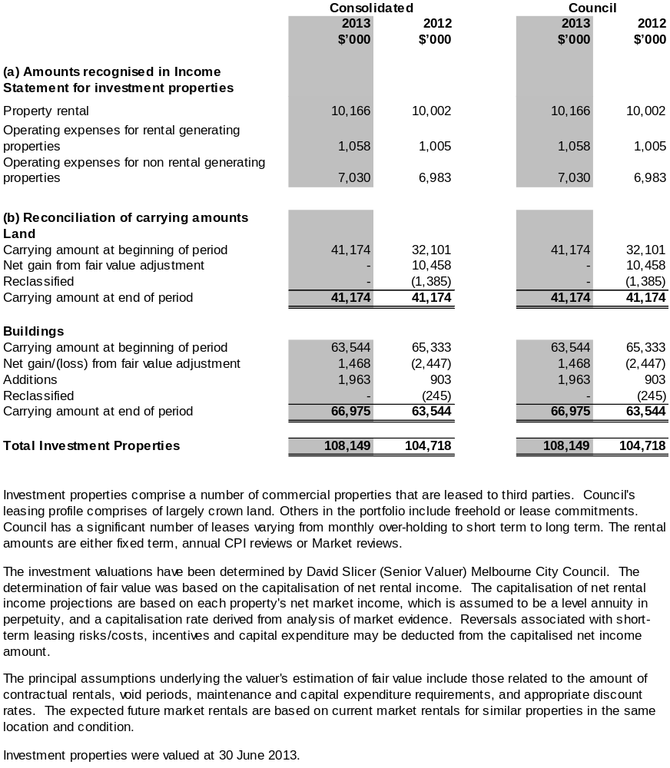

Notes to the financial statements
for the year ended 30 June 2013

Note 12. Trade and other payables

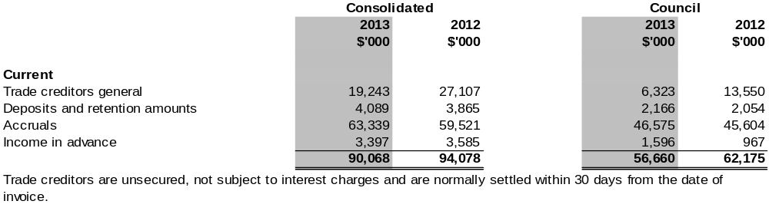

Note 13. Employee benefits
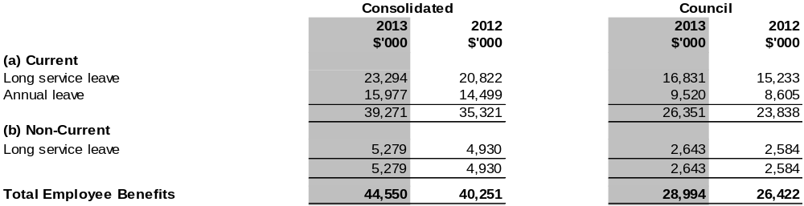

Note 14. Provisions

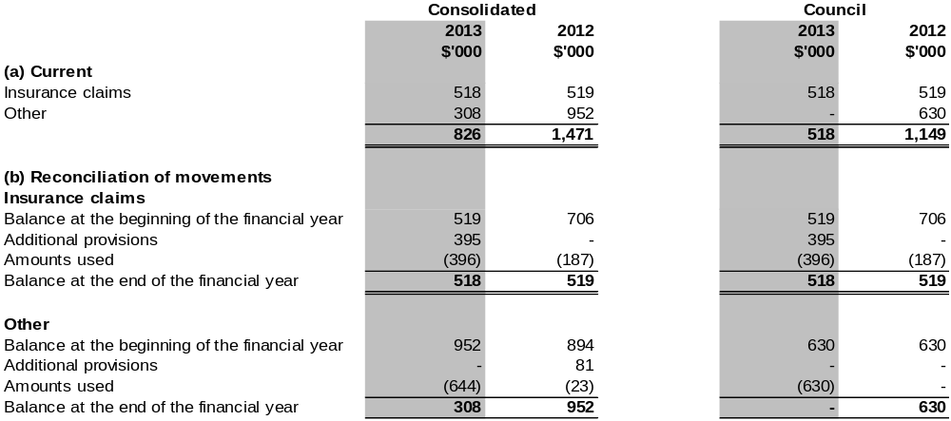

Notes to the financial statements
for the year ended 30 June 2013

Note 15. Reserves
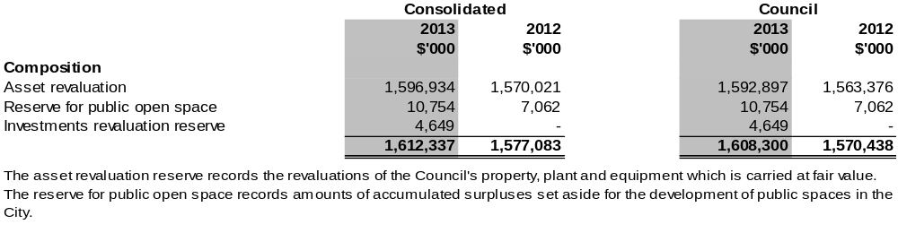
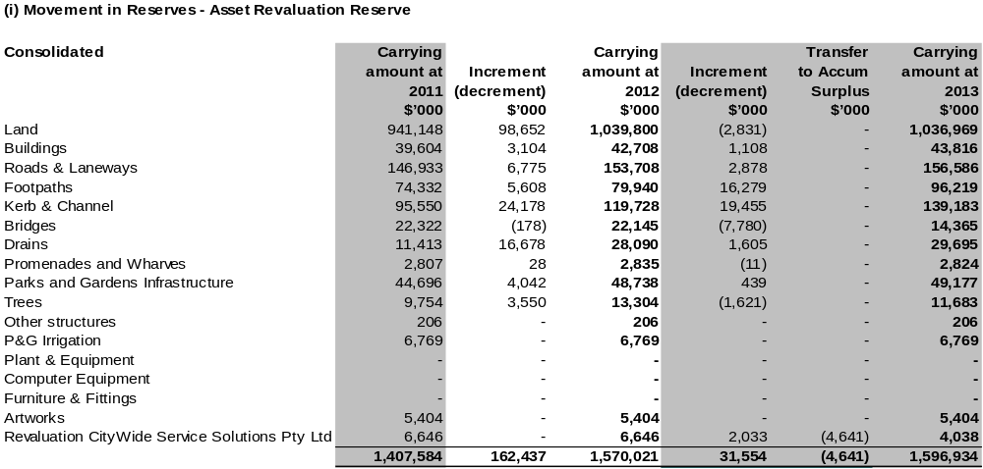
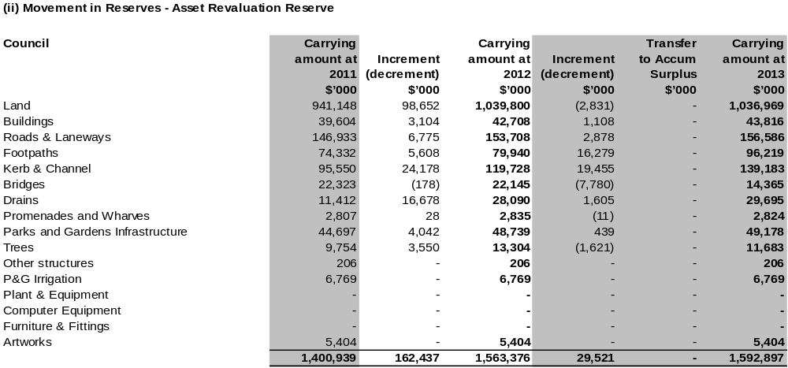
Notes to the financial statements
for the year ended 30 June 2013

Note 15. Reserves (continued)

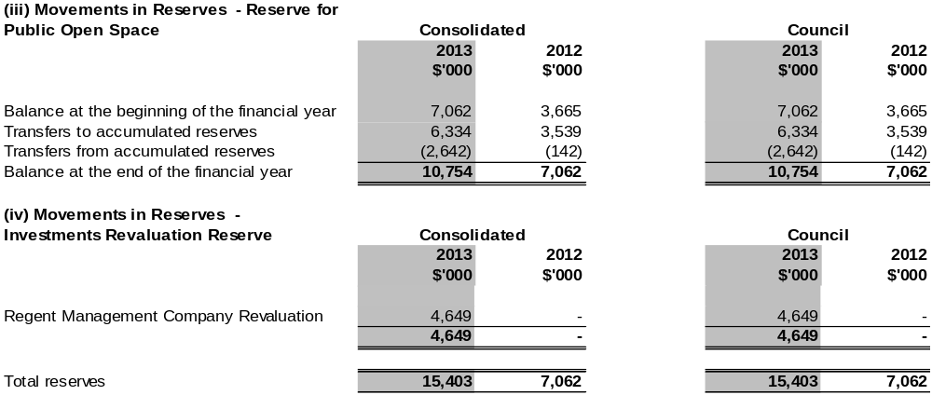

Note 16. Gain/(Loss) on sale of fixed assets

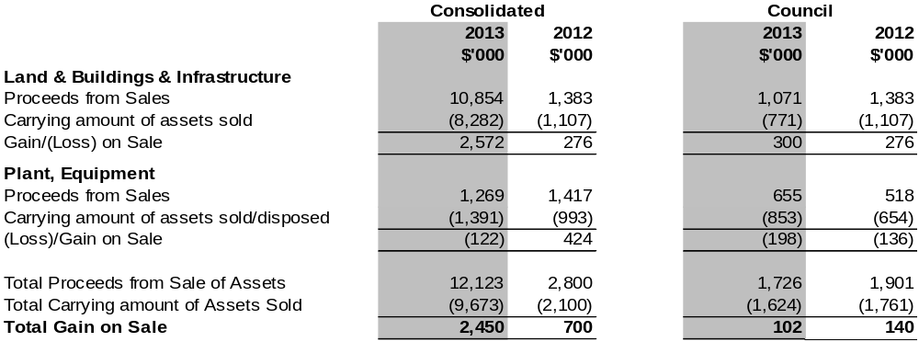

Notes to the financial statements
for the year ended 30 June 2013

Note 17. Cash flow information

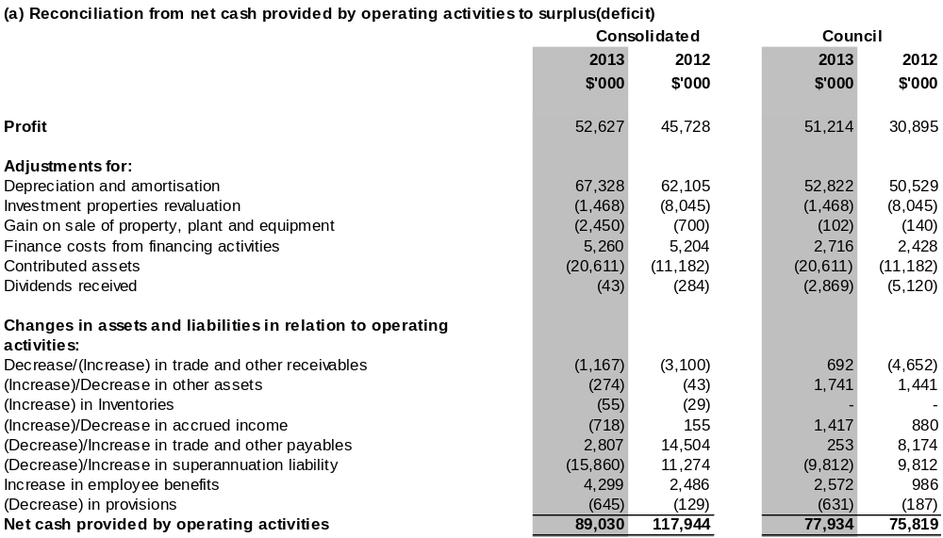

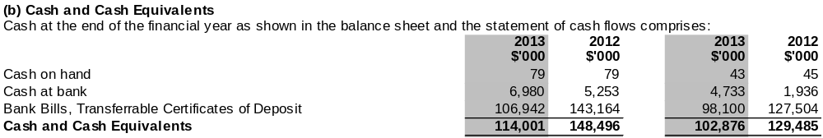

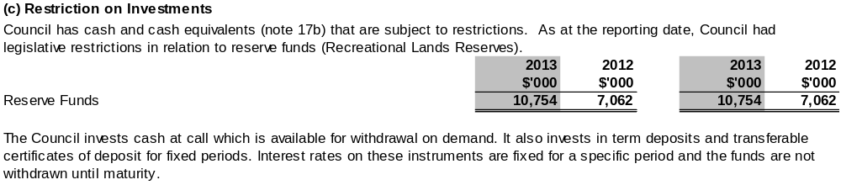
Notes to the financial statements
for the year ended 30 June 2013

Note 18. Leases and commitments
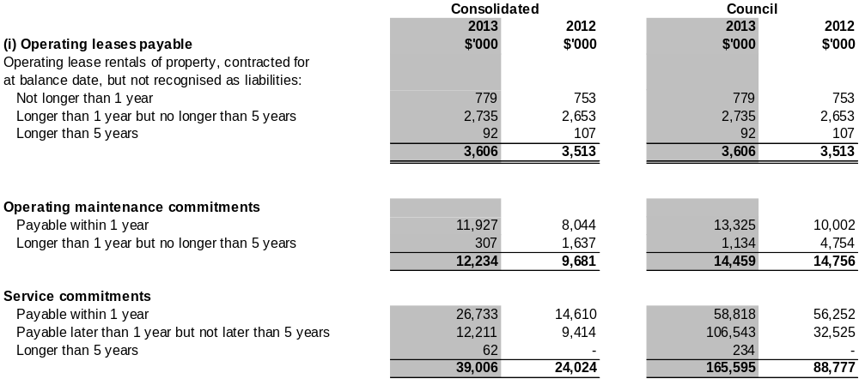

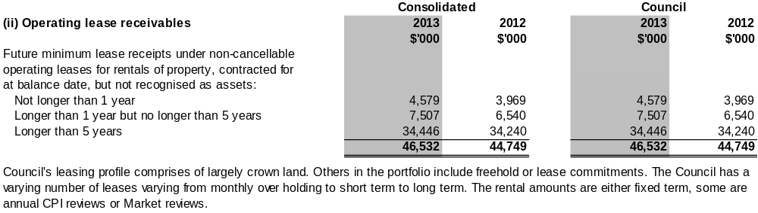

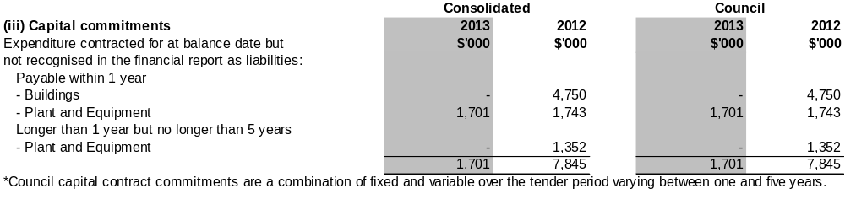

Notes to the financial statements
for the year ended 30 June 2013

Note 19. Contingent liabilities

The Council and the Victorian Government have indemnified, in equal shares, Regent Management Company Pty Ltd against any liability, loss or expense incurred or suffered by the Company. Over the financial year, no calls on this indemnity were made.

The Council and the Port of Melbourne Corporation hold differing views on the statutory valuations of the Port of Melbourne land holdings. As a result, there is a potential rate adjustment that may be necessary upon settlement of the matter. The Council’s exposure from the valuation objection is unable to be reliably estimated given uncertainty as at 30 June 2013.

Notes to the financial statements
for the year ended 30 June 2013
Note 20. Defined benefits superannuation funds
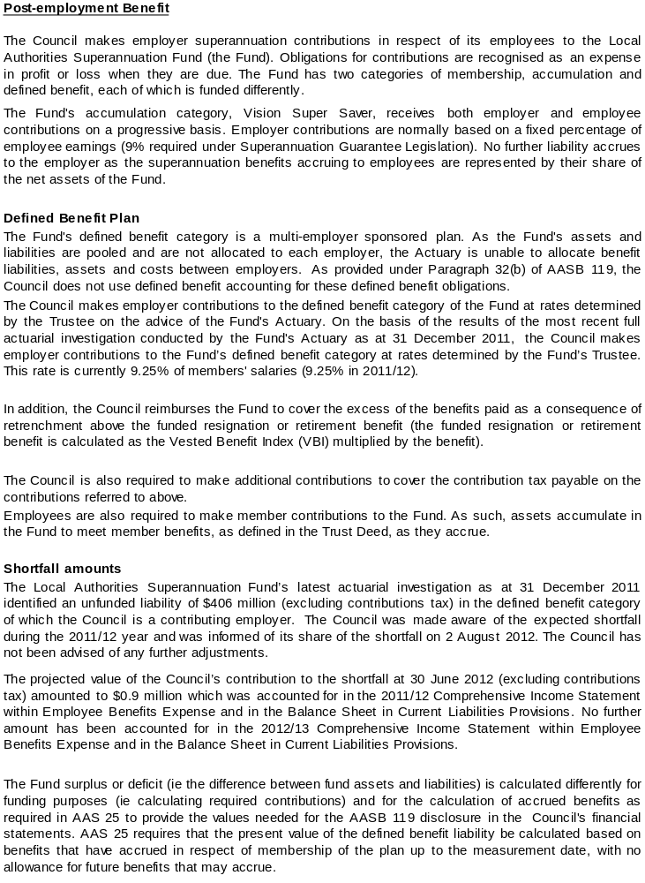
Notes to the financial statements
for the year ended 30 June 2013

Note 20. Defined benefits superannuation funds (continued)
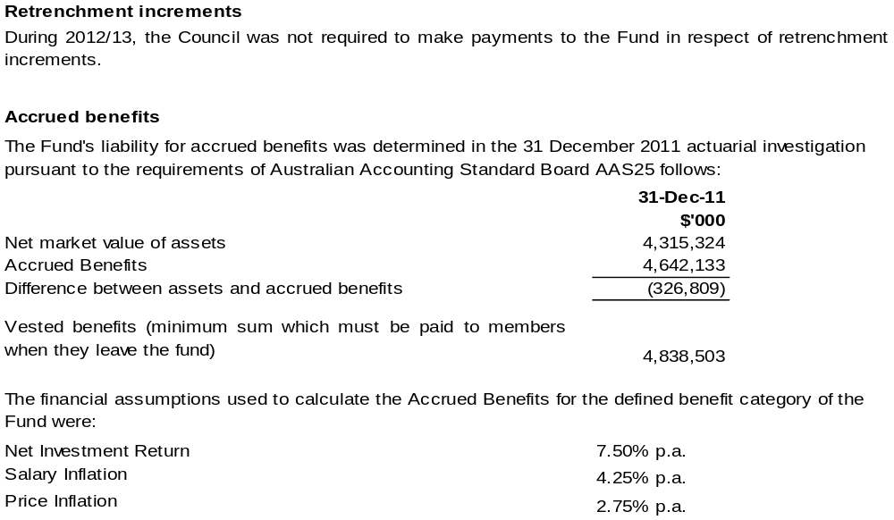

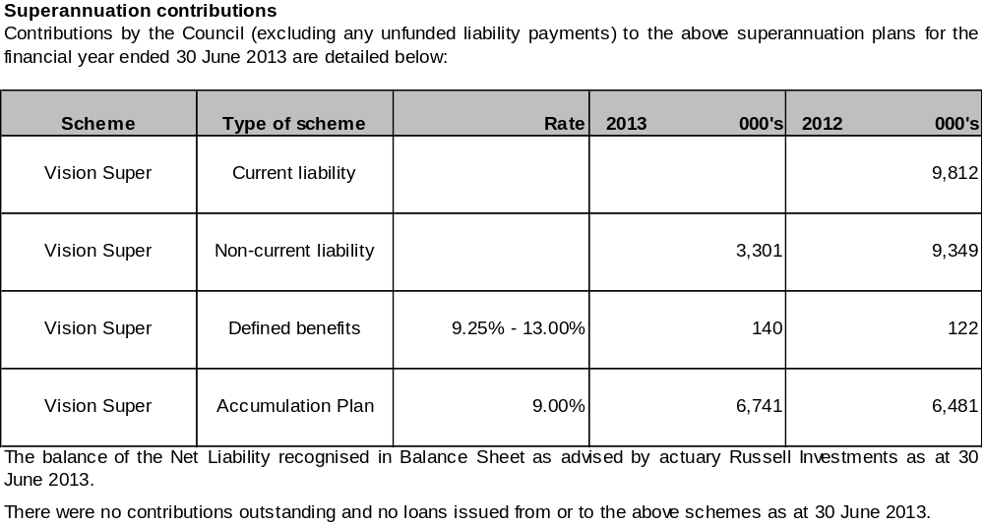

Notes to the financial statements
for the year ended 30 June 2013

Note 20. Superannuation (continued)
Melbourne City Council Superannuation Sub Plan (CMSSP) members
A separate plan is operated for Council defined benefit members. The CMSSP was closed to new members on 23 December 1993.
The CMSSP is a multi-employer sponsored plan. As the Fund's assets and liabilities are pooled and are not allocated by employer, the Actuary is unable to reliably allocate benefit liabilities, assets and costs between employers. As provided under Paragraph 32 (b) of AASB 119, the Council does not use the defined benefit accounting for these contributions, but as the majority of the members of the fund are employees of the Council group, the surplus or deficit of the fund is recorded in accordance to AASB119 at the consolidated level for reporting purposes. Member profiles will be reviewed periodically to determine if and when reporting at the individual entity level became appropriate.
The Council makes employer contributions to the defined benefits category of the Fund at rates determined by the Fund’s Trustee on advice of the actuary. On the basis of the results of the most recent update of the full actuarial investigation conducted by the Fund’s actuary as at 31 December 2011, the Trustee has determined that the funding arrangements were adequate for the expected CMSSP liabilities and the Council makes the following contributions:
- Increasing contributions to 13 per cent of salary for active defined benefit members, including 1 per cent for salary continuance cover, effective 1 July 2012;
- A single lump sum contribution of $6.02 million payable at 31 December 2012
- Top up payments for existing members equal to the difference between the Benefit Payment and the Vested Benefit Ratio amount, plus contributions tax, invoiced quarterly in arrears.
The actuarial investigation concluded that although the Net Market Value of Assets was in deficit of Accrued Benefits at 31 December 2011, based on the assumptions adopted, there was a shortfall for when the funding of future benefits was also considered. A liability of $6.02m was paid on 31 December 2012 as the Council’s share of the scheme’s liabilities, being the difference between the present value of employees’ accrued benefits and the net market value of the scheme’s assets at balance date. The Actuary will undertake the next actuarial investigation commencing at 31 December 2014 to ascertain if additional contributions are required.

The CMSSP Fund’s liability was determined in the 31 December 2011 actuarial investigation pursuant to the requirements of the Australian Accounting Standard AAS 25 as follows:
31-Dec-2011
$ Millions
Net Market Value of Assets | 52.4
Accrued Benefits (per accounting standards) | 54.5
Difference between Assets and Accrued Benefits | (2.1)
Vested Benefits | 59.6
Vested benefits index . 88%

The total amount of superannuation contributions paid by the Council (inclusive of its wholly-owned subsidiaries Citywide Service Solutions Pty Ltd, Queen Victoria Market Pty Ltd and Melbourne Wholesale Fish Market Pty Ltd) during the year was $15.31m (2012: $14.76m).

The Council has an ongoing obligation to share in the future experience of the Local Authorities Superannuation Fund Defined Benefits Plan and the Melbourne City Council Superannuation Sub-Plan. Favourable or unfavourable variations may arise should the experience of the Funds differ from the assumptions made by the Funds’ actuary in estimating the Funds’ accrued benefit liability.

CityWide Service Solutions Pty Ltd contributes in respect of its employees to the following sub-plans of the Local Authorities Superannuation Fund:
- The Melbourne City Council sub-plan,
- The Defined Benefits plan, and
- The Accumulation plan.
Notes to the financial statements
for the year ended 30 June 2013
Note 21. Related party transactions
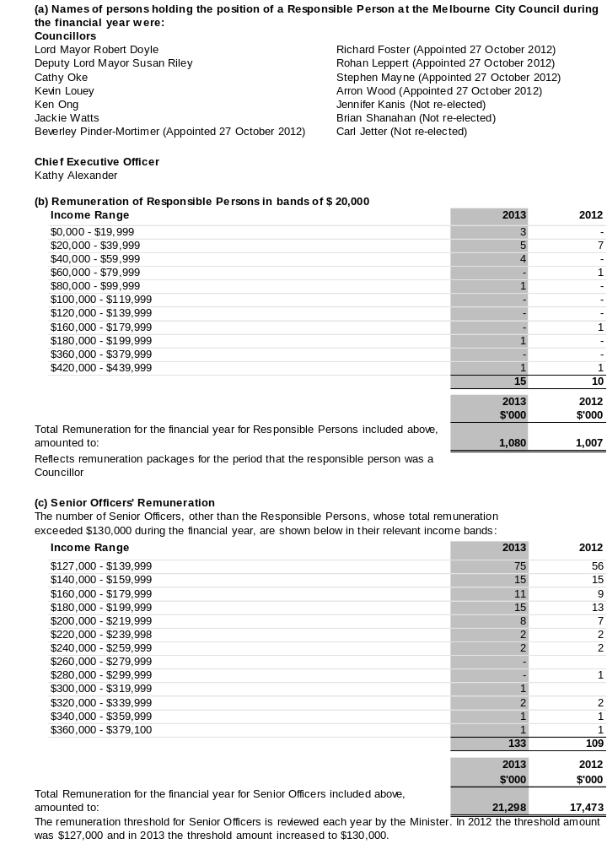
Notes to the financial statements
for the year ended 30 June 2013

Note 21. Related party transactions (continued)

- Retirement benefits
No retirement benefits were paid by the Council in connection with the retirement of Responsible Persons during the financial year or in the previous financial year.

- Other transactions
Other related party transactions requiring disclosure this financial year were considered and there are no matters to report. There were no matters to report in the previous financial year.

- Wholly-owned group
The Council is the ultimate parent entity in the wholly-owned group. Transactions with the controlled entities, Citywide Service Solutions Pty Ltd and its subsidiaries, Queen Victoria Market Pty Ltd, Melbourne Wholesale Fish Markets Pty Ltd and Sustainable Melbourne Fund Trust during the year are included in sub-sections (g) – (j) below.
All subsidiaries are established and are resident in Australia.

- Transactions with Citywide Service Solutions Pty Ltd
Transactions with the Citywide Service Solutions Pty Ltd during the financial year were based on a contract for the provision of services comprising property rental, contract sales and the payment of charges (tax equivalents) which includes income tax and payroll tax.
Intercompany revenue and expenditure
Revenue received from Citywide amounted to $403,000 (2012: $398,000) during the financial year.
Expenditure to Citywide amounted to $64,426,000 (2012: $58,931,000) during the financial year.
Income Tax and Payroll Tax Equivalent, and Dividend $9,097,000 (2012: $9,186,000) during the financial year.

- Transactions with Queen Victoria Market Pty Ltd
Transactions with the Queen Victoria Market Pty Ltd during the financial year were based on a contract for the provision of services comprising a Licence fee, IT charges and in accordance with the Tax Equivalent Policy, the payment of charges (tax equivalents) which includes income tax.

Intercompany revenue and expenditure
Revenue received from Queen Victoria Market amounted to $4,740,000 (2012: $4,743,000) during the financial year.
Tax Equivalent and Dividend $970,000 (2012: $1,368,000) during the financial year.

- Transactions Melbourne Wholesale Fish Market Pty Ltd
Transactions with the Melbourne Wholesale Fish Market relate to deregistration of this entity.

Intercompany revenue and expenditure
Tax Equivalent and Dividend $4,766,000 (2012: $39,000) during the financial year.

- Transactions with Sustainable Melbourne Fund
The Council has provided the Sustainable Melbourne Fund with grant revenue $63,000.

Notes to the financial statements
for the year ended 30 June 2013

Note 22. Financial instruments
Accounting policy, terms and conditions
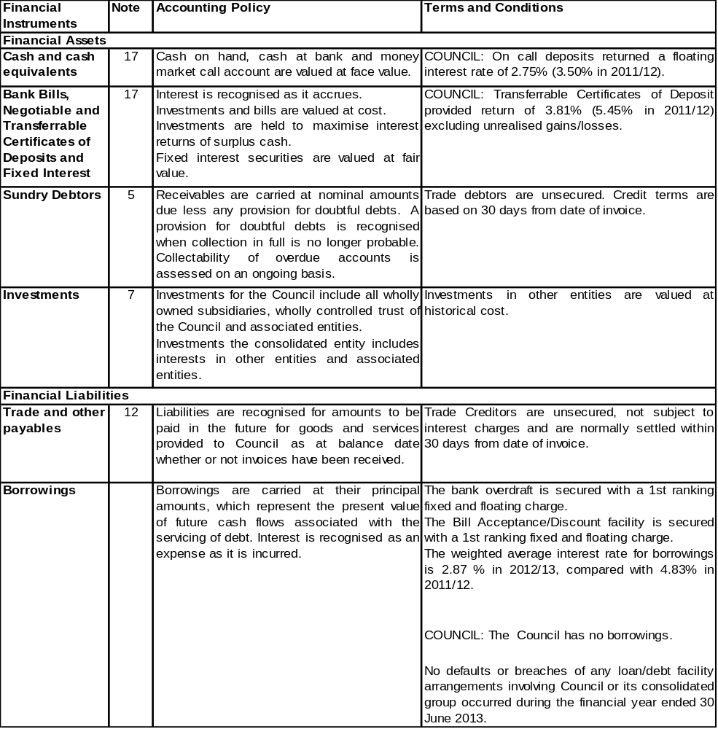
Notes to the financial statements
for the year ended 30 June 2013

Note 22. Financial instruments (continued)
(a) Interest rate risk
(i) The consolidated entity's exposure to interest rate risk, repricing maturities and effective weighted average interest rates on financial instruments at balance date is set out below:

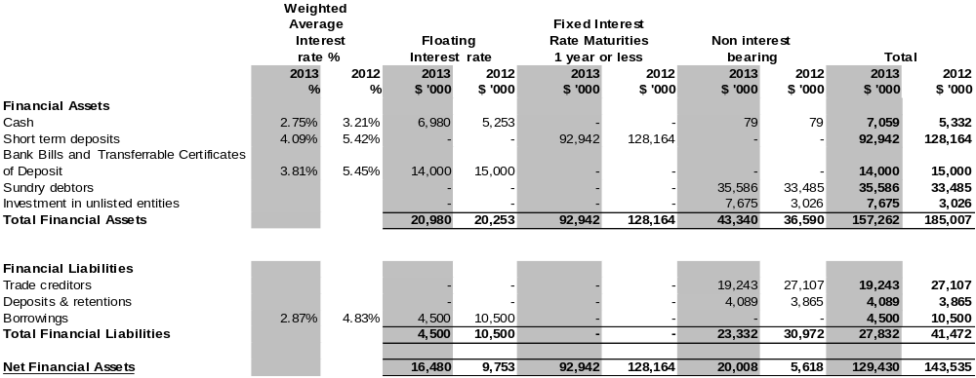

Notes to the financial statements
for the year ended 30 June 2013

Note 22. Financial instruments (continued)

(ii) The Council’s exposure to interest rate risk, repricing maturities and effective weighted average interest rates on financial instruments at balance date is set out below:

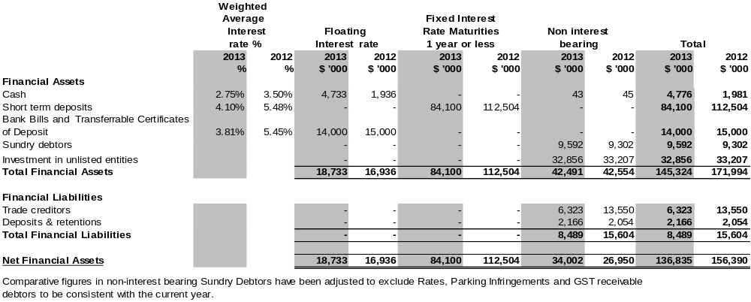

Notes to the financial statements
for the year ended 30 June 2013

Note 22. Financial instruments (continued)

(b) Reconciliation of net financial assets to net assets
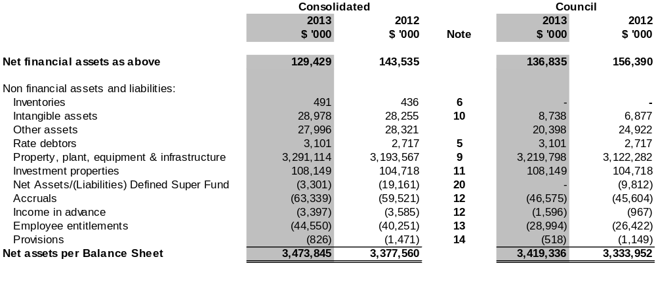

(c) Net fair values
The carrying amounts of all financial assets and liabilities are a reasonable approximation of their fair value due to the short-term to their maturity.

Notes to the financial statements
for the year ended 30 June 2013

Note 22. Financial instruments (continued)

(d) Credit risk exposures
The credit risk on financial assets of the economic entity which were recognised in the Balance Sheet is generally the carrying amount, net of any provisions for doubtful debts.

(e) Risks and mitigation
The risks associated with Council’s main financial instruments and Council’s policies for minimising these risks are detailed below.

Market risk
Market risk is the risk that the fair value or future cash flows of our financial instruments will fluctuate because of changes in market prices. The Council's exposures to market risk are primarily through interest rate risk with only insignificant exposure to other price risks and no exposure to foreign currency risk. Components of market risk to which we are exposed are discussed below.

Interest rate risk
Interest rate risk refers to the risk that the value of a financial instrument or cash flows associated with the instrument will fluctuate due to changes in market interest rates. Interest rate risk arises from interest bearing financial assets and liabilities that we use. Non derivative interest bearing assets are predominantly short term liquid assets. Our interest rate liability risk is limited to our subsidiary company’s Citywide Service Solutions Pty Ltd borrowings. Council has no direct borrowings.

Our subsidiary company Citywide Service Solutions Pty Ltd has a borrowing and overdraft facility which was arranged with a major Australian bank. Our subsidiary company manages the interest rate risk by:
- ensuring access to diverse sources of funding
- an ongoing review or borrowing levels
- having a limit imposed on the maximum borrowing amount allowed by Council.

Investment of surplus funds is made with approved financial institutions under the Local Government Act 1989 (Vic). We manage interest rate risk by adopting an investment policy that ensures:
- conformity with State and Federal regulations and standards
- adequate safety
- appropriate liquidity
- diversification by credit rating, financial institution and investment product
- monitoring of return on investment
- benchmarking of returns and comparison with budget.
Maturity will be staggered to provide for interest rate variations and to minimise interest rate risk.

Credit risk
Credit risk is the risk that a contracting entity will not complete its obligations under a financial instrument and cause us to make a financial loss. We have exposure to credit risk on all financial assets included in our balance sheet. To help manage this risk:
- The Council has a policy for establishing credit limits for the entities we deal with
- The Council may require collateral where appropriate
- The Council only invests surplus funds with financial institutions which have a recognised credit rating specified in our Treasury policy.

Trade and other receivables consist of a large number of customers, spread across the consumer, business and government sectors. Credit risk associated with the Council's financial assets is minimal because the risk is spread across many debtors. Ongoing credit evaluation is performed on the financial condition of our customers and, where appropriate, an allowance for doubtful debts is raised. The aging of receivables is disclosed in Note 5 “Trade and other receivables”.

(f) Borrowings
With respect to borrowings at Citywide Service Solutions Pty Ltd the following should be noted. The bank overdraft facility is a secured facility. In February 2012 the Bill Acceptance and Discount Facility was increased. This facility is also a secured facility. There is a 1st ranking fixed and floating charge. The bank facilities may be drawn at any time and may be terminated by the bank subject to default under the loan agreement. Subject to the continuance of satisfactory covenant achievement, the bank facilities may be drawn at any time. The facilities expire on the 2 June 2017.
Notes to the financial statements
for the year ended 30 June 2013

Note 22. Financial instruments (continued)
The Council may also be subject to credit risk for transactions which are not included in the balance sheet, such as when we provide a guarantee for another party. Details of our contingent liabilities are disclosed in Note 19.

Liquidity risk
Liquidity risk includes the risk that, as a result of our operational liquidity requirements:
- The Council will not have sufficient funds to settle a transaction on the date
- The Council will be forced to sell financial assets at a value which is less than what they are worth
- The Council may be unable to settle or recover financial assets at all.

To help reduce these risks the Council:
- have a liquidity policy which targets a minimum and average level of cash and cash equivalents to be maintained
- have a liquidity portfolio structure that requires surplus funds to be invested within various bands of liquid instruments
- monitor budget to actual performance on a regular basis
- Council has no direct borrowings.

The Consolidated Entity’s exposure to liquidity risk is deemed insignificant given our high levels of cash and cash equivalents and Citywide Service Solutions Pty Ltd borrowings and our current assessment of risk.

The table below lists the contractual maturities for financial liabilities. These amounts represent undiscounted gross payments including both principal and interest amounts.

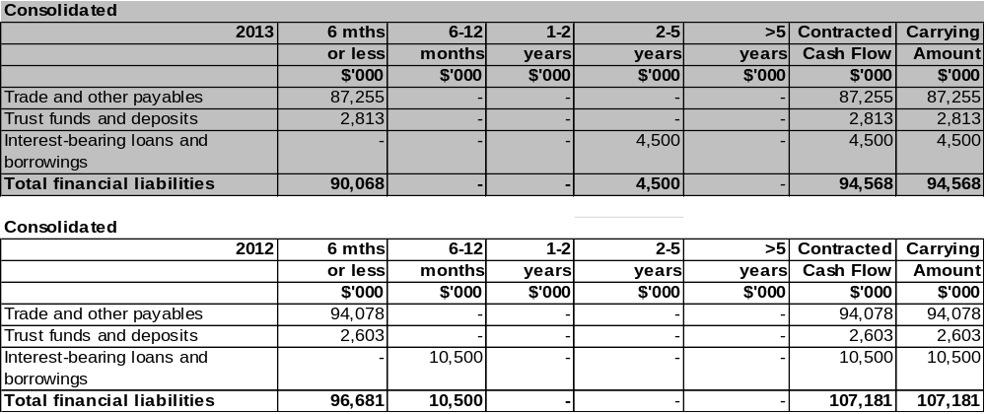

Notes to the financial statements
for the year ended 30 June 2013

Note 22. Financial instruments (continued)

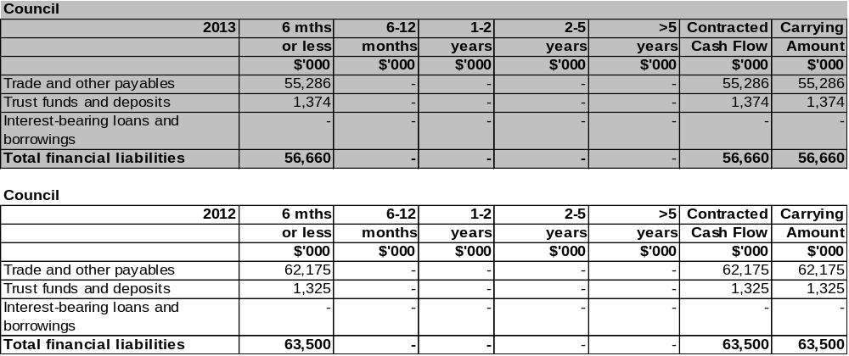
(f) Sensitivity disclosure analysis

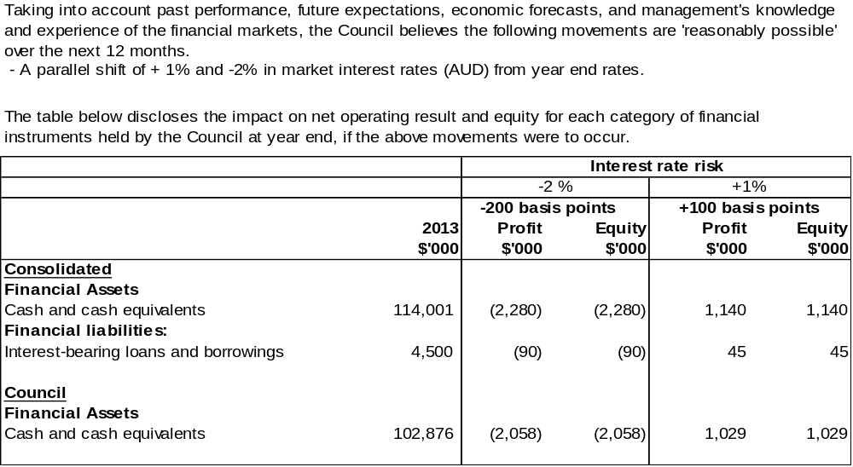

Notes to the financial statements
for the year ended 30 June 2013

Note 23. Financial ratios
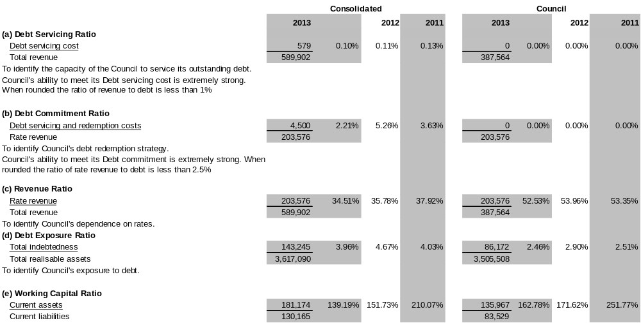
Notes to the financial statements
for the year ended 30 June 2013

Note 23. Financial ratios (continued)

Definitions
To assess Council's ability to meet current commitments.
For every dollar of current liabilities, Council has $1.63 of current assets as at 30th June 2013.

a) Debt servicing costs | Includes interest and charges on loans, overdrafts and interest on payments for capital items purchased on vendor terms.
b) Debt redemption | Includes the principal component of repayments on loans and financial leases and capital items purchased on vendor terms.
c) Rate revenue | Includes revenue from general rates, municipal charges, special rates, special charges, service rates and service charges.
Total revenue | Total revenue as shown in the Comprehensive Income Statement.
d) Total realisable assets  Total indebtedness | Total current assets and total realisable non-current assets.  Total liabilities, both current and non-current, as shown in the Balance Sheet.
e) Current liabilities | Total current liabilities as shown in the Balance Sheet.
Current assets | Total current assets as shown in the Balance Sheet.

Note 24. Business combinations

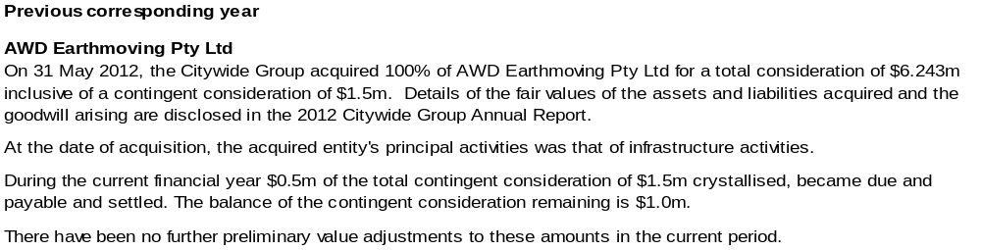

Note 25. Events occurring after balance date
There are no events that have occurred after balance date that need to be reflected in the Financial Statements.

Signed statement
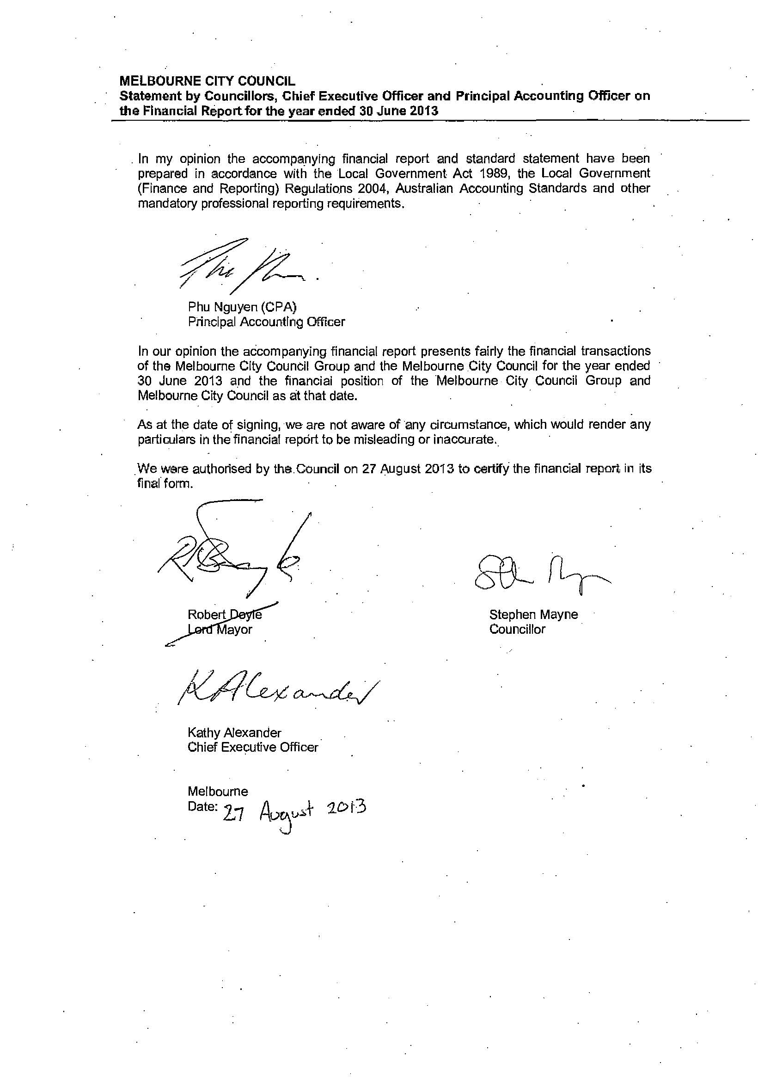

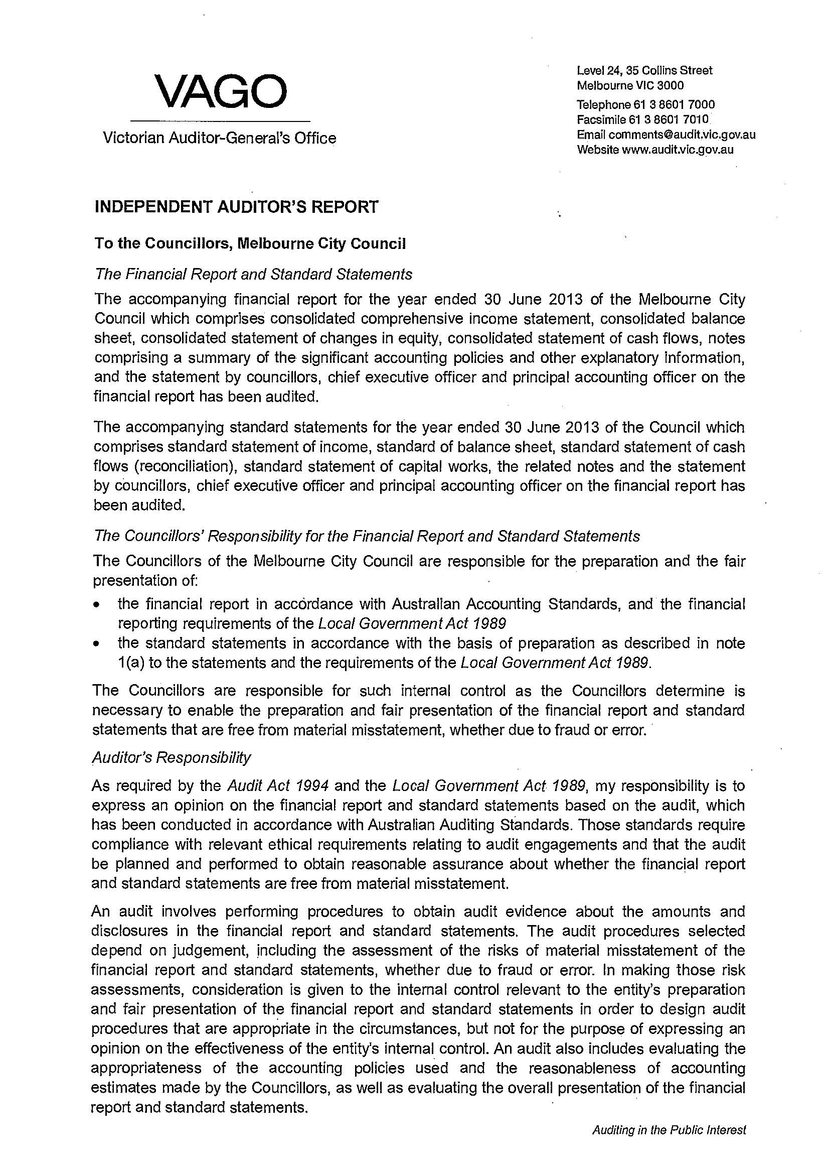
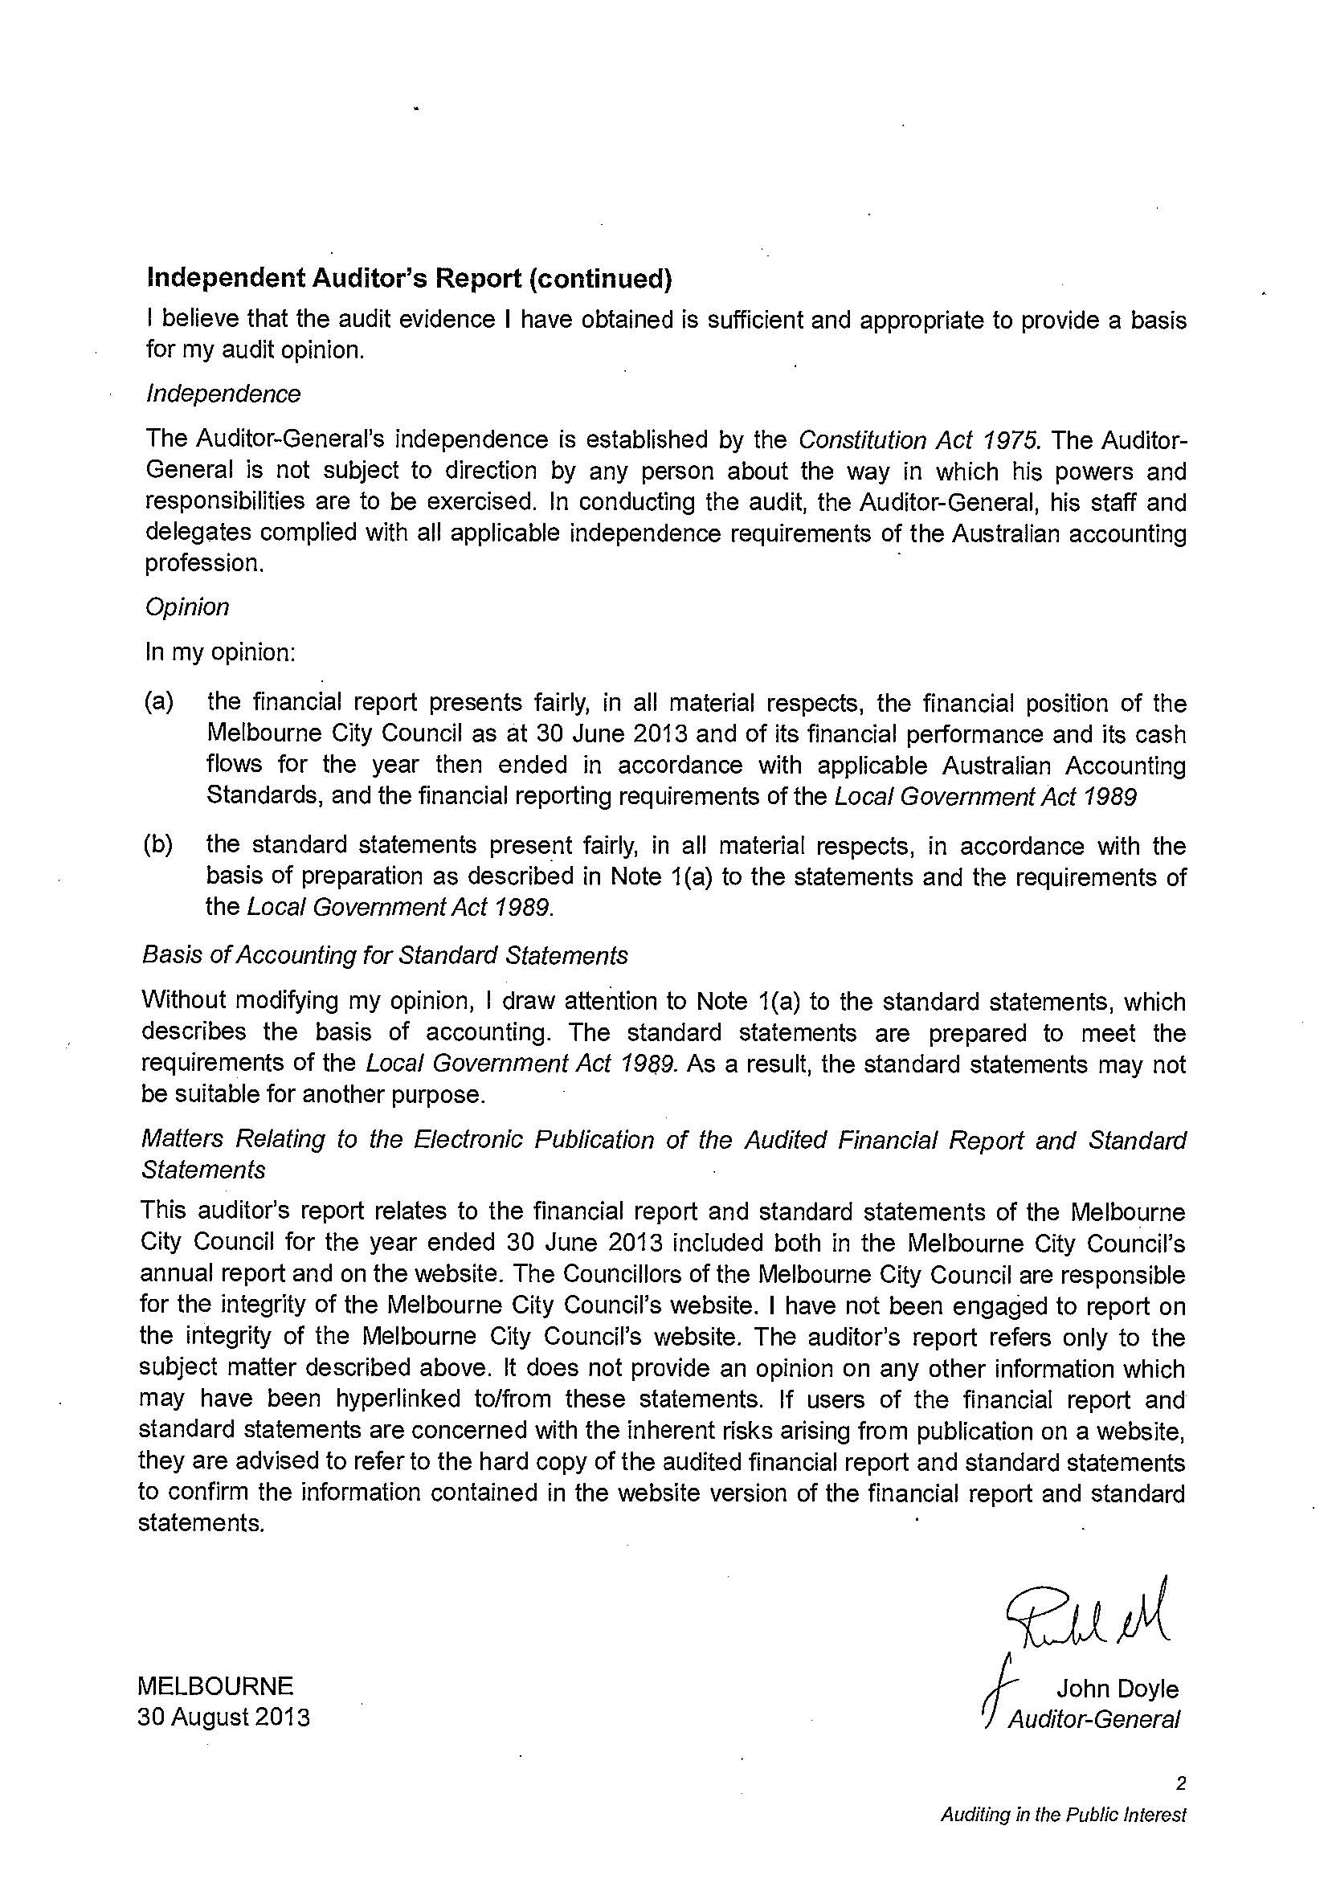

The final emissions figures for the 2012–13 financial year will be released at a later date as part of the National Carbon Offset Standard (NCOS) Carbon Neutral Program reporting.

