

Elizabeth Street South streetscape improvements - Construction update July 2021

The Elizabeth Street streetscape works are nearing completion with the footpath reopened at the beginning of July, and final works currently being carried out on the underground drain and new extended footpath area.

Footpath works

At the beginning of July, the hoarding along Elizabeth Street between Flinders Street and Flinders Lane was removed, re-opening the newly paved footpath for pedestrians to move through comfortably once again.

Key works completed over June and July include the installation of underground services and tree pits beneath the footpath.

Converted roadway
Work has continued on the 120-year-old drain located beneath the roadway. The slab required over the drain to help prolong the life of the drain has now been partially installed. Street furniture including new seating has also been installed. Conversion of the roadway into an extended footpath will continue over the next three weeks, with bluestone pavers currently being laid. Finishing touches such as line-marking and signage will also occur.
Trees
New trees are being planted along the extended footpath on the east side of Elizabeth Street, and tree planters were also recently added to the footpath on the west side of the street.
Timeline
All works will be completed by Friday 6 August. The City of Melbourne would like to thank nearby businesses and residents for their cooperation and patience during construction of this important project. We hope the updated streetscape will be enjoyed by the thousands of city workers and visitors who pass through the area every day.
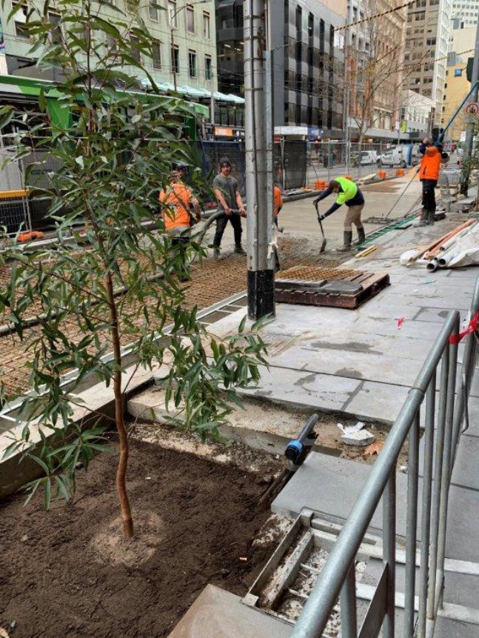
New tree pits beneath the footpath

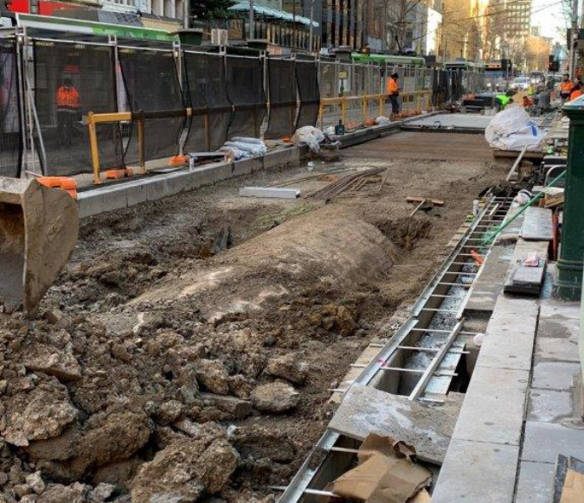
Drainage works beneath the roadway

To find out more, please contact 9658 9658, or visit melbourne.vic.gov.au/cityprojects or melbourne.vic.gov.au/contactus

https://www.melbourne.vic.gov.au/building-and-development/shaping-the-city/city-projects/Pages/city-projects.aspx
https://www.melbourne.vic.gov.au/Pages/contact-us.aspx

