Fast-tracking Neighbourhood Batteries
A guide for councils and community
A joint initiative by City of Melbourne, City of Yarra, City of Port Phillip
Made possible with the support of the Metropolitan Partnership and funding from the Victorian Government

This project was undertaken on the lands of the Wurundjeri Woi-wurrung and the Bunurong/Boon Wurrung peoples of the Kulin and we pay respects to their Elders past and present.

Table of contents
Table of contents 3
Introduction 4
A guide to neighbourhood batteries for inner urban councils and community groups 4
0.1 Project context 5
0.2 Key learnings to fast-track neighbourhood batteries 7
Section 1 – Policy and strategy landscape 9
1.1 Energy policy 9
1.2 Roles for councils 11
1.3 Roles for community groups 12
1.4 Decision-making considerations 14
Section 2 – Operating models, commercial considerations and site selection 15
2.1 Operating models 15
2.2 Ownership models 19
2.3 Site selection 22
2.4 Geographic analysis 24
2.5 Physical site considerations 25
Section 3 – Internal capacity considerations 27
3.1 Commissioning feasibility and implementation 27
3.2 Scenarios 30
3.3 Ongoing resourcing requirements 34
Section 4 – Social licence 36
4.1 Engagement design 37
4.2 Information and education 38
4.3 Placemaking 39
Glossary 42
Further reading 43

Introduction

A guide to neighbourhood batteries for inner urban councils and community groups
In 2022 and 2023, the Cities of Melbourne, Yarra and Port Phillip investigated neighbourhood batteries. We explored their local community benefits, their context in the broader national energy transition and how to accelerate their deployment. The project was supported by the Victorian Government’s Metropolitan Partnerships.
By summarising our learnings in this guide, we hope to assist other inner metropolitan councils and community groups to:
- understand neighbourhood batteries and their role locally
- decide whether neighbourhood batteries could benefit their community
- navigate a pathway to successful deployment.
This project focussed on inner urban municipalities, but we hope the guide is also relevant for councils and communities beyond this context.

What we found
We aimed to establish principles for fast-tracking neighbourhood batteries in inner urban areas. We discovered a range of complexities that make them highly bespoke. Choosing the right site for each battery takes highly detailed local analysis and consultation, while the business case is often challenging. They require significant investment and currently offer marginal financial returns. As a result, we didn’t uncover a clear pathway for councils or community groups to roll out neighbourhood battery projects at scale.
The insights presented here are intended to assist you in streamlining your individual project, exploring its benefits and realising its goals. To go ahead with a neighbourhood battery project, you will need sufficient risk appetite and resources to invest in scoping, installing and managing its ongoing operation – it may not be achievable for every council or organisation.
It’s critical to know why you’re installing a battery. Make sure you understand the problem you want to solve and explore a range of potential solutions before deciding that a neighbourhood battery is the answer. At key decision points throughout scoping and feasibility, keep testing whether a neighbourhood battery remains a fit-for-purpose solution.

About this guide
This document does not need to be read sequentially. If you have already established community support for a proposed project or site, or you’ve decided on your ownership and operating models, you may choose to skip those sections.
Key learnings highlight the lessons we took from the project, which can help other local governments and community groups to fast-track a neighbourhood battery project.
Section 1 lays out the policy and strategy fundamentals, including the roles of councils and community groups and how to develop a roadmap to implementation.
Section 2 dives into technical issues, including exploring the site and network considerations and designing the operating and ownership model before commissioning feasibility studies.
Section 3 explores the operational considerations for a council or community group, including resourcing, project management, procurement processes and sustainability issues.
Section 4 looks at how good engagement design and practice can help test the level of support and build social licence for neighbourhood batteries.
This is not a comprehensive technical guide to neighbourhood batteries. It also concentrates specifically on inner metropolitan areas, because that was the focus of our project. For more detailed information, review the many other excellent sources in the Further Reading section at the end of the guide.

Contact the project partners
To learn more about the project learnings shared in this report, contact:
City of Melbourne – power.melbourne@melbourne.vic.gov.au
City of Port Phillip – enviro@portphillip.vic.gov.au
City of Yarra – climateemergency@yarracity.vic.gov.au

0.1 Project context
The National Energy Market is rapidly transitioning from fossil fuel generation to renewables. To support this transition, energy storage is needed at both a grid and local level. Neighbourhood batteries – also known as community or mid-scale batteries – could fulfil this role while also benefiting councils, community groups and residents.
The fast-tracking neighbourhood batteries project was a joint initiative of the Cities of Melbourne, Port Phillip and Yarra with funding from the Victorian Department of Jobs, Skills, Industry and Regions’ Metropolitan Partnerships program. It ran from June 2022 to December 2023. The technical stream of work was conducted with Yarra Energy Foundation. We conducted community engagement with Capire Consulting Group.
We mapped the feasibility of neighbourhood batteries across the three municipalities while working alongside communities to build support for local renewable energy storage. We aimed to enable the acceleration of battery installations by removing barriers, creating social licence and empowering communities and businesses.
Each council shortlisted sites for deeper exploration, based on our policy priorities and different operating models. In detailed site assessments, we explored which types of projects may work best at each site. We designed a second stage of community engagement around the locations on this shortlist. Its results were incorporated into the technical site assessments for each council.

Partner council contexts
City of Yarra was the only council with an existing local community battery – FN1 in Fitzroy North, owned and operated by Yarra Energy Foundation. It was exploring potential locations for future batteries for council consideration, subject to developing a business case.
City of Port Phillip was researching viable locations for future batteries for council consideration, subject to developing a business case.
City of Melbourne’s existing Power Melbourne project will install a demonstration network of three batteries in 2024, owned by City of Melbourne and operated in partnership with a commercial provider.
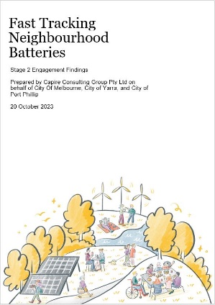
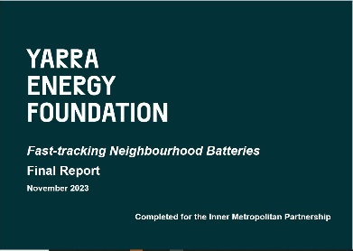

0.2 Key learnings to fast-track neighbourhood batteries
Before you get deep into the details, here are some important lessons from our research.
Installing neighbourhood batteries in inner urban areas is challenging – it is complex to establish appropriate sites and business cases. We did not establish a pathway to rapidly roll out neighbourhood battery projects at scale without councils or community groups assuming substantial levels of risk.
Therefore, this guide focuses on installing a single neighbourhood battery – how you can navigate decision-making, streamline the project design and realise your intended benefits.
Know your why | Location, location, location | Keep learning through uncertainty | The financial picture | Who benefits | Listen to community
- Understand the problem first. Is a neighbourhood battery the best solution? If so, target the most appropriate operating model.  - From a technical perspective, are there local solar constraints, or a high level of solar penetration? What are the usage patterns?  - Clearly articulate why you want a neighbourhood battery. Keep testing this along the way.  - Have a clear idea of realistic outcomes before engaging with community.  - Actively manage expectations. Neighbourhood batteries are complex, costly, financially marginal and require partnerships to deliver. | - Site specific constraints are numerous. Choose sites with least constraints on installation.  - Simple is better. Avoid making the installation more complex than necessary.  - To scale, choose sites that enable replicability. Bespoke models are expensive.  - Technical considerations for site selection include connection feasibility and costs of connecting to the low-voltage network. | - There are no experts in all aspects of a neighbourhood battery project. Every player is still learning in this new and developing field.  - Seek advice from specialists – technical, financial and engagement – and collaborate with other councils and community groups.  - Communicate realistic expectations at all project stages to stakeholders including council decision-makers.  - Be open to lessons from anywhere, throughout the whole project. | - The economic returns of mid-scale batteries are currently marginal at best.  - You will almost certainly need grant funding to proceed  - .  - Be clear that financial returns are uncertain, even with grant funding, and there is an inherent financial risk.  - Assess operational costs and plan for ongoing resourcing needs.  - Obtaining insurance for the full value of a battery asset is likely to prove prohibitively expensive for many small organisations. | - Prioritise what you want your battery to do and the role your organisation will take.  - A council-owned battery can provide council and/or community benefit, not only network benefit.  - The distribution of community benefit is driven by the operating model and the proponent’s priorities; for example, a retail plan, benefit fund or virtual storage.  - Test the feasibility of delivering the desired benefits. Set realistic expectations for council and community about what benefits the neighbourhood battery can deliver. | - Each neighbourhood is different, with hyperlocal needs and concerns around each site.  - People are generally highly supportive but hold misperceptions about what neighbourhood batteries can deliver.  - Community members are eager to learn more about this complex topic, which needs to be unpacked in plain language.  - A flexible approach using multiple tools will build understanding among a greater number and diversity of community members.

Section 1 – Policy and strategy landscape
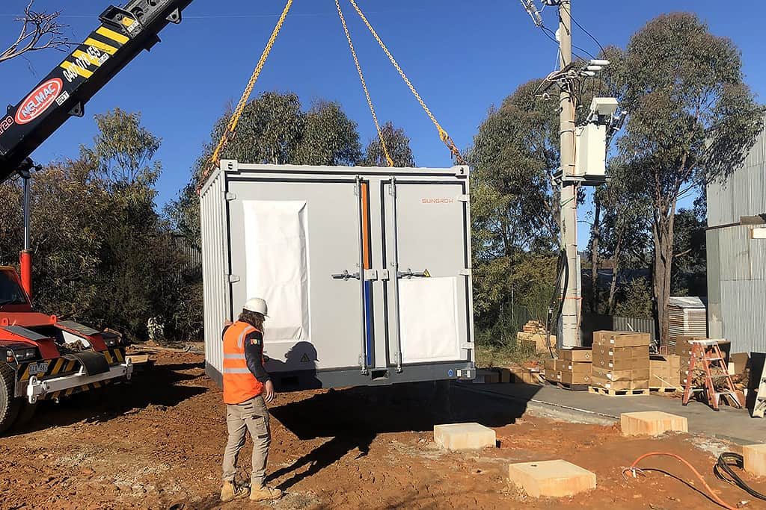

1.1 Energy policy

Energy system transformation
The Australian electricity market is undergoing an unprecedented change, shifting to renewable sources of generation – primarily wind and solar. Aging coal-fired generation units are becoming unreliable, expensive to maintain and uneconomic to operate. Across the country, a number of generator owners have announced that their power stations will close years ahead of schedule.
As old power stations close, we will need new generation capacity and intelligent power management systems to meet Australia’s energy needs. In 2022, the Australian Energy Market Operator (AEMO) called for a nine-fold increase in utility-scale, variable renewable energy capacity and a near five-fold increase in distributed solar photovoltaics (PV), in its Integrated System Plan. To support this increase in renewables, it forecasts that 21 GW of grid-scale batteries are needed to back up renewable supply sufficiently to replace coal-fired generation by 2040.
There is both a climate and an energy imperative for a drastic increase in renewable energy generation in the National Energy Market (NEM). Batteries will play a crucial role in enabling that transition.
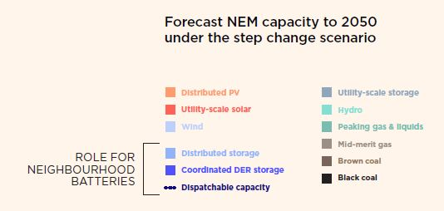
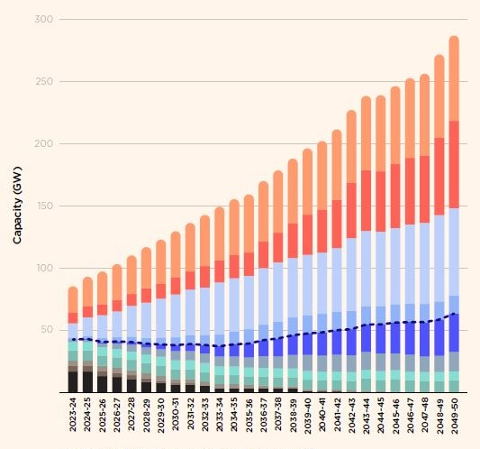

The role of batteries
The parallel development of battery technology and renewable energy holds potential for both large-scale and distributed batteries to solve a host of energy challenges and support the uptake of renewable energy. When coupled with renewable energy, batteries serve to make this energy available when it is needed, replacing fossil fuel generation and enabling higher penetration of variable renewable supply into the grid.
Increasingly, neighbourhood-scale community batteries that can store between 100kW and 5MW are playing a role in the local distribution network. They sponge up excess generation from rooftop solar to prevent voltage issues while storing that energy for later use, thereby smoothing demand and reducing energy costs for the broader community.
Batteries can be installed in a variety of locations and at different scales. In homes and businesses, batteries that are installed ‘behind-the-meter’ (BTM) can be charged directly from the building’s rooftop solar during the day and then supply the building with electricity at night, thereby reducing that site’s demand from the grid and saving on electricity costs. They are not connected to the grid. Neighbourhood scale batteries, by contrast, typically operate in ‘front-of-the-meter’ (FoM). They are linked directly to the local network and are typically operated in a way that supports the whole network’s operations, rather than any one specific site or building. These batteries can buy and sell electricity directly on the wholesale market and owners can be paid for providing network support services.
The energy industry often refers to a ‘battery energy storage system’ or BESS. In this document, we use the simple term, battery.
Due to the technology’s versatility and falling costs, the use of batteries for renewable energy is expected to increase over the coming years. There are already several examples of neighbourhood battery projects either installed or underway in the NEM, as well as grant programs from federal and state governments.
Yarra Community Battery Project
Power Melbourne
Bungarribee community battery by Endeavour Energy
Ausgrid Community Batteries
Victoria’s Neighbourhood Battery Initiative grants

1.2 Roles for councils
Councils can be involved in neighbourhood battery projects in a variety of ways, from ownership or investment, to enabling land access or in-kind support via community engagement and promotion.
The upfront costs of ownership or co-ownership are high and financial returns covering operating costs are uncertain. Grant funding can make the business case more attractive – grants are available from federal and state governments, covering up to 100 per cent of capital costs.
Insight: Understand the context. Councils should review the policy landscape and carefully examine the drivers and priorities for their position before scoping a neighbourhood battery project.
Lighter touch options for councils that prefer not to own a neighbourhood battery but wish to support an initiative proposed by third parties, such as community groups, include:
- identifying areas with high potential for installation
- providing engagement support in affected neighbourhoods
- encouraging neighbourhood batteries within future private developments and retrofits
- securing affordable insurance, which is inaccessible to community groups.
Factors influencing councils’ interest in developing a neighbourhood battery project include:
- existing climate action plans and emissions reduction targets
- risk appetite for capital investment, financial returns and partnering
- capacity to provide initial and ongoing asset management and community engagement
- availability of resourcing; for example, in-house expertise versus outsourcing commercial modelling, technical or engagement expertise.
Once all drivers and potential solutions have been considered, councils may prefer to pursue cheaper or more straightforward alternatives than a neighbourhood battery.
You can learn more about the role of government in the Hip v. Hype report, Neighbourhood Batteries: an opportunities assessment for local government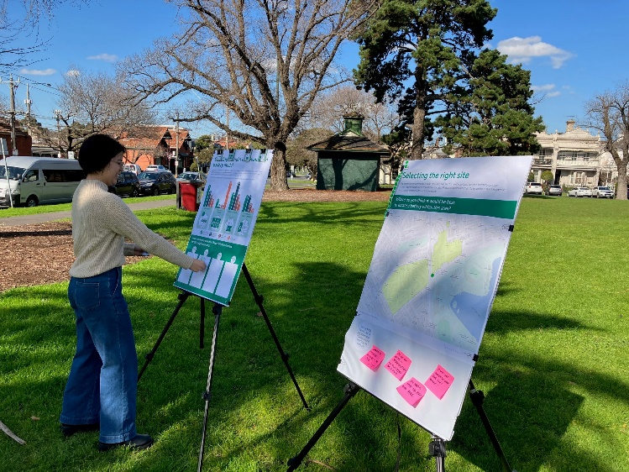
Insight: Clearly articulate why. Councils should consider whether supporting another proponent would fast-track a local neighbourhood battery project, if the council itself has no appetite for ownership, co-investment or substantial ongoing commitment. Third parties may particularly value support with community engagement where there is existing high trust in the council and established, effective channels of communication.
Insight: Have a clear idea of realistic outcomes. Councils may initiate or support a neighbourhood battery project for a range of reasons, such as:
- reducing local energy emissions
- supporting the transition to renewable energy
- addressing local network instability or constraints – reduce brownouts, backup supply
- deriving new revenue streams
- shifting energy – store and use rooftop solar within council facilities
- encouraging local rooftop solar installation
- demonstrating commitment to climate action.
Clarifying these priorities is critical to determining an appropriate ownership and operating model.

1.3 Roles for community groups
Community groups can play a number of roles: leading a neighbourhood battery project, taking part or full ownership, or supporting another proponent’s local engagement and communications.
As active members of the local community, an organised group is arguably closer than any other proponent to the retail customers and aspiring users of a neighbourhood battery. In particular, community organisations are well placed to understand and respond to highly localised matters, such as:
- network issues in the area, such as current and expected future levels of solar penetration and network conditions – brownouts and constraints such as reverse flows
- community preferences, including the location and visual appearance of batteries, associated initiatives such as public EV charging, support for increased household solar or battery storage and energy efficiency measures
- concerns, questions and misperceptions about energy and neighbourhood battery models – for example, clarifying the local appropriateness of virtual storage, membership or co-investment, microgrids or retail plans.
Given the complexity, cost and uncertainty inherent in developing a neighbourhood battery project, community groups should carefully assess the problem they are seeking to solve. Drivers for a community group proposing or supporting a local neighbourhood battery could include:
- reducing emissions
- increasing rooftop solar uptake
- increasing energy reliability.
A neighbourhood battery is not the only solution to any of these problems. Cheaper and more straightforward alternatives include:
- improved energy efficiency
- solar bulk buys
- household battery bulk buys
- purchasing GreenPower
- speaking to their local Distribution Network Service Provider (DNSP) about solutions to network issues.
You can learn more about these drivers and solutions at the Victorian Government Department of Energy Environment and Climate Action.
Insight: Keep learning and sharing. Neighbourhood batteries are an emerging field and even experienced participants are still learning. Community groups can benefit from sharing knowledge early and often with other players in the sector, including community groups that have scoped or participated in a neighbourhood battery or other relevant distributed energy project.
Insight: Plan for ongoing resourcing. Even with substantial grant funding to cover capital costs, neighbourhood battery projects are relatively expensive to scope. They involve specialist technical feasibility studies, data access, connection issues and community engagement. Once operational, batteries generate marginal returns with uncertain payback.
Capacity and resourcing constraints are critical. Be aware that neighbourhood batteries are complex, high cost, financially marginal and require high capability to deliver – for example, partnerships to bring together appropriate experience and technical expertise.
Assess these factors regularly against the project’s intended community benefit and its potential alternatives.
Insight: A flexible approach using multiple tools. Community groups can help fast-track other proponents’ neighbourhood batteries by taking on an advisory role, assisting proponents to understand hyperlocal preferences:
- Ownership – is there a strong belief that councils should not invest?
- Location and land use – not in parkland or in proximity to schools?
- Needs of distinct cohorts – apartment residents, renters, multicultural communities and public housing residents.
Community groups can support proponents to design project communications to ensure they address community interests and information gaps in language appropriate to the community.

1.4 Decision-making considerations
Councils and community groups need to understand and determine policy and priorities under a number of key themes before commencing or progressing a neighbourhood battery project.
Policy and strategy landscape | Ownership models | Operating models | Feasibility | Social licence | Internal capacity
- Define problem: is a neighbourhood battery the solution?  - Determine role for council or community group  - Land use priorities  - Risk appetite – reputational, capital  - Emissions targets | - Full ownership, co-investment or in-kind support  - Funding sought for capital and/or operations  - Who can affordably secure required insurances? | - Solar soaker, emissions-focused or revenue-driven  - Behind-the-meter, front-of-the-meter or both  - Community or other benefit desired | - Technical options  - Financial modelling  - Commercial solution  - Land use options | - Engagement design and scope  - Information and education  - Engagement tools and methods  - Engagement feedback loop | - Sustainable procurement  - Project management  - Asset management and operations  - Capacity to manage one or more battery projects

Section 2 and section 4 of this guide describe these decision-making phases in detail. The scenarios in section 3 map possible sequences and gateways for decisions.

Decision points
Although timelines vary from project to project, key decision points and sequencing of stages will be similar. Stages may overlap; for example, the exploration of ownership and operating models will be informed by policy and strategic considerations. Decisions on these two streams cannot be landed without taking into account the risk appetite for partnering, investment and debt.
Commissioning of detailed feasibility is dependent on deciding preferred ownership and operating models, land use and the distribution of benefits.
Community engagement can commence while feasibility is still underway but must provide clarity on which elements feedback can influence – such as the location, appearance and benefit-sharing approach.
From the earliest stages, organisations must assess their internal capacity, particularly where substantial additional expertise will be required for implementation and ongoing operations.
View the alternative text for detailed description of this image.
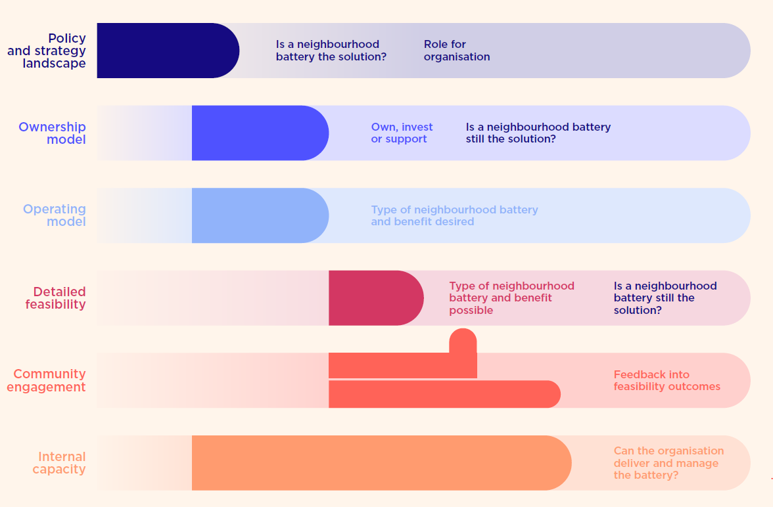

Section 2 – Operating models, commercial considerations and site selection

2.1 Operating models
Battery projects can be designed to deliver a range of different benefits of interest to councils and community groups. You must design the project model to deliver the benefit you are targeting.
- Support more renewable energy in the network: Renewable energy generation is variable by nature. Batteries are a way of shifting generation to times when it is more needed or of higher market value. In doing so, it supports an increase in renewable generation.
- Increase the resilience of the network: Storing electricity during times of surplus and discharging it during high-demand events can smooth the demands on the local network and reduce the risk of network failure.
- Reduce network costs: Storing electricity during times of surplus and discharging it during high-demand events can delay or avoid the need for expensive network upgrades – the cost of which would be passed onto network users
- Generate revenue: Financially responsible market participants (FRMPs) who operate batteries can generate revenue via energy arbitrage and network auxiliary services.
Insight: The benefit is driven by the operating model. The first step in choosing an operating model is to clearly understand the rationale for a neighbourhood battery and have a realistic picture of the benefits it can deliver.
What problem are you attempting to solve and which benefits do you wish to realise? This understanding should underpin your choice of operating and ownership model.
We classify operating models into four broad categories, which can overlap:
- solar sponge
- financially focussed
- services-based
- community support services.
This graphic gives an indicative weighting to four different benefit categories across the models. We developed this graphic and these categories for our community engagement activities to demonstrate the benefits and trade-offs that can be designed into various models. For example, in the financially focussed model the battery is less likely to support network resilience or reduce network costs given the algorithm is designed to optimise financial returns above any other potential benefit.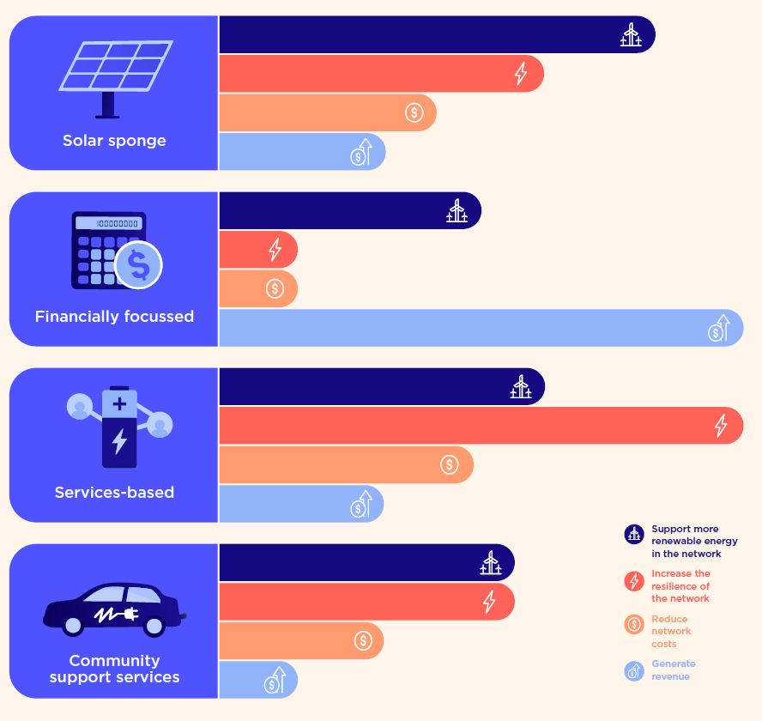

Solar sponge
Under the solar sponge operating model, the battery charges during peak solar generation periods and discharges in the evening – ideally in the peak demand period. Its goal is to maximise the generation and consumption of solar energy within a neighbourhood.
A rules-based schedule can be set to limit revenue loss – for example, by avoiding charging when prices are above $300/MWh and discharging when prices are below $0/MWh. By charging and discharging at 50 per cent power, the duration of the battery – and the period it is supporting the network – is doubled. It extends the time period the battery can capitalise on price troughs and spikes.
Advantages: Solar sponge is predictable, simple and low risk. It extends battery life and improves the local network’s ability to accommodate rooftop solar exports.
Disadvantages: It lacks the dynamic flexibility to achieve the best market returns possible. Using rules to determine when to dispatch the system does not allow the use of active foresight to reserve storage capacity for anticipated price spikes. Running the system at 50 per cent power reduces exposure to both favourable and unfavourable market events.
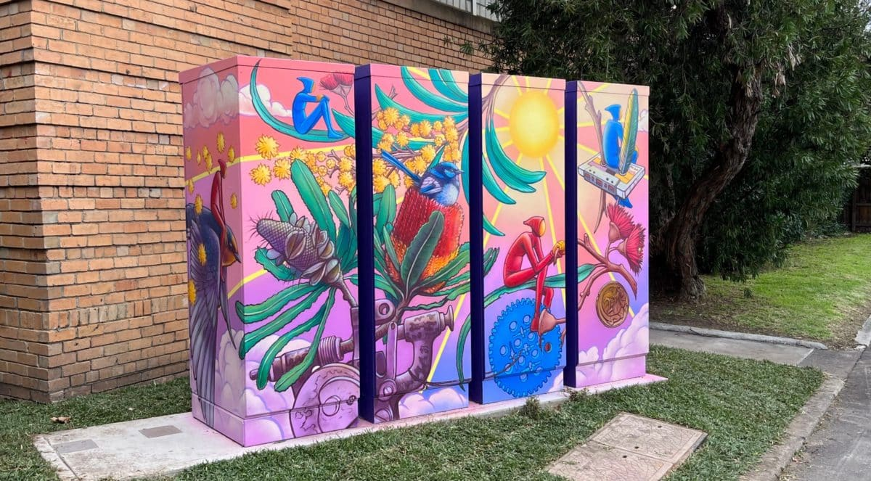

Case study: Yarra Energy Foundation’s Fitzroy North community battery
The battery is located at 193-205 McKean Street, Fitzroy North, in Melbourne’s inner north. The project was funded by the Victorian Government’s Neighbourhood Battery initiative. It has a simple operating model of trading on the electricity market (arbitrage) through retailer/aggregator Acacia Energy, the Financially Responsible Market Participant of the system.
CitiPower introduced a trial tariff for community batteries that became effective on 1 July 2022. This tariff is bi-directional and allows the battery to earn an income by charging and discharging at times that support the network. Its daily dispatch rules vary slightly through the year but generally consist of charging from 11 am to 4 pm, discharging from 5 pm to 9 pm, idling overnight and, at times, residually discharging in the morning peak.

Financially focussed
A profit-optimised operating model is one in which the battery is automatically dispatched to capitalise on energy arbitrage opportunities based on a short-term price forecast. This kind of dispatch engine is sometimes referred to as an optimiser. It aims to optimise the battery’s financial performance by anticipating future energy prices, given the battery’s technical parameters and settings and the trade-off between participating in different markets such as energy and Frequency Control Ancillary Services.
For example, if a high-pricing event is anticipated from 7 pm to 8:30 pm, the optimiser might choose to delay discharging the battery until then to ensure it has enough energy to capitalise on it. In some ways, using an optimiser requires less oversight than a rules-based schedule because responsibility for dispatch behaviour can be devolved to software with the understanding that it should perform more effectively.
Advantages: A financially focussed model is likely to generate the best financial outcomes of any model, assuming the council or community group has an ownership share in the battery and optimiser software is operated effectively.
Disadvantages: Its software is complex and depends on accurate data inputs, especially price forecasts. It only indirectly supports renewable energy uptake in the local low-voltage network, because charging and discharging are aligned to price events rather than surplus renewable generation.

Services-based
A services-based operating model is one in which the battery is sited and operated in a way that delivers benefits to the local network. This can include being placed in an area with existing network constraints and helping to increase its resilience and reduce the risk of network failures.
It may also help to alleviate the need for expensive network upgrades, the cost of which would be passed through to consumers via network charges.
Advantages: A services-based model can improve the resilience of local networks and avoid network costs to consumers.
Disadvantages: The benefits of cost reduction are only indirectly passed through to councils and community groups. The network owner is the primary beneficiary. This model only indirectly supports renewable energy uptake in the local low-voltage network, because charging and discharging are aligned to network requirements rather than using surplus renewable generation.

Community support services
This model seeks to use neighbourhood batteries for community benefit by installing the battery at a site with high community utility – for example, neighbourhood houses, sporting clubs or libraries. A combined metering arrangement can allow the battery to provide both behind-the-meter (BTM) benefits as well as generate front-of-the-meter (FoM) revenue by trading in energy markets.
Sites with excess solar PV during the day could realise BTM benefits by using the battery to store energy for use at night when the facility is occupied. EV charging linked to the battery can also be used to generate revenue in inner urban areas where off-street parking is limited and public charging infrastructure is sparse.
Advantages: Sites of community value and their tenants stand to benefit directly from BTM battery services. Any gains can be reinvested into the tenant’s service offering. If the battery uses a combined metering arrangement, then FoM revenue generation is also a possibility and can be shared with the community.
Disadvantages: Financial returns are more uncertain. There is a trade-off between BTM benefits and FoM market participation and revenue generation.

Hybrid models
The operating models discussed above pursue distinct goals. A hybrid model that combines these objectives could allow operators greater flexibility than selecting an operating model with a singular focus.
Hybrid models pursuing multiple operational objectives can be useful in circumstances where stakeholders have more than one objective for the battery.
Advantages: Stakeholders or owners can choose an operating model that targets multiple benefits. For example, a council with both climate targets and a commitment to achieve a return on investment can choose an operating model that targets revenue generation during periods of high renewable generation in the grid.
Disadvantages: Successfully targeting multiple objectives can be problematic. If the two objectives involve conflicting ways of operating the battery, then neither objective may be realised.

2.2 Ownership models
There is a huge variety of possible combinations of operators, owners and stakeholders in a neighbourhood battery project. Councils and community groups need to understand how they can best provide value and support to the project. This may be different depending on the type of owner and operator model chosen for the project. Table 1 outlines ownership options and considerations for neighbourhood batteries.
Table 1: Ownership and operator considerations for various stakeholders
Stakeholder | DNSPs | Retailers | Non-profits and social enterprises | Community groups | Public institutions | Local government | Commercial businesses
Has sufficient technical expertise and resourcing | Yes | Yes | Maybe | Challenging | Challenging | Maybe | Yes
Has effective and robust governance structures | Yes | Yes | Yes | Challenging | Maybe | Yes | Yes
Can participate in energy market | No | Yes | Through a FRMP | Through a FRMP | Through a FRMP | Through a FRMP | Yes
Is trusted by community | Challenging | Challenging | Yes | Yes | Yes | Yes | Challenging
Can take on financial risk | Yes | Yes | Maybe | Challenging | Maybe | Maybe | Yes
Can develop and manage project | Yes | Yes | Yes | Challenging | Yes | Yes | Yes
Source: Yarra Energy Foundation, ‘Fast-tracking neighbourhood batteries – site prioritisation report for councils’, unpublished.
Note: Distributed Network Service Providers (DNSPs) are owners of the local network. Financially Responsible Market Participants (FRMPs) are electricity retailers or other entities authorised to buy and sell electricity.

Owner-operator arrangements
There are different ways to manage ownership and operation. Broadly, there are three kinds of arrangements:
- The owner-operator is responsible for dispatch control, reporting and maintenance.
- The owner contracts an operator to dispatch by the owner’s rules and at a cost to the owner.
- The owner leases the battery to an operator for a fee.
The most appropriate arrangement will depend on the organisation’s risk appetite, funding availability, resourcing capability and the type of benefits sought.
Table 2: Advantages and disadvantages of various owner-operator models
Example arrangement | Owner | Operator | Description | Advantages for councils/community groups | Disadvantages for councils/community groups
Single owner-operator | Retailer | Retailer | Council supports a retailer to implement a neighbourhood battery in its LGA (Local Government Area) | - No liability for project/asset  - Leverages private capital  - Minimal financial contribution required  - No additional resourcing or expertise required  - Pathway to scaled deployment | - Minimal influence on operations and outcomes (e.g. environmental and community benefits)  - No economic return  - Reduced benefits from capacity-building, reputation and community element
Council ownership with contracted operator | Council | Retailer | Council facilitates neighbourhood battery implementation and contracts operation to a third-party FRMP | - Retain influence over operations  - Receive financial returns  - Opportunity for significant capacity-building, knowledge-sharing, reputation benefits, and community engagement  - Can cite neighbourhood battery outcomes towards strategic objectives | - Liable for operating expenses (and/or contracted operating fees)  - Engenders some financial risk  - Resourcing/capacity required to monitor and liaise with operator
Private partnership | Asset developer | Retailer | Council supports project development with asset developer, which contracts operation to a third party FRMP | See Single owner-operator | See Single owner-operator
DNSP ownership, leased to operator with council partnership | DNSP | Retailer and council partnership | Council supports a neighbourhood battery project led by DNSP, which then leases the battery to a retailer/council partnership | - Maintain influence over operations and outcomes with much-reduced risk/liability  - Reduced requirement for technical resourcing/capacity due to retailer partnership  - Streamlined project delivery through partnership with DNSP | - Potentially competing interests or divergent values between DNSP, retailer and council  - May be challenging to establish partnerships that benefit all parties  - Minimal economic return  - Potentially complex contractual agreements required
Community ownership | Co-operative or community group | Retailer | As part of a neighbourhood battery project, council supports the establishment of a community co-operative which contracts operation to a third-party FRMP | - Reduced liability for council  - Direct engagement with, and benefits for, community members  - Innovative model and industry leadership | - Increased liability for community group  - Financial risk for co-operative may implicate council  - Co-operative may require ongoing council support given uncertain technical and commercial capability/capacity
Equity investment | Equity investors | Retailer | Council sources equity investment in a neighbourhood battery; council and the investor group contract operation to a third-party FRMP | - Reduced liability for council  - Innovative model and industry leadership  - Leverages private capital  - If successful, potential for scaled deployment | - Minimal influence on operations and outcomes (e.g. environmental and community benefits)  - No or reduced economic return  - Unlikely to deliver return on investment
Source: Yarra Energy Foundation, ‘Fast-tracking neighbourhood batteries – site investigations’, unpublished.

2.3 Site selection
The best site for a project will depend on the ownership and operating model; for example, a detailed geographic analysis is necessary under a solar sponge model, because it relies on excess solar generation in a particular area. Table 3 details the actions required to select sites depending on your model. It builds on the information in Table 2. In the following analysis, we assume that any arrangement without council or community group ownership will locate its battery on private rather than council land.
Table 3: Selecting appropriate sites, according to ownership and operating model
Ownership arrangement | Owner | Operator | Description | Actions required under solar sponge model | Actions required under financially focused model | Actions required under services-based model | Actions required under community support services model
Single owner operator | Retailer | Retailer | Council supports a retailer to implement a neighbourhood battery in its LGA | N/A – site chosen by retailer | N/A – site chosen by retailer | N/A – site chosen by DNSP | N/A – site chosen by retailer
Council ownership with contracted operator | Council | Retailer | Council facilitates neighbourhood battery implementation and contracts operation to a third-party FRMP | - Geographic analysis  - Identify council/community-owned site with the required physical site characteristics  - Community engagement | - Identify council/community-owned site with the required physical site characteristics  - Community engagement | N/A – site chosen by DNSP | - Identify council/community-owned site with the required physical site characteristics  - Community engagement
Private partnership | Asset developer | Retailer | Council supports project development with asset developer, which contracts operation to a third-party FRMP | N/A – site chosen by asset developer | N/A – site chosen by asset developer | N/A – site chosen by DNSP | N/A – site chosen by asset developer
DNSP ownership, leased to operator with council partnership | DNSP | Retailer and council partnership | Council supports a neighbourhood battery project led by DNSP, which then leases the battery to a retailer/council partnership | N/A – site chosen by DNSP | N/A – site chosen by DNSP | N/A – site chosen by DNSP | N/A – site chosen by DNSP
Community ownership | Co-operative or community group | Retailer | As part of a neighbourhood battery project, council supports the establishment of a community co-operative which contracts operation to a third-party FRMP | - Geographic analysis  - Identify council/community-owned site with the required physical site characteristics | - Identify council/community-owned site with the required physical site characteristics | N/A – site chosen by DNSP | - Identify council/community-owned site with the required physical site characteristics
Equity investment | Equity investors | Retailer | Council sources equity investment in a neighbourhood battery; council and the investor group contract operation to a third-party FRMP | N/A – site chosen by equity investors or retailer | N/A – site chosen by equity investors or retailer | N/A – site chosen by DNSP | N/A – site chosen by equity investors or retailer

2.4 Geographic analysis
The aim of geographical analysis is to determine current and future locations for neighbourhood batteries.
It prioritises the role of local solar generation and storage as a primary consideration for site selection. Existing solar installations across the municipality are mapped, via a desktop review, to determine the potential for neighbourhood battery storage.
The viable regions are low-voltage networks that have:
- a high proportion of residential customers
- existing or future potential for solar PV
- low daytime demand
- evening or overnight peak demand.
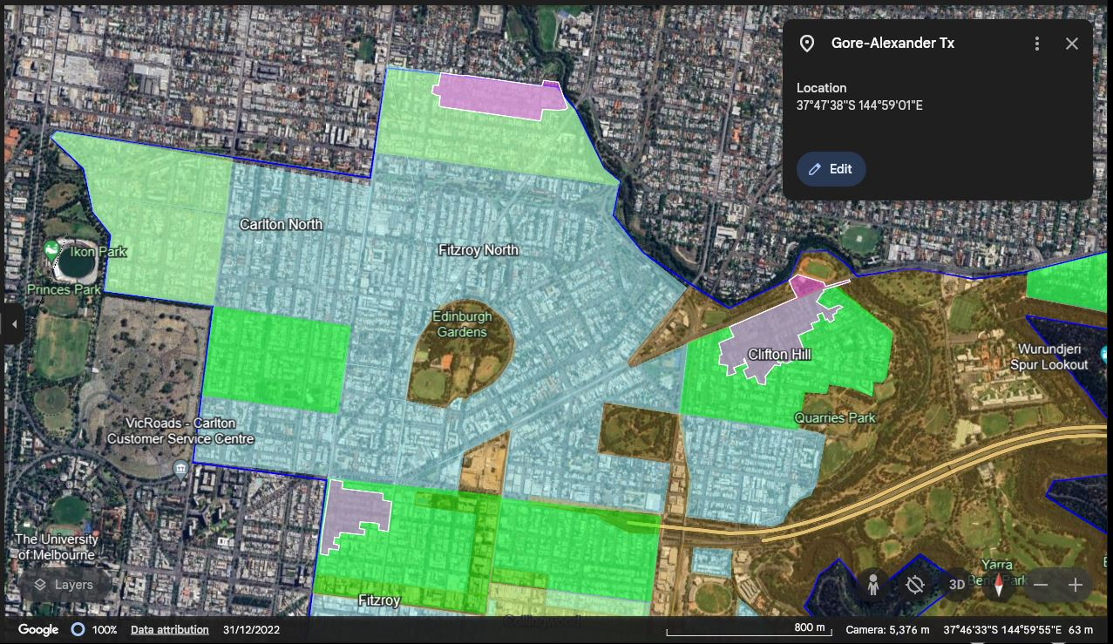

Fast-tracking neighbourhood batteries project: geographic analysis
Yarra Energy Foundation's geographic analysis of the three partner municipalities determined that the Cities of Yarra and Port Phillip have greater residential solar penetration and capacity compared to the City of Melbourne and would, therefore, be more suitable for batteries using the solar sponge operating model.
The analysis identified optimal locations for batteries in the low-voltage networks of all three municipalities, with regard to existing network infrastructure and with minimal disruption to public amenity.
The image shows part of a map that displays increasingly detailed layers of data, including viable areas, areas of strong potential and low-voltage networks with distribution transformers marked.
Insight: Seek advice from specialists. A thorough geographic analysis requires specialist skills and the use of data that is not necessarily available to most community groups or councils. Consultant assistance is likely required.
Insight: Choose sites that enable replicability. Using a geographic analysis to select a neighbourhood battery location aligns with projects seeking to support the roll-out of renewable energy, especially the solar sponge model.
Insight: Simple is better. The geographic analysis needs to be considered in combination with physical site considerations to form a holistic view of site suitability.

2.5 Physical site considerations
To determine whether specific sites are suitable to host a neighbourhood battery, you must consider various overlays, regulations and laws.
When a battery is located on council land or assets, councils will also consider competing priorities, such as public access for recreation or impacts on parking and road use.
The following table, prepared by electricity distributor Powercor, summarises potential planning application processes that may need to be considered as a part of a site assessment. The table was not written for inner metropolitan sites specifically, but the general principles are directly applicable.
Table 4: Planning application processes
Assessment | Reason | Application for neighbourhood batteries
Environmental overlays | Identifying potential impacts to any known or anticipated sites of environmental significance | May lead to added controls on the battery  Lifecycle of the project needs to be defined
Flood overlays | Apply to land identified as carrying flood flows associated with waterways and open drainage systems including land subject to inundation | Most batteries are rated against certain water penetration and are installed on an elevated rigid base such as a concrete footing  These measures are not intended to protect against the risk of inundation
Cultural heritage | Protecting Aboriginal Cultural Heritage in Victoria and recognising Aboriginal people as the primary guardians, keepers and knowledge holders of Aboriginal cultural heritage | A cultural heritage management plan may be required if the neighbourhood battery site is located in an area of cultural heritage sensitivity
Native title | Recognition by Australian law that some Indigenous people have rights and interests to their land that come from their traditional laws and customs | Needs to be considered as part of a site selection criteria, particularly for sites on Crown Land
European heritage | Manage places with heritage significance to the local area | Depending on the location for the battery, it may require approval from Heritage Victoria to ensure heritage places and objects are not impacted
Bushfire overlays | Identifies land that may be significantly affected by extreme bushfires | Locations in hazardous bushfire risk areas will need to mitigate bushfire risk
Amenity impacts | Protecting built form, neighbourhood character and liveability | The size of the land needed depends on the size of the battery itself as well as other requirements including necessary clearances  Batteries may emit an audible hum during charging and discharging or there may be noise from a fan as part of the cooling system  Clearances between a battery and a property typically recommend a minimum of 7.5 m depending on the size of the battery and the outcomes of acoustic studies of the noise impacts  Visual amenity impacts can be managed by vegetation or other screening or painted surfaces.
Source: Powercor, 2022, The Powerful Neighbours Report.

Section 3 – Internal capacity considerations
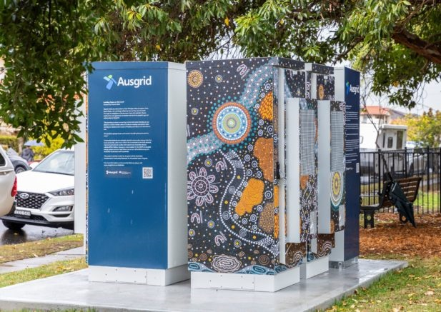

3.1 Commissioning feasibility and implementation
The feasibility of a project and the resourcing it requires are shaped by its ownership and operating model. In Table 5, we summarise these requirements for councils and community groups wishing to become stakeholders in a neighbourhood battery project.
Table 5: Feasibility requirements
Arrangement | Owner | Operator | Description | Effort and resourcing | Council and community group feasibility requirements
Single owner-operator | Retailer | Retailer | Council supports a retailer to implement a neighbourhood battery in its LGA | Minimal | - Understand the project  - Gauge community reactions and expectations
Council ownership with contracted operator | Council | Retailer | Council facilitates neighbourhood battery implementation and contracts operation to a third-party FRMP | Significant | - Energy consultant advice to develop operating model  - Secure council capital budget and ongoing operational budget  - Secure external grant funding  - Tender for operator partner and battery installation  - Financial modelling  - Community engagement  - Site selection and feasibility with regard to:  - battery specifications  - site load  - operating model  - planning and heritage restrictions  - low-voltage network connection point  - DNSP engagement  - Legal consultant advice during contract negotiations
Private partnership | Asset developer | Retailer | Council supports project development with asset developer, which contracts operation to a third-party FRMP | Minimal | - Understand the project  - Gauge community reactions and expectations
DNSP ownership, leased to operator with council partnership | DNSP | Retailer and council partnership | Council supports a neighbourhood battery project led by DNSP, which then leases the battery to a retailer/council partnership | Moderate | - Community consultation  - Advocate for specific community benefits or share in revenue  - Due diligence on retail partner  - Secure budget for ongoing resourcing requirements  - Legal/contract advice to support the arrangement
Community ownership | Co-operative or community group | Retailer | As part of a neighbourhood battery project, council supports the establishment of a community co-operative which contracts operation to a third-party FRMP | Moderate | - Legal/contract advice to support the arrangement and minimise risk to council  - Advocate for specific community benefits or share in revenue  - Secure budget for ongoing resourcing requirements
Equity investment | Equity investors | Retailer | Council sources non-community equity investment in a neighbourhood battery; council and the investor group contract operation to a third-party FRMP | Minimal | - Understand the project  - Gauge community reactions and expectations

Insight: You will almost certainly need grant funding. Given the economic case for neighbourhood batteries is still highly uncertain, any council or community group seeking an ownership stake will almost certainly need grant funding to proceed.

3.2 Scenarios
You’ve got an idea for a battery, but how do you make it happen? Who else do you need to get involved? In the following two scenarios, we outline key issues and decisions made by a community group and a council as they develop battery projects.

Scenario 1: A community group proposes a neighbourhood battery, supported by the local council
As its next major project, a local renewable energy community group decides to install a neighbourhood battery. The project will demonstrate to local residents how battery storage can feed locally generated rooftop solar into the grid, increasing the proportion of renewable energy available and even earning a small amount of revenue. During preliminary research to develop a grant application, they scope potential sites, as well as the support and partnerships they’ll need to install and operate the battery.
Support from the council is vital to the project’s success. It is secured through a series of detailed discussions, contingent on the community group demonstrating the capacity to manage ongoing operations and strong local community support for the selected site.
Step number | Decision category | Action
1 | Policy and strategy landscape | You research the policy landscape, including the council’s position on renewable energy and neighbourhood batteries.
2 | Policy and strategy landscape | Council informs you it doesn’t wish to own or invest, but will secure insurances and allow you to lease the land, contingent on some specifics.
3 | Policy and strategy landscape | Council offers you support – expertise and resourcing – in planning and engagement prior to installation phase.
4 | Ownership model | Your community group decides to own the battery, with government grant and philanthropic funding. You request to lease council land.
5 | Detailed feasibility | You prepare to submit a grant application, which includes analysis of solar penetration and a shortlist of sites that maximise solar sponge potential to retain renewable electricity in the local area and allow more residents to install solar PV.
6 | Detailed feasibility | You identify the battery operator you will partner with.
7 | Community engagement | You did a letterbox drop and surveyed local residents in shortlisted neighbourhoods. There’s a small but positive response, but you haven’t contacted business or visitors.
8 | Operating model | You determine the battery will be operated to generate financial returns. A significant portion of the revenues will be delivered to your community group. The remainder will be shared with the battery operator.
9 | Detailed feasibility | Council confirms potential to lease all but one of your proposed sites. You conduct detailed feasibility of the possible sites.
10 | Detailed feasibility | You determine the best site, via the feasibility process.
11 | Community engagement | With the council, you engage the community in this neighbourhood, reaching other stakeholders beyond the survey. Council support is contingent on neighbourhood community endorsement.
12 | Community engagement | Council confirms community feedback meets its benchmark and identifies issues that came up. Your group commits to continue communication about these issues during installation and to provide information online.
13 | Internal capacity | You demonstrate ongoing capacity to manage operations. Your group strikes an agreement with council to lease the site. Council confirms its support for your group proceeding with the neighbourhood battery as proposed.

Scenario 2: A council pilots a neighbourhood battery at a local sports ground
A council is refurbishing clubrooms and facilities at a local sports ground it owns, which is operated by a tenant. The council decides to explore a neighbourhood battery as part of the project scope. The clubrooms have an existing solar array that will be increased as part of the refurbishment project. Following the refurbishment, all the facilities will be electric. The council wants to reduce municipal emissions, encourage solar uptake in residential neighbourhoods and, wherever possible, include storage capacity at all council-owned facilities with a large solar array.
Step number | Decision category | Action
1 | Policy and strategy landscape | Council establishes policy position on renewable energy and neighbourhood batteries.
2 | Operating model | Its position aligns with its climate action strategy, requiring a rapid transition to renewable energy at all council facilities
3 | Internal capacity | Whole-of-life sustainability considerations, including recyclability, are already embedded in existing sustainable procurement practices.
4 | Ownership model | Council prefers to own or co-own in order to operate both behind-the-meter and front-of-meter.
5 | Detailed feasibility | Revenues will be shared with the battery operator.
6 | Community engagement | In early discussions with the tenant and site users, council agrees to explore including public EV charging associated with the battery in the project scope.
7 | Detailed feasibility | The proposed operating model will soak up solar electricity produced during daily peaks and sell any excess not used by building during the evening.
8 | Policy and strategy landscape | Any residual revenues will be shared with the community through an existing grant for energy efficiency measures (adding a funding stream to an established scheme).
9 | Detailed feasibility | Preliminary financial modelling indicates Council will need government grant funding for the project to be financially viable, given high up-front and capital costs. It starts the application process.
10 | Detailed feasibility | Council conducts a detailed feasibility study of locations around clubrooms to determine the best site, as well as the solar array and switchboard upgrades. It models revenues and payback periods and scopes incorporating a public EV charger.
11 | Community engagement | Council engages the local community, including residents, businesses and neighbourhood sustainability groups. It targets key stakeholders for deeper engagement, including the tenant and local sports clubs who have been advocating to council for the all-electric clubroom refurb.
12 | Community engagement | The community overwhelmingly endorses the neighbourhood battery as part of the refurb and wants Council to create learning materials for local schools and sports clubs to better understand the initiative. Most respondents prefer installation of an EV charger to revenues being distributed via community grant fund.
13 | Internal capacity | Council determines the management structure for ongoing operations – it is incorporated into asset management and business-as-usual for the infrastructure team.

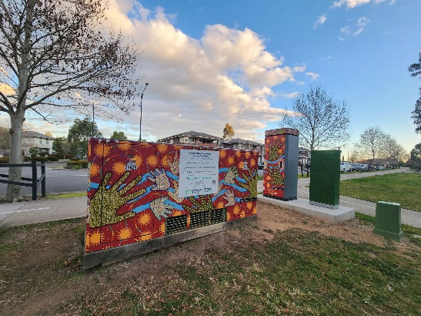

3.3 Ongoing resourcing requirements
Installing a neighbourhood battery takes a lot of effort and energy, but the job isn’t done when you’re ready to switch it on. You need to plan for how you’ll keep it running in the long term. The level of complexity depends on your ownership and operating models.
Table 6: Ongoing resourcing for neighbourhood batteries
Arrangement | Owner | Operator | Description | Effort and resourcing | Council/community group ongoing resourcing requirements post-installation
Single owner-operator | Retailer | Retailer | Council supports a retailer to implement a neighbourhood battery in its LGA | Minimal | Minimal to none; if battery is sited on council land, then some liability management may be required
Council ownership with contracted operator | Council | Retailer | Council facilitates neighbourhood battery implementation and contracts operation to a third-party FRMP | Significant | Council will need to allocate ongoing resourcing to support the retailer partnership and ensure that targeted benefits are realised/passed through to the community
Private partnership | Asset developer | Retailer | Council supports project development with asset developer, which contracts operation to a third-party FRMP | Minimal | Minimal to none; if battery is sited on council land, then there some liability management may be required
DNSP ownership, leased to operator with council partnership | DNSP | Retailer-council partnership | Council supports a neighbourhood battery project led by DNSP, which then leases the battery to a retailer-council partnership | Minimal | Minimal ongoing resourcing required to support contractual relationship between retailer and council
Community ownership | Co-operative or community group | Retailer | As part of a neighbourhood battery project, council supports the establishment of a community co-operative, which contracts operation to a third-party FRMP | Significant | The community group or co-operative will need ongoing funding and personnel to administer the battery’s financial liability, support the retailer partnership and ensure that targeted benefits are realised/passed through to the community
Equity investment | Equity investors | Retailer | Council sources non-community equity investment in a neighbourhood battery; council and the investor group contract operation to a third-party FRMP | Minimal | Minimal to none; if battery is sited on council land, then some liability management may be required

Section 4 – Social licence
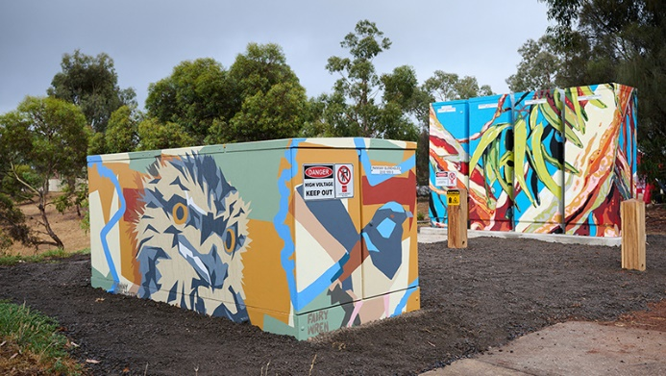
For the long-term success of this work, it is vital to nurture the development of social licence. It ensures the community understands the project and has confidence that it aligns with local interests and priorities. It reduces the likelihood of misunderstandings that lead to a lack of support.
To build social licence for your neighbourhood battery project – or any innovative renewable energy initiative – you must run an engagement process that develops the community’s capacity to participate in the conversation. You need to foster the community’s understanding of the options available and their capability to identify preferred sites, types of benefits and project delivery models.
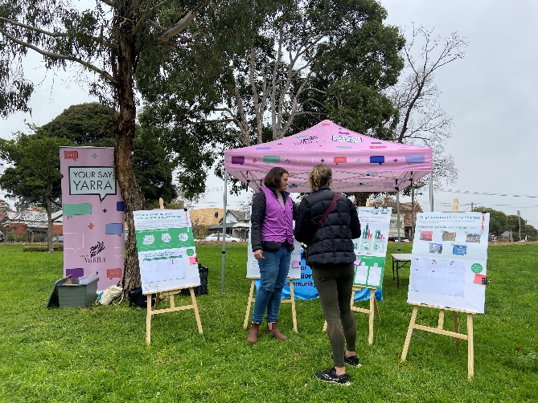

Fast-tracking neighbourhood batteries project: engagement principles
The partner councils set out to design and deliver engagement that ensured community members were:
- encouraged to provide input and direction into the potential sites of neighbourhood batteries in their municipality
- motivated to remain engaged with their local council
- engaged in providing input into future battery initiatives.
A core objective of our initial engagement strategies – an online survey, focus groups and interviews – was to build the community’s understanding of the purpose and benefits of neighbourhood batteries and the tangible ways people could participate. This knowledge formed a foundation for deeper dialogues in the next stage. To test and confirm preferences and explore how the community would like to be involved, we ran neighbourhood activations within the shortlisted areas and trained Community Champions to hold conversations in their networks.

4.1 Engagement design
High-quality, well-planned and executed engagement – ideally that aligns with the IAP2 framework – takes time and dedicated resources, including staff, which not all councils or community groups will be able to access. This is particularly true where the engagement aims to reach beyond the usual suspects who connect with councils about sustainability or energy projects and, instead, hear from more diverse voices.
Given the diverse makeup of every neighbourhood and the variety of preferences and priorities that may be expressed by communities in each, it is vital that engagement not only seeks broad, municipality-wide views but also dives deeper into neighbourhood-specific needs and concerns that may impact interest and support for a neighbourhood battery.
Authentic engagement requires proponents and partners to be open about what the community can influence at each stage of the consultation; for example, which elements of the project are negotiable or non-negotiable. Uncertainties should be explained and contextualised, so participants understand why certain technical information is not available at a specific phase. Detailed feasibility is required to accurately scope potential locations and, at early stages of engagement, answers to some questions may not be available.
Transparency – including what is known and what is still to be developed or discovered – can reassure participants of the genuineness of the engagement and build trust that the project will continue to respond to community questions or concerns and share timely, accurate information.
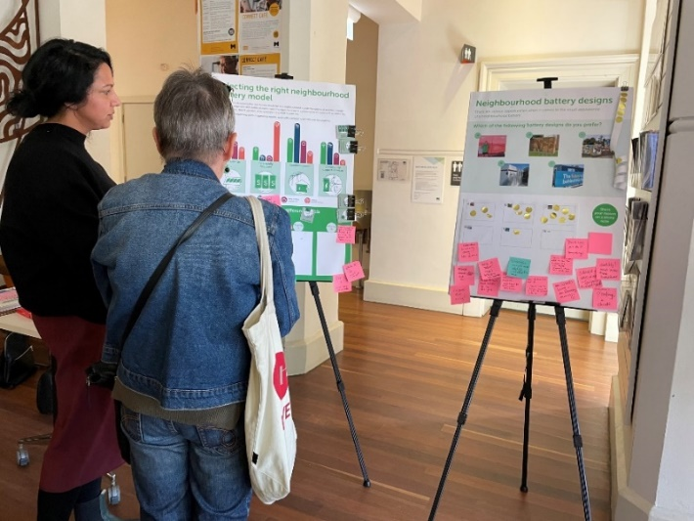
Insight: Each neighbourhood is different. Projects should design and deliver engagement that reaches into the impacted neighbourhoods and seeks to understand hyperlocal views.
Insight: A flexible approach is required. Projects should design and deliver engagement that is flexible enough – with strategic design, multiple tools and adequate time – to adjust to the learnings gained as the engagement rolls out.
Insight: A flexible approach is required. Partnering with trusted organisations can improve and amplify the design and delivery of high-quality engagement. Councils can support community groups and other proponents by lending engagement capacity. Community groups can help councils reach less-often-heard cohorts.
Community Champions participating in workshops, 2023
Images: Aspire Pictures

Fast-tracking neighbourhood batteries project: community champions
In neighbourhoods that demonstrated high technical potential for a local battery, we explored a range of themes with community members. We had not yet undertaken detailed feasibility, so many features remained uncertain – for example, installation locations, visual appearance of the battery units and ancillary services such as EV charging.
We planned our activities to open up conversations about the range of operating models available and the types of community benefits neighbourhood batteries can deliver. If we had already chosen the location, we would have required a different design approach so that the scope of community influence was transparent.
We used a range of tools, including online surveys and in-person pop-up activations in targeted neighbourhoods, as well as recruiting a pool of Community Champions. These volunteers represented the diversity of the community across the municipalities. Following a series of deep-dive discussions, workshops and training the champions engaged in informed conversations within their personal and professional networks, supported with a bespoke conversation toolkit and a dedicated project point of contact.
The involvement of the Community Champions expanded the reach of our consultation and enabled deeper conversations that engaged with hyperlocal concerns. It helped us understand the motivations behind questions and concerns, and, ultimately, build the community’s capacity to participate confidently in the renewable energy transition.
Insight: A flexible approach is required. Projects should consider engagement approaches that go beyond intercept or transactional activities, where the intent is to engage with the community on themes that require long-term, trust-based relationships to build buy-in or social licence.
Community Champions participating in workshops, 2023
Images: Aspire Pictures
More information about the engagement design, delivery and Community Champions program is available at:
City of Port Phillip – neighbourhood batteries
City of Yarra – neighbourhood batteries
City of Melbourne – Power Melbourne

4.2 Information and education
Neighbourhood batteries are complex projects. Most community members are likely to have limited experience or knowledge of this new technology, let alone the various ways it can be designed, depending on your priorities. You need to support community members to develop their knowledge in order to participate actively and provide informed responses.

Fast-tracking neighbourhood batteries project: community interest and expectations
The project team quickly encountered participants with very different levels of baseline knowledge – from virtually zero to highly experienced – but we noted a great thirst to learn more, regardless of prior experience.
People’s support for, or scepticism about, neighbourhood batteries also didn’t influence their desire to learn more and stay connected with the project. Overall, support was consistently high. A small proportion of participants were unsure and wanted more information, or didn’t support a neighbourhood battery in their local area.
The community demonstrated a high degree of trust in councils to provide dispassionate, accurate information that improved general knowledge about the energy system. They expected us to engage openly and authentically, particularly around the uncertainties councils face and the scope of community influence.
In designing the project engagement approach, we assumed a lower baseline level of interest and underestimated people’s appetite to learn rapidly about operating models, social benefits, energy markets, emerging technology and the renewable energy transition.
We also underestimated the degree of myth-busting required to address preconceptions about battery storage and unrealistic expectations about the community benefit that mid-scale batteries can deliver. People didn’t understand how new and uncommon neighbourhood batteries are in Australia.
Project materials and activities were designed to assist any community member to participate in the engagement and provide informed opinions on the themes under exploration. We updated materials such as online FAQs and handouts responsively, based on questions raised by community members, as the series of activations rolled out across 15 neighbourhoods and as our project teams learned more about effective ways to communicate complex concepts.
Insight: A complex topic – use plain language. Projects should ensure engagement and information campaigns are supported with materials in varying formats – hard copy and online, text and graphics, translated into various languages – and unpack technical jargon in plain language to maximum Year 8 reading level.
Insight: Multiple tools to build understanding. Projects should ensure that technical and engagement experts collaborate to develop accessible information materials that support the community on a learning journey about neighbourhood batteries and the energy transition.
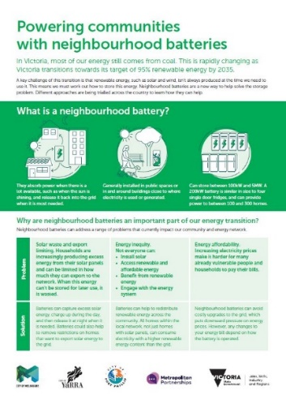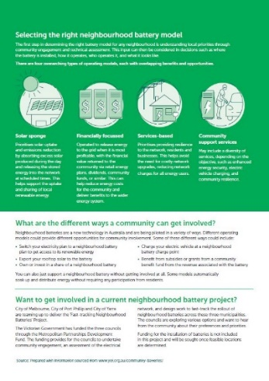

4.3 Placemaking
There are substantial placemaking opportunities associated with a neighbourhood battery; however, doing it well requires planning and ongoing resourcing. Community members engaged with battery projects often express a desire for the units to become talking points, teaching tools and a source of civic pride.
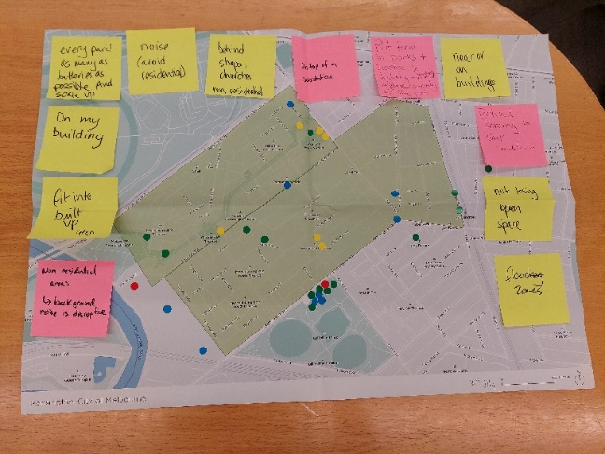
Insight: Each neighbourhood is different. Projects should ensure that the local community is consulted about the educative value of a battery project. Where relevant, support people’s desire to learn more – via the design of both the battery unit and ongoing communications around it.
Insight: People are supportive but may hold misconceptions. Projects should proactively communicate about potential sites and manage expectations regarding compromises that may need to be made.

Fast-tracking neighbourhood batteries project: education and revitalisation
Many engagement participants saw the installation of a neighbourhood battery as an opportunity to educate people about renewable energy, emissions reduction and climate action.
They wanted the councils to leverage the presence of a battery to communicate to the local community and beyond, both in place (via artworks or signage with QR codes) and online (with real-time energy usage data and emissions reduction reporting). Young people, including school-aged children, were identified as a key audience. Many respondents expressed a desire to use batteries as a talking point within their families.
While there was a great appetite to make a feature of battery units, community members also said that public green space is highly valued in inner urban municipalities. As such ‘underused’ land – such as car parks or land adjacent to train corridors – was often suggested as the appropriate place to site a large battery unit. Some even saw the battery installation as an opportunity to revitalise spaces and integrate other measures such as solar arrays and productive plantings (community fruit and food gardens).
The sites suggested were not always technically feasible, however. Equally, there can be tensions between a desire to install more batteries more rapidly, and ensuring they are not visually obtrusive or considered too close to houses or schools. Notably, a small number of participants preferred batteries not to be installed near schools, while others wished to see batteries installed on school campuses to harvest rooftop solar and act as teaching tools.
Overall, engagement participants preferred fast-tracking projects to install a lot of batteries, rather than battery projects that deeply involved the community.

Glossary
Term and abbreviation | Definition
Behind-the-meter (BTM) | Energy-related activities that occur on the consumer’s side, typically within or close to their premises. It involves the generation, consumption, storage and management of energy, using various distributed energy resources located on-site.
Distribution Network Service Provider (DNSP) | Organisations that own and control the hardware of the distributed energy network such as power poles, wires, transformers and substations that move electricity around the grid. They also supply the electricity meter at your home.
Frequency Control Ancillary Services (FCAS) | FCAS is a process used by the energy market operator to maintain the frequency of the system within the normal operating band, around 50 cycles per second. Put simply, FCAS provides a fast injection of energy, or fast reduction of energy, to manage supply and demand.
Front-of-the-meter (FoM) | Energy-related activities that occur on the utility side of the grid, typically involving large-scale energy generation, transmission and distribution infrastructure.
Financially responsible market participants (FRMP) | Entities that have the financial responsibility for a connection point in the electricity market. Their obligations include establishing metering installations and ensuring compliance with regulatory requirements.
Local government area (LGA) | An administrative division of a country – a municipality – that a local government is responsible for. Its size varies by country, but it is generally a subdivision of a state, province, division or territory.
Low-voltage network (LVN) | A part of the electric power distribution system that carries electric energy from distribution transformers to the electricity meters of end customers. They are operated at a low voltage level, which is typically equal to the mains voltage of electric appliances.
National Electricity Market (NEM) | The NEM is a wholesale market through which generators and retailers trade electricity in Australia. It interconnects the six eastern and southern states and territories and delivers around 80 per cent of all electricity consumption in Australia.

Further reading
Australian National University, 2020, Implementing community-scale batteries – Final report for the ARENA-funded Community Models for Deploying and Operating DER project, carried out by the Battery Storage and Grid Integration Program (PDF 724 KB).
Australian National University, Battery Storage and Grid Integration Program, Neighbourhood Battery Knowledge Hub.
CitiPower, Powercor, Electric Avenue Feasibility Study.
CitiPower, Powercor, 2022, The Powerful Neighbours Report (PDF 8.6 MB).
CitiPower, Powercor, 2022, Neighbourhood Battery Site Selection Criteria (PDF 182 KB).
Department of Energy, Environment and Climate Action, Victorian Government, 100 Neighbourhood Batteries.
Department of Energy, Environment and Climate Action, Victorian Government, Neighbourhood batteries.
Hepburn Energy, Community-Scale Batteries – A guide for community members across Central Victoria to learn more about community-scale batteries (PDF 2.4 MB).
Hip v. Hype, 2021, Neighbourhood Batteries: an opportunities assessment for local government, City of Melbourne (PDF 1.5 MB).
International Association for Public Participation, IAP2 Spectrum of Public Participation (PDF 755 KB).
KPMG, 2020, Ausgrid Community Battery Initiative – Feasibility Study Report (PDF 3.6 MB).
Yarra Energy Foundation, 2023, Fitzroy North Community Battery Project Year 1 Performance Report (PDF 1.7 MB).
Yarra Energy Foundation, Community battery resources.
Zero Emissions Noosa / Noosa Council, 2021, Facilitating Community Understanding of Electricity Battery Options for Noosa Shire (PDF 1.3 MB).

https://www.yef.org.au/community-batteries/yarra-community-battery-trial/
https://participate.melbourne.vic.gov.au/power-melbourne
https://www.endeavourenergy.com.au/in-the-community/communitybattery/trial-participation
https://www.ausgrid.com.au/In-your-community/Community-Batteries
https://www.energy.vic.gov.au/grants/neighbourhood-batteries/neighbourhood-battery-initiative
https://www.melbourne.vic.gov.au/SiteCollectionDocuments/neighbourhood-battery-opportunities-assessment.pdf
https://www.energy.vic.gov.au/renewable-energy/batteries-energy-storage-projects/neighbourhood-batteries
https://haveyoursay.portphillip.vic.gov.au/neighbourhood-batteries
https://yoursayyarra.com.au/neighbourhoodbatteries
https://participate.melbourne.vic.gov.au/power-melbourne/community-consultation
https://arena.gov.au/assets/2020/12/implementing-community-scale-batteries-bsgip.pdf
https://bsgip.com/neighbourhood-battery-knowledge-hub/
https://www.citipower.com.au/network-planning-and-projects/network-innovation/electric-avenue/electric-avenue-feasibility-study/
https://www.citipower.com.au/static/2609a8f0a2496b19fe2616ee94805b0d/12011-Powercor_Powerful-Neighbours-Report-and-Guide_WEB_FA.pdf
https://media.powercor.com.au/wp-content/uploads/2022/07/04103343/Neighbourhood-Battery-Site-Selection-Criteria.pdf
https://whttps://hepburnznet.org.au/wp-content/uploads/2021/08/Community-Scale-Batteries-Guide_Final-2-1.pdfww.energy.vic.gov.au/grants/neighbourhood-batteries/100-neighbourhood-batteries
https://www.energy.vic.gov.au/renewable-energy/batteries-energy-storage-projects/neighbourhood-batteries
https://www.melbourne.vic.gov.au/SiteCollectionDocuments/neighbourhood-battery-opportunities-assessment.pdf
https://iap2.org.au/wp-content/uploads/2020/01/2018_IAP2_Spectrum.pdf
https://www.ausgrid.com.au/-/media/Documents/Reports-and-Research/Battery/Ausgrid-Community-Battery-Feasibility-Study-Report-2020.pdf
https://www.yef.org.au/app/uploads/2023/07/Year-1-Performance-Report_FN1_YEF.pdf
https://www.yef.org.au/community-batteries/community-battery-resources/
https://static1.squarespace.com/static/5c464fbdf407b4298dcc0cb3/t/62721e796ebde26577b76296/1651646079134/Facilitating+Community+Understanding+of+Electricity+Battery+Options+for+Noosa+Shire+-+Final+Report+%281%29.pdf

