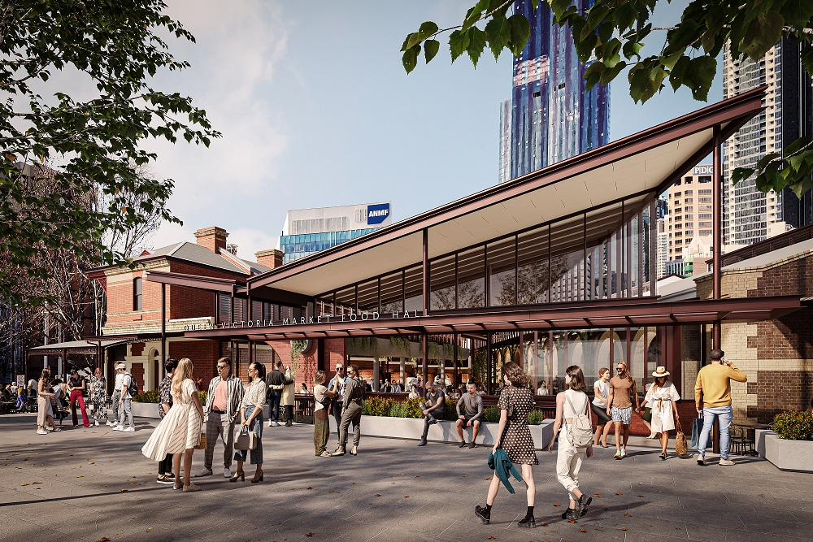
Artist impression of the new Food Hall
Works Notification

February 2022
New Food Hall

Construction of the market’s exciting new dining experience is now underway. The new Food Hall will offer customers an inviting contemporary place to eat, meet and enjoy the market atmosphere.
Through the market renewal program, we are creating a new Food Hall that will be a centrepiece of the market, contributing to the overall visitor experience and creating a welcoming and vibrant indoor dining destination while improving connections to the rest of the market.
The works include:
- New façade and canopy on Queen Street.
- Improved dining experience and layout to maximise seating, including new furniture and landscaping.
- New roof structure to replace the existing canvas ‘tent’ roof.
- Upgrades to air conditioning, lighting, toilets and new flooring.
- Replacement of the Victoria Street Terraces’ slate roof.
McCorkell Construction is undertaking the works on behalf of City of Melbourne under Heritage Victoria Permit No: P35301 and Planning Permit TP-2021-603.
Works are expected to be completed in early September 2022 with the new Food Hall a major drawcard for the market.
Thanks for your patience as we work to make a great market even better.

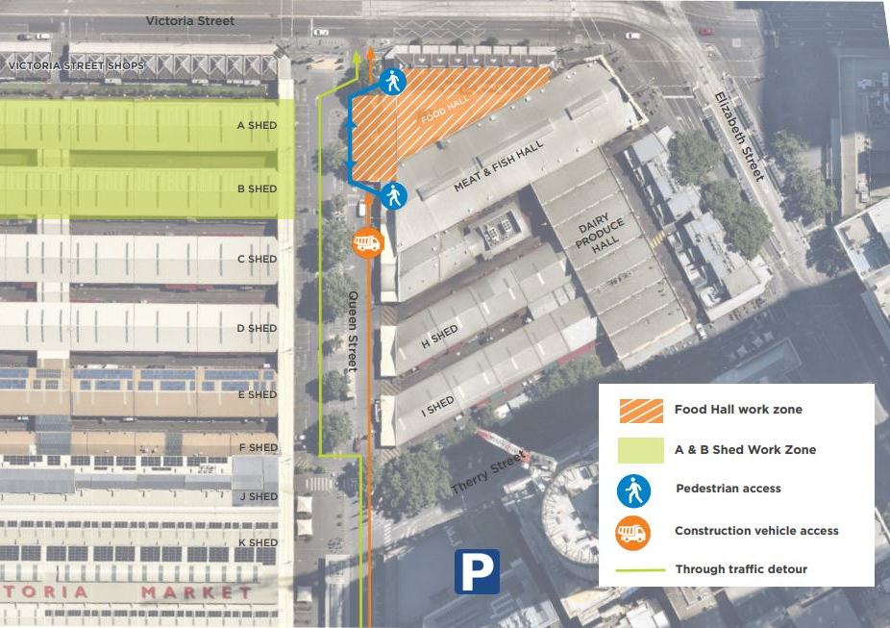Aerial map of work zone and pedestrian access.
What’s happening February to April
- Site establishment including set up of the site office and installation of fencing.
- Internal demolition of current Food Court including removal of the tent roof.
- Repair and restoration of the Victoria Street terraces slate roof.
All works will be carried out in accordance with the approved construction and traffic management plans and in accordance with WorkSafe, EPA and COVID Safe guidelines.

What to expect
As with any construction project there will be short-term disruption and changes to the way you access the area. For your safety, please be patient and follow the signage, as well as instructions of traffic controllers.
When
Construction hours are:
7am to 5.30pm - Monday to Friday
7am to 3.30pm - Saturday
Construction impacts
- Businesses and shoppers in close proximity to the work area may experience some inconvenience.
- Works are expected to generate noise and dust during construction hours. However, there are measures in place to minimise noise pollution and dust where possible.
Pedestrian access
- The work area will be fenced off for the duration of construction and pedestrians will be diverted around the site.
- Please take note of signage on temporary fencing to assist with safe pedestrian access and be mindful of changed conditions.
Changed traffic conditions
- The east side of Queen Street in front of the current Food Court will be closed.
- Changes to traffic conditions in Queen Street with all through traffic via the west side of Queen Street. Between 6am to 9.30am, market traders will load/unload in front of sheds C to F. There will be a slightly different traffic route during these times.
- Construction vehicles will enter and exit the site from Queen Street.
- Traffic controllers will be on site as required to manage vehicle and pedestrian movements. For your safety, please be patient and follow the instructions of traffic controllers.
Parking
There will be some changes to parking arrangements on Queen Street between 6am and 9.30am on market days to enable operation of a trader loading zone in front of sheds C to F (see map above).

Queen Victoria Market Precinct Renewal Program
The $268 million renewal of the Queen Victoria Market precinct is well into delivery with a clear road map to complete the market improvements by end 2024 and broader precinct renewal commitments by 2026.
It is estimated that investment in renewal to revitalise the Queen Victoria Market precinct will attract 18 million visitors a year by 2051. And every dollar spent will return more than $4 into the local economy, delivering almost $1 billion in local area benefits.
To date, over half the market’s heritage sheds have been restored, a new 500-space underground market car park has opened at Munro and a new pop-up park with grass and seating has replaced asphalt car parks.
In 2022, the Food Court will be redeveloped, and construction will commence on two new buildings that will deliver contemporary facilities for all market workers, shoppers and visitors.
Queen Victoria Market will be open for business throughout the renewal with plans in place to ensure the market can maintain safe operations and continue to provide a great shopping experience.
The market is open Tuesday, Thursday, Friday, Saturday and Sunday, and Wednesday evenings during the seasonal Night Market. Visit for a wide variety of fresh produce, food, cafes, restaurants, specialty retail and services. Visit qvm.com.au for more details and opening hours.
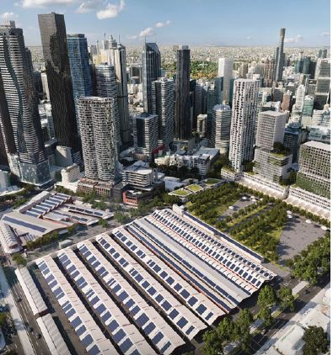
Aerial view of the Queen Victoria Market precinct
Upcoming works: February to April 2022
Site establishment and work hours
The east side of Queen Street in front of the existing Food Court will be closed for the duration of works. Through traffic will be maintained during the works via detour on the west side of Queen Street. Works will occur 7am to 5.30pm Monday to Friday and 7am to 3.30pm Saturday.
Demolition
All works will be carried out in accordance with construction and traffic management plans and comply with WorkSafe, EPA and COVIDSafe guidelines.
Foundations and structure
Construction of the new Food Hall foundations will include archaeological investigations. The main ‘tent’ roof of the existing Food Court will be replaced, and the Queen Street facade will be updated.
Victoria Street Terraces repair and amenity upgrades
The slate roof of the Victoria Street Terraces will be replaced as part of this project. Amenities including the public toilets will also be upgraded.
Like to know more?
To find out more about the new Food Hall and the Queen Victoria Market Precinct Renewal program, please contact 9658 9658, or visit melbourne.vic.gov.au/qvmrenewal

https://qvm.com.au/
https://www.melbourne.vic.gov.au/building-and-development/urban-planning/local-area-planning/queen-victoria-market-precinct-renewal-plan/Pages/queen-victoria-market-precinct-renewal-plan.aspx

