

New Park on Market Street

Construction update

December 2020

New open space

Works are continuing on the creation of a new park on Market Street which will create 1900 square metres of public open space in the centre of the city.

The northern section of the park (towards Collins Street) has opened and the southern park extension (towards Flinders Lane) will be completed and opened by 18 December.

The City of Melbourne is aware of increased skateboarding activity in the completed sections of the park and has been working with its skate ambassador to engage with the skateboarding community.

Additional skateboarding deterrents will be introduced around the park in coming weeks to provide a safe and enjoyable environment for park users.

Changes to Market Street

Due to recent COVID-19 restrictions, works have moved slower than planned and the completion date has been extended. Construction of the section of Market Street between Collins Street and Flinders Lane will now commence in late January 2021 and be completed by early May 2021.

Works will include:

eastern footpath upgraded to bluestone paving

new northbound and southbound bicycle paths

alterations to the stormwater drainage system

Market Street converted to one way and road pavement upgraded

new pedestrian crossing to the open space

new line marking and traffic signage.

completion of paving and line marking associated with new traffic signals at the Market Street and Flinders Lane intersection.

Traffic signal changes

Works to the traffic signals at the intersection of Collins and Market streets are now complete and the signals have been activated. Signal changes at Flinders Lane and Market Street have also commenced and final activation is expected by the end January 2021.

Smoke-free area

In September this year, Council endorsed a proposal to make the new Market Street Park a smoke-free area. New bins with ‘no smoking’ signage will be installed by the end of the year to remind users that smoking is prohibited in the open space.

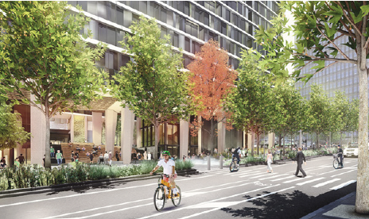
Artist impression of new park on Market Street

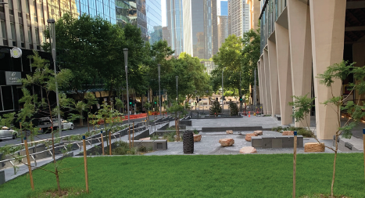

Completed northern open space opened to the public

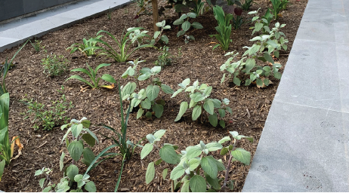

Southern park extension nearing completion

To find out more, please contact 9658 9658, or visit melbourne.vic.gov.au/cityprojects

https://www.melbourne.vic.gov.au/building-and-development/shaping-the-city/city-projects/Pages/city-projects.aspx

