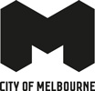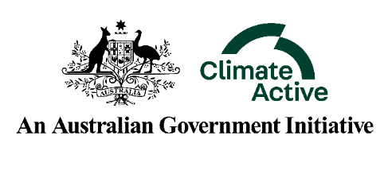
Australian Government Climate Active Public Disclosure Statement
NAME OF CERTIFIED ENTITY: City of Melbourne
EVENT NAME: Melbourne Knowledge Week
EVENT DATE/S: Certification Period July 2019 – July 2020
EVENT TYPE: Large Event Portfolio
Declaration
To the best of my knowledge, the information provided in this Public Disclosure Statement is true and correct and meets the requirements of the Climate Active Carbon Neutral Standard.
Signature | Date 24/06/2020
Louise Scott
Director – Tourism and Events, City of Melbourne
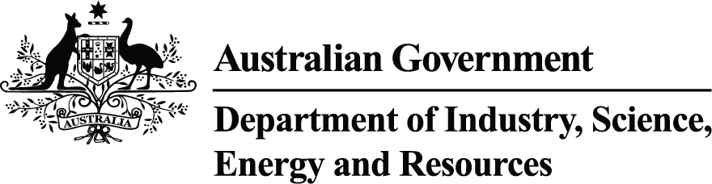
Public Disclosure Statement documents are prepared by the submitting organisation. The material in Public Disclosure Statement documents represents the views of the organisation and do not necessarily reflect the views of the Commonwealth. The Commonwealth does not guarantee the accuracy of the contents of the Public Disclosure Statement documents and disclaims liability for any loss arising from the use of the document for any purpose.

Carbon neutral information

Description of certification
Melbourne Knowledge Week (MKW) is City of Melbourne's annual festival of ideas for a smart and innovative city, where we engage all Melburnians to explore, discuss and ideate our future together. We celebrate Melbourne’s best and brightest, as the community explores smart, innovative and unique solutions to improve one of the world's most liveable cities.
As a certified carbon neutral organisation, the City of Melbourne manages an active emissions reduction plan. This plan identifies City of Melbourne’s large events as a material emissions source which prompted the carbon neutral certification of this large event portfolio. This is the second consecutive year the portfolio has been certified carbon neutral.
Greenhouse gas emissions considered include carbon dioxide (CO2), methane (CH4), nitrous oxide (N20), hydrofluorocarbons (HFCs), perfluorocarbons (PFCs), sulphur hexafluoride (SF6) and nitrogen trifluoride (NF3).
The City of Melbourne follows the Climate Active Carbon Neutral Standard for Events in the data collection and preparations of this report and used guiding Greenhouse Gas Protocol principles of; relevance, completeness, consistency, transparency and accuracy in the development of any new methodologies for this Large Event Portfolio.

Changes since pre-event report
Melbourne Knowledge Week 2020 was cancelled due to COVID-19, following advice provided by state and federal government.

Emissions reduction strategy
N/A

2. Emission Boundary
N/A

3. Emissions summary
N/A

4. Carbon offsets
Expected emissions for MKW 2020 were calculated at an estimated 105t/CO₂. With the cancellation of MKW 2020, offsets purchased for MKW 2020 were re-allocated to City of Melbourne’s Large Event Portfolio for the July 2019 – July 2020. No offsets have been banked for future use. All evidence of offset retirements for the Portfolio can be found in the MMW and MFW PDS.

5. Use of trade mark
N/A

6. Additional information
N/A

Appendix 1 - Excluded emissions
N/A

