Checklist for planning applications
Licensed Premises
Background Information
This checklist provides information about what you will need to provide Council when applying for a Licensed Premises permit.
You should include the type of Liquor License being applied for in the description of your application, i.e. an “on-premises” bar or tavern
You may need this checklist if you are:
- Using your premises such as a cafe, restaurant, bar, nightclub and or bottle shop to sell or consume liquor under the provisions of the Melbourne Planning Scheme
For further guidance about whether you will need to use this checklist, please consider booking a pre-application meeting.
To be accepted for assessment, your application must include:
☐ A completed application form, including a signed declaration
☐ A recent copy of the title for the land (dated no more than 30 days prior to the application) including a copy of the diagram or relevant plan of subdivision and the Register Search Statement which lists any encumbrances or restrictive covenants that may affect the land. A Certificate of Title may be obtained online from LANDATA or by contacting the Land Information Centre
☐ The prescribed application fees
☐ Details of the proposed operations of the license premises. Some of the items listed under ‘Written Submission/ Management Plan’ below may be relevant to your business
☐ A ‘red line’ plan that shows the floor area of the proposed building where liquor will be sold or consumed (i.e. clearly mark the proposed licensed area).
Note: An application fee is requested by the Responsible Officer after the application is lodged. Please ensure the section of the application form titled “Cost of Works” is completed when you lodge your application to prevent delays in calculating the correct fee.

In addition to the mandatory items above, you will need some or all of the following:
Note: Please refer to the endnotes at the bottom of this document to determine which requirements may apply to your application. You can also discuss these requirements with a Council Planner via a pre-application meeting.

Fully dimensioned site analysis plan, showing:
Note: A Site Analysis Plan is a clear drawing that shows your site and all bordering sites, including the location of buildings and their uses
☐ The proximity of the premises to other taverns/ bars, hotels and nightclubs
☐ The location of properties used for sensitive uses (such as residential uses, childcare centres, education centres etc) in direct line of sight and within 100m of the site – details of doors, windows and open space areas should be shown if applicable to give further context to the sensitive uses
☐ Taverns/ bars, hotels and nightclubs accommodating in excess of 100 patrons should provide the following information regarding public services and infrastructure in the immediate locality:
- CCTV
- public toilets
- street lighting
- taxi ranks and access to public transport services
- pedestrian crossings and traffic management measures

A fully dimensioned floor plan, showing:
Note: A Proposed Floor Plan is a clear drawing that shows the location of the proposed site where liquor is proposed to be sold and or consumed.
☐ All areas to be used by patrons including areas outside the boundaries of the site, i.e. public spaces or footpaths
☐ The licensed area marked within a red line
☐ The existing and proposed internal layout of the premises
☐ The total numbers of patrons to be accommodated on the premises and the allocation of these patrons to identified areas
☐ Car parking and bicycle layout (if to be provided)

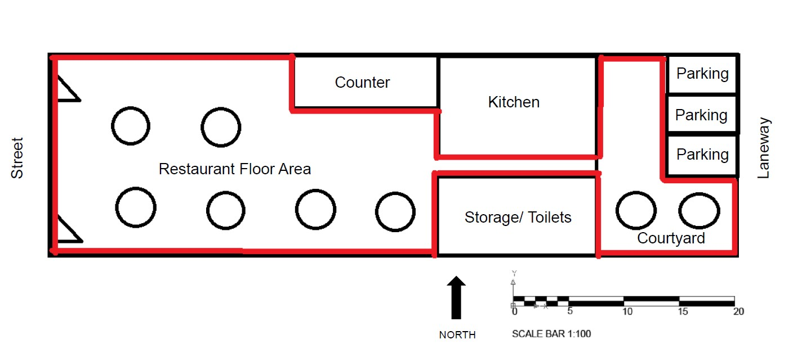
Sample red line plan:
Note: Hand-drawn plans showing aerial site plan (top) with dimensions (lengths and width), may be acceptable for your red line plan. Alternatively, you may wish to engage a person suitably qualified to prepare architectural plans which often tend to show your proposal more clearly
Written submission/Management Plan, including:
Note: The written submission can be used to explain in writing how the proposed business will operate and manage potential amenity concerns. Please note details on the management of the site must be provided for taverns/bars, hotel and or nightclubs. Details on the management of the site may be less important for more modest uses which proposed the sale and consumption of liquor for uses such as a food and drinks premises (café). Finally, the written submission needs to respond to the relevant requirements of the Melbourne Planning Scheme
☐ Details of the type(s) of liquor licence sought – refer to definitions in the Liquor Control Reform Act 1998
☐ Hours of operation for all parts of the premises
☐ Details of the maximum number of patrons to be permitted on the premises
☐ Security arrangements including hours of operation and management to minimise queues outside the venue
☐ Entry and exit locations
☐ Pass-out arrangements
☐ Training of staff in the management of patron behaviour
☐ A complaint management process including provision for the logging of complaints, contact details, responses to verified complaints, consultation with the local community and access to data by officers authorised by the Responsible Authority, the Director of Liquor Licensing, the Environment Protection Authority and Victoria Police
☐ Management of any outdoor areas to minimise impacts on the amenity of nearby properties
☐ Management of patrons who are smoking
☐ Lighting within the boundaries of the site
☐ Security lighting outside the premises
☐ General waste (including bottle) storage and removal arrangements (including hours of pick up)
☐ Noise attenuation measures including the use of noise limiters
☐ Details of any proposed special events
☐ Details of the provision of music including the frequency and hours of entertainments provided by live bands, live music (DJ), amplified music and any other forms of entertainment
☐ Details of the consideration of the Disability (Access to Premises-Buildings) Standards 2010
A cumulative impact assessment (depending on the number of licensed premises near the vicinity of the site).
A cumulative impact assessment depends on the number of licensed premises near the vicinity of the site. Cumulative impact refers to both positive and negative impacts that can result from clustering a particular land use or type of land use. Potential cumulative impact from a cluster of licensed premises will vary between locations, depending on the mix and number of venues and whether the area is a destination for activities associated with the supply of alcohol. Cumulative impact is a product of the number and type of venues present, the way they are managed, and the capacity of the local area to accommodate those venues.
An acoustic report, including:
Note: The acoustic report must demonstrate that the amenity of the area will not be unreasonably impacted by your proposal as a result of the patrons or operations of the site. The report will need to be prepared by an acoustic engineer or consultant.
☐ Assessment of whether the noise levels generated by the proposed use at the premises meets the requirements specified in the State Environment Protection Policy. In particular 1826.4: EPA Noise limits
☐ Identification of sensitive nearby uses, all potential noise sources and sound attenuation work required.

Helpful Hints
- This checklist outlines the standard information required for application lodgment. Additional information may be requested by the assessing planning officer.
- If you would like to discuss your proposed licensed premises, you can arrange a pre-application meeting at Planning pre-application advice
- For information about fees, please refer to the Schedule of fees. Please note, you may require other permits, and these may incur additional fees.
- A planning permit is required to use land to sell or consume liquor if any of the following apply:
- You require a license, or a change in license category under the Liquor Control Reform Act 1998 except for:
  - A limited license
  - To a license to manufacture liquor
- The hours of trading allowed under a licence are to be extended. No permit is required to reduce the hours of trading
- The number of patrons allowed under a licence is to be increased. No permit is required to reduce the number of patrons
- The area that liquor is allowed to be consumed or supplied under a licence is to be increased or changed. No permit is required to reduce the area within which liquor is allowed to be consumed or supplied.
- People often confuse this planning permit requirement with a Liquor Licence. A Liquor Licence can only be issued by the Victorian Gambling and Casino Control Commission, however the process requires that Council’s regulations are met first If you do need a license from the Victorian Gambling and Casino Control Commission (VGCCC) further information on can be found at the VCGLR website.
The VCGLR may require you to provide a planning permit or written permission from Council with your liquor license application. You can make a request for a written response by contacting the Planning Department.
- If you obtain a planning permit from Council and Victorian Gambling and Casino Control Commission, before you commence servicing alcohol, you may also need to consider other permits and permissions such as a Street Trading Permit, Food Safety and Building Approval.
Application lodgement guidelines
Please submit your application electronically – by email, online file sharing service or USB. Your email should include the complete application as a single PDF document, optimised to reduce file size and not encrypted or password protected. Alternatively, you may lodge the application via our online portal Lodge a planning application. For other lodgement options, please contact Council.
To get in touch with Council about your application
Telephone: (03) 9658 9658
Email: planning@melbourne.vic.gov.au
Online: Contact us

https://www.landata.vic.gov.au/
https://www.land.vic.gov.au
https://www.epa.vic.gov.au/about-epa/publications/1826-4
https://www.melbourne.vic.gov.au/building-and-development/planning-and-building-services
https://www.melbourne.vic.gov.au/SiteCollectionDocuments/planning-schedule-of-fees
https://www.melbourne.vic.gov.au/building-and-development/planning-and-building-services/planning-applications
https://www.melbourne.vic.gov.au/pages/contact-us.aspx

