Block – La Trobe Street, William Street, Lonsdale Street, King Street
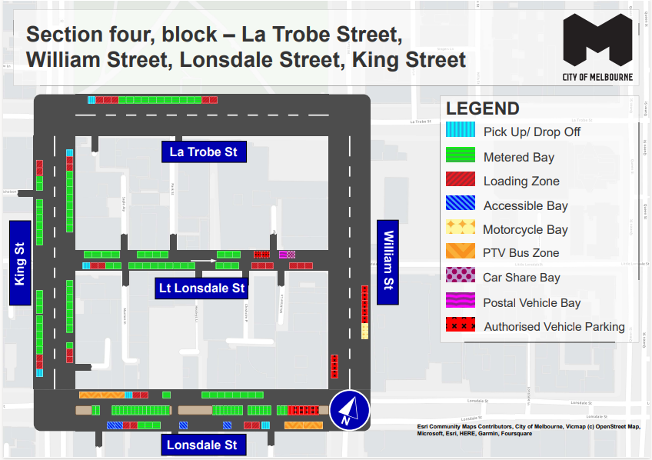
This map presents the parking conditions to be applied within this block as part of the CBD parking improvement project.

La Trobe Street
The north side, from west to east, includes one pick up/drop off space, followed by three loading zones, 11 metered parking spaces and two loading zones.

William Street
The west side includes three authorised vehicle parking spaces.
The east side, from north to south, includes five authorised vehicle parking spaces followed by a motorcycle parking area.

Lonsdale Street
The north side, from west to east, includes PTV bus zones followed by one pick up/drop off space, two loading zones and nine metered parking spaces.
The south side, from east to west, includes two PTV bus zones followed by one pick up/drop off space, two loading zones, two accessible parking spaces, three metered parking spaces, two loading zones and two accessible parking spaces
The centre of road, from west to east, includes 34 metered parking spaces followed by eight authorised vehicle parking spaces.

King Street
The west side includes, from south to north, will include one pick up/drop off space followed by two loading zones, eight metered parking spaces to the intersection of Little Lonsdale Street. This is followed by eight metered parking spaces and two loading zones.
The east side, from north to south, will include one pick up/drop off space, two loading zones, eight metered parking spaces to the intersection with Little Lonsdale Street. This is followed by eight metered parking spaces and two loading zones.

Little Lonsdale Street
The north side, from west to east, will include 11 metered parking spaces, two authorised vehicle spaces, one postal vehicle space and one car share space.
The south side, from west to east, will include one pick up/drop off space, two loading zones, 14 metered parking spaces and six loading zones.

Parking controls to be applied
Simplified and consistent parking controls will be applied across the CBD.
Pick up/drop off spaces will typically be signed ‘No Parking’. We will add signage to explain that the space is for passenger pick up / drop off for up to 2 minutes.
Metered spaces will typically be signed ‘2P Meter, 7am – 10pm, Mon – Sun’. Off-peak pricing in the CBD started on 3 July 2023 and includes a reduced rate of $4 per hour after 7pm weekdays and all weekend. The offer of $0 payment for short stops of up to 15 minutes in any CBD metered parking space via the EasyPark app started on 3 July 2023. This allows short stops in any green-sign space rather than limiting short stops to a small number of specific bays (for example, ‘¼P’).
Loading Zones will typically be signed as ‘Loading Zone, 30-minute, 7am – 4pm, Mon – Fri’. These spaces will typically become ‘2P Meter, 4pm – 10pm, Mon – Fri’ and ‘7am – 10pm, Sat – Sun’. We will place some full time Loading Zones in areas with very high demand for deliveries. People making deliveries can also use green-sign spaces for short stays of up to 15 minutes for $0 via the EasyPark app.
Accessible (disability) parking spaces will typically be signed ‘2P, Disability Only, 7am – 10pm, Mon – Sun’. We will apply blue line-marking to these spaces.
Motorcycle parking will be signed as ‘P, Motor Cycles Only’ with no time restrictions.
Car Share spaces will typically be signed as ‘Permit Zone, Car Share Vehicles’ for the permitted car share vehicle operator.
Postal Vehicle spaces will be signed as ‘No Parking, Postal Vehicles Excepted’. They can be used by Australia Post vehicles, and by any other vehicle needing to access an adjacent postbox for up to 2 minutes.
Taxi Zones will be placed in areas with high demand for taxis. This includes at railway stations to support transport interchange and at key tourist destinations.
Tourist coach spaces will typically be signed as ‘No Stopping, Buses Stopping Less Than 15 Minutes Excepted’. This allows passenger pick up / drop off in the CBD. We will provide longer term parking for tourist coaches at key tourist destinations and in selected areas outside the CBD.
Authorised vehicle parking means access for permitted uses only (for example, Swanston Street delivery permit holders).
Non-vehicle occupation includes temporary infrastructure in a parking space (for example, an outdoor dining parklet).
Construction Zones will be signed as ‘Permit Zone, Construction Vehicles’ to allow construction vehicles with a permit to stop and park.

